Unibase Solutions
UniProp – The BUSINESS of PROPERTY


Printed Product Manual

www.unibase.co.za
Unit 5, Townsend Office Park
Townsend Road
Bedfordview, 2007

Tel: +27 10 065 0890

© 2019 Unibase Solutions

Contents
1. Getting Started 5
1.1. System Overview 5
1.2. Accessing and Operating 5
1.3. Functionality Roadmap - How do I.... 7
1.4. Common Functional Roles 7
1.4.1. General business management 7
1.4.2. Property management - Rental properties 7
1.4.3. Property management - Sectional Title and HOA properties 7
1.4.4. Accounting 7
1.4.5. Cash control and reconciling 7
1.5. Common procedures and processes 7
1.5.1. Setting up and Processing 7
1.5.2. Regular routines 113
1.5.3. Utilities 123
2. Menu's 129
2.1. Branch 129
2.1.1. Template Variables 129
2.1.2. Template Upload 129
2.1.3. Create/Maintain Branch 130
2.1.4. Create/Maintain Directory 152
2.1.5. Managed Assets 159
2.1.6. External Links 165
2.1.7. Auto Options 165
2.1.8. Management Log 167
2.2. Debtors 194
2.2.1. Debtors Master Maintenance 194
2.2.2. Journal 204
2.2.3. Debtors Loan 204
2.2.4. Auto Menu 205
2.2.5. Csos Manual Journal 218
2.2.6. Debtors Refund 218
2.3. Creditors 219
2.3.1. Creditors Master Maintenance 219
2.3.2. Creditors Transaction Enquiry 221
2.3.3. Auto Menu 222
2.3.4. Management Log 226
2.4. General Ledger 226
2.4.1. G/L Reporting 226
2.4.2. Journal 236
2.4.3. Bank Statement Menu 237
2.4.4. Data Base Setup 253
2.4.5. Data Base SMS Table 263
2.4.6. Bank Statement Capture 263
2.4.7. Bank Recon Report 264
2.4.8. Budget Capture 264
2.4.9. Auto - General Reports 265
2.4.10. Set up Override Group Details 268
2.5. Purchasing 270
2.5.1. Other 270
2.6. Invoicing 272
2.6.1. Bulk Sundry Invoice 272
2.7. Fixed Assets 273
2.7.1. Maintain/Create Fixed Asset 273
2.7.2. General Ledger 290
2.7.3. Debtors 290
2.7.4. Maintenance 307
2.7.5. Unit Management Log 309
2.8. Employees 311
2.8.1. Create/Maintain 311
2.8.2. Management Log 311
3. FAQ ? 312
3.1. How do I link two units to pass on charges and payments ? 312
3.2. How do I set up and charge Bank Charges to clients ? 314
3.3. How do I setup Debt Collector Letters and their Charges 314
4. Terminology 316
4.1. Branch 316
4.2. Debtor 316
4.3. Directory 317
4.4. Fee Structure 317
4.5. Fixed Asset 317
4.6. Head Office 319
4.7. Intergroup 320
4.8. Invoicing 320
4.9. Purchasing 320
4.10. Sharing - Bank, Debtors, Creditors and VAT 320
4.11. Old and new 322
5. Report Templates 323
5.1. Template variables 323
5.2. Templates in more detail 325

Getting Started
This section contains overviews of the system, and how to access and use it.

System Overview
'The System' is a comprehensive , generic accounting, information, management and control system, which has various specialised modules to facilitate, for example, Property Management, which is the primary focus of this help facility.

The system is accessible via. any web browser, and has various contact and input points using smartphone app's, and automated email updating.

As part of the base philosophy, the system aims at developing and maintaining its core functionality, and allowing easy interfaces with external specialised support systems. This principle has been applied in some of the core system functioning (eg. Document production and eMail/Message delivery and tracking), and in creating API's allowing external applications to access and update information, and trigger events in the system.

Whilst specialised document archiving and work flow systems are available, the system has its own for covering key processes which are significant to the system.

Some of the features that assist in property management, include -
- Shared banking facilities and control.
- Open item debtors and creditors, with a brought forward expression.
- Deposit control structure with refund and daily interest calculations
- Manual and Host to Host banking interfaces

Accessing and Operating
Operational access to the system is via the internet, usually using an internet browser or a dedicated App.

Dedicated system users will receive a system user name code and password, giving them access to predetermined system functionality and authorised information. Apps and specific function access use temporary token logins, allowing the particular functionality offered by the App or specific function - for example, reporting a maintenance requirement or obtaining a debtors statement.

Web browsers are offered by several different product developers, with different advantages and restrictions. Historically, web based application software access has often been based on a specific browser that the particular program is customised to. We have tried to accommodate the use of most browsers, by developing our own version of browser functionality for key operations. Access to our system should therefore work successfully using most web browsers.

App and specific function access information will be given with the introductory information when they are offered/downloaded.

Operational access is arranged as follows

1. | Obtain a user name, password and url to log in. Usually obtained from the help desk.
2. | Open your browser and navigate to the url for your company, for example - https://dbname.unibase.web.za - saving the address as a favourite.
3. | The log in prompt is displayed:  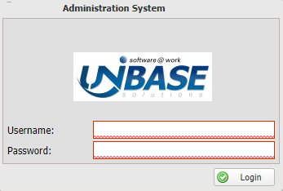
   | The login screen and the browser are usually branded to reflect your company's branding
4. | Click on Login.  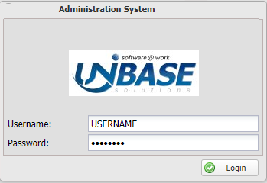  The system will remember your credentials.

The system is menu driven, with menus tailored to your requirements
Your menus will be customised to your operational requirements:

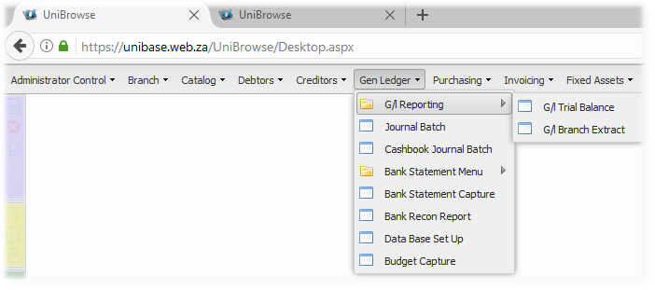

The left hand toolbar will contain options relevant to the particular menu item that you choose:

Refer to the Functionality Roadmap for the next steps.

Functionality Roadmap - How do I....
This section lays out the main areas of activity in the system.

It is best viewed and used, using the online help facility - http://www.unibase.co.za/UPnew/functionality-roadmap---how-do.html

Common Functional Roles
Enter topic text here.

General business management
Enter topic text here.

Property management - Rental properties
Enter topic text here.

Property management - Sectional Title and HOA properties
Enter topic text here.

Accounting
Enter topic text here.

Cash control and reconciling
Enter topic text here.

Common procedures and processes
In this section we describe procedures, processes and utilities that are commonly employed and are useful in operating the system.

We have grouped them into categories for ease of reference:

1. Setting up and processing
2. Regular routines
3. Utilities

Setting up and Processing
This section contains information relating to the setting up of and processing of various system functions and processes. Choose from the topic groups in the sub-sections below.

Structure / System Related
Information relating to setting up various structures and systems.

Setting up report templates
The system contains various links to it's underlying data, which in the context of reports are called variables. Report Templates contains information on how to access and view the various levels of template variables, and how to download, create and upload report templates into the system.

The overall template usage rule, is that any template can be uploaded to any branch, with that branches stationery as its base. When reports are run, the relevant branches template will be used. If the branch does not have its own template, it's Group branch template will be used if it has one, else the data base branch template will be used.

Setting up a bank account structure
Bank accounts are a key source of transaction input in the system. Bank statements are downloaded and imported into the system, with automated matching and batch building on import, based on import formats that you can set up.

The balancing and control of bank accounts is easily achieved in the import process. The aim of the system is to have all bank accounts imported and reconciled on the system, not encouraging external control schedules (Excel) to be maintained outside of the system.

Branches can either use one of four bank accounts setup per branch, and/or share bank accounts with another branches set up as a central bank account used by many branches. Bank charges can be recovered based on usage, in the centrally shared environment. You can set up as many centrally shared environments per database as required. Each will follow the central account rules described below.

The system has a bank account directory structure. All bank accounts can be captured in the directory, with details of the account holder, and a facility to verify the account if linked to Host to Host banking. The branch bank account structure is linked to the bank directory, which enables the system to produce bank export files where necessary.

Bank account structures
Branches can either use their own bank accounts, share bank accounts as part of central sharing (Head Office), or a combination of both.

The system automates and controls the cash flow between the defined bank accounts, as illustrated in the image below:
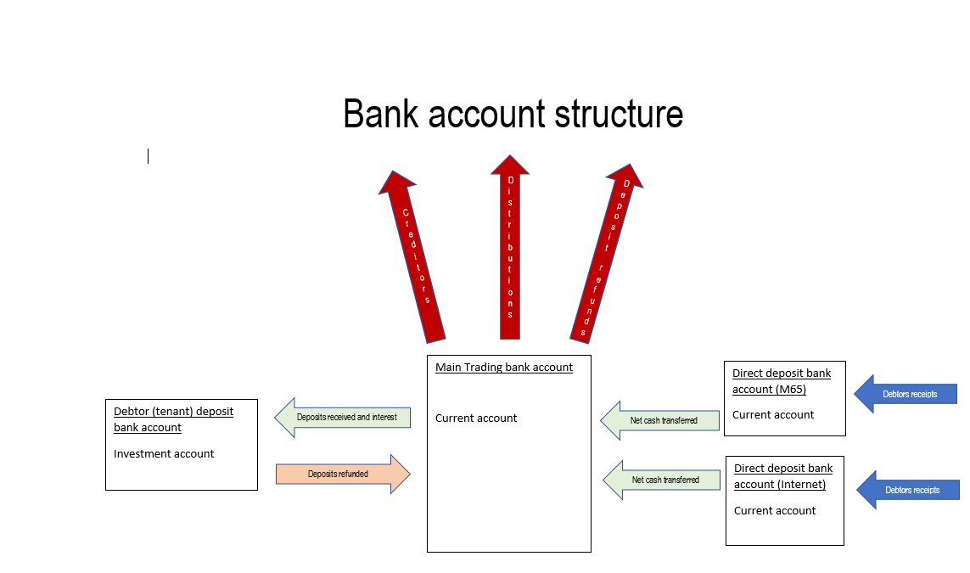

Each branch can set up four bank accounts, and link each one to a particular bank directory item. Only the accounts needed should be set up. If, for example, the branch doesn't set up a separate account for its deposits, the system will keep them in the main trading account. If it does, the system will transfer them to the deposit account.

Each branch sets up its own bank accounts, and chooses which banking structure it will use by default. These are set up using Create/Maintain Branch, Bank accounts and Head Office Linking:

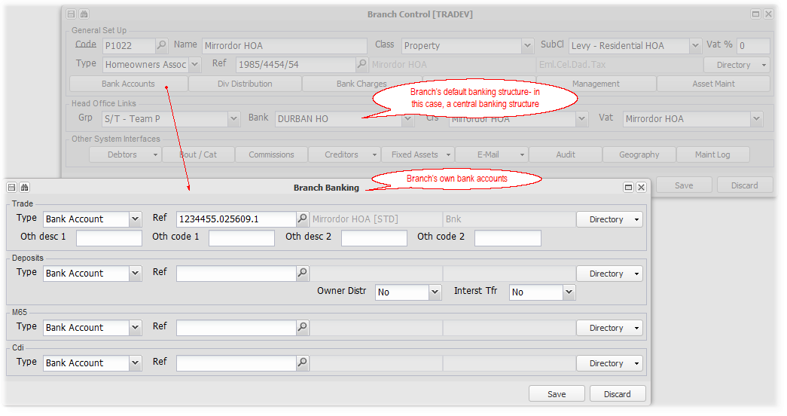
A branch as in the example above, can use both banking structures. If it wants to only use its own structure only, the head office link is set to the branch itself. Several system defaults will derive from the default bank structure (head office link), for example, the default bank account details on debtors statements.

If only a trading bank account is captured, all transactions will be routed to it. If a trading and deposit account is set up, the system will move any deposit receipts from the trading account to the deposit account, etc.

Branch own account structure
To set up that a branch will only use its own banking structure, choose the branch itself in the bank head office link of Create/Maintain Branch, and add the relevant bank accounts to the bank accounts field. Refer to the diagram above.

The normal cash flow would be all receipts into the trading account, direct deposit (M65) or internet (CDI) bank accounts, with deposits automatically routed to the deposit bank account. The direct and internet deposits would also be automatically routed to the trading account.

All payments would be made from the trading account, with the system recovering deposit refunds from the deposit account. Refer to Create/Maintain Branch for deposit interest cash flow rules and deposit distribution rules.
Refer to Bank account and cash control for more information on operating and controlling bank accounts.

Central bank account sharing
To set up a branch to use a shared bank structure banking structure, choose the shared banking branch in the bank head office link of Create/Maintain Branch. Any branch that is set up as a Head Office (Create/Maintain Branch, Class), can be used as a shared bank account branch. Add the bank accounts necessary to the Head Office branch's bank field.

The normal cash flow would be all receipts into the trading account, direct deposit (M65) or internet (CDI) bank accounts, with deposits automatically routed to the deposit bank account. The direct and internet deposits would also be automatically routed to the trading account, all in the Head Office branch. 'Member' branches would be allocated a share of the head office bank accounts based on their transactions, and be reflected in a bank sharing account. Refer to Accounting explained below for more information on how this is managed.

All payments would be made from the trading account, with the system recovering deposit refunds from the deposit account. Refer to Create/Maintain Branch for deposit interest cash flow rules and deposit distribution rules.

Refer to Bank account and cash control for more information on operating and controlling bank accounts.

Central bank account and branch own bank accounts
Any branch can choose to use both of the above banking structures. Their primary bank link would be to the central head office, and they would set up their own bank accounts on their bank section.

This would allow them to conduct their own banking transactions directly through their bank accounts, and allow bank transactions to flow through from a head office branch, via a bank sharing account.

Bank statements for their own bank accounts will be uploaded to their branch. The head office branch will upload its bank statements to its branch, and the system will allocate relevant transactions to each 'member' branch.

Accounting explained
The following examples demonstrate the accounting processes of both a branch being part of a head office shared bank structure, and of having its own bank structure (In this case, at the same time).
General ledger codes for bank accounts
Menu: General Ledger, Data Base Setup.

Having chosen and captured/imported your general ledger account codes, click on the Bank button, to enter your chosen bank accounts and their matching suspense codes. The suspense codes hold unallocated transactions pending their processing:
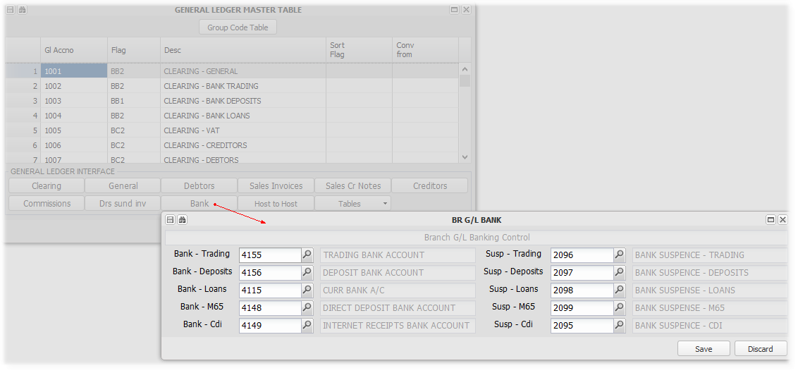

General ledger code for bank sharing
Menu: General Ledger, Data Base Setup.

Having chosen and captured/imported your general ledger account codes, click on the Clearing button, to enter your chosen sharing/clearing codes. These codes can be chosen by you, and are used to facilitate inter-branch sharing, in this case, bank account sharing (1002):
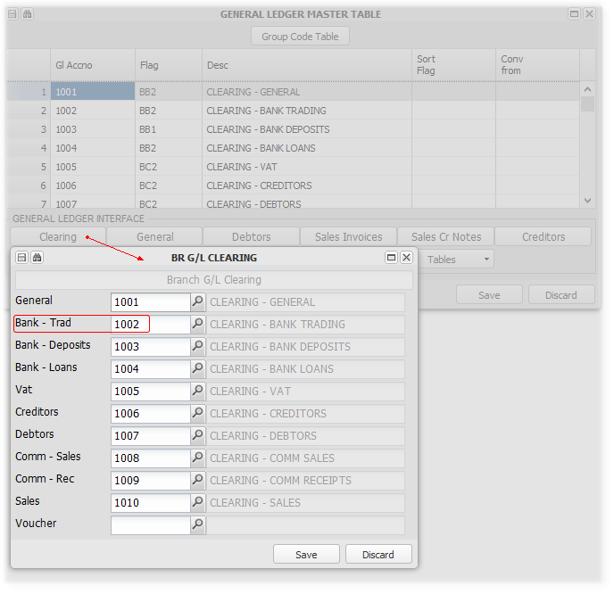

Processing two receipts in a dual bank structure
The following images demonstrate the accounting effect of two debtors receipts, one through the head office bank structure, and one into the branches own trading bank account. The following trial balance reflects two debtors (R3000 for a Levy of R2000 and a Remote deposit of R1000, and R1500 for a Levy):
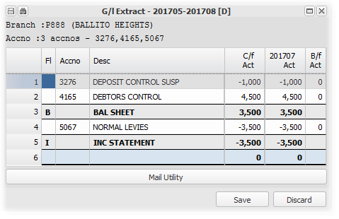

The one debtor pays into the head office bank account - import below:
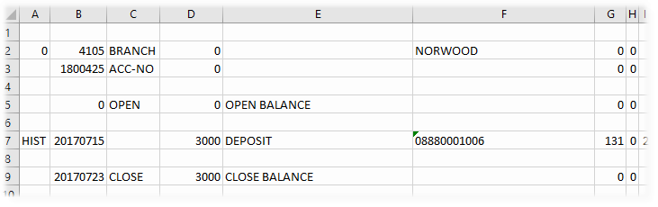

After the first receipt is processed:
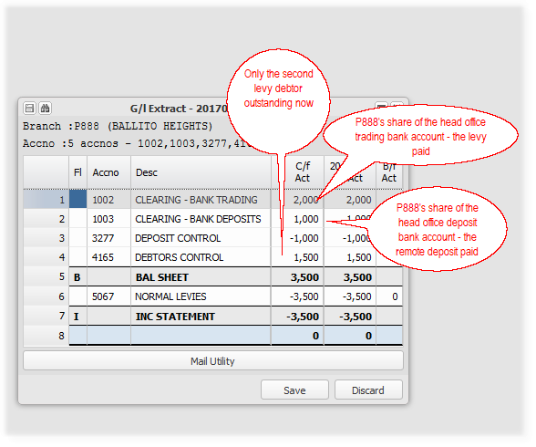

The other debtor pays into the branches own trading bank account - import below:
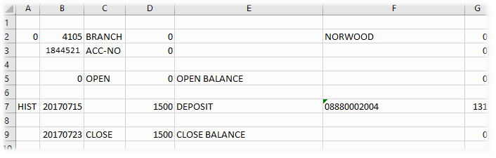

After the second receipt is processed:
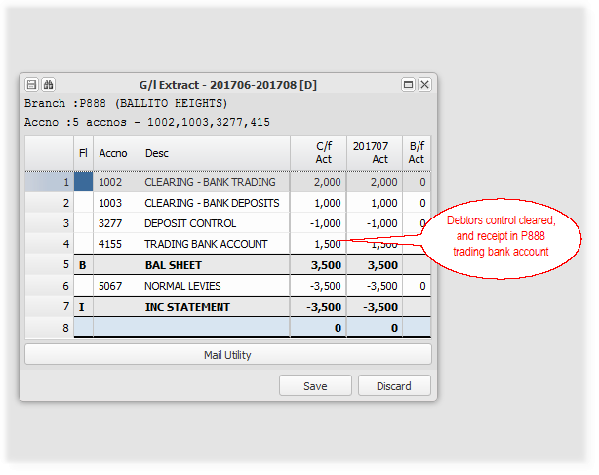

Bank account directory
Menu: Branch, Create/Maintain Directory
Menu: Branch, Create/Maintain Branch

Each actual bank account should be recorded on the system by means of a bank directory item. this item can be created directly by adding it from the directory menu item, or from the relevant master file screen. This item is then linked to every entity that uses it, for example - a branch, a debtor. The directory item contains key information about the bank account and its related account holder. Bank accounts can be verified if your account has Host to Host banking enabled:

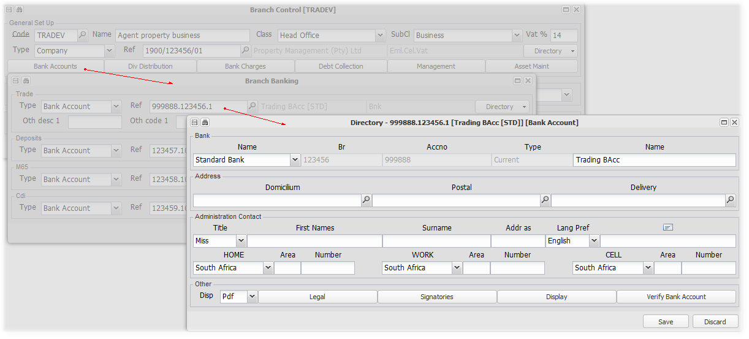

Setting up import layouts and rules
Bank statements are imported and then allocated using Bank Statement Upload and Bank Statement Maintain. When uploading, you choose which import format you would like to use. You can set up five different formats, which include data positioning rules, bank charge indicators, transaction batch type indicators, and allocation rules. These formats are set up using Bank Statement Formats - refer to that topic for more detailed information.

Setting up bank charge recoveries
The recovery of bank charges becomes relevant in a shared banking structure. The system automatically charges bank charges based on your set up table. The charges are allocated to the 'user' of the service, the recovery being allocated to the head office branch. The default table is set up on the central database branch, and any change to the default on the relevant branch.

Menu: Branch, Bank Charges
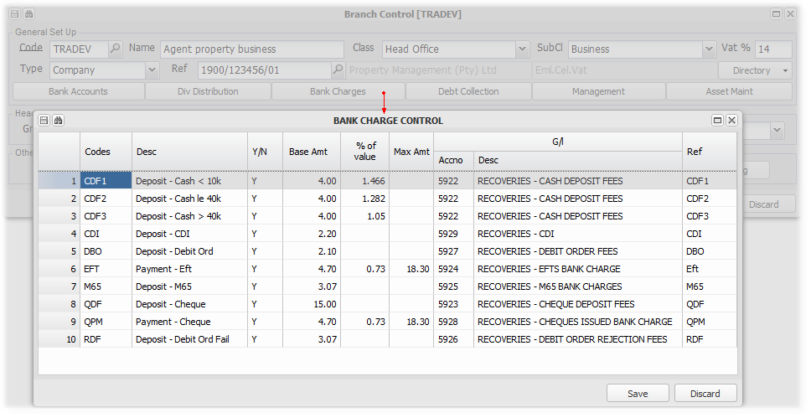
The various charge types and rates, and general ledger allocation are self explanatory from the table above. The specialised charge types - M65, CDI and Debit orders are triggered when using those particular exports or imports.

Menu: General ledger, Bank statement Menu, Bank statement formats:
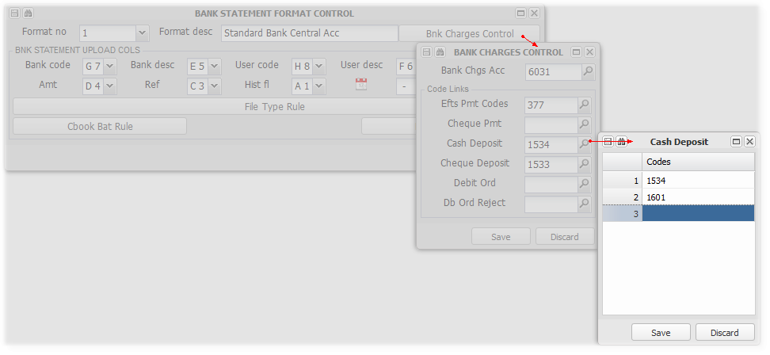
Link bank transaction codes to bank charge types, to trigger bank charges.

Refer to Setting up Bank Charge Recoveries for more information

Refer to Bank account and cash control for more information on operating and controlling bank accounts.

Setting up the link to Property 24
Details below regarding the system link to Property 24, used to advertise properties available for letting.

Capturing the Property24 login credentials
Enter topic text here.

Setup by help desk

Administrator Controls, Machine Setup:

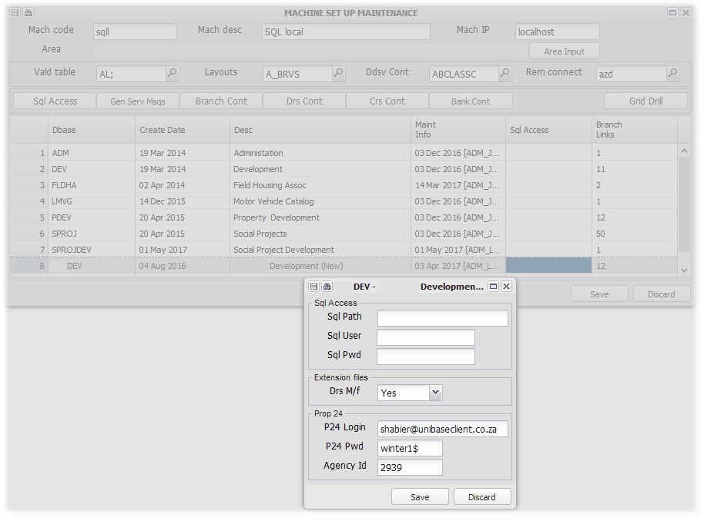

Setting up letting consultants/agents on Property24
Enter topic text here.

Activate an ID directory -

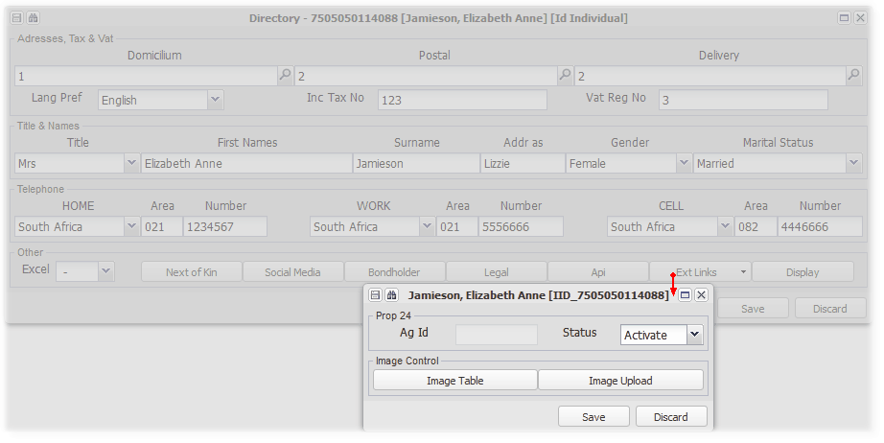
Refer to Natural Person Directory for more information.

Upload picture of agent/consultant
P24 will return their ref no

Linking a letting consultant/agent to a property
Enter topic text here.

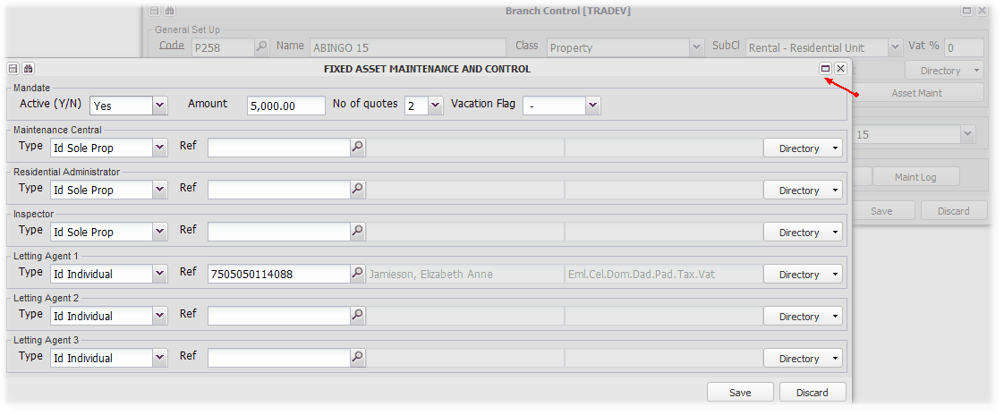

Listing etc. a unit on Property24
Enter topic text here.

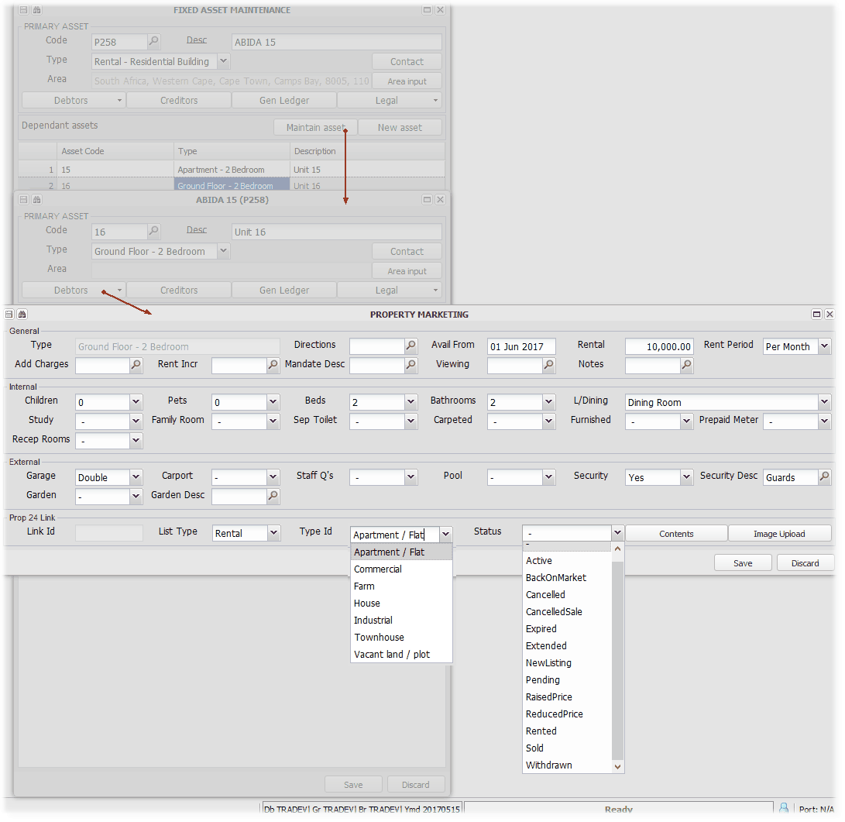

Setting up and using the Management Logs, Document Storage and Retrieval
The system facilitates the capturing of key information relating to several aspects and processes involved in managing a property or conducting a business. In support of these processes, the system allows the upload of related documents that can then be viewed in their relevant context. As an example, let's look at the Management Log for an Annual General Meeting:
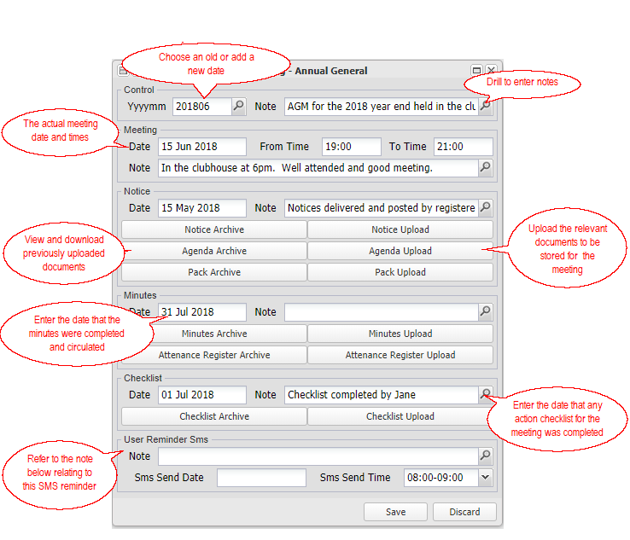 | For a financial year end, the various indicated details and working notes relating to the annual general meeting can be captured.  Documents relating to the meeting can be uploaded and then viewed.  The date that the minutes for the meeting were circulated can be entered, which then confirms that the minutes have been circulated, and indicates whether they were circulated in accordance with your expected time limit (If an exception, the Property Management Report indicates the exception)  The actual minutes and attendance register for the meeting can be uploaded and then viewed.  The date that the meeting checklist was completed can be entered, which, as for the minutes above, indicates that the checklist has been completed and if it was done withing the expected time limit.  Set an SMS reminder to follow up any aspect to yourself if you wish.

The system also allows you to upload several types of documents to be uploaded and then viewed as required.

The various Management Logs and other document storage areas:
Branch
Menu: Branch, Management Log

Management items and documents related to a Branch (Property).

The main areas covered:
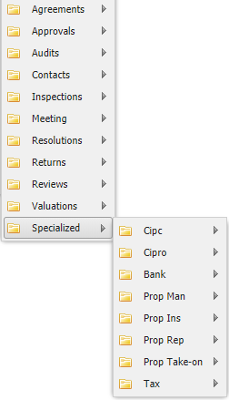

Refer to the Branch Management Log for more detailed information.

Creditor
Menu: Creditors, Management Log

Management items and documents related to creditors linked to branches.

The main areas covered:
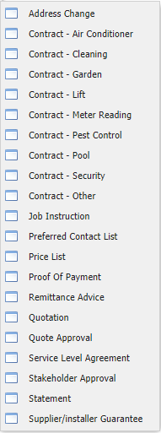

Refer to the Creditors Management Log for more information.

Unit (Fixed Asset Level 2)
Menu: Fixed Assets, Unit Management Log

Management items and documents related to units (fixed asset level 2's).

The main areas covered:
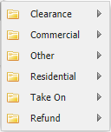

Refer to the Unit Management Log for more information.

Employee
Menu: Employees, Management Log

Management items and documents related to employees of a branch (property).

The main areas covered:
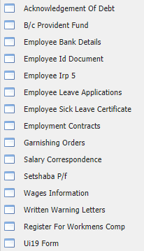

Refer to the Employees Management Log for more information.

Other
There are various other places where documents linked to a particular processes.

Loan
Lease

Setting up the Utility reading system and charging Debtors for Utility usage
This facility allows for the importing of utility usage readings for various types of utilities, and for the calculation and charging of the cost of the usage to debtors. It also allows for the importing of files that contain readings and costs, and charging the imported cost to debtors. The manual capturing of readings and charges is also achieved using this process.

Utility reading slips based on various templates, can be sent and charged.

Any utility which is used in measurable units, should be accommodated by this structure - eg. Hot water from a central boiler, electricity, water.

The overview of the process is as follows:
Setup
Set up the following areas to create the framework for charging debtors for utilities:
Set up Invoicing Codes
Menu: General Ledger, Database setup, Debtors Sundry Invoicing
The type of meter (utility charge) is determined by the name use for the Debtors Sundry Invoice Code. By setting up different codes, the system allows different type of utilities to be imported and charged for.

The type of meter in the files imported, will be matched first to the invoice code set up, and then to the relevant reading table (Refer to the Reading Rate Table section below). For example, if your imported files have a charge indicator, say 'E' for electricity, then you would set up a sundry invoice code called 'E':
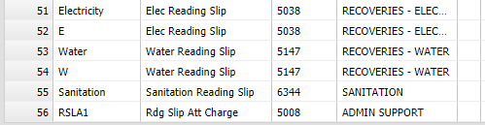

Set up and link a meter reading slip template/s
Menu: Branch, Create / Maintain Branch, eMail, Attachments
The system accommodates a variable replacement template which accommodates any number of utility reading types per period. A sample can be obtained from the support desk. Once created, upload your template to the relevant branch (Central database, Group or Individual branch).

Once uploaded, link the attachment to the program that calls it using the attachments option under eMail on the Create / Maintain Branch menu:
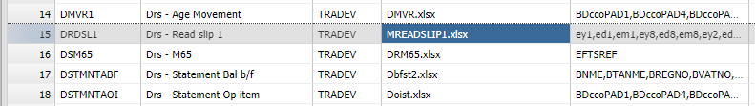

Utility reading slip templates can be linked to the various import layout options, enabling third party formats to be used when you have permission to do so. Refer to the section below covering the setting up of import layouts.

As with most templates, different templates can be set up for the database, for any group, or for an individual branch.

Set up import layouts and linking reading slip templates
Menu: Fixed Assets, Debtors, Reading Slip Formats
Set up file import details based on a either a columnar or a text string. Refer to the link above for more information.

The normal capturing of readings is also achieved using an import from an Excel spreadsheet.

Set up Reading Rate Tables
Menu: Branch, Create / Maintain Branch, Debtors, Reading Rates
From a Utility perspective, the reading rate table is set up to charge for usage based on a fixed rate per unit of usage, an incremental calculation table or a standard usage table. Refer to the example below which explains the difference between the two tables:
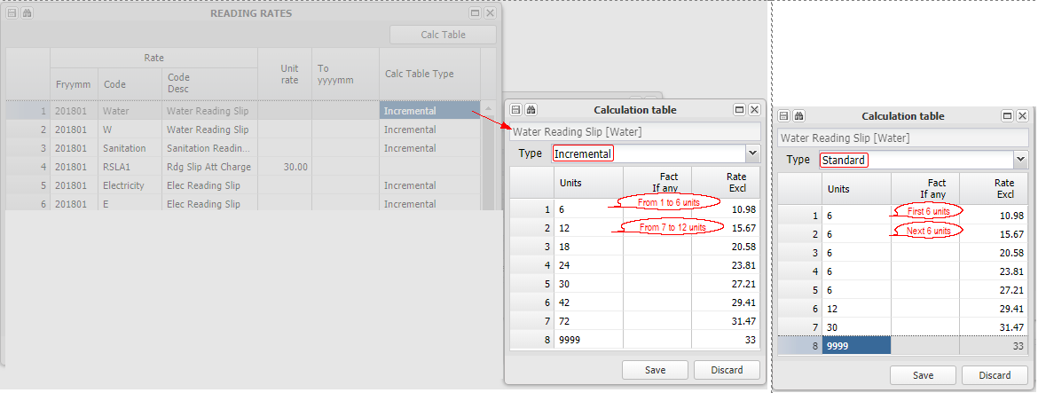

The standard system precedence rules apply to reading rates -
Central - The rates set up on the data base branch, will apply to all branches that do not have group branch or their own rates set up
Group - The rates set up on a group branch (agent), will override the central ranch rates, and apply to all branches (properties) in the group, except those that have their own rates set up.
Branch - The rates set up on an individual branch will override any group or central rates and be applied for that branch only.

Add unit Occupants and reading slip billing options
Menu: Fixed Assets, Maintain / Create Fixed Asset, Level 2 assets, Debtors, Occupants Table
If the utility reading import type for a branch includes a reading slip template, the reading slip will be sent to the relevant debtor (unit owner), and to any occupants who have been captured on the system. If the occupant is flagged to charge for the slip (refer to the image below), the debtor on the system will be charged by the group branch (agent), at the rate set up in the reading rate table above:
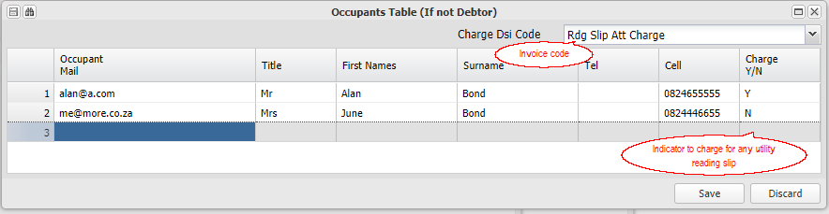

Upload readings and calculate charges
Menu: Fixed Assets, Debtors, Debtors - Auto General, Debtors Asset Readings
Having set up the various options described above, the next step is to import actual reading and charges. The following information is important to remember in processing import files:

1. If the import file has an amount to charge, the system will use that amount and not perform any calculations. The amount is assumed to include VAT.
2. It the import file has an opening reading (or there is an opening reading on the system), and a closing reading but no amount, the system will attempt to calculate the charge.
3. If the imported opening reading date or the actual opening reading is different from any system stored information, the line won't be imported, and will be displayed in the Run Errors list.
4. You can re-upload and overwrite any uploaded readings before they are invoiced. If the opening reading is the same as a previous upload, the new upload will over write the old.
5. You can upload more than one reading for the same period, as long as the dates are consecutive. This could be useful when occupants change during a month.
6. The system will automatically charge any amount to the occupant of the unit at the time of the consumption, based on the occupation and vacate dates.

Follow these steps to import your readings into the system:

1. Choose Debtors Asset Readings from the drop down menu
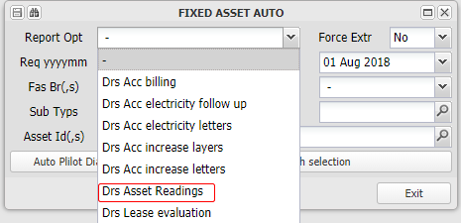

2. Select the period into which the charges should be billed, and their due date within that period
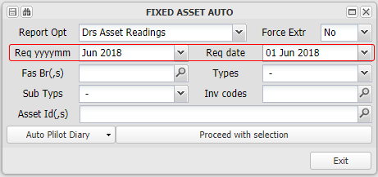

3. Apply any filters - usually not used
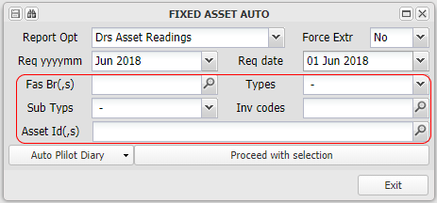

4. Click 'Proceed with Selection' and choose an import format
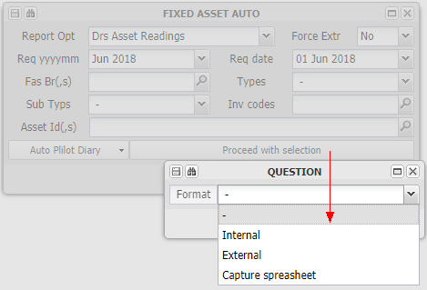

5.Select the import data from a file or a spreadsheet, and 'Copy' (Ctrl C)
Drag over and highlight the data to import, and 'Copy' (Ctrl C) it:
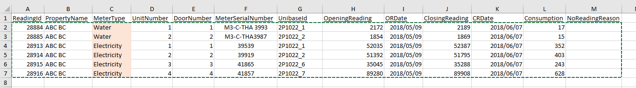

6. And 'Paste' as prompted (Ctrl V)
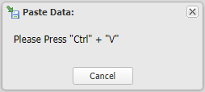

7. Check the import result, balancing the total and checking any Run Errors (see example below) and Save the import
The system imports the selected data, calculates the charges if required, and displays an import report for checking. Any errors or warning will be displayed in a Run Errors button that appears if there are any (See example below):
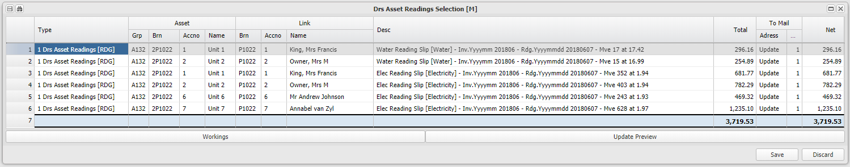

Select the correct items or All:
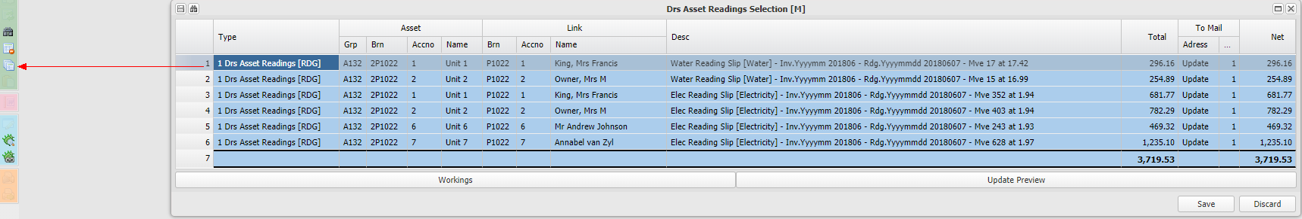

and 'Save'

8. Check the import if you wish to, by checking an asset (unit) history
Menu: Fixed Assets, Maintain / Create Fixed Asset , Level 2 assets, Debtors, Reading Slip History
Reading history for all categories of readings - note that in the example below, the reading have not been invoiced, as no invoice numbers are shown. See the later example below which indicates that these reading have been invoiced:
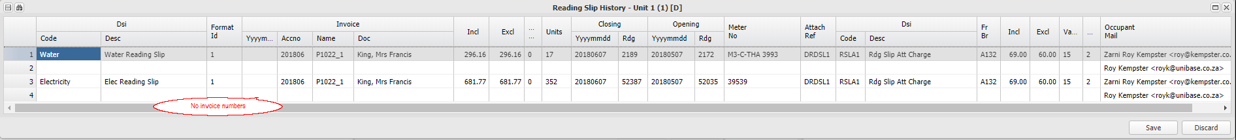

9. An example with an import error
Note that the next months import's opening reading for unit 1 is one unit different from the previous closing reading:

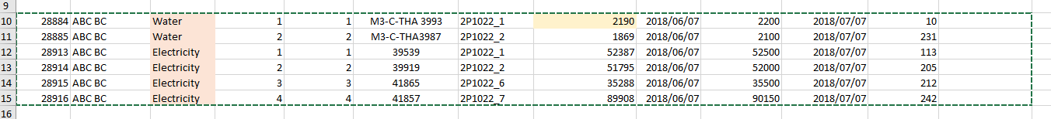

The unit is excluded from the successful uploads, and displayed in the Run Errors list:
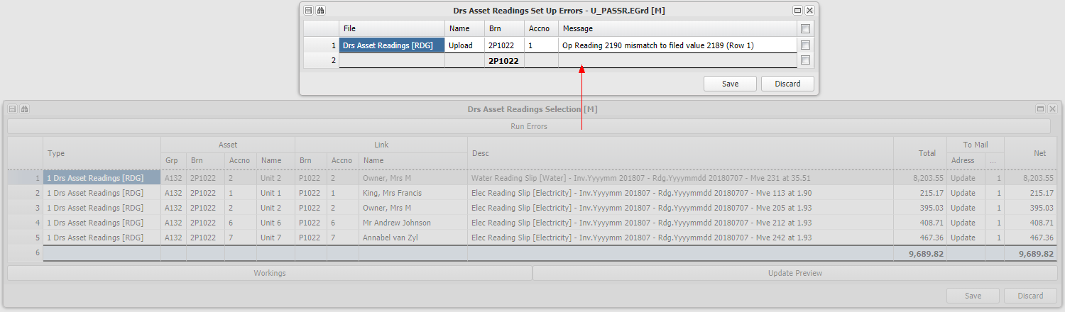

Process invoices to debtors for imported readings and charges
Menu: Fixed Assets, Debtors, Debtors - Auto General, Debtors Account Billing
All uploaded utility charges will be raised when the full fee raise is run. Charges for sending reading slips will also be raised:
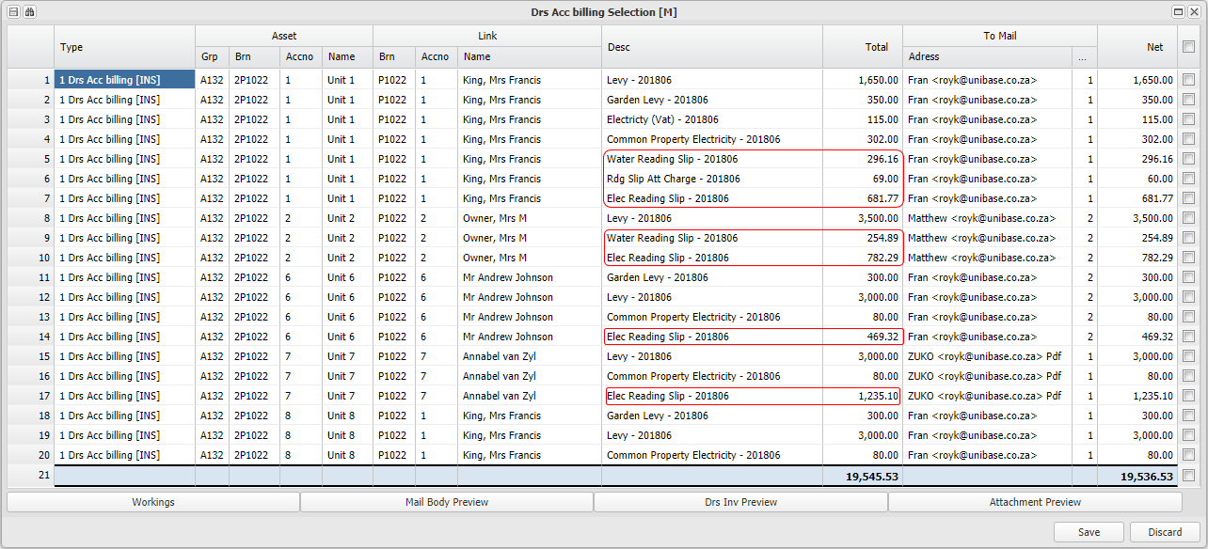

After the fee raise above, note that the reading history now has invoice numbers:
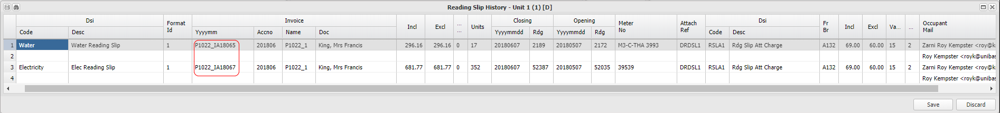

Send out statements and reading slips
Menu: Debtors, Debtors - Auto Menu, Debtors Account Statements
Focusing on unit 1, a statement, deposit slip and reading slip is sent to the linked debtor, and a reading slip sent to both occupants:
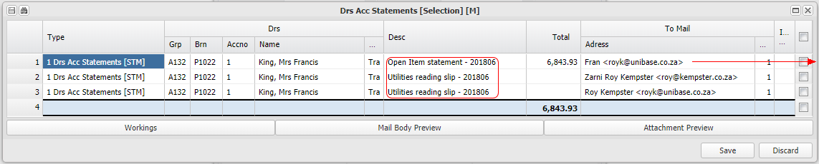 | 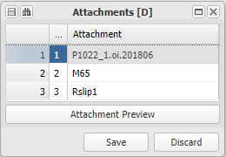

Checking reading history
Menu: Fixed Assets, Maintain / Create Fixed Asset , Level 2 assets, Debtors, Reading Slip History
Another look at the reading slip history, shows two are invoiced and two waiting to be invoiced:
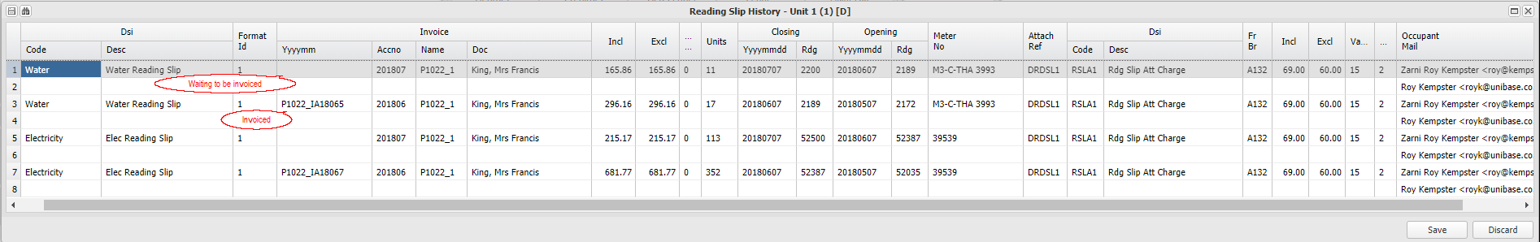

Setting up Bank Charge Recoveries
Bank charge recoveries are set up and applied in a head office (shared) banking environment. The head office branch is the bank account holder, and it will be charged directly by the bank for the services it renders. This system allows the head office to recover these charges from the various branches based on their transaction related charges.

There are two set up steps:
Set up a central bank charge table and any branch specific tables
Menu: Branch, Create/Maintain Branch
The table set up on the database branch, will apply to all branches using shared banking as a default. You can set up a local branch, bank branch or group branch table that will override the central table, following the precedence rule detailed below.. You can block bank charges for one branch by setting the 'Block Flag' to Yes.for the relevant branch.

Bank charge table precedence rule - Bank charges will be charged, unless the branch is blocked or the branch uses its own bank account, based on the bank charge table set up on:
First the Branch itself,
If none, then on the Bank Account Branch,
If none, then on the Group Branch,
If none, then on the database Branch.

The bank charge service fee also works as per the above precedence rule. The amount is exclusive of VAT. It is raised monthly using Debtors, Auto Menu, Drs Igr Bank Charge Service Fee.
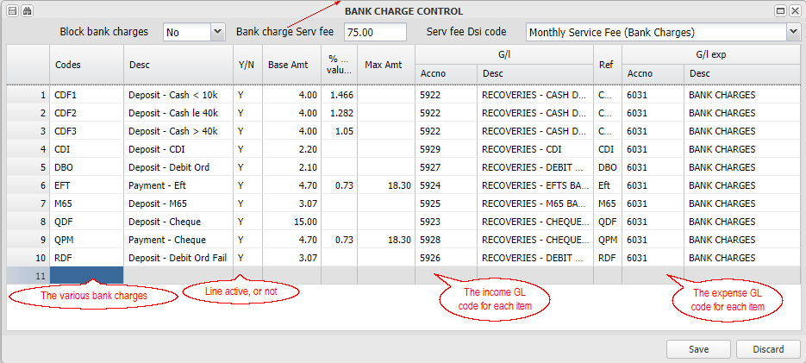

Refer to Create/Maintain Branch for more information

Add the bank charge bank code triggers to the bank import format
Menu: General Ledger, Bank Statement Menu, Bank Statement Formats

Ascertain the various bank transaction codes that incur the different bank charges, and capture them as indicated in the image below:
The above example displays the two bank transaction codes that indicate that a deposit is a cash deposit.

Refer to Bank Statement Formats for more information

The various transaction based bank charges are automatically raised when the bank statement is imported and updated. The monthly base service fee is raised manually once a month as part of month end processing - Debtors, Auto Menu, Drs Igr Bank Charge Service Fee.

Setting up the database general ledger and key settings
Once your data base has been created and user access arranged, there are a few key set up steps before you can get going:

Capture or import your general ledger codes and link to your control accounts
Import or capture your general ledger account codes, groups and link them to your control accounts eg. debtors control.

Note the key debtors and creditors control set ups. There are several debtors and creditors control accounts that should be set up. The two key accounts for both debtors and creditors, are the general control account and the inter group control account. The inter group accounts are used as required in special circumstances, for example, in paying trade creditors available funds will be reduced by the inter group creditors, to prioritise their payment. The other accounts can be used as required for their special purpose. The various debtors reports (eg. Age Analysis) will group all the different debtor types together in one report.

Refer to Data base setup for more information

Set up debtors sundry invoice codes
Capture the invoice codes and their rules (eg. Vat or No Vat) used when invoicing debtors.

Refer to Data base setup for more information

Set up any commissions in the commission table
Create sales or receipt based commission rates and rules, and link them to an invoice code.

Refer to Data base setup for more information

Set up branch type and sub-type tables
Branches have a type and a sub-type - set up those categories for the data base.

Refer to Data base setup for more information

Set up your database defaults on the database branch
Using Create/Maintain Branch, set up:
1. Bank accounts - used by the branch and if a head Office, any branches linked to it.
2. Bank charges - The charge rates that will be charged on bank transactions to branches that use this branch's bank accounts (Local branch's can have their own settings)
3. Debt Collectors Act charges grace days and limits - default rates and charges
4. Fixed asset types and related detail levels - add types and sub-types used to catgorise your fixed assets - eg. Homeowners association, Normal levy units etc.
5. Default interest rates - prime, arrears, loan and deposit rates that will default through the database

Setting up (choosing) a debtor (tenant) deposit structure
The system accommodates various structures for the receiving, holding and refunding of tenant deposits. It allows for interest to be calculated and either only accrued, or accrued and cash moved to match the effectively increased deposit.

It accommodates the use of a shared central (Head Office) banking structure with a separate deposit account, or a branch's own banking structure, with only a trading bank account, or with a trading and separate deposit bank account. The system facilitates the cash flow between the bank accounts in respect of deposits received, interest on the deposits, and refunded.

Deposits are received into the main trading account and moved to the deposit bank account. Refunds are paid from the main trading bank account, which is reimbursed from the deposit bank account.

The branch's banking and deposit structure is set up using Create/Maintain Branch. The following demonstrates a Head Office structure, and a Branch's own structure:

Head office structure
Set up
A head office (shared or central) bank structure will usually have all of the primary bank accounts set up as seen below. In the example below, we have set up that any deposits that 'belong' to this branch (unusual for a head office branch), will be held centrally and not paid out to the branch's trading bank account. We have also set that interest due to tenants in respect of their deposits, will be accrued and cash for the interest will be added to the deposit bank account - this will apply to all linked branches, irrespective of the flag setting on their branch.

Head office branch:
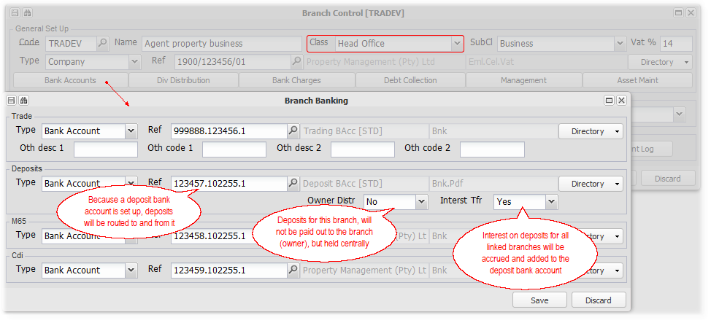

A branch using a head office banking structure:
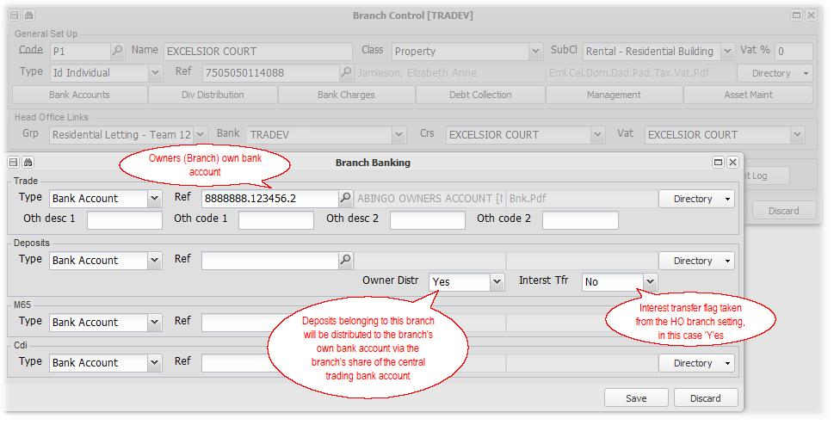

Cash movement and accounting
Deposits received are first paid directly or indirectly into the Head Office trading bank account. Depending on the flags, they are then either transferred to the head office deposit bank account (Owner distribution - N in the deposit owning branch), or to the deposit owning branch (Owner), via the main trading bank account.

Interest accrued due to the tenant, follow the same distribution rules above. The interest cost is charged to the holding branch, which will be receiving interest from the investing bank to recover the cost. The cash to add to the deposit bank account will be taken from, in this case, the Head Office trading bank account. Refer to Setting up and crediting interest on deposits for more information.

Deposits are refunded from the central main trading account, will either be reimbursed from the central deposit bank account (Owner distribution - N) or from the relevant branch's share of the central main trading account.

Branch own structure
Set up
A branch bank structure will usually have at least a main trading bank account, and sometimes a separate deposit bank account (as in the image below). In the example below, we have set up that any deposits will be held in the branch's separate deposit account, being transferred there from the main trading account. We have also set that interest due to tenants in respect of their deposits, will be accrued and cash for the interest will be added to the deposit bank account.
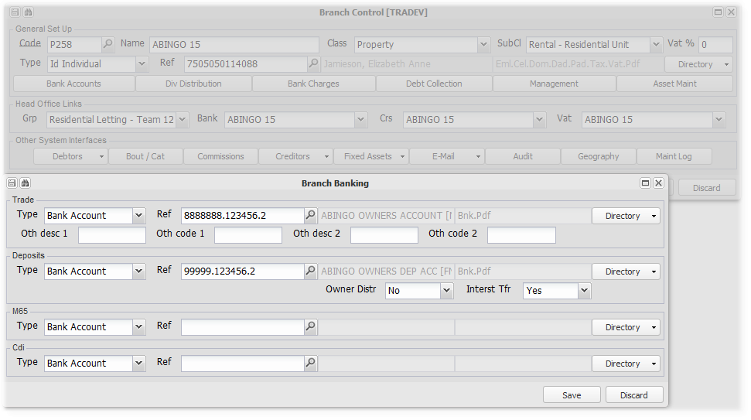
A branch that only has a trading account set up, will hold deposits in that account, and only accrue interest.

Cash movement and accounting
Deposits received are first paid directly or indirectly into the main trading bank account. If the branch has set up its separate deposit bank account, they are then either transferred there, or they remain in the main trading bank account.

Interest accrued due to the tenant, will be transferred from the main trading account to the deposit bank account if it is set up. If not, interest will only be accrued. The interest cost is charged to the holding branch, which will be receiving interest from the investing bank to recover the cost.

Deposits are refunded from the main trading account, which will be reimbursed from the central deposit bank account (if it is set up).

Refer to Bank account and cash control for more information

Setting up, Charging and Remitting CSOS levies
The Community Schemes Ombud Service (CSOS) is a public entity that exists to resolve community scheme disputes. It is established by the Community Schemes Ombud Service Act. To fund this service, community schemes pay a levy to CSOS based on the levies that they charge to their members. In system terms, this would be 'L'evy type invoices that are flagged to attract a CSOS levy. CSOS is a VAT exempt organisation, so the CSOS levy will never include VAT.

• | This facility assists in controlling the process of raising the CSOS levy from scheme members, and paying it to CSOS.
• | In essence, a CSOS levy will be calculated and charged to a unit (debtor), and accrued as payable to CSOS. A scheme could decide to pay the CSOS levy out of it's levy fund, and not charge its members, or block the raising or accruing of the CSOS levy completely. These options are accommodated as described below.
• | The main CSOS levy raise will analyse each debtors transactions for a selected period, selecting and accumulating the total of all included Levy Invoice code amounts. It will then deduct the Exemption amount and apply the Percentage up to the Maximum amount, and charge and accrue that amount for each relevant unit.
• | Should an adjustment to a prior period be processed to a debtor using one of the included invoice codes, the system will calculate and process the CSOS effect of the transaction in it's period, when a later CSOS levy raise is processed.
• | Branches can elect to block the raising of CSOS levies by setting the block flag to Yes, or by using invoice codes that are not included in the CSOS set up table.
• | CSOS levies charged are by default 'swept' to a central branch, accumulated and paid from there. Sweeping can be blocked by setting the Block Sweep flag to Yes.
• | Each invoice will have its pro-rata share of the CSOS levy allocated to it in a separate column of the debtors statements.

The process and utilities cover three main areas:

1. Setup and Control
Capture the base information as described in the CSOS Act to be used in calculating the CSOS levy
Menu: General Ledger, Database Setup, Tables, CSOS Control

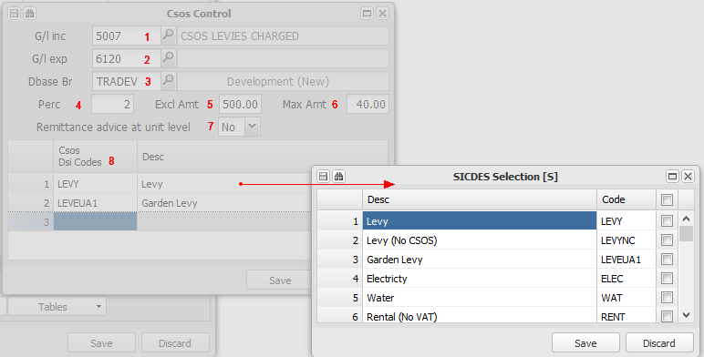

1. Income GL Code - | Enter the GL code to which the CSOS levy raise to units must be posted.
2. Creditor GL Code - | Enter the GL code to which the CSOS levy accrual due to CSOS must be posted.
3. Dbase branch - | This will always be the database branch
4. Percentage - | Enter the percentage that will be applied to the unit levy total in excess of the exemption amount in calculating the CSOS levy
5. Exclude Amount - | Enter the amount that can be deducted from the unit levy total amount before calculating the CSOS levy. Eg. If the unit levy total is R1200-00 and the Exempt amount is R500-00, the CSOS levy will calculated on R700-00 (In this case 2% of R700 - R14-00)
6. Maximum Amount - | Enter the amount defined by the CSOS Act as the maximum amount of the levy. The system will calculate the levy up to this amount.
7. Remittance option - | Remittances are generally provided at a branch (property) level - all units added together per month. Set this flag to Yes, for the remittance to be provided detailing each unit.
8. Levy includes DSI codes - | List the Debtors Sundry invoice codes used is the unit fee raise (Fee amounts on fixed asset 2 level), that constitute a levy amount on which the CSOS levy will be calculated. You can have two main levy DSI codes, both going to one general ledger code, and only include one for CSOS,

Enter the branches CSOS registration number and it's local CSOS settings:
Menu: Branch, Create/Maintain Branch, Other

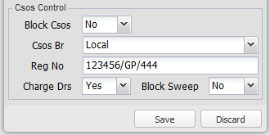

• | Block CSOS | Set this flag to Yes to prevent CSOS from being raised in respect of levies charged by the relevant branch
• | CSOS Branch | Select the branch to which CSOS levies will be swept. Refer to Set up sweeping options below for an overview of the sweeping set up.
• | CSOS Registration No. | Enter the CSOS registration number for each relevant branch. This number will be included in the CSOS remittance advice.
• | Charge Debtors | By default, CSOS levies will be charged to debtors, and accrued to CSOS as a creditor. Set this flag to Yes, to only accrue the creditor, and not charge any debtors.
• | Block Sweep | Set this flag to Yes to not sweep CSOS to a central branch. Refer to Set up sweeping options below for an overview of the sweeping set up.

Set up sweeping options
As a default, CSOS levies charged and accrued in each relevant branch, are 'swept' to a central branch, where they are combined with other branches levies and remitted to the CSOS authority. If a particular branch decides that it does not want its CSOS levies swept, this can be blocked (Block Sweep - Yes), keeping them in that branch, and being remitted to CSOS from there.

The branch to which levies are swept, is determined by the following rule:

First, to the CSOS Branch chosen for a branch in the window above.
If the branch does not have a CSOS branch selected (the default position), the system will look for a CSOS branch set on the branches group branch. If there is one, the levies will be swept to that branch.
If the group branch does not have a CSOS branch selected, the system will look for a CSOS branch on the central database branch. If there is one, the levies will be swept to that branch.
If the central database branch does not have a CSOS branch selected, the system will sweep the CSOS levies to the central database branch.

2. Raising and Adjusting
Automated CSOS levy raise
The calculating and raising of the CSOS levy per unit is based on the parameters defined in the CSOS Act which are captured in the setup table above. To charge the levy to a unit each month could easily be done by manually calculating the levy and adding it as part of the unit fee structure. This works well, but needs to be updated each time the unit levy changes, and can be easily forgotten.

This utility will apply the CSOS parameters automatically, for the current and previous periods

Menu: Debtors, Auto Menu, Drs CSOS levies

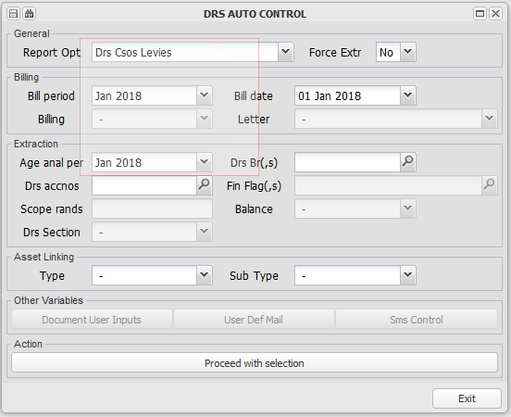

This process is usually run just after the monthly levies etc. are raised. These are usually raised in advance - February fees raised in January. In the same way, this process will raise CSOS levies based on the fees already raised, for the next month, to be included on the relevant debtors statements. In the example above, we raised CSOS levies for January 2018, based on the CSOS included levies etc. for the same month.

This process will add up the value of invoice types that are included on the set up table above, and then calculate the CSOS levy based on the values set up in the same table.

This process, each time it is run, will include any CSOS levy adjustments based on a previous period invoice raised. These will be posted to their relevant period, and calculated based on the relevant transactions for that period.

The CSOS levy is displayed in a CSOS column on debtors statements, linking to each related invoice. The levy will be pro-rated across all relevant invoices for a particular month.

An example below, demonstrating the flow and information drills relating to the levy raise process:
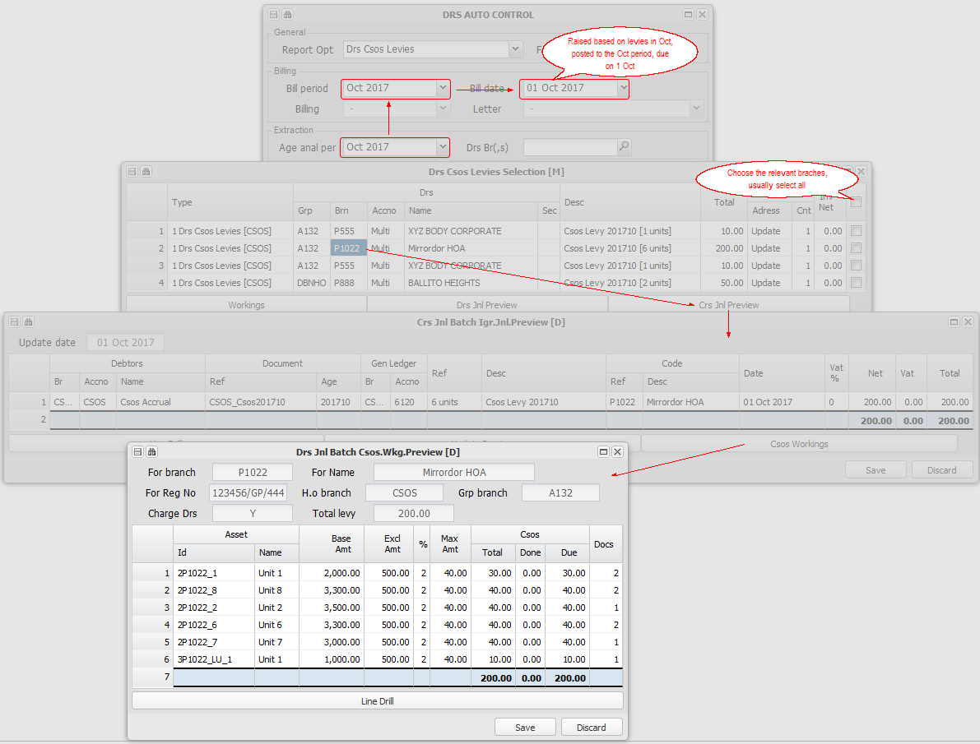

Moving the funds for raised CSOS levies to the sweeping branch
Menu: Debtors, Auto Menu, Debtors Intergroup Clear - CSOS

This utility will transfer the funds from the raising branch to the sweeping branch. It will transfer the funds within a shared bank account environment without checking if there are any funds available, and without charging bank charges. It should be run immediately after the CSOS levies have been raised, usually for the next month. The system uses debtors and creditors to account for the flow of funds. The period that is used for the cash transfer, is based on the payment terms of the CSOS debtors in the sweeping branch (This debtor is automatically created if not present). If no terms are defined, '0-Month End' is used as the default. This means that CSOS levies raised for January 2018, will be swept in January 2018 unless the default terms are set differently for any particular debtor:
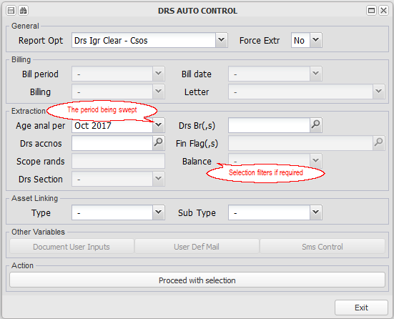

Adjusting CSOS levies
There are occasions where manual adjustments or charges need to be captured in respect of CSOS levies. These would unusual situations, for example, when a new property is taken onto the system, where the opening debtors balances include CSOS levies. This utility will allow the capture of an adjustment as a CSOS levy, remitting or deducting the adjusted amount.

Menu: Debtors, CSOS Manual Journal

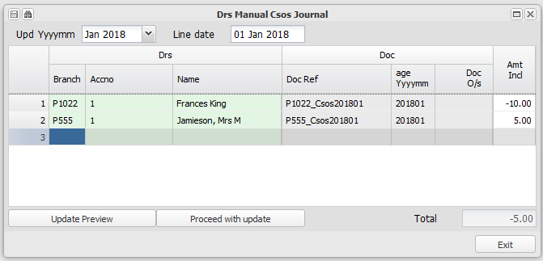

Remember that you can copy the screen input from an Excel spreadsheet, and paste it into this screen. This will save time if you have many adjustments.
Refer to Importing information from a spreadsheet for more information.

3. Remitting the CSOS levy to CSOS
Menu: Creditors, Auto - General Functions, Creditors Branch Payment Batch
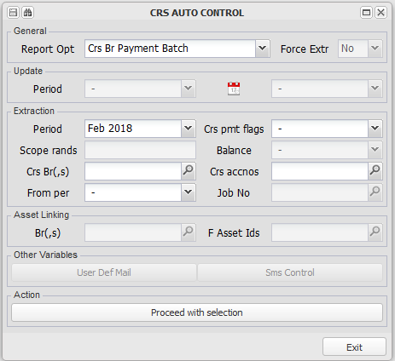

Choose the branch that is remitting the payment - in this case, the sweeping branch, or if sweeping is blocked, the relevant branch (property).

The remittance for the payment will be automatically emailed if the creditor (CSOS) has an email address set up. The remittance will be by branch (property), unless the remit at unit level flag has been set to 'Yes".

Menu: General Ledger, Database Set up, Tables, CSOS Control
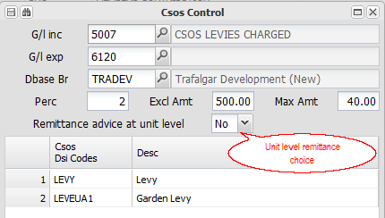

Remittance Template: Csos1.xlsx. Refer to Setting up Report Templates for more information.

Setting up and charging fees in terms of the Debt Collectors Act
The Debt Collectors Act controls the amount and type of charges that registered debt collectors can charge to overdue debtors in the process of collecting outstanding amounts.

There are two categories of charges - A receipting commission based on the amount collected, and various fixed amount fees based on functions performed.

The system supports the set up and charging of both type of charges, and has central, group and individual table set ups. Individual branches (properties) and debtors can be blocked from charging the fees if required.

The various aspects of the process:
Setting up
Per DB, Group, Branch

Late Receipt Commission
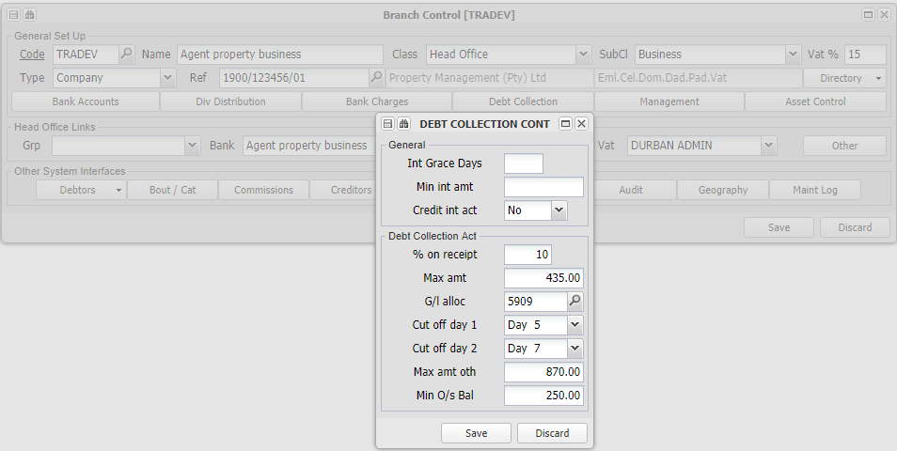
Letter and Other Charges - Invoice Codes
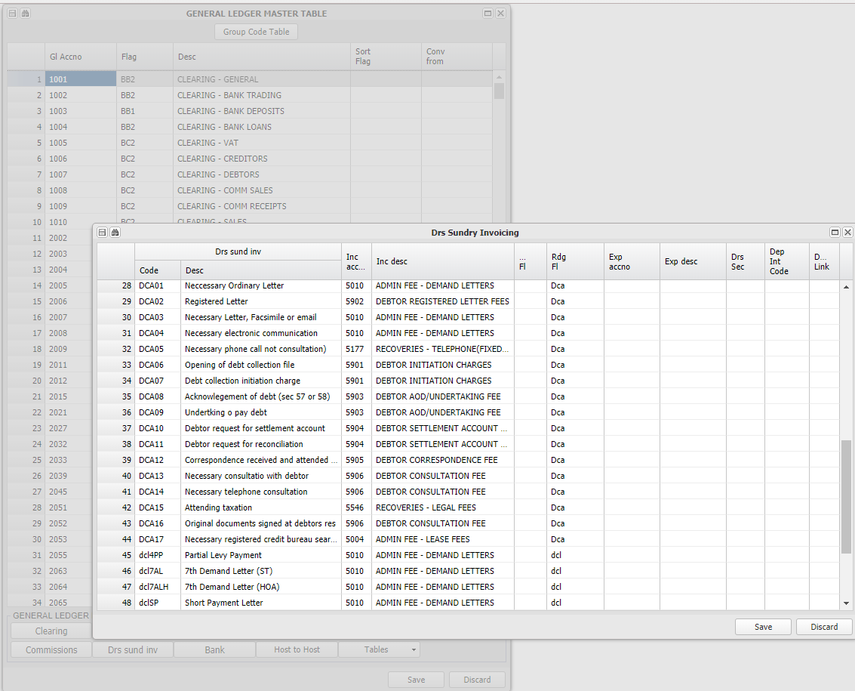
Letter and Other Charges - Amounts
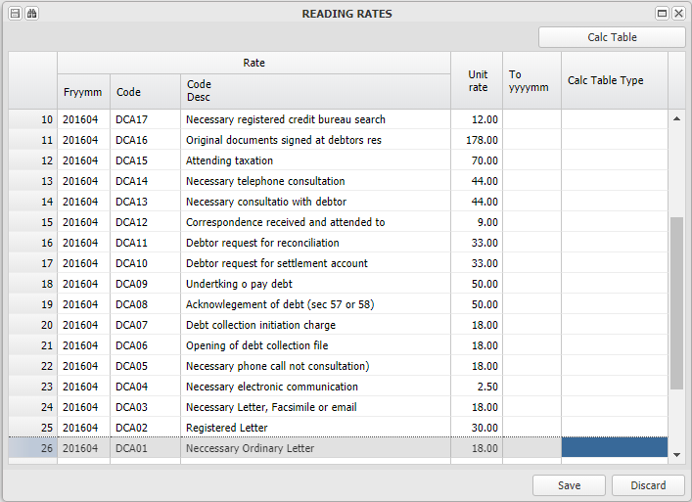

Charging DCA fee amounts
Late Receipt Commission
Activity Based Fees
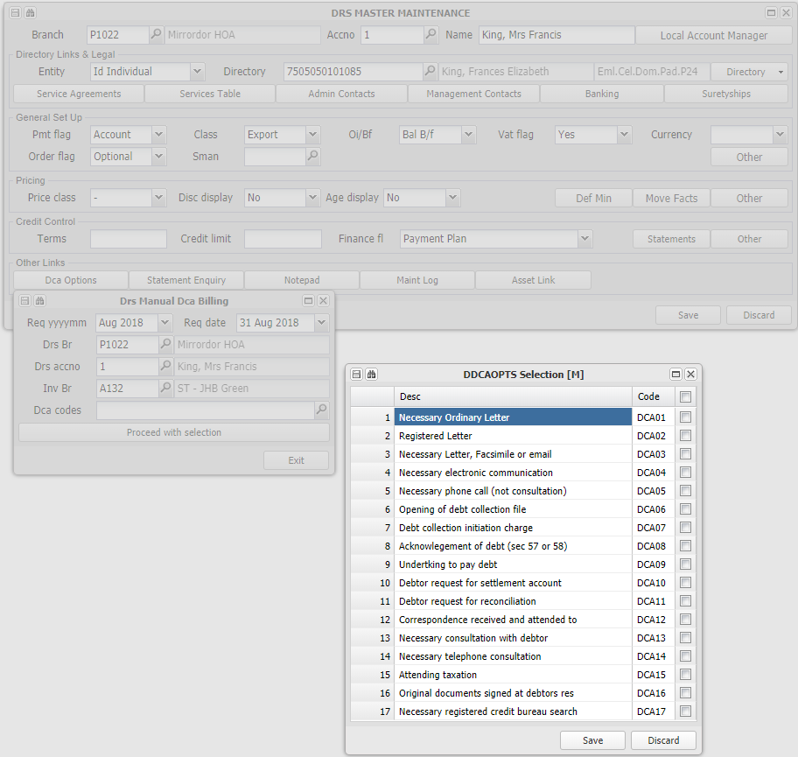

Arrear Letters and SMS's

Blocking the charging of fees
If no setup on DB, else ) setup on branch or flag

Group level (Agent)
Branch Level (Property)
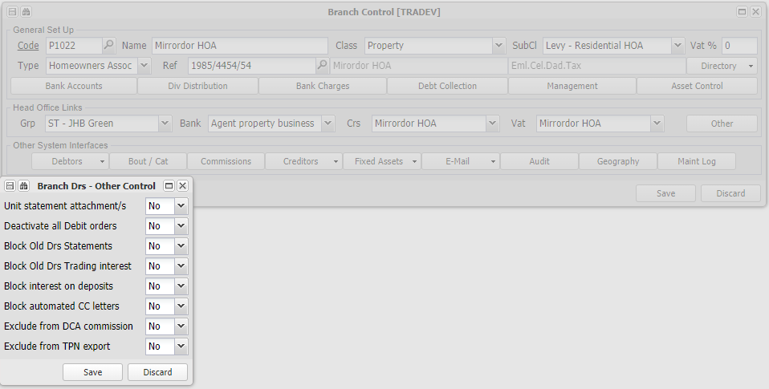
Debtor Level (Unit)

TO FINALISE

Branch (Property) Related
Information relating to setting up and processing various aspects relating to Branches (Properties).

Setting up and charging interest on shared banking overdrafts
Should a branch be allowed to overdraw its share of a shared bank account, this facility will raise interest on the overdrawn account, based on the transaction dates for a month. If the average balance for a month (based on transaction amounts and dates) is overdrawn, interest will be raised.

The interest will be accrued (raised as a creditor), and paid when the inter group invoices are cleared. The interest will be charged by the branch that 'owns' the bank account, to the branch that is overdrawn.

The interest rate that is used is based on the overdue interest rate set up on the bank account branch, and overridden if necessary on the debtor in the bank account branch for the branch being charged. .

The following are the steps required to process the interest:
Set up interest rates
Menu: Branch, Create/Maintain Branch, Debtors, Tables Control, Overdue Interest
The Overdue Interest rate set up on the branch that controls / owns the shared bank account that is charging the interest, is the default rate that the system will use to charge interest:
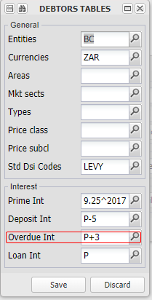

If you wish to charge a different interest rate for a particular branch, you can set that rate up on the debtor linked to the bank account branch, for the branch being charged.
For example, if the bank account branch is 'BBRANCH', and the branch being charged interest is P1022:
Menu: Debtors, Debtors Master Maintenance, Credit Control, Other

Click on the Other button:
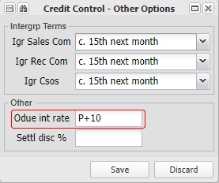

Branch P1022 will be charged at Prime plus 10%, as opposed to the central rate of Prime plus 3%

Raise interest due
Menu: Debtors, Auto Menu, Drs IGR Bank Interest Accrual
Choose the month and branch/es that you wish to raise interest for. This is usually done as part of the month end processes, and can only be run once for a branch for a month:
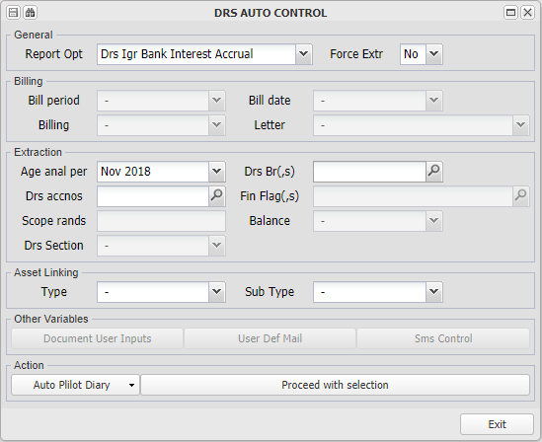

All branches for which interest will be raised will be displayed. Clicking on Run Errors and Run Messages will provide relevant selection information
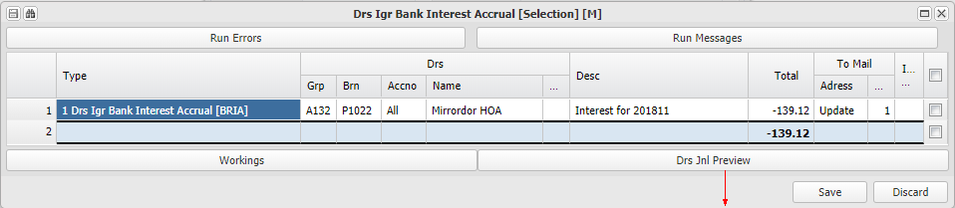
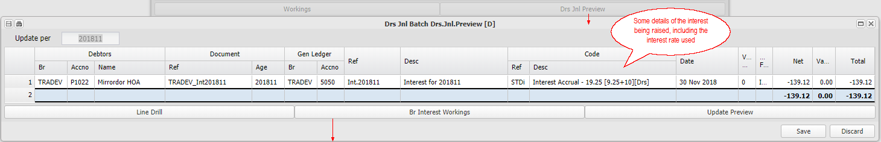
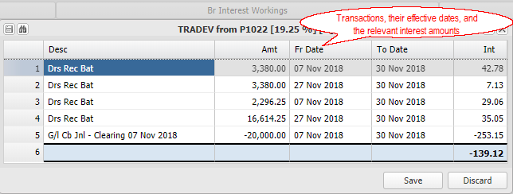

Pay interest raised
Menu: Debtors, Auto Menu, Drs Igr Clear - Invoices

Inter group interest is raised as an invoice, and cleared (paid) together with other invoices:
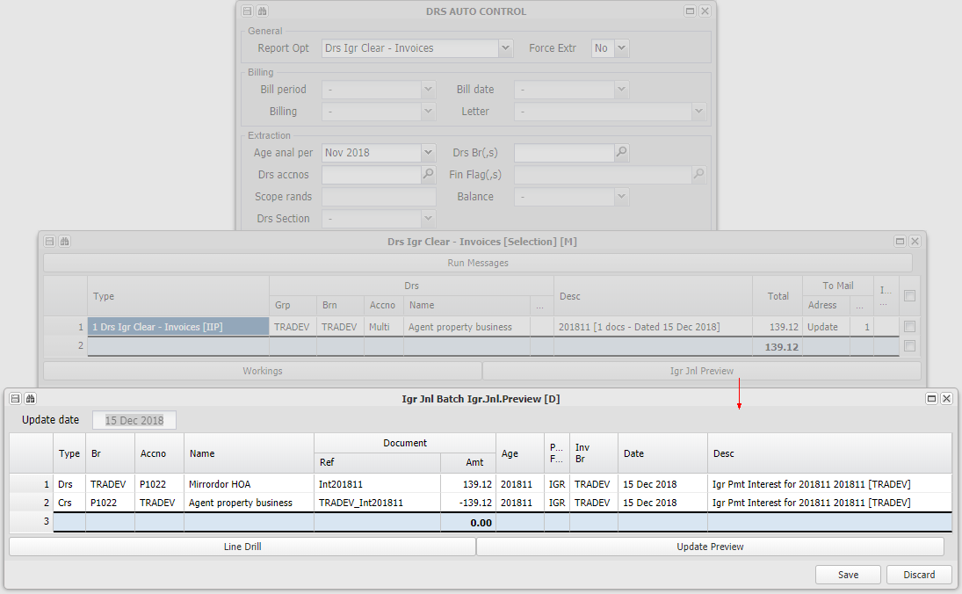

Setting up Branch Distributions and making the related payments (Owner payments)
Distributions from branches usually relate to a dividend being declared or to a distribution of the available shared bank account amount to either a local bank account or to a branch stakeholder.

The rules for the two distribution types are as follows:

Dividend (Default)
Using this option, the system calculates the available profit held in a branch from which a dividend can be declared, and deducts all short term creditors. This amount is then reduced to the cash available in all bank accounts.

This option relies on a complete set of accounting records being maintained on the system, and is generally not used in the UniProp system.

Shared bank account distribution
This option is commonly used in the UniProp system. It facilitates the distribution of the amount held in the shared bank account (usually a trust account), to the authorised recipients of the monies distributed. The system allows the set up of rules for calculating the amount, and the general ledger code to which the distribution will be posted.

The distribution is calculated by starting with the available balance in the shared bank account, and then deducting outstanding Trade creditors, Vat, Both or neither.
You can override the system default settings, by setting up distribution rules on the data base branch, the group ranch, or the actual branch that is distributing.

Refer to Set Up Distribution rules below for more information.

The steps in achieving the distribution:
Create a Creditor/s in the relevant branch for the distribution
Menu: Creditors, Creditors Master Maintenance.

Create a creditor/s for the authorised recipients of distributions using Creditors Master Maintenance

Set Up the Distribution rules
Menu: Branch, Create/Maintain Branch

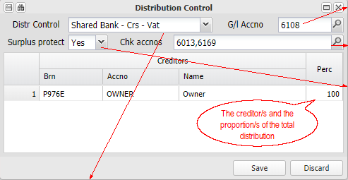 | The general ledger code that the distribution will be posted to.  Select general ledger codes that you would expect movement on before any surplus funds are distributed. If there is no movement in the month that a distribution is being processed, a message will be displayed on the selection screen indicating which accounts have no movement. Refer to the payment section below.  The surplus protect flag set to Yes, will not allow any payments from the shared bank account that exceed the available funds as determined by the Distribution Control rule as set above. You can allow any payments to be accrued, by setting the flag to No, which will require a password to be entered.

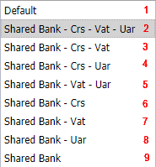 | 1.The system default is a classical dividend amount, or the data base or group branch default (one of the choices below)  2.The Balance on the Shared Bank account less the balance on Creditors Control, the Net VAT outstanding and less Debtors in advance (adj. for any collection commission).  3.The Balance on the Shared Bank account less the balance on Creditors Control and less the Net VAT outstanding.  4.The Balance on the Shared Bank account less the balance on Creditors Control and less Debtors in advance (adj. for any collection commission).  5.The Balance on the Shared Bank account less the Net VAT outstanding and less Debtors in advance (adj. for any collection commission).  6.The Balance on the Shared Bank account less the balance on Creditors Control  7.The Balance on the Shared Bank account less the Net VAT outstanding  8. The Balance on the Shared Bank account less Debtors in advance (adj. for any collection commission).  9. The Balance on the Shared Bank

The system default is a Dividend distribution.

You can effectively change the Default for the whole data base, a group of branches, or an individual branch, by setting a different value for both the Distribution Control and GL code, on either the data base branch, a group branch or an individual branch.

Process a Journal to the distribution creditor for the amount to be distributed
Menu: Creditors, Auto - General Functions

Choose Branch Distribution Accrual from the drop down selection list, select the month and branch/es required, and Proceed with Selection.

Choose from the list of available distributions, or all, and check the Run Errors by clicking on the Run Errors button. This process will raise a creditor in the relevant branch for the distribution/s.

Refer to the link above for more information.

Pay the Creditor
Menu: Creditors, Auto - General Functions

Select the distributions / creditors that you wish to pay. Check the Run Errors and Run Messages:
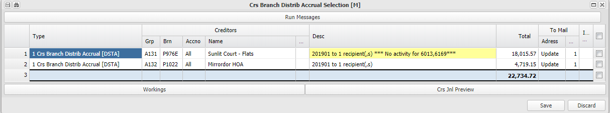
Note the yellow warning above that there is no movement on general ledger codes 6013 and 6169, in this case assessment rates and levies paid. These codes are set up per branch as indicated above. You can still choose to pay out the distribution.

Release the payment batch
Menu: General Ledger, Bank Statement, Bank Transaction Approval

As with general creditors, release the distribution creditors payments.

Setting up a Property branch and it's Units
A managed property is comprised of several components that need to be set up on the system. To simplify the process, the system automatically creates a structure based on your input, and then allows the import of detailed information from Excel spreadsheets.

Setting up a property is achieved in three steps:
Import or create all the necessary directory items
Menu: Branch, Auto Options, Directory Upload - Import
Menu: Branch, Create/Maintain Directory - Create

You will need directory items for the main branch (Owner, body corporate etc), Own bank accounts, and all the debtors (unit's).

Refer to Create/Maintain Directory for more information

Create new managed Property
Menu: Branch. Managed Assets, New Managed Property

This screen allows the capture in one screen of all the key setup information:
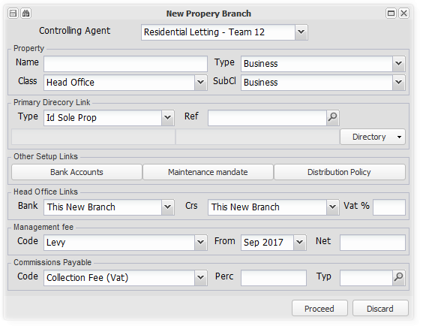
On filing, the system will create all of the entities and the links with the fee and other information captured.

Refer to New Managed Property for more information, and to the diagram below which indicates the entities and their links.

Create new managed Units
Menu: Branch, Managed Assets, New Managed Units

This option allows the importing of debtor and fixed asset level 2 (Units) (With their invoicing details (levy etc.), which will create and populate the required information.

Refer to New Managed Units and to the diagram below which indicates the fixed asset/debtor structure.

The various report templates for a property branch will usually default from the central database branch (or its agent branch), but if not, remember to add the templates relevant to the new branch - eg. A particular property might want debtors statements sent out with it's branding, and not the agents.
Refer to Templates in more detail for more information.

An overview of a managed property structure:

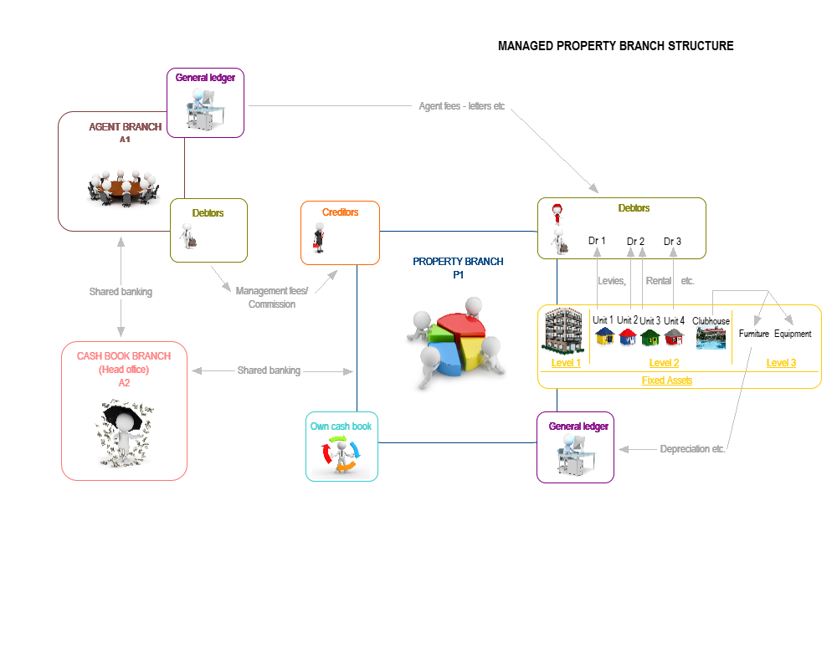

Setting up a Branch (Business) and it's accounting
This setup is a classical accounting setup, as opposed to the various links and components that are set up for a Property Branch.

Depending on the nature of the business entity that is being set up you would follow as many of the following steps as are relevant:
Create or import the necessary directory items
Menu: Branch, Create/Maintain Directory

Branch legal, bank accounts, debtors, creditors, office bearers
Create a Branch
Menu: Branch, Create/Maintain Branch

Choose a default bank account, creditors branch (if shared creditors), VAT branch (if shared VAT) and link the branch legal directory item. The general ledger for the branch is automatically set up when it is created.

Remember to capture the branches financial year end under the Audit button.

Refer to the link above for more information.

Create and upload any required report templates
A branch can either use the central database templates, its group (agent) templates, or its own templates. If a branch uploads its own templates, they will be used as default, if not, those for its group, else the database templates will be used. These templates will be for example, a debtors statement and invoice template.

Refer to Templates in more detail for more information

Create any Debtors Required
Menu: Debtors, Debtors Master Maintenance

Create as many debtors as required, linking them to their relevant directory items. Refer to the link above for more information.

Create any Creditors required
Menu: Creditors, Creditors Master Maintenance

Create as many creditors as required, linking them to their relevant directory items. Refer to the link above for more information.

Create any Fixed Assets required
Menu: Fixed Assets, Maintain/Create Fixed Asset

Create as many fixed assets as required, linking them to their relevant directory items. Refer to the link above for more information.

Setting up and charging fees to a property client
This topic covers the charging by an Agent to a Property for services, both regular amount fees and fees charged based on amounts collected, and the payment thereof in a shared bank account environment.

The detail of setting this structure is described below, which are automated when using New Managed Property to create a new property. You will be able to add to or amend the details that were set up automatically, using the details described here.

The steps in this process are described below (The setup is automated as described above):

Set up the Intergroup Debtor and Creditor, and the applicable fees.
In the example below, the Agent (Branch) is A132, and the Property (Branch) is P1022.

A debtor is set up on the agent branch, with the number of the property branch - A132 has a debtor P1022 - and is flagged as Intergroup

A creditor is set up on the property branch, with the number of the agent branch - P1022 has a creditor A132 - and is flagged as Intergroup

Fixed amount management fees:
The fixed monthly management fee is added under the Services Table, with the invoice code, amount, period and link to the agreement reference. As these are linked as intergroup, the system will charge the fee to the linked creditor, and there is no need to indicate which creditor is to be charged.

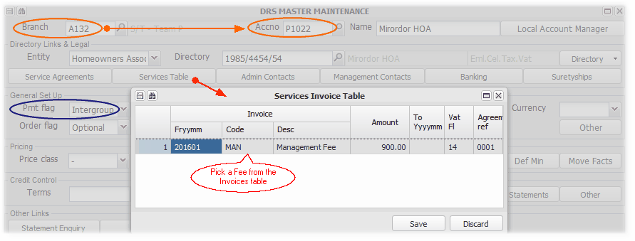

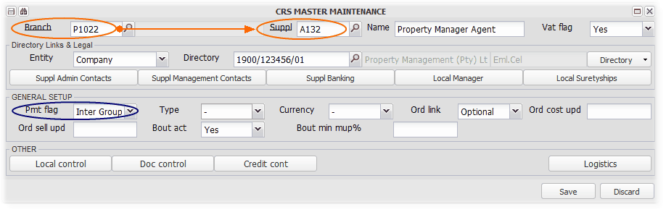

Commissions:
Menu: Branch, Create/Maintain Branch.
Receipt or Invoice triggered fees are setup on the property branch, and you can indicate which debtor they are to be accrued in. You can also select which invoice codes will attract the relevant commission. in a property environment, for example, commission is often only charged on rental receipts, and not deposit or utility recoveries. You can also choose which branch to accrue the cost in (Creditor), and in which branch to accrue the income (Debtor). If you leave out a debtors link, only the expense will be accrued:
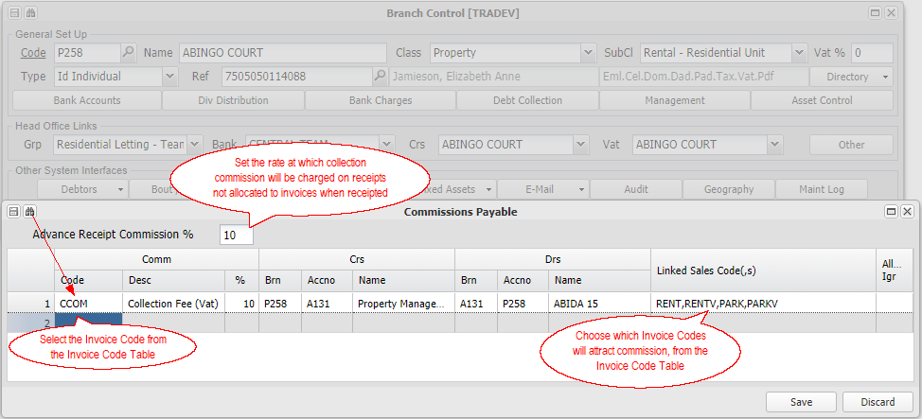

Choosing all invoice codes:
You can choose a special invoice type from the drill list of options ' All Trading DSI's' - this will charge commission on receipts allocated allocated to any trading DSI code. It will exclude 'Deposit' and 'Loan' transactions:
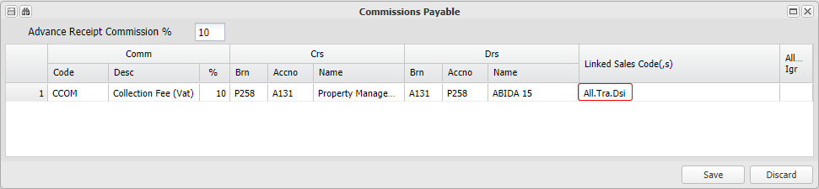

Adding more than one collection commission:
You can add several collection commission charges, each based on different invoice codes and having different rates:
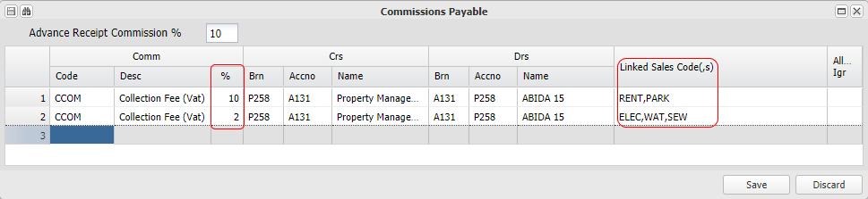

This option can be useful if you have a varied commission arrangement with your client. Eg. Charging 10% on rental collections, but only 2% on utility collections.

Commission on unallocated receipts
Occasionally, debtors (units) will pay amounts before invoices have been raised. When invoices are raised for the debtor, the system will allocate the advance receipts against the new invoices.

Commission will usually not be charged until the receipt is matched against invoices, because the system cant know what rate to charge until allocation.

If you wish to charge commission on unallocated receipts, set the 'Advance Receipt Commission' to the rate to be used. Commission will be charged at that rate, reversed and recharged on allocation:
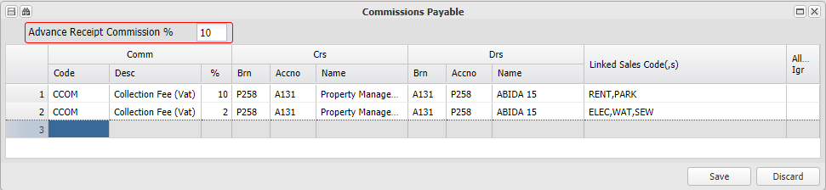

If you choose not to charge commission on advance receipts, you risk paying an owner the gross amount received without deducting commission.

Commission on inter group transactions
The calculation of commission will by default, only be performed on the relevant branches local transactions. If you set the 'Allow Igr' to 'Y', commission will also be charged on other branch transactions to the local branch debtors, at the commission rates on the invoicing branch:
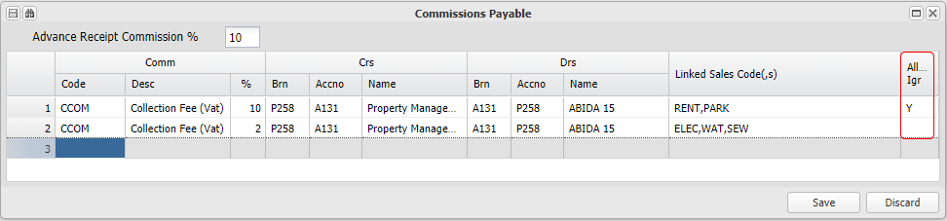

Raise the fees that have been set up
Menu: Debtors - Auto Menu, Debtors Account Billing.

This option will display a list for selection, and raise fixed amount fees in terms of a service agreement, set up using Debtors Master File, Services Table. Choose the period, branches and if necessary which invoice codes. You will only be allowed to raise these fees once per branch / code per a period. This fee raise will normally happen for all branches and is usually run at the beginning of a month, for that month:

Sales and Collection Commissions will be automatically raised by the system, as they are triggered - on invoice or on receipt. They will be accrued in the branches selected in the setup.

Pay the fees raised using a shared bank account
Menu: Debtors, Auto Menu
Pay fee invoices
Menu: Debtors, Auto Menu, Debtors Inter Group Clear - Invoices. This will pay the creditor on the property branch, and receipt the payment on the agent branch, using the commonly shared bank account.

Choose the period to which you wish to pay / receipt the fee invoices raised, and click on Proceed with selection:
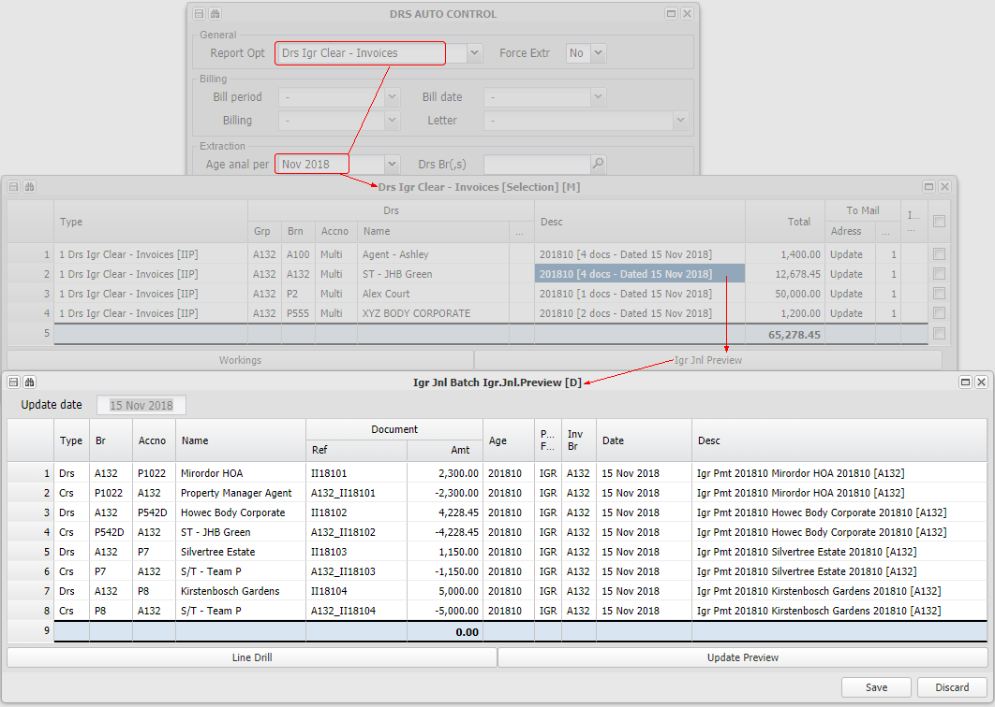

If the inter group accounts are within a shared banking environment, they will be automatically paid and receipted. If not, the funds will be paid using Transaction Approval either via. Host to Host banking or manually using a bank interface.

Pay collection commissions accrued
Menu: Debtors - Auto Menu, Debtors Inter group Clear - Collection commissions

This option will display a list of amounts due in respect of collection commissions accrued for selection and payment.

Refer to the Inter group Invoices option above, which uses the same method of payment.

Pay sales commissions accrued
Menu: Debtors - Auto Menu, Debtors Inter Group Clear - Sales Commissions

This option will display a list of amounts due in respect of sales commissions accrued for selection and payment.

Refer to the Inter group Invoices option above, which uses the same method of payment.

Release the Payment Batch/'s processed above
Having processed the various payment batches, inter group transactions not within a shared banking environment, can be released and actually paid.

Menu: General Ledger, Transaction Approval

If the inter group accounts are within a shared banking environment, they will be automatically paid and receipted. If not, the funds will be paid using Transaction Approval, either via. Host to Host banking or manually using a bank interface.

Refer to Setting up a services agreement and charging a debtor for more information.

Creditors (Suppliers) Related
Information relating to setting up and processing system aspects relating to Creditors (Suppliers).

Setting up Creditors and processing Invoices
The payment of supplier invoices is a key process in the property management environment. It is important that proper control is maintained over the paying of invoices, and that the process is efficiently conducted.

The following is an overview of the various aspects of the process:

Creating and setting up a Creditor
Menu: Creditors, Creditors Master Maintenance
Creditors are either set up manually for a branch, or copied to a branch from another branch. The system will, where necessary, automatically create a creditor, usually for Inter Group creditors. Directory items, such as banking details and creditor contacts, will be automatically changed on all branches to which the creditor is linked, when they are changed on any branch.

The creditor payment flag indicates how the creditor is to be paid - On account, COD etc. The option for Inter Group is set where there is a matching Inter Group debtor in the system. Inter Group creditors are paid internally within the system, when running the relevant payment option.

The creditors normal payment terms can also be captured i=under the credit control button. If they are not set, the system will default to zero days.

The creditors banking details can be verified if your account is linked to Host to Host banking, which verification is stored on the bank accounts directory item.

Setting up the Creditors (Supplier) Update / Approval Rule for a Branch (Property)
Menu: Branch, Create / Maintain Branch, Creditors, Document Control - Approval rules
Menu: Branch, Create / Maintain Branch, Directory, Office Bearers

Set up whether a branch (property) requires invoice payment approval, the amount over which it does, and the number of approvals.

Set up which of the branch office bearers are authorised to approve the payment of invoices.

Refer to Setting up and obtaining payment approval for suppliers invoices for more information.

Issuing an Order to a Creditor (Supplier)
Orders are issued either manually using Other Purchase Order - New or automatically as part of the Maintenance work flow.

Where an order is issued, when the relevant supplier invoice is received, it is matched to the originating invoice.

Capturing Creditors (Suppliers) invoices
Invoices are captured when they are received into three main areas:
Invoices linked to a Order
Menu: Purchasing, Other, Other Purchase Batch - Order

Use this option when an order has been issued to a supplier, and where invoice payment approval is not required for the branch.

Invoices not linked to an order
Menu: Purchasing, Other, Other Purchase - Bulk No Order
Use this option where no orders have been issued to suppliers, and where invoice payment approval is not required for the branches. The screen supports the capturing of multiple lines. Copies of the invoice need to be uploaded for each line of the batch.

You can import a batch from a spreadsheet by pasting the spreadsheet content into the batch screen, as long as the layout of the spreadsheet matches the layout of the screen.
Invoices that need to approved using the Invoice Approval Work flow
Menu: Other Purchase - Document Set Up, Other Purchase Order - Document Set Up, Other Purchase - Document Upload

These options are used to initiate the payment approval work flow. If the uploading of invoices is a separate function, use Document Upload, where the invoice is uploaded, it's details captured, and is linked to a branch (property). Uploaded invoices can be linked to the two set up screens referred to below.

If the uploading of the invoice is part of the set up process, use the Order Document Set Up option for orders or the Document Set Up for invoices not linked to an order.

Refer to Setting up and obtaining payment approval for suppliers invoices for more information.

Obtaining branch (property) office bearer payment approval for invoices
Where a branch is set up to require payment approval for supplier invoices, the system will facilitate the obtaining of the approval using the relevant work flow.

Refer to Setting up and obtaining payment approval for suppliers invoices for more information.

Paying Creditor / Supplier Invoices
Menu: Creditors, Creditors - Auto General, Creditors Branch Payment Control

The above option will consider the outstanding invoices for all creditors for all branches (properties) that you have access to. An unrestricted selection of branches will select all branches where there are sufficient funds to pay all amounts due by the branch, and indicate which branches have amounts due but have insufficient funds to pay them all. These branches can then be followed up by choosing only one branch at a time, and choosing which invoices to pay.

Once the payment batch has been created, it is included in the Bank Transaction Approval and Bank Transaction Perform queues, to be released by releasing operators.

A remittance advice detailing the invoices paid or partially is automatically sent our to all suppliers email address's once the bank transaction has been performed.

Refer to the Creditors Branch Payment Batch for more information.

Setting up and obtaining payment approval for suppliers invoices
Supplier invoices are captured into the system through a few different paths. Once captured, a branch (property) can choose to either just pay the invoices based on available funds, or obtain office bearer approval (usually only over a certain amount), before paying them.

This section describes the rules and the process relating to invoice payment approval.

Invoices enter the work flow, as invoices that relate to an Order, and invoices that don't. They are each entered using the relevant capture screen, as described below.

The invoice payment approval work flow processes are automated, unless any of the available check points are set to 'Wait' before automatically proceeding. The default for all wait points is 'No', which automates the full process. Once any 'Yes' wait point for a job is set to 'No', the job will automatically proceed to the next wait point. You can view the status of items in the approval process using the Unapproved Document Extract explained below.

Click on the '+' button to view the Invoice payment approval 'Wait' points

Purchase Wait | If set to 'Yes', the accrual of the purchase in the books of the branch once the document is set up, will not happen until the flag is set to 'No'
Trustee Wait | If set to 'Yes' the trustee / office bearer requests for approval will not be sent until the flag is set to 'No'
Administrator Wait | If set to 'Yes' the request to the Administrator for final approval will not be sent out until the flag is set to 'No'
Approval Wait | If set to 'Yes' the invoice will not be flagged as approved, despite all stakeholders having approved it, until the flag is set to 'No'

Click on the '+' button to view a list of the steps in the Maintenance Job and Payment Work flow
 | Action | Menu item
1. | Receive the supplier invoice and set up the invoice | Other Purchase - Document Set up
2. | Accrue the purchase into the books of the branch | Other Purchase - Document Set up
3. | Send the invoice for payment approval | Other Purchase - Document Set up
4. | Receive office bearer approvals | Other Purchase - Document Set up
5. | Send invoice to the administrator for checking and final approval | Other Purchase - Document Set up
6. | Receive the administrator approval | Other Purchase - Document Set up
7. | Final release for payment | Other Purchase - Document Set up

The steps in more detail:

Setting up the approval requirement, approval limit and number of approvers
Menu: Branch, Create / Maintain Branch, Creditors, Document Control

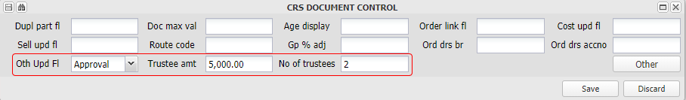
Set the Other Update Flag to 'Update' if no invoice payment approval is required, or to 'Approval' if approval is required. Capture the amount over which quotes need to be approved by branch office bearers, the number of approvals that need to be obtained for each invoice, and the number of approvers that need to approve an invoice.

Set up Approving office bearers
Menu: Branch, Create / Maintain Branch, Directory, Office Bearers

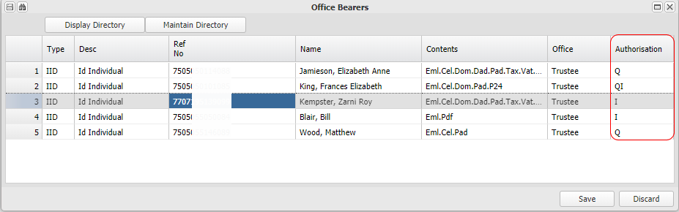

For each office bearer that is authorised to approve quotes and or creditors invoices, add a 'Q', 'I' or 'QI' in the authorisation column as indicated above. Francis King is authorised to approve both 'I'nvoice payment and Job 'Q'uotes.

Receiving the Supplier Invoice, matching it to the Order, or setting it up
The invoice can be uploaded and indexed into the system as a first step, or uploaded and set up in one step:
Upload and index the invoice document
Menu: Purchasing, Other, Other Purchase - Document Upload

If the invoice document is uploaded as a separate process, the following screen is used. The invoice is uploaded, linked to a creditor (supplier) and the amounts captured. The uploaded invoice can be linked to the set up screens demonstrated below,

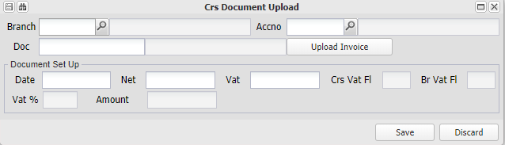

Upload the invoice document and set the document up - Order and no Order
Menu: Purchasing, Other, Other Purchase - Document Set Up or Other Purchase Order - Document Set Up

When the supplier invoice is received, it is linked and uploaded into the system, using the Order or no Order screen, and will follow the relevant payment approval processes. One it is fully set up, the system will include the invoice in the general ledger of the relevant branch as an unapproved creditor.

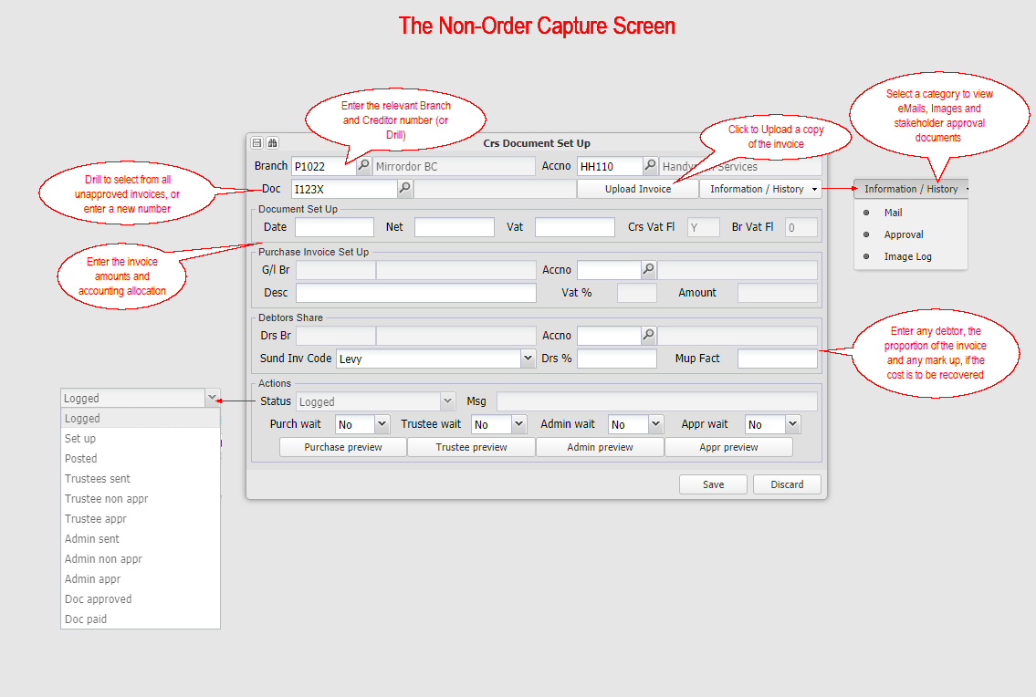

Obtaining Payment Approval and paying the Supplier
Unless the various wait points are set, and the invoice is below the mandate amount, the system will automatically accrue the invoice into the branch books, send the invoice for payment approval, first to the branch office bearers, and then to the payment administrator for final checking and approval.

Office bearers that are flagged as Invoice approvers will be asked to approve the invoice before it will be available for payment.

Emails with the invoice attached are sent to the Invoice approving office bearers
An example of an email sent to an invoice approver, for approval:
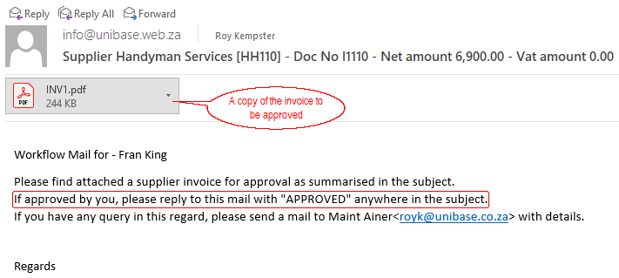

An example of a reply email from an invoice approver, approving the payment of an invoice:

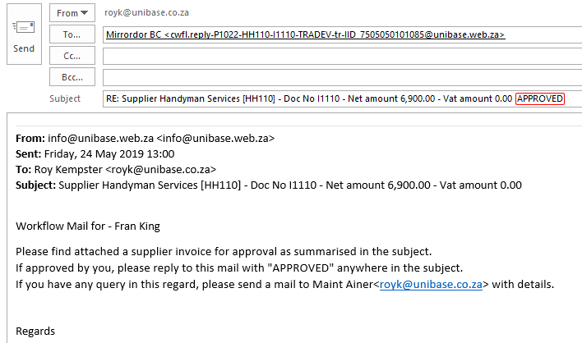

Once the required number of office bearer approvals have been received, the administrator releases for payment
As soon as the required number of quote approvals has been received, the system will send an email to the Buying Controller for the relevant branch. The administrator will perform a final check, and approve the invoice for payment, by replying to the request email. The invoice will then be flagged as an approved invoice, and be able to be paid through the normal branch creditors payment process.

Capturing approvals manually
Should the various stakeholders not reply via. eMail, their approvals can be manually captured using the following menu items:

Other Purchase - Trustee Manual Approve
Other Purchase - Administrator Manual Approve

Managing the overall process
Menu: Purchasing, Other, Unapproved Document Extract

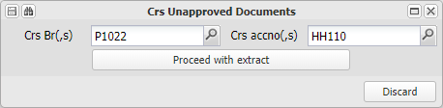

Enter a branch number and creditor to view all documents in the approval process for that branch,, or leave all fields blank to view a list of all jobs related to branches (properties) that you have access to. The list is sorted by job status, and gives you an overview of all jobs that you are responsible for.

Debtors (Unit) Related
Information relating to setting up and processing system aspects relating to Debtors (Units).

Setting up levies and charging a debtor
An overview of this process. Levies will usually be Fixed Asset related, and hence set up and raised from the Fixed Asset Menu

For levies to be charged, a Branch, it's Fixed Assets and it's Debtors will have to have been set up. Refer to Setting up a Property Branch and it's Units for more information on performing these tasks.

Levies are usually linked to a physical unit (Fixed Asset Level 2) in a Property (Fixed asset Level 1). A unit (FA2), has a link to a customer (Debtor). and an Invoicing Table (Fee structure). The levy to be charged is set up on the invoicing table, and the debtor to be billed on the customer table.

Both the invoicing table and customer link table have from and to dates, which enable the system to store the history for both, and for it to know who was in occupation for the charging of certain utilities.

Examples of the two tables:

Menu: Fixed Assets, Create / Maintain, Click on the unit, and Maintain Asset, Debtors - Customer Link and Invoicing:
Invoicing Table
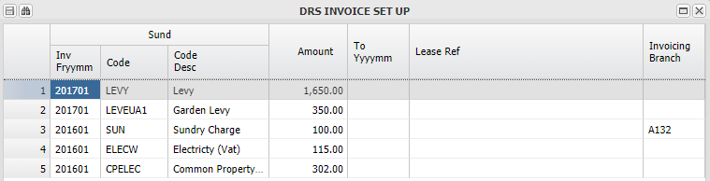

Customer Table
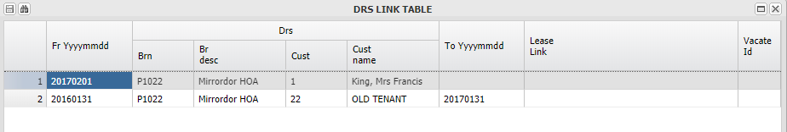

You can view and edit any linked assets fee structure table/s from the Debtors - Master Maintenance screen:
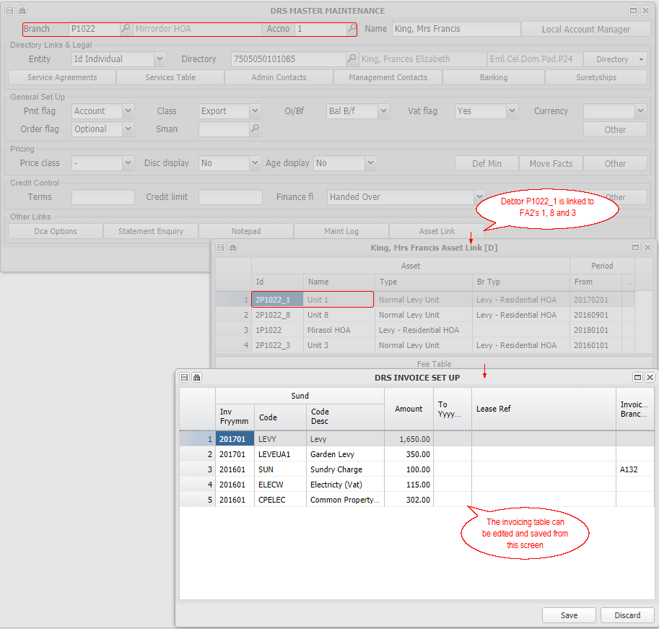

Setting up and sending Debt Collector Letters (Dcl)
Adding new (or updating existing) debt collection letters can be achieved by following the following steps:
Add a Debtors Sundry Invoice (DSI) code for the new letter
Menu: General Ledger, Database Setup, Debtors Sundry Invoices

Insert a new line, and add the details as in the example below, noting the naming conventions:
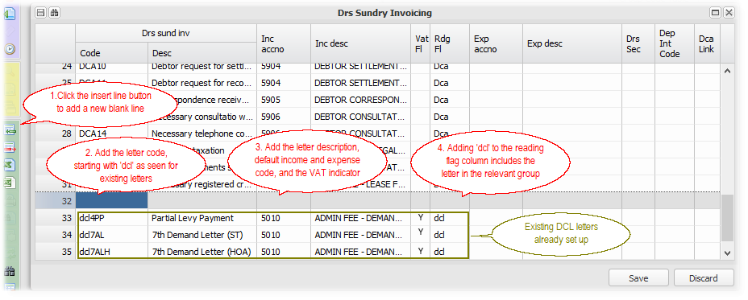
Add the new letter to the selection options
Menu: Administration Control, Machine Selection Control, DR - Dcl Opts

This uses a technical area of the system, to which access is restricted to trained users.

Add a new line to the table, using the same letter description and code as used on the invoice setup screen:
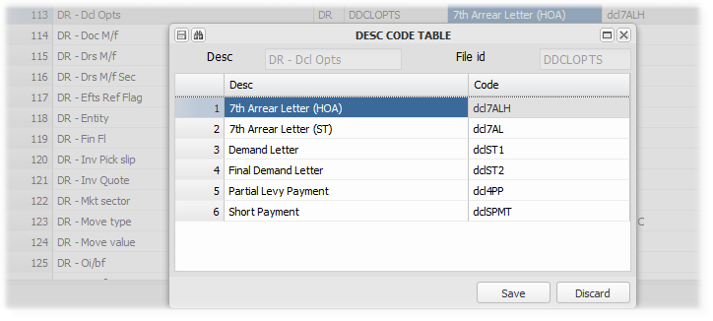
Add the amount to be charged for the letter to the Branch, Reading Rates Table
Menu: Create/Maintain Branch, Debtors, Reading Rates

Charges are branch based. Enter the charges for the relevant branch, or on the central data base branch, which will be the default if a branch has no charges setup. This creates a precedence rule for these charges - charge based on the debtors branch rate first, and if no charges are captured, then use the data base charges. As the letter charges are generally prescribed by statute, they are usually only set up on the data base branch.

1. Add a new line, and add the charge from date.
2. Drill on the Code column to display a list of invoice codes, and select the code set up for this letter:
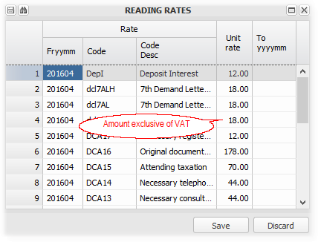
Create and Upload the letter template
Letter templates are created using Microsoft Word. Template variables relevant to Debtors are added to the letters, which are then uploaded into the system.

Letters for a particular branch (Property) are uploaded for that branch, else the letters uploaded to the data base branch will be used. This means that you can have branch specific letter templates, and if not, use the central branch letter templates.

Having created the template, naming it the same as the letter code that you added above, upload it to the relevant branch (or the data base branch). You would save the template relating to 'dcl7AL' as 'dcl7AL'

Menu: Branch, Template Upload

Click here for more information on uploading templates.

Letters are sent out using Debtors, Auto-General, DCL Letters

Setting up and sending Debt Collector SMS's
SMS's are often sent out as part of the credit control and debt collection processes.

The system allows for the setting up of standard messages, with variable links to system information (eg. outstanding balances), which can be charged to debtors.

The two primary steps in the process are described below:
Setting up standard SMS's
Menu: General Ledger, Data Base SMS Table

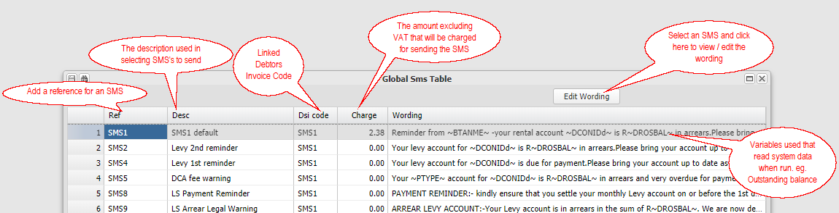

Refer to Template variables for more information.

Selecting debtors and sending SMS's
Menu: Debtors, Debtors - Auto Menu, Debtors Account SMS

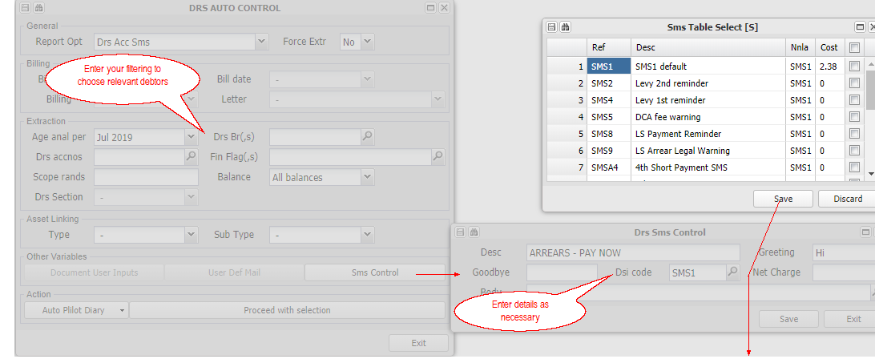
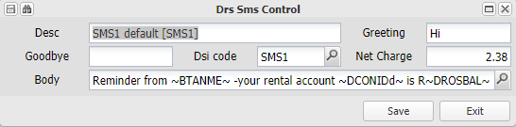

A list of matching debtors will be displayed for you to either choose from or choose all, to send the messages

Setting up Debtor (Unit) statement messages and statement attachments
Messages on debtors statements can be captured and will appear at the foot of the statement. Attachments will be added to the email that is sent attaching the statement.

Messages are set up in one of three places -
On the actual debtors master file record for only that debtor
Menu: Debtors, Debtors Master Maintenance
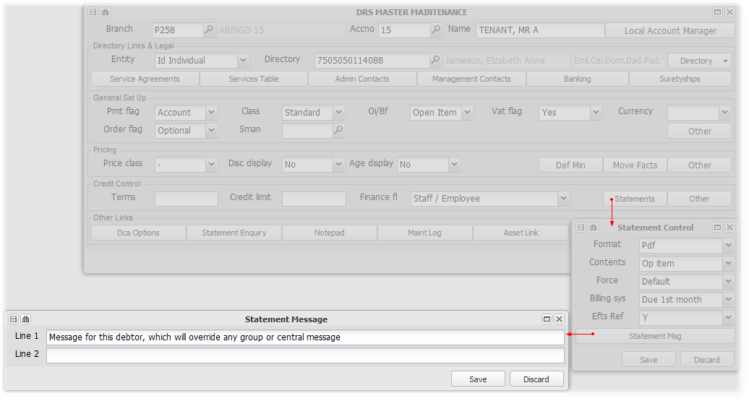

On a group branch - for all debtors in linked branches
Menu: Branch, Create/Maintain Branch
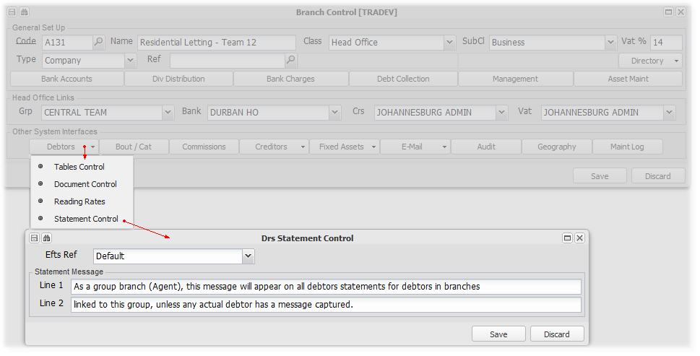

On the central database branch, as a default message for all debtors
Menu: Branch, Create/Maintain Branch
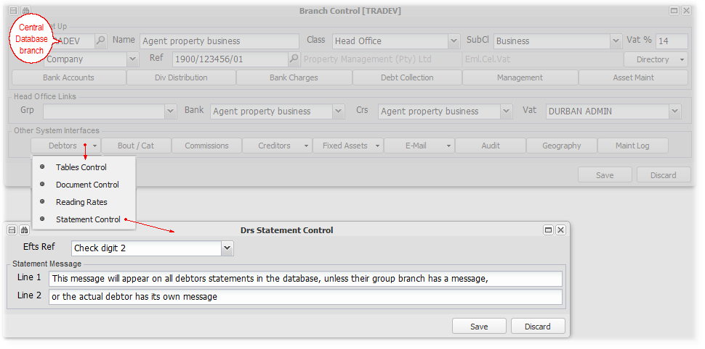

Messages have a precedence rule -
1st display any message on the actual debtor, if none then,
2nd display any message on the controlling branch of the actual debtors branch, and if none then,
3rd display any message on the central database branch

Statement attachments are controlled by adding their detail and uploading the attachment using Create / Maintain Branch, Debtors, Statement Control:

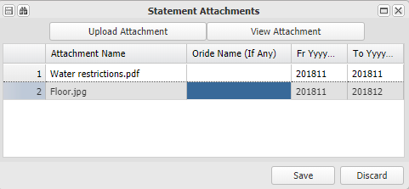

Use this window to capture the details of the attachment/s as indicated in the image above, and to upload or view uploaded attachments.

The attachments set up will be added to the emails that attach debtors statements, based on their date range. If no dates are specified, the attachments will be sent indefinitely.

Setting up the link to TPN and conducting credit checks
The system has a link to Tenant Profile Network (TPN) to enable you to perform credit checks and other verification services offered by TPN.

Credit checks are performed from the relevant directory item. A history of credit checks is stored and available from the directory edit screen.

Set up live and test TPN login in details
Menu: Branch, External Links

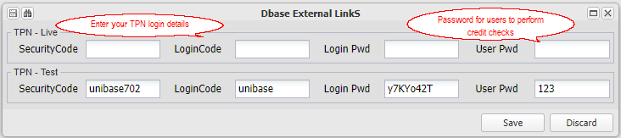

Perform a credit check for a:
Natural Person
Menu: Branch, Create/Maintain Directory

Credit check enquiries are performed in respect of individuals, and stored, linked to the individual directory item. When a debtor is linked to a new or existing lease, the system will inform the user of the date of the last credit check, and request confirmation to continue. Each enquiry will be stored, with the links to the TPN reports enabling their retrieval on demand.

Choose TPN enquiry from the external Links button on the Directory screen:
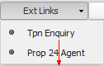
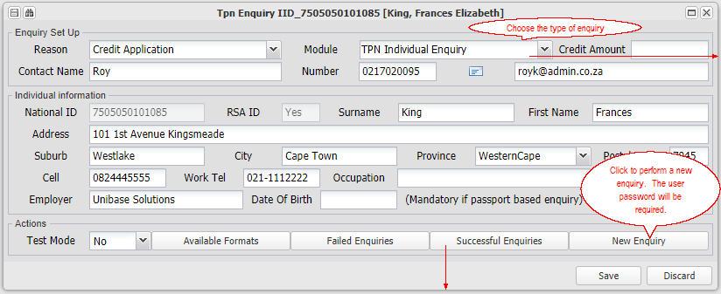 | 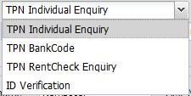
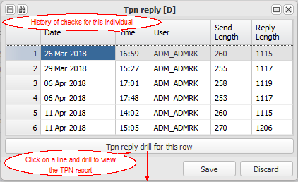
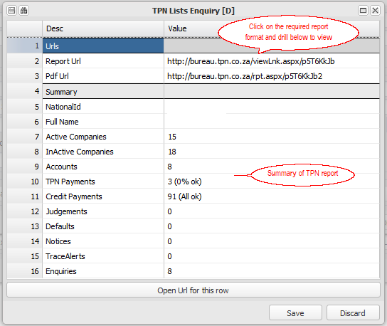

Refer to the Natural person directory for more information

Setting up and charging Interest on overdue amounts
The system supports the charging of interest to debtors, on invoices that have not been paid by their due date.

You can setup interest rates centrally or per branch, and setup rates relative to the central prime interest rate. Rates are set up and stored from their relevant dates. By setting a branch or individual debtors rate to 0, you can effectively block interest being charged to all debtors in a branch, or the relevant debtor.

The transaction line date (due date) is the key date for interest calculations. The system will calculate interest from the due date of the invoice up to the selected period, should interest not have been calculated before, applying varying rates as necessary (To block this historic calculation, set a 0 rate interest on the relevant branch, up to the period that you want to begin charging from). It will also recalculate past interest if a rate error was corrected on the relevant interest table.

Whilst you can select the periods that you wish to charge for, interest is usually charged up to the last completed month end, and on the next months statement. This accommodates the norm in the property management industry, where statements are sent out in advance, so that payments can be made on the 1st of the next month. For example, when sending statements out for August changes (due on 1st August) in July, the last completed month would be June. Interest for June is therefore usually charged on the August statements. An interest grace period can also be set for a branch - No interest will be charged if payment is made in full before the end of the grace period, else interest will be charged form the 1st of that month. Refer to the interest control settings for details of the grace period, minimum or credit amounts.

Interest is effectively compounded if it is not paid on it's due date. As mentioned above, interest for say, June 2017, will be charged in August 2017, and itself attract interest from 1st August if it remains unpaid.

Interest is charged on all transactions for a debtor, even charges by another branch. Interest for another branch's transactions is automatically accrued and receipted back to the originating branch. In the property management industry, charges by an agent to a debtor for letters etc., if unpaid, will attract interest which interest will be accrued back to the agent branch.

Setting up
Interest rates
Menu: Branch, Create/Maintain Branch, Debtors, Table Control.
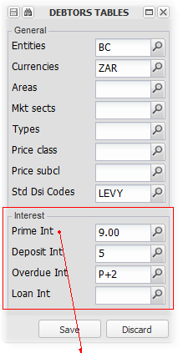
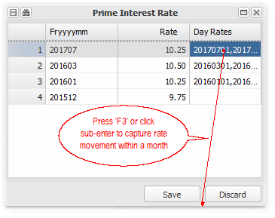
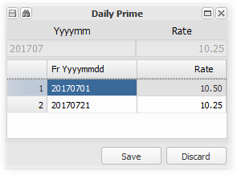
The first step is to set the prime interest rate and overdue interest rate on the central database branch. These will become the default rates if no other rates are set up. The Overdue interest rate can either be a fixed value rate, or a rate relative to the prime rate as in the example above. Note also that the rates are stored from a date, and will be applied as such until a later rate and date is added. Enter the end of month rate in the rate column, and enter the effective dates and rate changes within a month in the Day Rates column.

If a particular branch wants to charge a different rate, you can set up their rates on the relevant branch, which will be used in place of the central rates. You can also block an individual debtor from being charged interest, by setting the rate for the debtor to 0:

Menu: Debtors, Debtors Master Maintenance, Other.

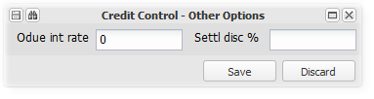
Debtors Sundry Invoice code
As with all charges to debtors, interest requires an invoice code to be set up. The system expects the code for standard trading interest to be 'STDi' It will not raise interest if this code is not captured, and will follow its rules if it is.

Refer to General Ledger, Database Setup, Refer to General Ledger, Database Setup,

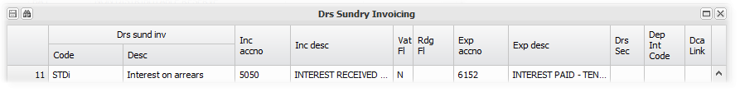

As interest is always Vat exempt in South Africa, set the Vat flag to N. Add the general ledger codes for the income and the expense side of the interest charge.

Charging interest
Charging for the first time
Refer to charging each month below, for details on charging the interest.

The first time interest is run, the system will 'catch up' in that it will charge interest according the the applicable rates, from the due date of each invoice up to the selected period. The monthly runs would then calculate for the updated periods, until the invoice is paid.

To stop historic interest from being raised, set the branch interest rate to 0 up to the end of the period that interest should not be charged for.
Charging each month
Choose Debtors Account Interest:
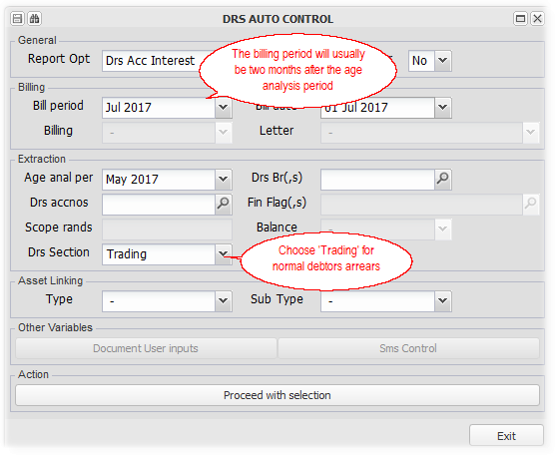
Select the billing and extraction periods, apply any filters and proceed with your selection:
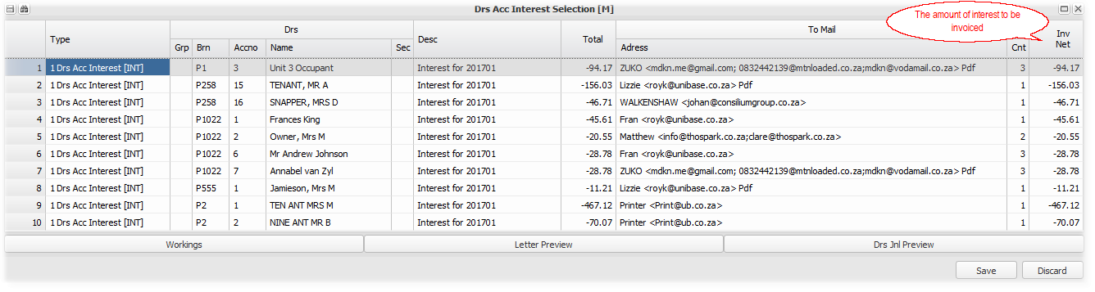
Select the relevant lines or all, and Save to raise the interest.
Checking the calculation for one debtor
If you select only one debtor, a calculation schedule for each invoice will be displayed. This would only be used to check what will be raised and how it is calculated. It can also be used to check the previously raised interest transactions for a selected month:
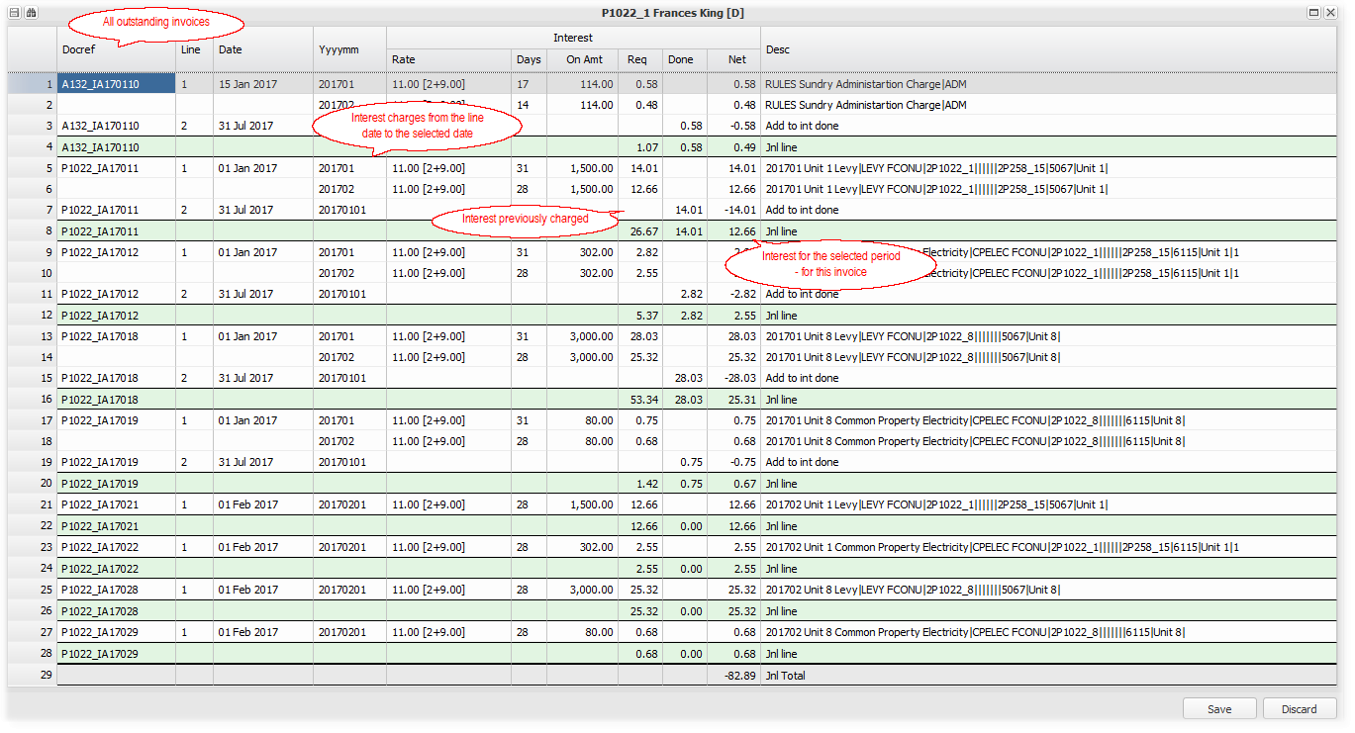
You will note that the interest raised for each month is listed, and the interest previously raised is deducted. The difference is what is to be charged. The above example raises interest for February, on invoices that remain unpaid from January.

Calculation rules
The key date in the calculation of interest is the transaction line or due date. Charges are generally due from the 1st of a month, but occasionally charges, for example, arrears letters, are charged from a different date.

Interest will be charged from the due/line date of each invoice, if not paid within the grace period set per branch, at the rate setup centrally or for the branch. The system is set to calculate for a period of three years backwards from the current period, for each outstanding invoice.

Interest will not be raised on deposit billing that is overdue.

Refer to the compounding section below, which shows the detail of how the interest is calculated.
Compounding
The example below illustrates both the calculation of interest, and its compounding.

We have taken one debtor, and raised its charges for several months, without capturing any payments.

The displays below are produced when calculating interest for one debtor, as explained above.

This debtor, P1022_6, had two invoices per month that were raised from January 2017. As is usual practice, interest for January was raised and posted into the March period. As the debtor only became aware of the interest charge in March, interest will only compound from March.

The interest rate applicable for this branch, is the prime rate plus 2%, 11%.

Interest raised on January transactions, posted into March. There are two invoices per month for this debtor:
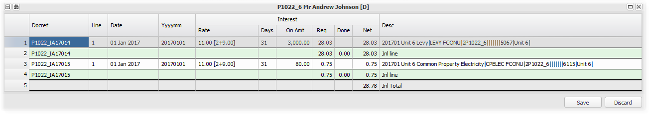
Note that as both invoices were due (line date) on 1st January and remained unpaid at 31st January, interest for 31 days at 11% was calculated and then charged. The interest invoice would only be due on 1st March.

Interest raised on February transactions, posted into April:
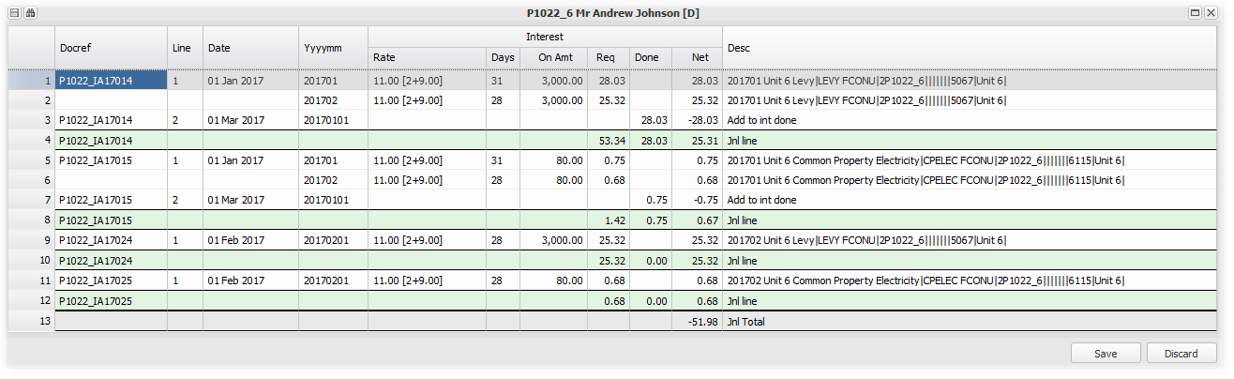
Note that the January invoices attracted additional interest for 28 days. The February invoices attracted interest only for 28 days. As the January interest invoices were due on 1st March, no compounding has started.

Interest raised on March transactions, posted into May, focusing from now only on the first invoice - P1022_IA17014:
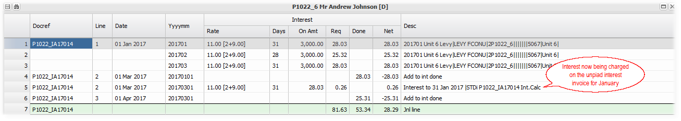
Interest for March is added, and now interest on the January interest (due on 1st March), now starts to accrue.

Interest raised on April transactions, posted into June:
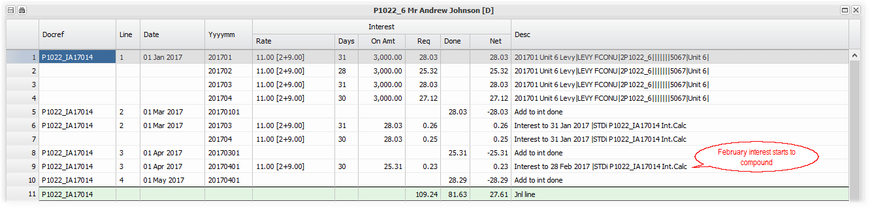
Interest raised on May transactions, posted into July:
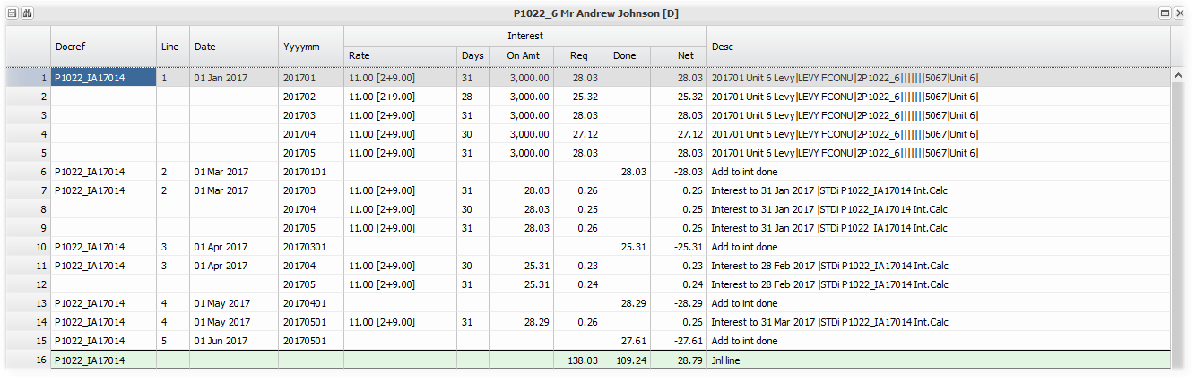
Interest on remote branch transactions (Sharing)
The interest changed by a branch not directly linked to a debtor, will also incur interest charges, at the rate applicable to the debtors branch. The interest income will be routed back to the branch that the original invoice was generated from.

This is usually the case where and agent branch charges a debtor in a property branch, for letters etc., which are not paid in time. The amount due to the agent, together with interest, is allocated automatically when the debtor pays and the receipt is allocated.
Other information
Interest control settings
Menu: Branch, Create/Maintain Branch, Debt Collection
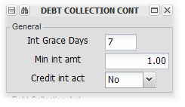
Set | - the number of days allowed from the first of a month, that if an invoice is paid in full within, no interest for that month will be charged.
 | - the minimum amount that will be raised as interest. ie. if the interest due is less than this amount, it will not be charged.
 | - whether or not to allow the crediting of interest to debtors accounts that are in credit.
 | all for a particular branch, or as central database settings.

Interest will only be raised for periods that have not been raised for before.

If the relevant interest rate tables change, the system will apply the new rates retrospectively, and charge an adjusted interest amount accommodating the rate changes, in the next interest charge.

Setting up and processing Loan debtors
This facility provides a controlled process for a loan being made from one branch to another, or from a branch to one of its own debtors. It covers the initial assessment and quote, storage of the signed loan agreement, the transaction processing and the loan settlement. The system will facilitate the cash transfers between or within relevant bank accounts. The process is summarised as follows:

Capture and Set up loan worksheet details, quote and activate
Set up the inter group Loan debtor and Loan creditor.
Before starting the quote process, set up a debtor in the lending branch - Debtors Master Maintenance. If the loan will be to an existing branch on the system, use that branch number as the debtor number. For example, if the the loan is to branch P1022 and from branch A903, then create a debtor in A903 with a number P1022. Before activating the loan, also set up a creditor in the borrowing branch, using the lending branch number as the key. In both the debtor and creditor, set the payment flag to 'Intergroup'. Defining the payment method as intergroup will facilitate the monthly installment payment and receipt process. This link will also replicate interest charges automatically.

If the loan is to an entity that is not a branch on the system, you only need to set up the debtor in the lending branch, and set the payment flag to 'Account'.

In the example below, the lending branch (A903) uses its own trading bank account (4155), and the borrowing branch (P1022) uses a central shared bank account (1002).

Capture and process the loan details in the loan worksheet
Menu: Debtors, Debtors Loans :
Capture loan details, calculate the transaction details and produce a loan quote
This screen is based in the lending branch (A903), and it's debtor (P1022). As the borrowing ranch has a creditor with the same number (A903), entries will be mirrored from the lending to the borrowing branch.
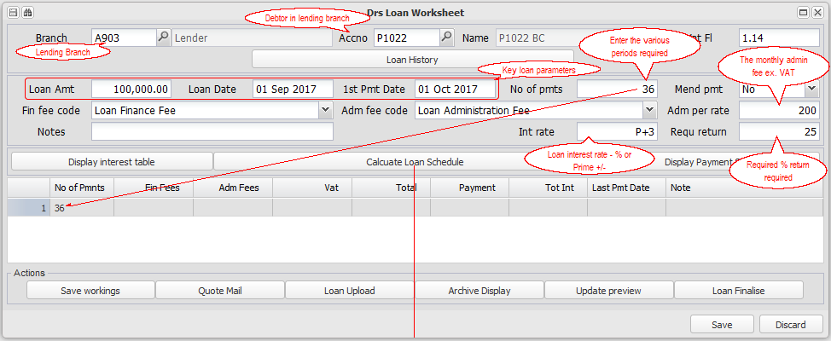
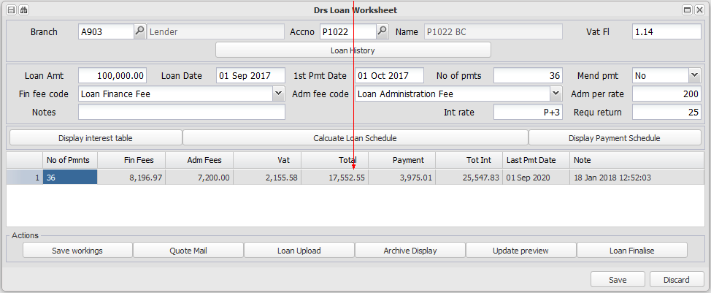

Add a line for 60 months:
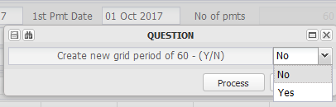

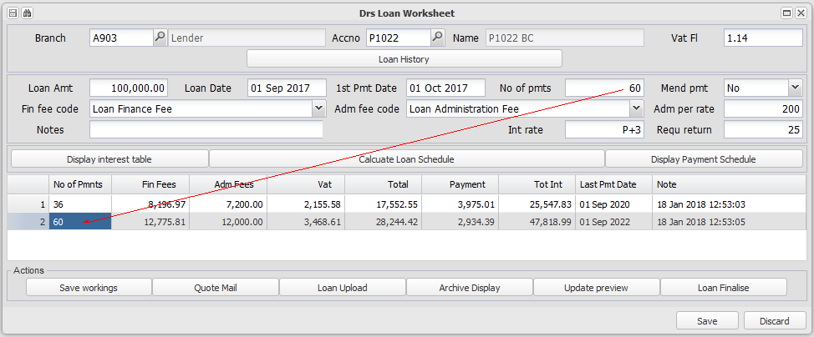

Send the loan quote and save the workings
To send or view the loan quote, click on 'Quote Mail'. You can then either choose to view the quote and schedule, or to send the quote to the borrower.

Click on 'Save Workings' to store the loan workings, awaiting the quote acceptance and loan agreement being signed. Should you need to amend the quote before signing, open the loan workings as above, delete the relevant detail lines, and recalculate the transactions.

Upload a copy of the signed loan agreement and activate the loan
Once the agreement has been signed, open the loan workings, and click on 'Loan Upload' to upload a copy of the signed loan agreement.

If you wish too, you can preview the accounting entries that will be put through when the loan is activated, by clicking on 'Update Preview', and drilling in as required. Then, with the relevant detail line (accepted loan period) highlighted, click on 'Loan Finalise'. You will be warned if a copy of the signed loan agreement hasn't been uploaded, but will be able to proceed anyway. In our example, we will activate the 60 month loan period:

Accounting entries processed on activation
The lending branch:  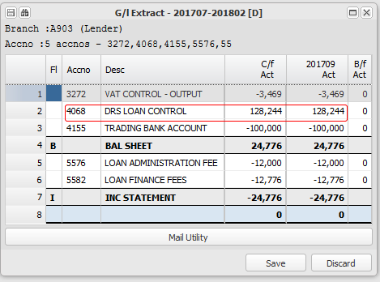  Note that the initial loan advance of R100000 is reflected as having been paid (4155), but the actual cash transfer still has to be effected. It would reflect as an outstanding item on the bank reconciliation statement. Refer to the section below on processing the initial loan advance payment. | The borrowing branch:  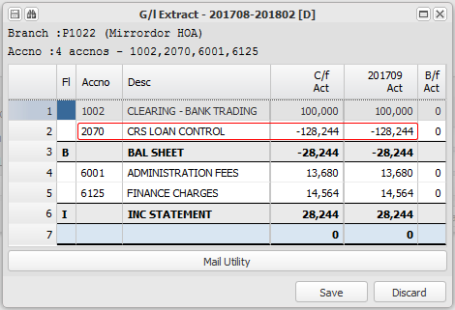  Note that the initial loan advance of R100000 is reflected as having been received in the default bank account (1002), but the actual cash transfer still has to be effected. It would reflect as an outstanding item on the bank reconciliation statement. Refer to the section below on processing the initial loan advance payment.

Process the initial loan advance payment
In the example above, the cash needs to be transferred from the lenders bank account to the borrowers share of the shared central bank account. The following step produces an EFTS batch to transfer the initial loan advance from the lending branch's bank account to the borrowing branch's bank account:.

Menu: General Ledger, Bank Statement Menu, Transaction Approval

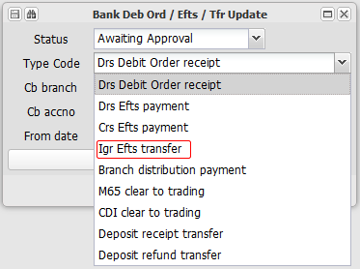

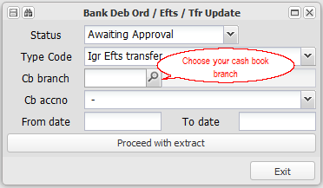

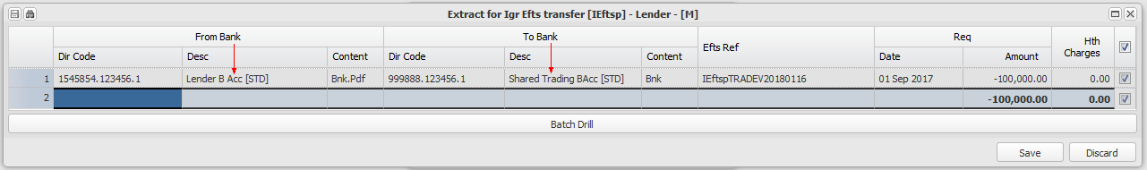

If your account has Host to Host banking active, the transaction will be processed through your bank accounts directly, after the Pool Update (Second release). If not, an EFTS batch will be produced, or you can process the transaction using you bank interface program.

Raise loan interest
Menu: Debtors, Auto Menu, Debtors Account Interest

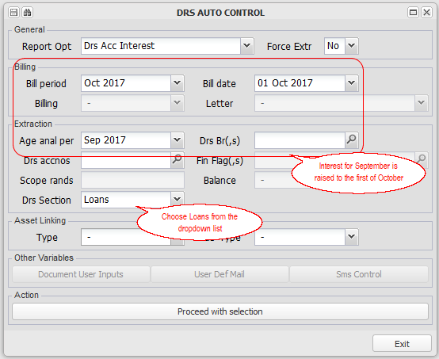

Choose the lines/s to update by selecting the tick box on the right, and click Save. Interest for September 2017 of R 1396.63 will be charged to the loan debtor:
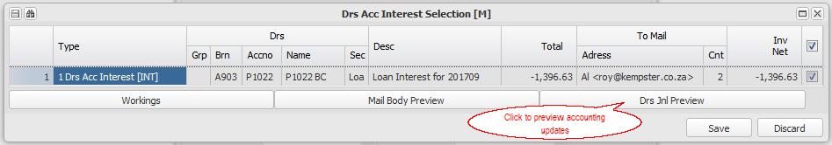

Interest calculation details:
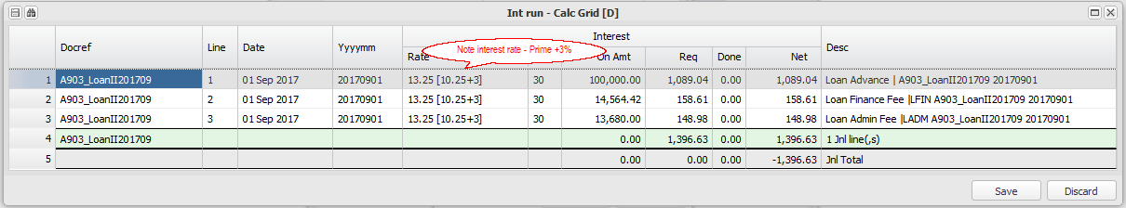

Note: Interest is calculated from the line date of each transaction. If the lending and borrowing branches are linked as described above, the interest charge will be accounted for in both branches automatically (Refer to the accounting update below for an example of this.

Accounting update
The lending branch:  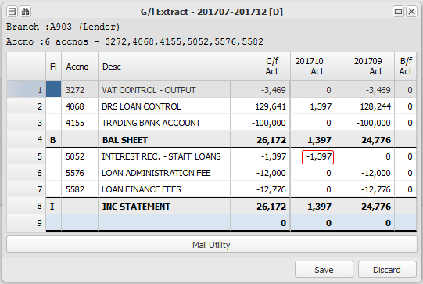 | The borrowing branch:  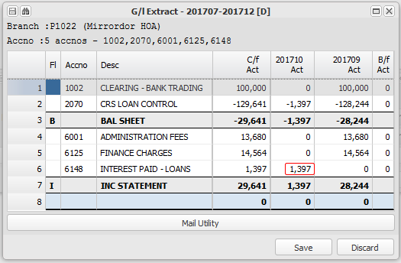

Raise and process monthly installments
Menu: Debtors, Auto Menu, Debtors Intergroup Loan Payment

Choose your extraction period and Proceed with selection. Select the loan payments for the resultant list (usually all), and Save to update the transactions:
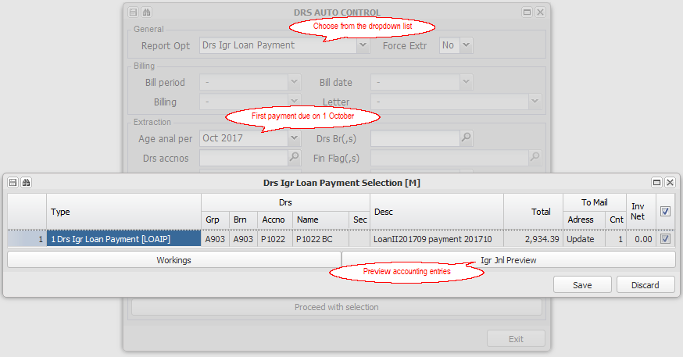

As with the initial loan advance, process the EFTS cash move:
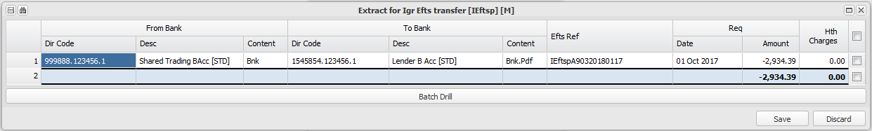

If your account has Host to Host banking active, the transaction will be processed through your bank accounts directly, after the Pool Update (Second release). If not, an EFTS batch will be produced, or you can process the transaction using you bank interface program.

Accounting update
The lending branch:  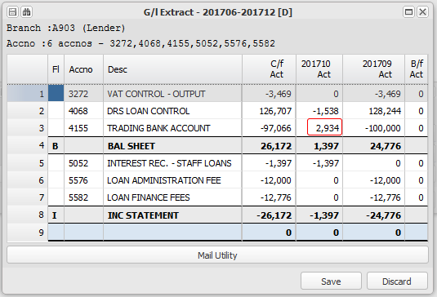 | The borrowing branch:  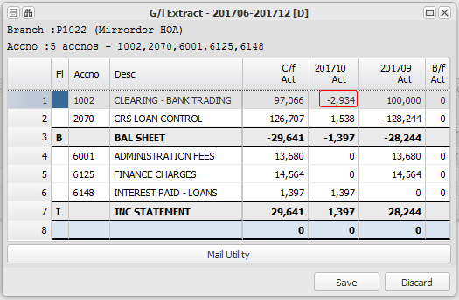

Processing journal adjustments
Menu: Debtors, Journal

Use this option to process any additional adjustments required during the currency of the loan. Examples of these are an additional valuation fee, an administration fee, and an adjustment to the original finance fee. The system houses the whole loan transaction as a single open item, so the journal below is an adjustment to that open item document:

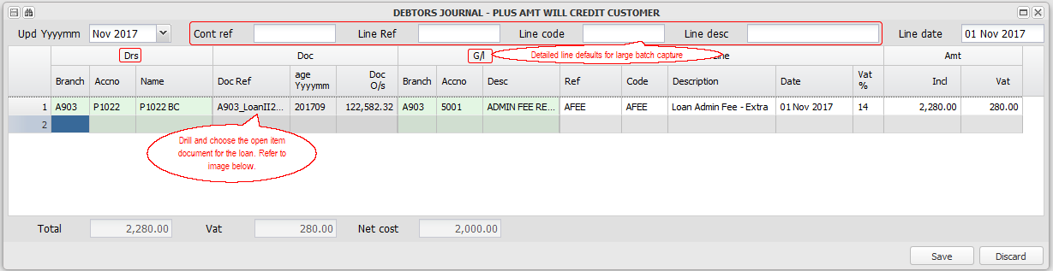

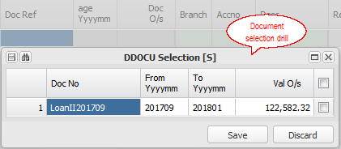

Note that the screen confirms that a plus amount will credit the debtor, and that the line amount is inclusive of VAT.

Loan statement and transaction information
Loan transaction information can be obtained from two main areas:
Debtors statement enquiry
Menu: Debtors, Debtors Master Maintenance, Statement Enquiry

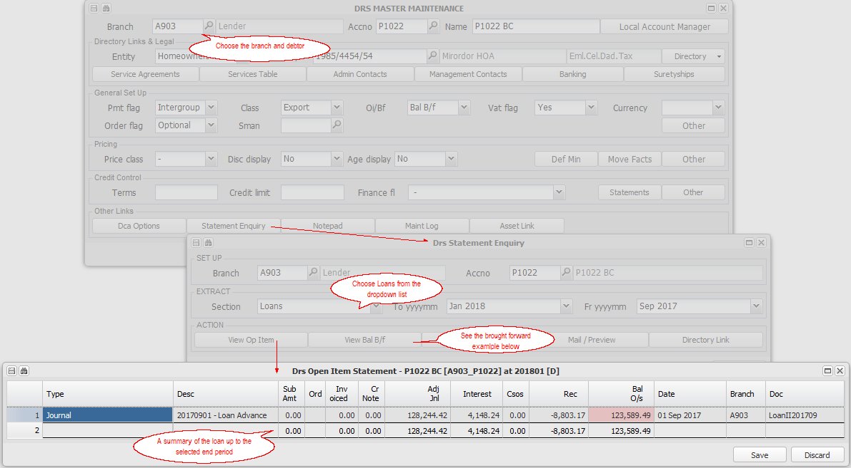

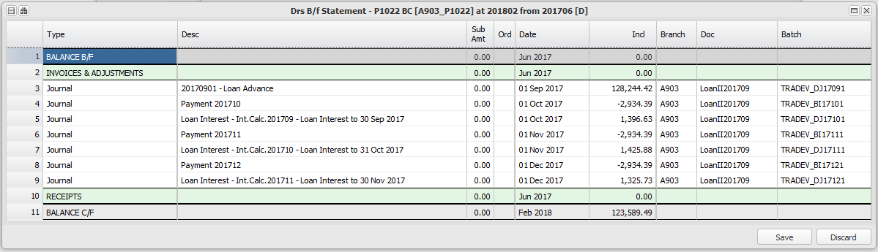
Loan statement
Menu: XXXXXXXXXXXXXXXXXXXXXXXXXXX

Smooth installments over the remaining loan term
Menu: Debtors, Auto - General Functions and Reports, Debtors Account Loan Recalculation

This option is generally used each month, usually as a last end of month process. It recalculates the monthly loan installment to ensure that the loan balance will be recovered withing the remaining loan term. It is essential to run this, for example, if the prime interest rate changes, a loan installment is missed, or an adjusting loan journal is processed:
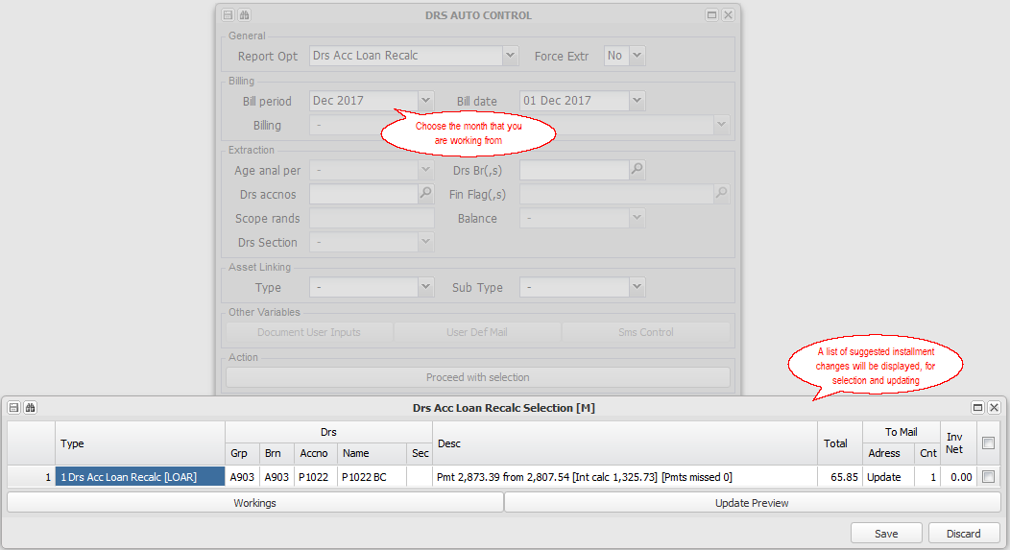

The updated installments will be effective from the next installment raise.

Loan settlement
Menu: Debtors, Debtors Loan

This option will calculate an amount that will settle the loan at a future date, which is based on the current balance and interest rate:
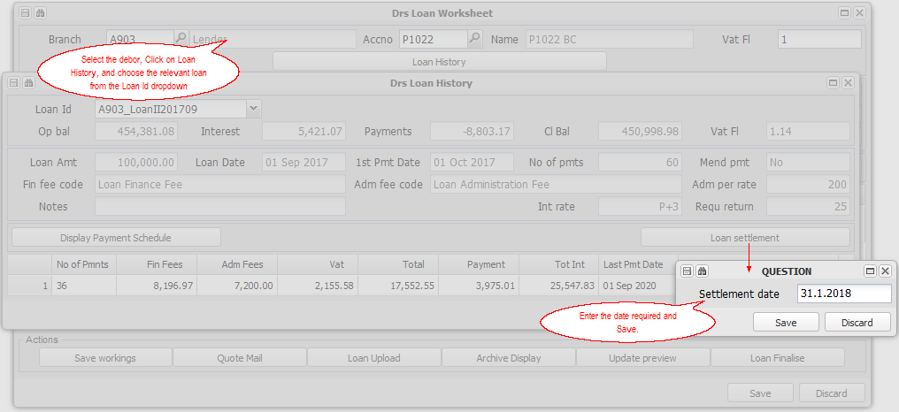

You can email or preview the letter.

Loan history and document archiving
Menu: Debtors, Debtors

As for the settlement selection process above, choose your debtor and relevant loan from the Loan ID drop down list:
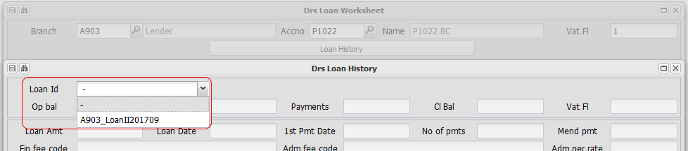

Note that the Loan Id is based on the debtor number and loan start date.

The initial loan worksheet for the selected loan will be displayed:
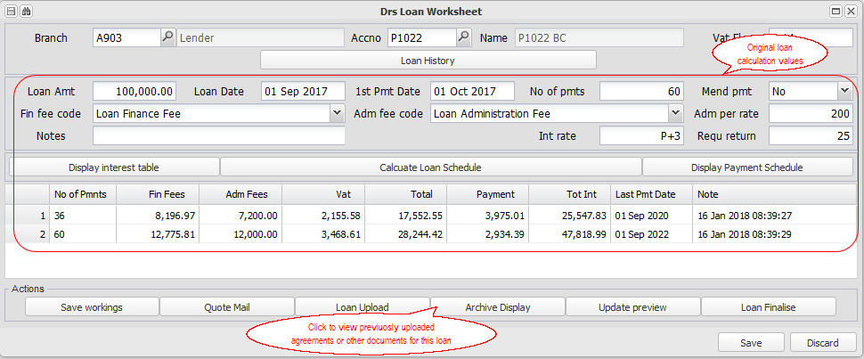

Setting up and crediting Interest on deposits
The system supports the crediting of interest on deposits from debtors, held by one of your branches. This is common in the property management industry, in respect of damages deposits received from tenants, held in a trust account.

Interest is effectively paid by the branch that holds the deposits, usually the central data base branch, and credited to the deposit section of each relevant debtor, in it's branch. The interest earned on the investment of the deposits will offset this cost. If the deposits are held by the owner of a property, interest will be charged to that branch.

You can setup interest rates centrally or per branch, and setup rates relative to the central prime interest rate. Rates are set up and stored from their relevant dates.

The transaction line date (receipt date) is the key date for interest calculations. The system will calculate interest from the date the deposit was received up to the selected period, should interest not have been calculated before, applying varying rates as necessary (To block this historic calculation, set a 0 rate interest on the relevant branch, up to the period that you want to begin charging from). The system will also recalculate past interest if a rate error was corrected on the relevant interest rate table.

Setting up
Interest rates
Menu: Branch, Create/Maintain Branch, Debtors, Table Control
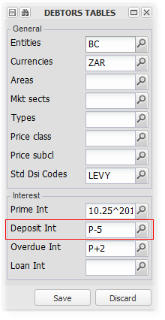
Once the prime rate has been set, set the deposit rate relative to prime (Prime-5% in the above example) or a fixed rate as you require. This is done centrally and, and, if different rates apply, per branch.

For more information on setting up the prime rate, refer to Trading interest setup.

Debtors Sundry Invoice code
As with all debtors transactions, interest requires an invoice code to be set up. The system expects the code for deposit interest to be 'DEPi' It will not raise interest if this code is not captured, and will follow its rules if it is.

Refer to General Ledger, Database Setup, Refer to General Ledger, Database Setup,

The following image is an example of a deposit interest invoice code set up:
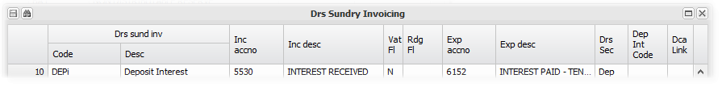

As interest is always Vat exempt in South Africa, set the Vat flag to N. Add the general ledger codes for the income and the expense side of the interest charge

Crediting interest on Deposits
Menu: Debtors, Auto Menu, and choose Debtors Account Interest from the option drop down menu.

Interest on deposits is usually credited at the end of a month, for that month. It can be credited in a later period.
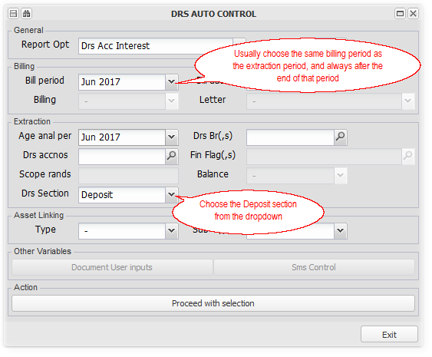
Usually a bulk monthly raise is run, by selecting many branches and choosing all. If you choose one debtor, a detailed calculation window will display, as in the examples below. This option is useful in checking the calculation of interest in a previous month.

Calculation rules
Interest is calculated from the date that the deposit was received (deposit invoice paid), as indicated from the line date of the bank statement import. The interest rate applicable over time, as set up, will be applied. If the rate varies within a month, interest will be calculated accordingly.

If the interest table was set up incorrectly and is amended, the next time interest is credited, the new rate will be historically applied, and the correction applied in the current calaculation period.

In the example below, a deposit was received on 16th June, and the deposit rate was set at 5%. Interest for June was therefore calculated for 15 days:
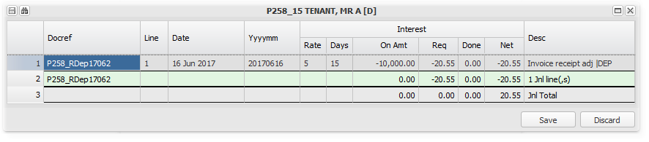

Interest for July was calculated for 31 days, but on the balance at the end of June, including interest. Interest is compounded in this way:
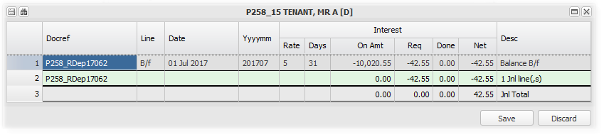

Cost allocation rules
Interest paid is charged to the branch that holds the deposits.This branch will earn interest on the deposits invested to offset the interest paid to the deposit holder.

Any surplus interest will be for the holding branch, usually used to offset the cost of administering the central account, and any surplus distributed according to the relevant industry. In the property management industry in South Africa, half of this final surplus accrues to the Estate Agents Board.

Interest is credited to the deposit holder, in the relevant debtors branch, and to it's deposit section. This will increase deposit control, and that branches share of the central deposit account, or the account that is set to hold the deposits.

Setting up General Ledger based Debtors (Unit) Billing
This utility allows you to charge a debtor/s (Unit/s) based on a general ledger account, as part of the monthly billing cycle.

This is useful in recovering variable costs incurred by a branch, from one or more of its debtors, based on one of five allocation tables. Two examples of where this utility is useful:

1. Recovering the cost of assessment rates for a month, based on the amount paid for that month, from all debtors in proportion to the size of their units.
2. Recovering the net cost of common property water, based on the year to date balance of the relevant water general ledger account, split equally between all Debtors (Units).

The process has two set up areas:
Set up Unit Allocation Tables
Menu: Fixed Assets, Maintain/Create Fixed Asset

Set up tables that determine the proportion of the relevant billing amount that will be charged to each unit. You can either capture the relevant proportion or import the system participation quota, and adjust as you will. You can set up, up to five different tables:
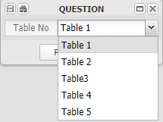

We chose Table 2 -  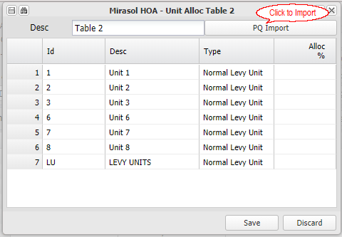 | 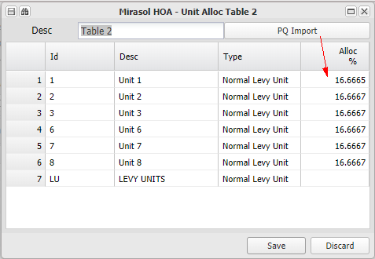

You can exclude one or more debtors (units) by setting their allocation percentage to 0%.

Set up Unit Allocation Invoicing
Menu: Fixed Assets, Maintain/Setup Fixed Asset

An invoicing line can be added for each type of billing that you wish to raise.

In the example below, any plus month move in GL account 6013, for two months prior to the month being billed for, will be billed to Debtors |(Units) in the proportions set up on Table 2, using the Sundry Charge (SUN) invoice code:
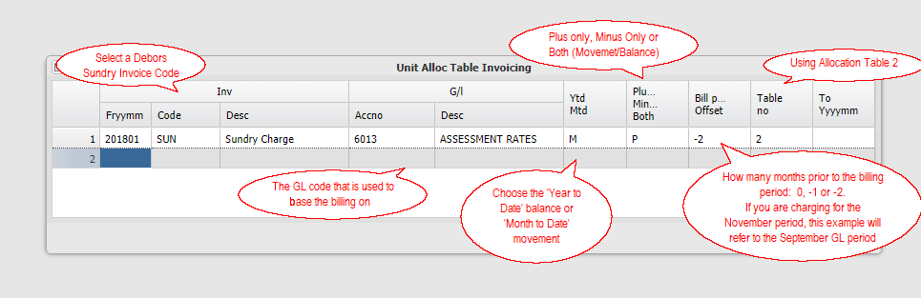

The charges will raise when raising the monthly Debtors Account Billing, for all units on the selected allocation table with customer links.

Setting up a lease agreement and charging a debtor
Producing a new lease agreement and charging out the relevant amounts in terms thereof, is accomplished in two main steps -

1. Creating a new debtor and a new lease record - Menu: Fixed Assets, Debtors, Lease New Customer, and
2. Entering the new lease information, producing and archiving the lease, and setting up and invoicing the lease amounts - Menu: Fixed Assets, Debtors, Lease Existing Customer

Setting up a services agreement and charging a debtor
These options are generally used in the property management industry to charge clients fees for services - usually a fixed fee or a receipt based fee on amounts collected. The agent branch (Agent) , charges it's debtor, which in this case would be a property branch (Property). The Payment flag is set to Inter Group indicating to the system that it must manage the payment of the fees, even if the branches use different bank accounts.

Fixed amount fees
Fixed amount fees are fees charged for services rendered by one branch to another. These could be monthly management fees (common in property management), or other periodic fees charged in terms of a service agreement.

Fees are set up on the debtor, in the charging branch. When raised, if the debtor and related creditor have Inter Group as their payment flag, the fees will be raised in both the charging branch (agent), and in the service recipient branch (property).

1. Fees are set up on a Services Table, and can be linked to a Service Agreement:
Services Table - Fees to be Charged
Menu: Debtors, Debtors Master Maintenance, Services Table

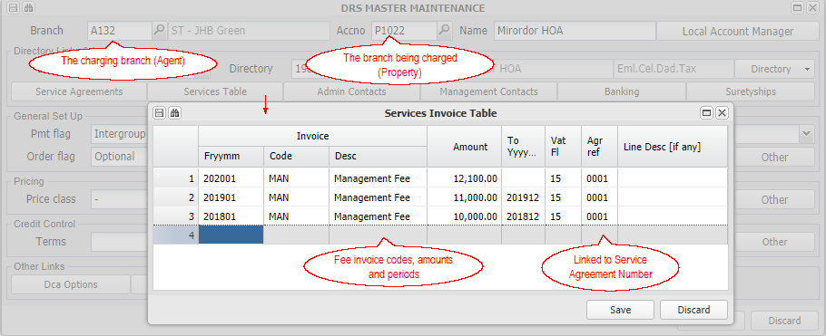

Service Agreements - Contract Summaries
Menu: Debtors, Debtors Master Maintenance, Services Table

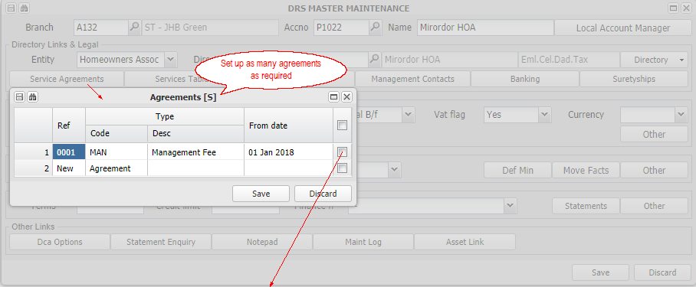
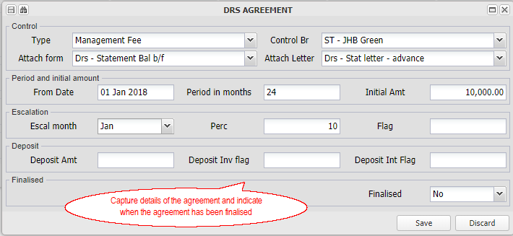

2. Fees are raised from the Debtors - Auto, Debtors Account Billing
Debtors Account Billing
Menu: Debtors - Auto Menu, Debtors Account Billing

Fees set up are raised using Debtors Account Billing:
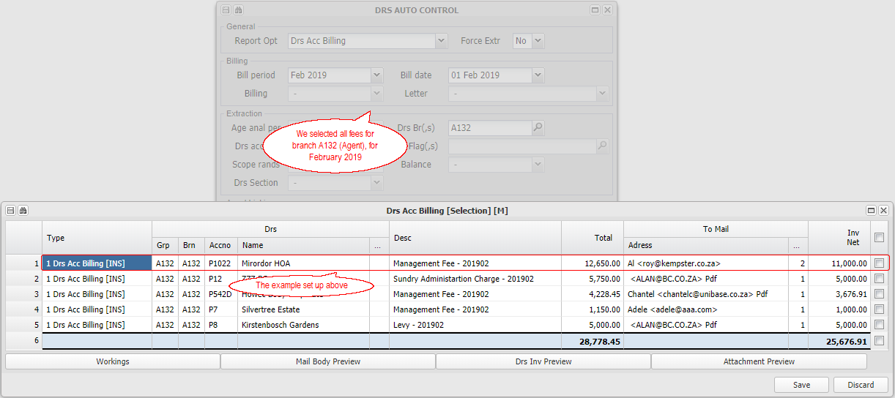

3. Fees are paid using Debtors, Debtors Inter Group Clear - Invoices
Paying Inter Group Debtors / Creditors
Menu: Debtors - Auto Menu, Debtors Inter Group Clear - Invoices

Fees are paid when clearing (paying) inter group invoices, effectively moving funds within the shared bank account or invoking an EFTS transfer between the relevant bank accounts: 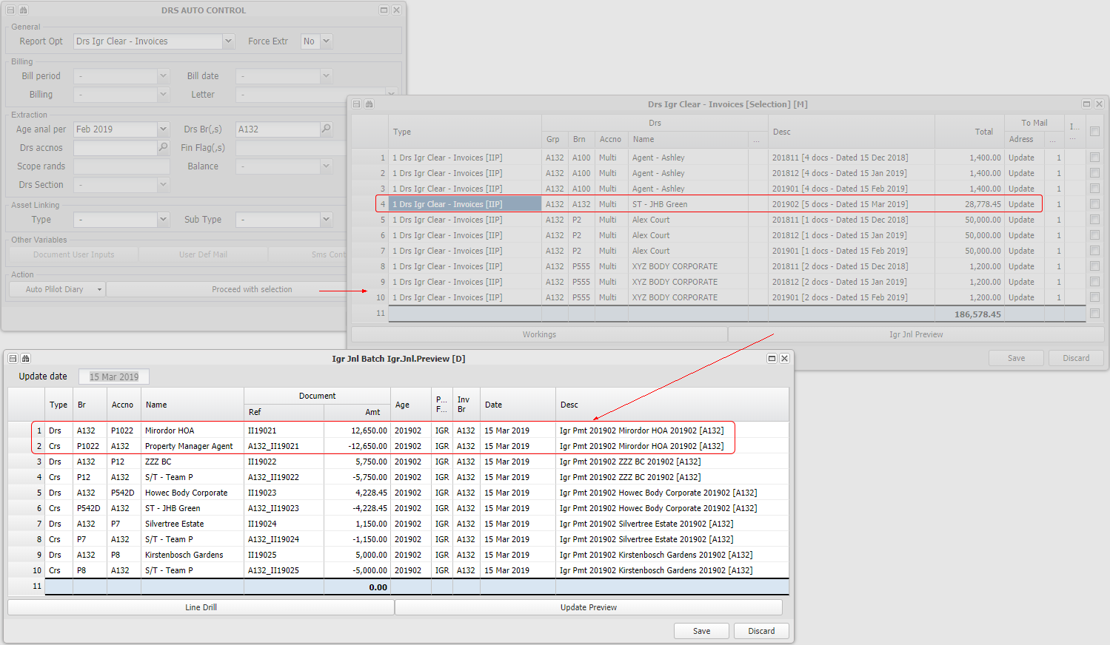

Transaction based fees - Receipts or Invoicing
These type fees are set up in the database setup (types of commissions), and then linked to a branch (details of the commission):
Menu: General Ledger, Data base set up, Commissions
Menu: Branch, Create / Maintain Branch, Commissions

Transaction based fees are based on either debtors collections (collection commission) or invoices (sales commission), and are automatically raised by the system when the relevant transactions are processed.

Collection commission is commonly used in the rental collection section of property management. Refer to Setting up and charging fees to a property client for more information.

The above links contain more information on both type fees.

Fixed Asset Related
Information relating to setting up and processing system aspects relating to Fixed Assets (Properties and Units).

Setting up, processing and paying for Maintenance Jobs
This utility facilitates and controls the process of logging and arranging to attend to maintenance requests, obtaining quotes and their approval, paying the supplier invoice after it is approved, and accounting for it's cost.

The system will keep the various stakeholders informed as necessary via. SMS's and emails, with relevant supporting images and documentation.

The approval limit and list of approvers is set up per branch, and applied to all jobs related to that branch. There are password protected overrides where necessary.

Maintenance requests are logged with uploaded images and allocated to a manager to process. Quotes are then requested from suppliers, and sent to branch approvers when the required number have been received. Once approved, the appointed administrator finally approves the job. and issues the purchase order to the successful supplier. Once completed, the job is inspected. On receipt of the supplier invoice, it is set up and uploaded into the system, which triggers the payment approval work flow. Once the branch payment approval process has been completed, the approved invoice is submitted to the payment process.

The approvals and submissions are generally sent and received using emails, which automatically update the relevant parts of the system. There are also manual update utilities where necessary.

The system has an information drill and search to facilitate the management of jobs.

Copies of quotes, invoices, authorising emails etc. are stored and made available to the relevant party at the appropriate stage of the process.The various stakeholders are kept up to date with the process by sending them appropriate SMS's and emails. A history of these is stored and can be viewed on the Processing a Job screen, and clicking on the:
Information/History button
Select the relevant group to view the details that you require:
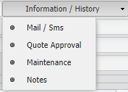

Image Table button
Choose from the list of stored items (Which include images and reply emails), and click on Image Display to view the item:
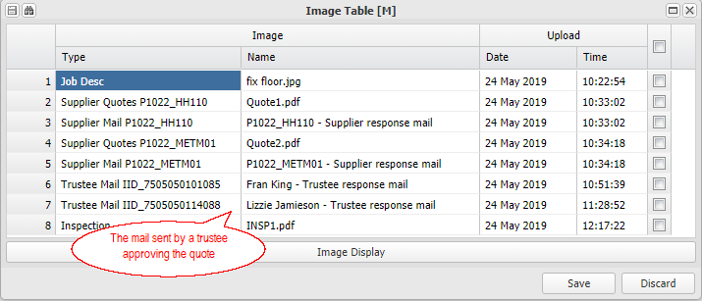

The quote approval and the invoice payment approval work flow processes are automated, unless any of the available check points are set to Wait before automatically proceeding. The default for all wait points is 'No', which automates the full process. Once any 'Yes' wait point for a job is set to 'No', the job will automatically proceed to the next wait point. You can view the status of items in the approval process using the Unapproved Document Extract explained below.
Quote approval work flow 'Wait' points

Supplier Wait | If set to 'Yes' quote requests will not be sent out until the flag is set to 'No'
Trustee Wait | If set to 'Yes', the trustee / office bearer requests for approval will not be sent out until the flag is set to 'No'
Administrator Wait | If set to 'Yes', the request to the Administrator for final approval will not be sent out until the flag is set to 'No'

Invoice payment approval 'Wait' points

Purchase Wait | If set to 'Yes', the accrual of the purchase in the books of the branch once the document is set up, will not happen until the flag is set to 'No'
Trustee Wait | If set to 'Yes' the trustee / office bearer requests for approval will not be sent until the flag is set to 'No'
Administrator Wait | If set to 'Yes' the request to the Administrator for final approval will not be sent out until the flag is set to 'No'
Approval Wait | If set to 'Yes' the invoice will not be flagged as approved, despite all stakeholders having approved it, until the flag is set to 'No'

Click the '+' button to view a list of the steps in the Maintenance Job and Payment Work flow
 | Action | Menu item
1 | Log a Job | New Job
2 | Allocate responsibility for the job set up the order | Maintain Job
3 | Request quotes from suppliers | Maintain Job
4. | Receive quotes from suppliers | Maintain Job
5. | Send quotes for approval | Maintain Job
6. | Receive quote approvals | Maintain Job
7. | Send approved quotes to the administrator for checking and final approval | Maintain Job
8. | Receive administrator approval | Maintain Job
9. | Issue purchase order | Maintain Job
10. | Inspect the job and confirm its completion | Maintain Job
11. | Receive the supplier invoice and set up the invoice | Purchase invoice upload - Creditors Document Upload from a Job
12. | Accrue the purchase into the books of the branch | Purchase invoice upload - Creditors Document Upload from a Job
13. | Send the invoice for payment approval | Purchase invoice upload - Creditors Document Upload from a Job
14. | Receive office bearer approvals | Purchase invoice upload - Creditors Document Upload from a Job
15. | Send invoice to the administrator for checking and final approval | Purchase invoice upload - Creditors Document Upload from a Job
16. | Receive the administrator approval | Purchase invoice upload - Creditors Document Upload from a Job
17. | Final release for payment | Purchase invoice upload - Creditors Document Upload from a Job

Work flow steps in more detail:

Setting up the branch (property) parameters
The three main areas of set up that impact these processes, are:
Setting up the branch (property) maintenance mandate
Menu: Branch, Create/Maintain Branch, Asset Control

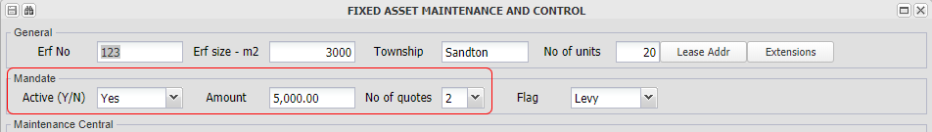

Capture the amount over which quotes need to be approved by branch office bearers, and the number of quotes that need to be obtained for each maintenance job. The number of approvers that need to approve a quote is set up in the next section of these notes.

Refer to setting up branch approvers below

Setting up the branch (property) invoice payment approval rules
Menu: Branch, Create / Maintain Branch, Creditors, Document Control

If the branch (property) require that creditors documents over a defined limit need to be approved by its office bearers, then set the Update flag to 'Approval', add the amount over which they need to be approved, and the number of office bearers that need to approve payment. The number of approvers is also used as a rule for approving maintenance job quotes.

Refer to setting up branch approvers below.

Setting up the branch (property) quote and invoice approver office bearers
Menu: Branch, Create / Maintain Branch, Directory, Office Bearers

For each office bearer that is authorised to approve quotes and or creditors invoices, add a 'Q', 'I' or 'QI' in the authorisation column as indicated above. Francis King is authorised to approve both invoice payment and job quotes.

The maintenance quote approval rule -
If two approvals are required, the first quote that receives two approvals will be flagged as the approved quote.

Logging a new Job and starting the workflow
Logging a new Job - Occupied and Unoccupied assets
Menu: Fixed Assets, Maintenance, New Job - Occupied and New Job - Unoccupied
Enter the debtors number and details, or the branch and fixed asset, of the maintenance required:
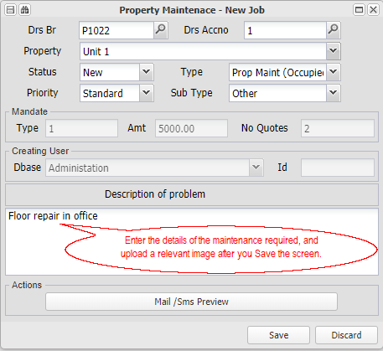

Images related to the maintenance request can be uploaded once the Save button has been clicked:
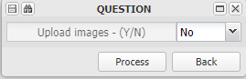

This image, and any others uploaded later, will be sent to suppliers when quote requests are send out to them.

Processing a Logged Job
Menu: Fixed Assets, Maintenance, Maintain Job

The Maintain Job screen facilitates, supports and controls the process of completing the job:
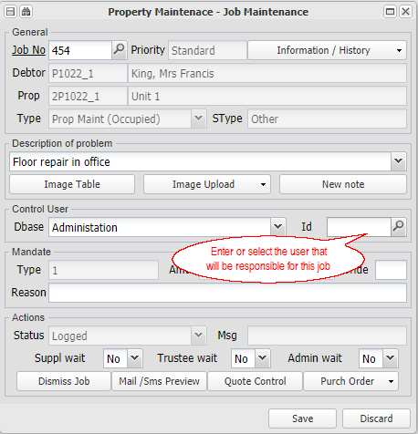

Allocating Responsibility
When the job is logged, the system will allocate it to the portfolio manager for the relevant branch, if there is one and the manager has a linked system login. The portfolio manager can then allocate the job to the system user that will manage the process of the job. The job will then be restricted to that user in the job drills:
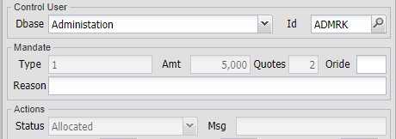

The various stakeholders will be advised each time the responsibility is changed.

Dismissing a Job
A job can be dismissed by the job manager if necessary, by flagging it as dismissed and entering a reason for the dismissal:


Changing the number of Quotes required
The default number of quotes per the branch maintenance mandate can be changed with a password:
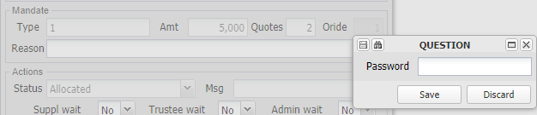

The system will ensure that the required number of quotes is obtained before allowing the job to proceed.

Setting up purchase order information
Click on Purchase Order and capture the general ledger code to which the job cost will be allocated. Enter the proportion of the cost and any cost markup, if the cost is to be charged to the debtor:
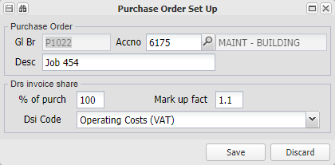

At least the general ledger code must be entered before quotes can be requested:
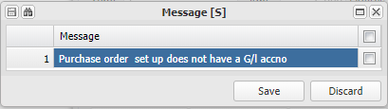

Requesting Quotes from suppliers
Once at least the general ledger code above has been entered, click on Quote Control and select the creditors that you would like to request quotes from. They must be creditors linked to the relevant branch:
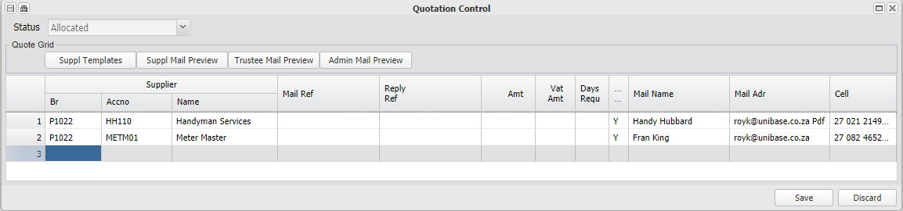

Having entered the suppliers and branch numbers, Save the screen.

The system will automatically sent an email to each supplier, including the job related images, and requesting a quote. An example of the email can be seen in the next section.

Supplier submission of quotes and system updating
Suppliers receive an email similar to the example below, requesting them to submit a quote for the relevant maintenance. The wording of emails will vary per database.

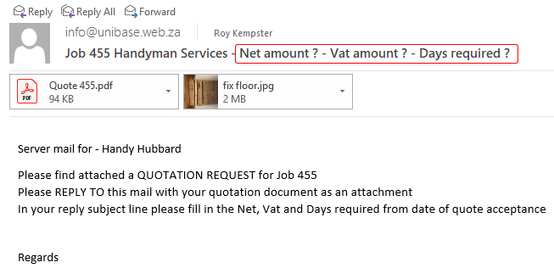

Suppliers can either send their quotes back for manual updating, or reply to the requesting email with their quote amounts added to the subject line of the email, and attaching their quote.

An example of a reply to the above email request:
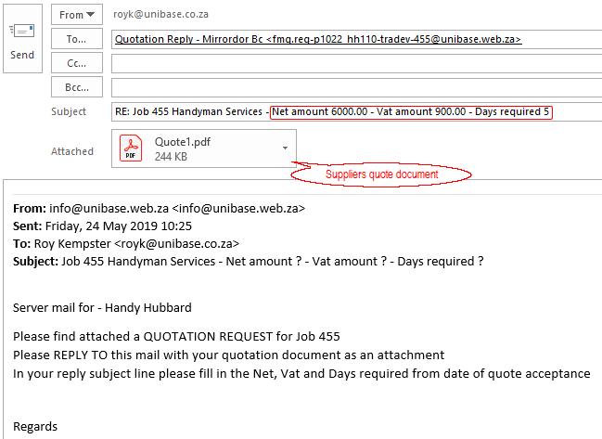

Receiving Quotes
Suppliers usually reply to the quote request email (as described above), attaching their quote and adding the amount and days required to the subject line. The system will automatically receive the reply email, update the Quotation control section with the amount and days required, store a copy of their quote, and confirm the receipt and updated details to the supplier. If the supplier doesn't attach a quote, or doesn't include VAT at the current rate (if registered), he will be advised and asked to submit the quote document or correct the VAT amount..

If the supplier delivers their quote in a different way, the quote can be manually captured using the manual capture utility.

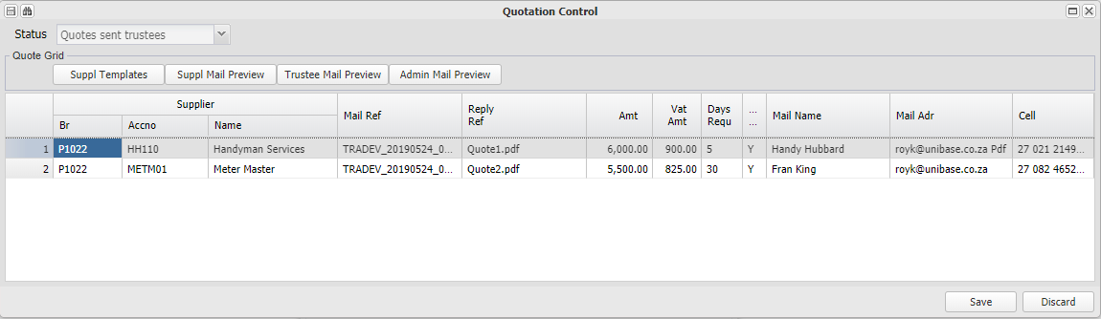

You can resend the quote request email by drilling on the Information/History button. selecting the relevant email and clicking Resend..

Quote Approval and the Approval process
If the quote amounts exceed the mandate limit, the quotes are sent to the designate quote approvers for approval.

Approvers usually reply to the quote approval request email, indicating which quote they approve in the subject line of their reply. The system will automatically receive the reply email, and update the approval.

If the approver delivers their reply in a different way, the approval can be manually captured using the manual capture utility.

Quote approvers are the designated branch office bearers. An office bearer flagged with a 'Q' in the Authorisation column will be sent a request to approve quotes.
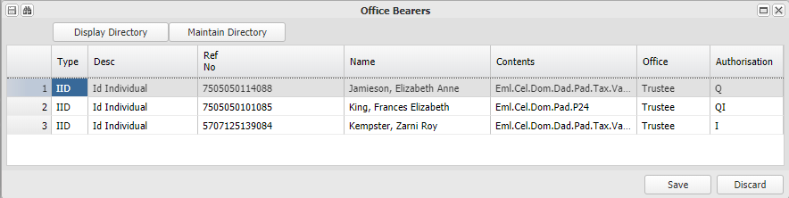

The following is an example of an email to a quote approver:
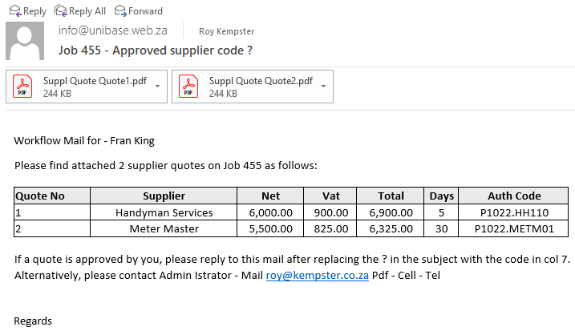

The following is an example of an approver reply email, approving the first quote in the list:
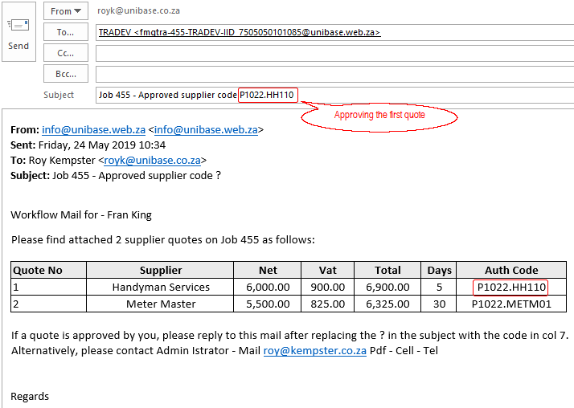

Once the required number of approvals for a quote have been received, the system will send a final approval request to the maintenance administrator.

Administrator approval before order placed
As soon as the required number of quote approvals has been received, the system will send an email to the Maintenance Administrator for the relevant branch. The administrator will perform a final check, and approve the placing of an order by replying to the email confirming the approved quote as in the examples below. Once approved, the system will allow a purchase order to be sent to the successful supplier.

Email received by the Maintenance Administrator:
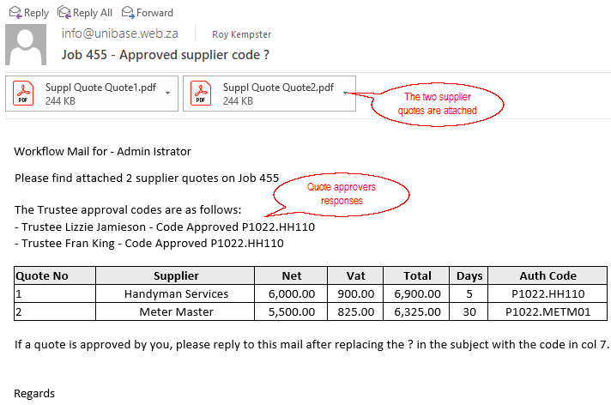

The administrator reply eMail approving the supplier approved by the quote approvers:
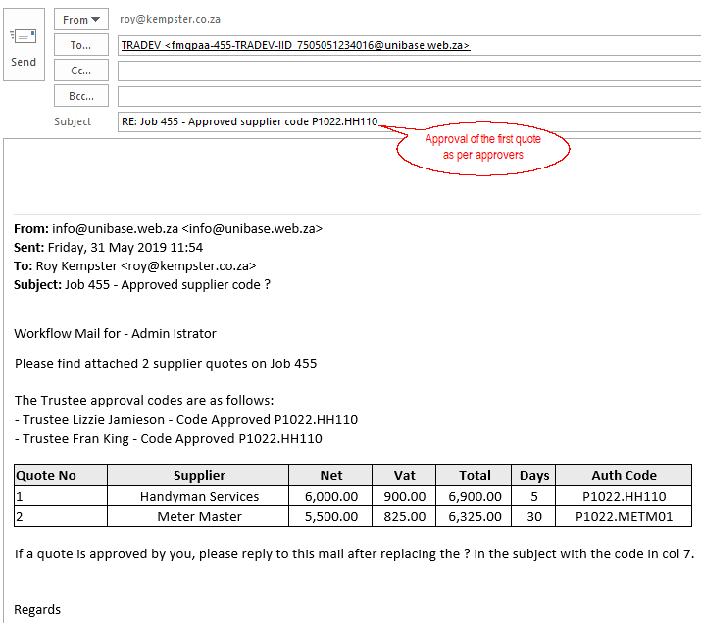

The administrator can view the quotes, pictures etc. using the Maintain Job screen is confirming the final approval. The administrator will not be able to approve a quote that hasn't been approved by the branch office bearers.

The unsuccessful suppliers will be advised via. email that their quotes were not accepted. The successful supplier will receive a quote acceptance confirmation when the order is placed.

Placing an Order for an Approved Job
After the final approval by the maintenance administrator, an order can be placed.
Click on Purchase Order:
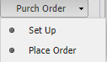

and click on 'Place Order':
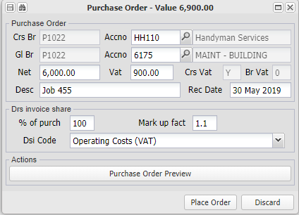

Check the detail and click on Place Order.

The system will send the successful supplier an email confirming acceptance their quote:
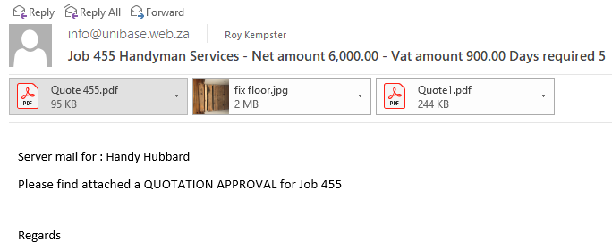

Inspecting the Completed Job
Once the job is completed and inspected, upload the inspection document, which will indicate to the system that the job has been inspected:

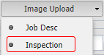

Manual quote capture and approvals
Should the various role players not reply via. email, their quotes or approvals can be manually captured using these menu items:

Manual Reply - Supplier Quote
Manual Reply - Trustee Quote Approval
Manual Reply - Administrator Quote Approval

Each approval allows for the manual uploading of a supporting document.

Receiving the Supplier Invoice and matching it to the Order
Menu: Fixed Assets, Maintenance, Purchase Invoice Upload
When the supplier invoice is received, it is linked and uploaded into the system, and will follow the relevant payment approval processes. One it is fully set up using the following screen, the system will include the invoice in the general ledger of the relevant branch as an unapproved creditor.

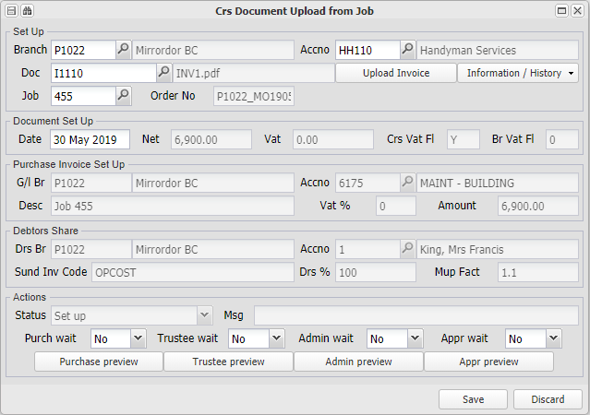

Obtaining Payment Approval and paying the Supplier
Unless the various wait points are set, and the invoice is below the mandate amount, the system will automatically send the invoice for payment approval, first to the branch office bearers, and then to the payment administrator for final checking and approval.

Office bearers that are flagged as Invoice approvers will be asked to approve the invoice before it will be available for payment.

Emails with the invoice attached are sent to the Invoice approving office bearers
An example of an email sent to an invoice approver, for approval:

An example of a reply email from an invoice approver, approving the payment of an invoice:

Once the required number of office bearer approvals have been received, the administrator releases for payment
As soon as the required number of quote approvals has been received, the system will send an email to the Buying Controller for the relevant branch. The administrator will perform a final check, and approve the invoice for payment, by replying to the request email.

Managing the overall process
Menu: Purchasing, Other, Unapproved Document Extract

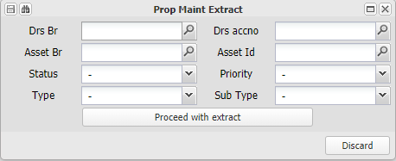

Enter a branch number and / or other required filter, or leave all fields blank, to view a list of all jobs related to branches (properties) that you have access to. The list is sorted by job status, and gives you an overview of all jobs that you are responsible for..

Accounting and Reporting Related
Information relating to setting up and processing system aspects relating to various Accounting and Reporting set ups and functions.

Setting up general ledger reporting group and description overrides
This facility allows for income statement reporting flexibility relating to income and expense descriptions and grouping, and group descriptions. It also allows you to create base templates for the groups and descriptions for the different types of property groups (eg. Body Corporates, Home Owners Associations), or to create a unique template for one property (branch).

Usually income statements have the the overall categories of income and expenditure broken down in terms of groups within income and groups within expenditure, that the branch management feel best suit their reporting intentions. As legislation and other dynamics develop different requirements and focus based on their area of jurisdiction, the reporting requirements per group become different form the original reporting definitions. For example, the introduction of the administrative and reserve fund requirements in sectional title, a sectional title branch income statement has different groups and a different composition form that of a home owners association.

Especially in larger branches, their management sometimes require reporting based on groups and descriptions that are meaningful to them.

This facility provides a default structure that will apply if no specific group is selected, or a specialised group as set up below.

Income statements are run from General Ledger, Auto General Reports

The default general ledger codes and the groups that they and linked to are set up using Data Base Setup. The income statements have been designed to allow for five income categories (II1 to II5) and ten expense categories (IE1 to IE10) per defined group.

The following overrides can be defined and stored for any 'type' group (eg. Rental property, Body Corporate):
1. The general ledger account description.
2. The group to which the account is linked.
3. The group description.

Having set up your default descriptions and groups as described above, you can set up override groups as follows:

Set up a list of override groups
Menu: General Ledger, Database Setup, Tables

Set up a list of groups that are required. These will usually be for 'like' type branches where descriptions and grouping are largely the same.

You can also set up a group for one branch, with its unique requirements.

Set up the override details for each group
Menu: General ledger, Setup Override Group Details

Having set up your list of groups, use the above utility to define and store any general ledger code, group link or group description redefinitions that are required for each group.

Link the branch to a override group if the central default is not relevant
Menu: Branch, Create / Maintain Branch, Audit

Having set up the groups as described above, you can then link a branch to a group:
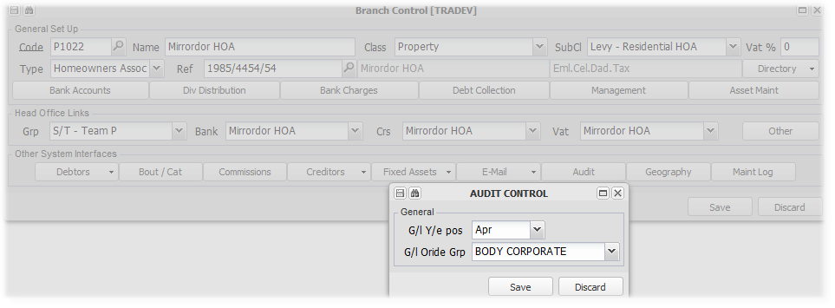

Setting up and producing a Branch Financial Report Pack
The Branch Financial Report Pack is a group of reports, set up per group or branch (Property), that is usually sent to the office bearers of a branch each month.

The pack is emailed to branch office bearers, choosing either a PDF or Excel format. You can also upload additional documents that will be attached to the email with the report pack.

The common system precedence rule also applies to the set up of report pack components. Report pack components can be set up on the data base branch, which set up will apply to all branches in the database, unless the branch group has a different set up (in which case that will be applied to all branches in that group), or an individual branch has its own set up, in which case that set up will be used.

Using the above rule, group type packs can be produced tailored to suit a group of similar properties (branches). For example, if the properties in a group are all commercial properties, the set up on that group branch can be suited to commercial properties. If one property has a very large rent roll that is impractical, that property can exclude the rent roll from its pack, without affecting other properties in the group.

There is an Override option that can be used to produce any of the component reports for internal purposes.

Setting up report packs
Menu: Branch, Create / Maintain Branch, Audit

On the Audit tab, you can Setup/Maintain the pack components, Delete the set up and Upload supporting attachments:



Maintain - Choose the components and formats of the report pack
The various options in the Maintain function:
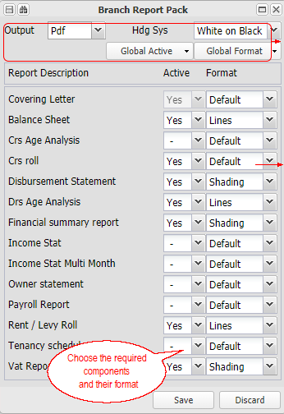 | 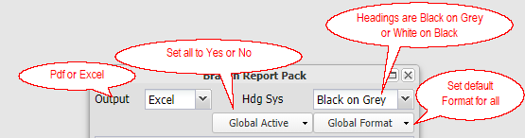  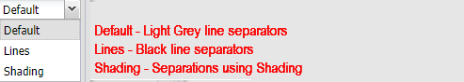

The pack will only include a selected report if it has information for the selected period. The Covering Letter will not mention the report if it isn't actually included in the pack..

The eMail to which the pack is attached, includes relevant branch contacts.

Refer to Component Reports in more detail below for more information and report specific rules

Delete - previously set up report pack options
If you have previously set up a branch or group branch to have its own pack contents, and you wish to remove the set up, use this option. You can change the components without deleting the whole set up if necessary:

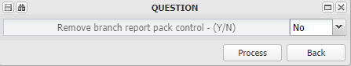

Attachments - Add other uploaded attachments to the sending email
Menu: Branch, Create / Maintain Branch, Audit, Report Pack Attachments

Report packs are produced based on a selected month and year. You can upload attachments and specify the period/s to which they should be applied.. When the packs are emailed out, and uploaded attachments for the selected pack period will be
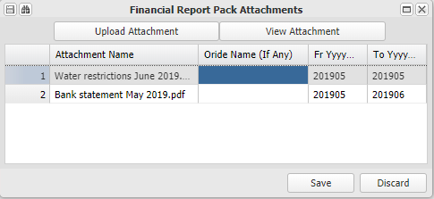

Producing and sending report packs
Menu: General Ledger, Auto - General Reports

Choose the period and branch/es that you wish to send reports for, and click on 'Proceed with Report':
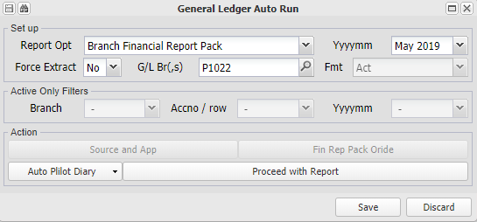

Confirm your selection and send the reports via. eMail. You van preview the report and any attachments from the confirmation window.

Producing individual pack reports, and changing the default format
Menu: General Ledger, Auto - General Reports

This option is usually used to either send one or more selected reports to branch office bearers, or to produce one or more reports for internal use. Choosing the Override button, will enable you to choose the reports and the format that you require. The reports can either be downloaded or sent via. eMail:
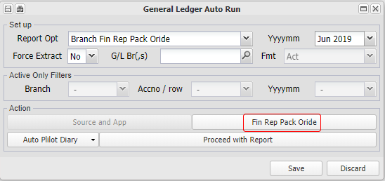

The selected options when using this option will not change the defaults stored for the branch

Component Reports in more detail
The following sections contain more detail relating to each report, and some system rules that are applied in including certain information.
Covering Letter
Letter signature from barnch directory name - group
Balance Sheet
Creditors Age Analysis
Creditors roll
Disbursement Statement
surplus retention rules
Rules - distr crs grouping if crs roll else details
Debtors Age Analysis
Financial summary report
Income Statement
Income Statement - Multi Month
Owner statement
Rules - cres detail or summary based on cr's roll
Payroll Report
Rent / Levy Roll
Tenancy schedule
Vat Report

Regular routines
Enter topic text here.

Raising monthly standard charges
Enter topic text here.

CSOS

Raising, Receipting and Refunding Deposits
Deposits are usually taken from debtors (tenants) who rent properties, as security for the owners of the property. These deposits are linked to Fixed Assets, and are separate from standard Debtors deposits.

Deposits are usually held in a separate (trust) account, and earn interest for the benefit of the deposit holder (debtor). They are refunded when the debtor vacates the premises, less any outstanding amounts, the cost of any damages, plus any accumulated interest.

The normal process is:
Charge the deposit to the debtor
A deposit is invoiced to a debtor, using the Deposit sundry invoice code. The system will allocate the deposit to the deposit section of the debtor, based on the invoice code set up.

The Deposit invoice code is set up using Data base set up, Debtors Sundry Invoice:
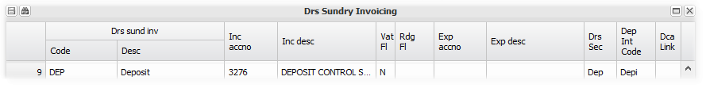
The invoicing of the deposit is either by way of the invoicing structure of the unit (Fixed Asset 2):
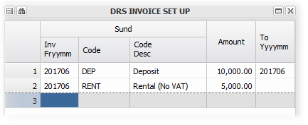
or a Sundry invoice:
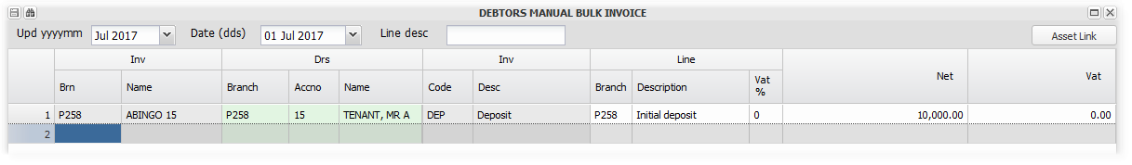
Interest on unpaid deposit invoices (Trading interest), will not be raised on overdue deposit invoices. Debt collection commission will be charged if the invoice is paid after the due date.

Receipt the deposit paid by the debtor
Receipts from debtors, for normal and deposit invoices, are receipted and allocated when the relevant bank statement is uploaded and maintained. This will be automatically done, or manually if necessary.

The receipt allocation to the outstanding deposit invoice, will trigger the allocation of the deposit to the relevant deposit bank account, based on the banking arrangements as set up on Branch Maintenance.

Raise interest on the deposit
Interest is usually raised monthly, and the amount of the deposit increased, as the interest is added to the original deposit.

Refer to Setting up and crediting interest on deposits for more information.

Refund the deposit to the debtor
Menu: Fixed Assets, Debtors, Deposit refund.

On vacation of a unit, the deposit held for the unit is refunded to the debtor. Any amounts due are deducted, and the balance refunded.

The deposit refund screen details the breakdown of the amount refunded, which is then processed via an Efts to the debtors bank account.

A breakdown of the refund calculation will be emailed to the debtor automatically on processing the refund batch.

If the deposits for a branch have been distributed to the branch, the refund will only be processed from the trading bank account if the branch has sufficient cash available in the trading account to cover the refund.

Bank account and cash control
Having chosen and set up the banking structure that you require, the following information is useful in operating and controlling bank transactions.

Bank account structures
Whether you are using a shared head office banking structure, or an own branch structure, the anticipated system cash flows are the same.

The trading bank account is the central account, through which all funds should flow. If you do set up any other accounts on the branch, the system will anticipate the relevant cash flows. These are described in Setting up a bank account structure

System defined inter-bank account movements
As stated above, the anticipated cash flows are the same for both banking structures.
Head office banking
As indicated in the diagram in setting up a bank structure, the trading account receives all cash inflows and all cash outflows flow through it. Specialised receipting bank accounts are ofter used to assist the inflow from debtors, and a holding account used for debtor (tenant) deposits.

The head office branch usually has all of the accounts set up on its banking table.

A head office structure allows other linked branches to use the head office bank accounts, keeps track of each participating branch's share of the bank accounts, and recovers the bank charges that it incurs from the participating branch's based on their usage. Refer to Setting up Bank Charge Recoveries for more information.

The sharing of the accounts is tracked using the bank sharing general ledger code, as described in accounting explained.

Remember that a branch can use both it's own accounts, and a head office's banking structures at the same time.

Branch own banking
A branch that uses it's own bank account structure, incurs its bank charges directly, and has no sharing arrangements with any other branch.

The system will anticipate cash transfers based on the bank accounts entered on the banking table for the branch.

Processing - Uploading, balancing, matching and updating
Menu: General Ledger, Bank Statement Menu, Bank Statement Upload, Bank Statement Maintain, Bank Statement Ext Maintain.

Convenient and transparent control over bank accounts is a key system principle. All bank accounts should be imported into the system based on a relevant import format. Refer to the above links for more detailed information relating to each step.

The system ensures that the opening balance of each imported bank statement matches the last imported statement's closing balance, and tracks the statement dates. Once imported, each transaction is allocated or accounted for and stored for later allocation.

The following is an example that illustrates the processes:

Uploading and balancing
Menu: General ledger, Bank Statement Menu, Bank Statement Upload

We start with a bank statement export with three debtors receipts, into a head office bank structure. The first two reference numbers are correct, the third incorrect:
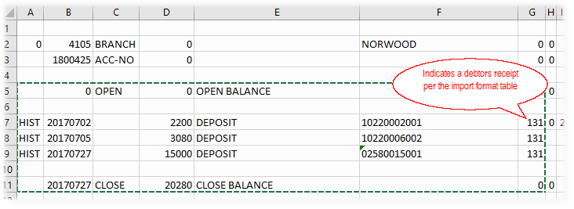

The statement is uploaded, and the opening balance and date is checked:
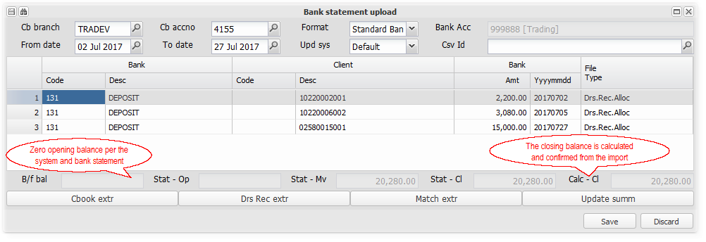

The imported bank statement batch is saved with a unique date and number reference (20170727.1 in this case) for processing.

Matching and updating - Maintaining
Menu: General ledger, Bank Statement Menu, Bank Statement Maintain.

Selecting the same branch and bank account number, we choose 20170727.1 from the available batches:
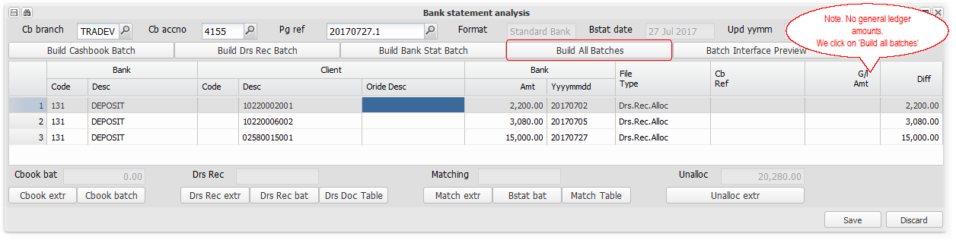

The two correct references are matched, and a debtors receipt batch, matching to open item invoices (earliest first), built:
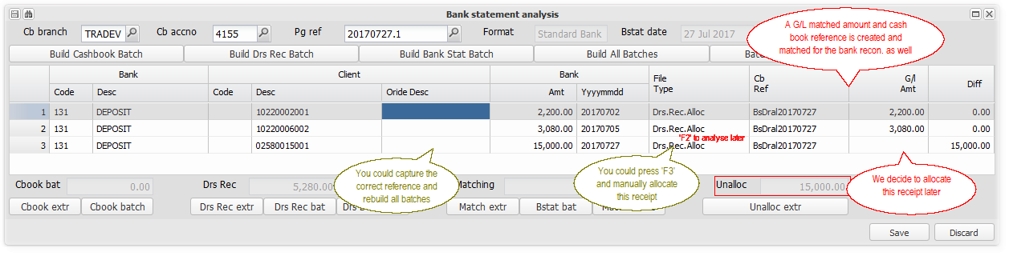

For the incorrect reference we choose to analyse it later, by pressing 'F2' on the file type cell, and choosing Analyse Later:

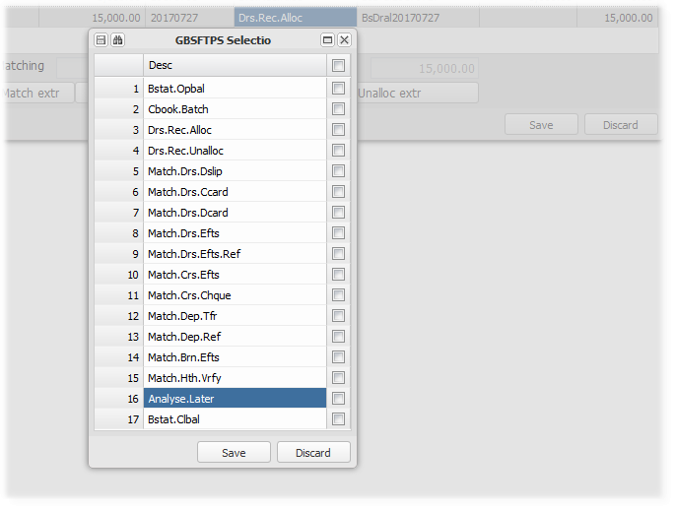

The bank statement batch is fully allocated, and ready to be updated:
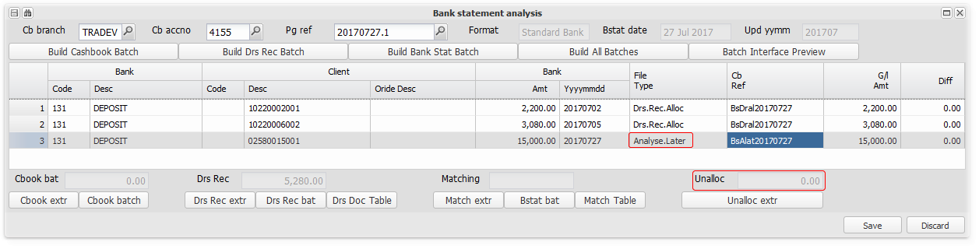

The cash book branch trial balance, demonstrating the effect of the above processes:
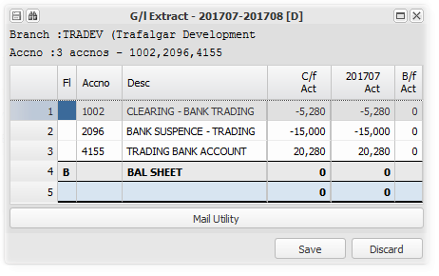
The total amount in the bank - 4155 R20280-00 - of which R15000-00 is unallocated - 2096 - and R5280-00 allocated to branch P1022 - 1002.

Analysing later
Menu: General ledger, Bank Statement menu, Bank Statement Ext Maintain

We have now established the correct debtor for our unallocated receipt, and will process the entry.

Having selected the relevant branch, a list of unallocated items is displayed when selecting the Page Reference search option:
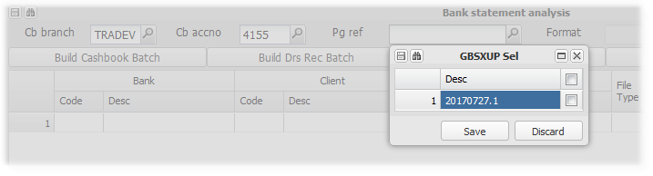
We chose 20170727.1, and found our batch:
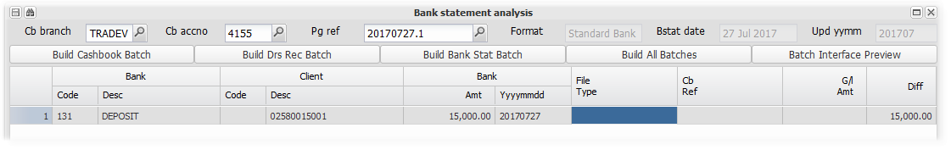
Highlight the File Type block by clicking on it, and then press 'F2' to choose what type of batch the transaction represents:

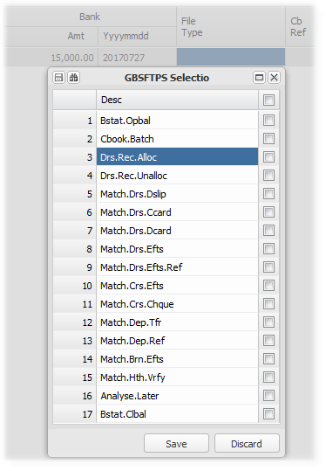

We then press 'F3' on the File Type block to manually allocate and match:
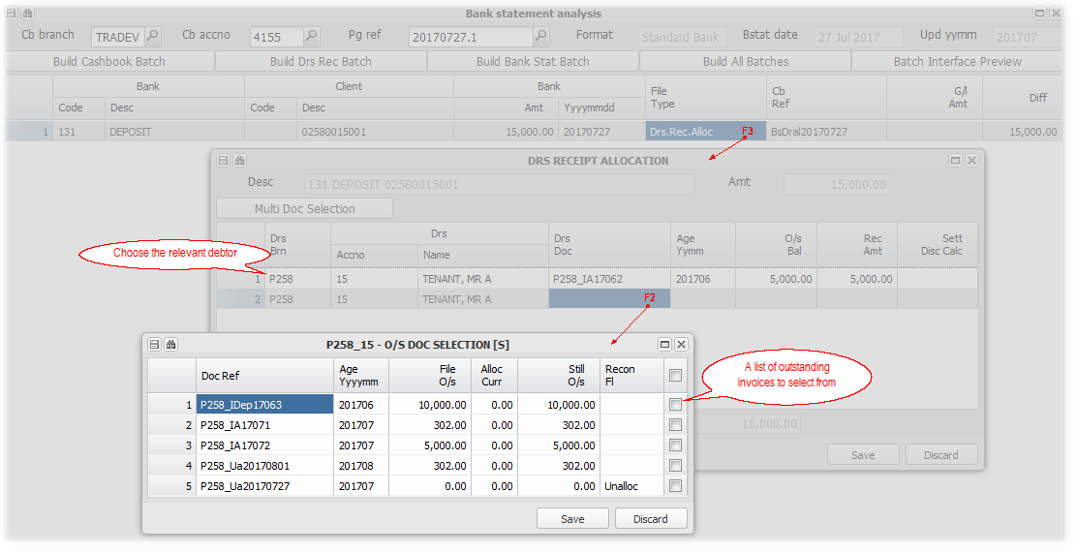
The receipt fully allocated:
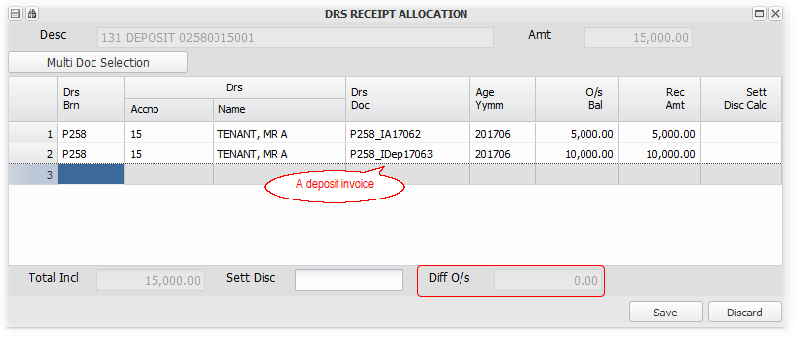

The debtors receipt batch created and cash book references matched:
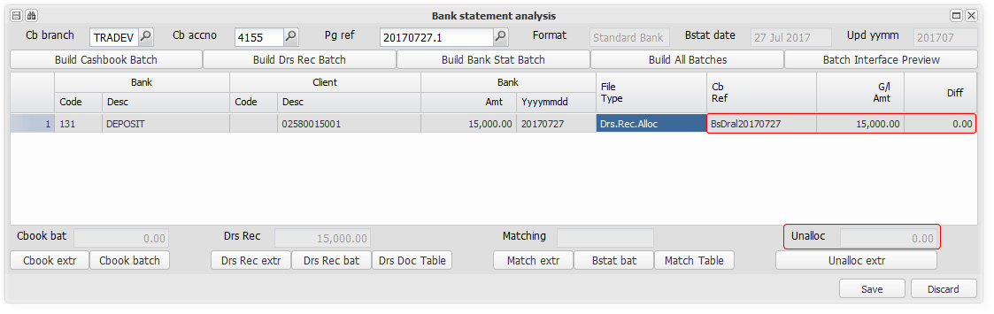

The system has now allocated all receipts both to the correct debtor, branch and bank account:
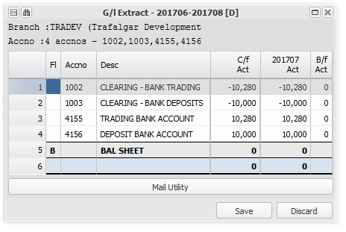

The deposit received has been allocated to the Deposit bank account (4156) - Indicating a share of it is held by P258 (1003), and the rental and levy is in the trading bank account (4155) - indicating a share of it is held by P258 and P1022 (1002).

The cash however, remains in the main trading bank account. The system stores up the required transfers, in this case a deposit account transfer, and prompts for the actual cash transfer in the next step below.

Effecting default bank account transfers
Menu: General ledger, Bank statement menu, Transaction Approval

These steps are a two step authorisation and release process to facilitate the actual transfer of funds in the bank. The first step creates the necessary batch/instruction, and the second releases it. These can take the form of a batch in bank format to be uploaded into the bank, a host to host direct instruction, or a manual prompt to move the funds manually.

In this example, we received a tenant deposit of R10000-00, that needs to be moved from the trading bank account to the deposit trust account bank account - a deposit receipt transfer:

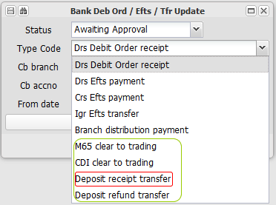 | The last four options relate to inter-account bank transfers

We chose deposit receipt transfer and the relevant bank account:
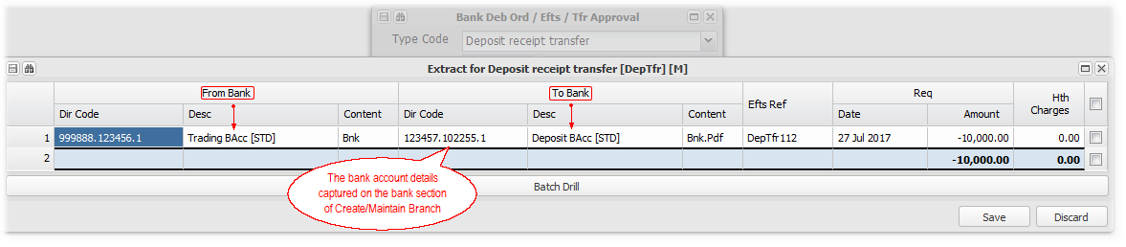
Select and Save the required line to process.

Interest on tenant deposits will be transferred to the deposit bank account with deposit receipts, if the holding branch's interest transfer flag is set to 'Y'es.
Refer to Create/Maintain Branch, Bank Accounts, for details of this rule.

Exporting system bank transactions to the bank
Menu: General ledger, Bank statement menu, Transaction Approval

These steps are a two step authorisation and release process to facilitate the actual transfer of funds in the bank. The first step creates the necessary batch/instruction, and the second releases it. These can take the form of a batch in bank format to be uploaded into the bank, a host to host direct instruction, or a manual prompt to move funds manually.

The first four options relate to external cash flows (in and out), and will produce batches/instructions as mentioned above:
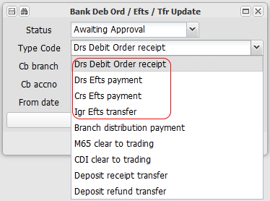

Bank reconciliations
As most bank accounts are controlled by importing them, they will automatically reconcile. Payments, receipts and charges are captured and referenced using the bank statement maintain option as described above.

The system has options to manually (capture or import from Excel) reconcile any bank account, including the initial take on of reconciling entries, the transfer between references, and to view the actual bank reconciliation statement.

Recovering bank charges in a shared banking structure
As mentioned above, branches that use a shared bank account structure, are usually charged for that use based on the types of transactions and what the bank charges the head office branch.

A bank charge table is set up on the head office branch, which becomes the default charge table for all transactions. A participating branch can have different charges based on the table set up on its branch, which will override the central table. The following is an example of a table set up, with amounts that are either charged to the branch or the branches debtor:
The charges allocated to each participating branch, are recovered as income to the head office branch.

Refer to Setting up Bank Charge Recoveries for more information.

Interest on deposits
Interest due to debtors (tenants) on their damages deposits, is calculated and credited to them. Refer to Setting up and crediting interest on deposits for more information.

The system regards the deposit interest as an increase in the deposit held, and will transfer the cash to the relevant deposit bank account, based on the branches bank account structure. This will be included in the Efts transfers mentioned above. Refer to Setting up (Choosing) a deposit structure for more information.

The interest credited will be charged to the branch that holds and invests the deposits, who can set the cost off against the income earned from the investment thereof.

Capturing Key Management Information and Reporting
The system has a facility to capture and store key information and related documents used in the management and control of a properties (branches) activities.

Areas covered include meetings, financial indicators and statutory returns. Information and documents are stored and linked to a, for example particular meeting - the annual general meeting held in June 2018. Copies of signed minutes etc. can be uploaded and retrieved.

Some of the information is used in the Property Management Report, indicating where, for example, the minutes of a meeting were distributed to long after the meeting, or where a key agreement has expired.

The management information is captured using the relevant item under Branch, Management Log:
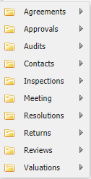

The Property Management Control Report is on the General Leger Menu, Auto-General Reports

Utilities
The left hand toolbar in detail and other utilities

Searching the grid
 | When in a grid, click on the 'Binoculars' in the left hand toolbar, to search the grid contents for any text, The matching results will be displayed in a list for you to choose from. After choosing one, your focus will be directed to the selected record in the grid.

Export information to a spreadsheet
Enter topic text here.

Import information from a spreadsheet into a screen
Essentially, you copy information from a spreadsheet in the same format as the target screen, and paste it 'into' the screen. Follow the steps in the example below:

1. Select the information on the spreadsheet that you want to import, and click 'Copy':
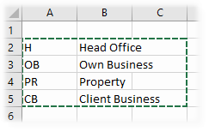
2. With the target screen open, and the focus on the first cell that the information must occupy, click on the Special Paste button on the left hand toolbar:
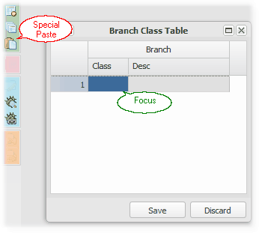

3. The information will be imported into the screen, and must then be saved to retain it:
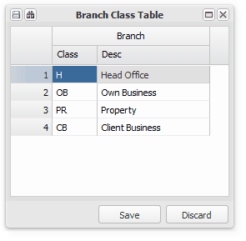

• The usual screen validations will be applied to each field as the import takes place.
• This facility is often used for copying information, by exporting a screen to a spreadsheet, and then importing it.
• This facility is often used to import transaction batches, and bank statement imports.

Selecting lines in a grid
When you have chosen a group of items to process, the system will usually present a list of items that match your selection.

You can usually choose all of the items by ticking the top selection box, which will tick all of the boxes below it, or choose individual lines by ticking their boxes:
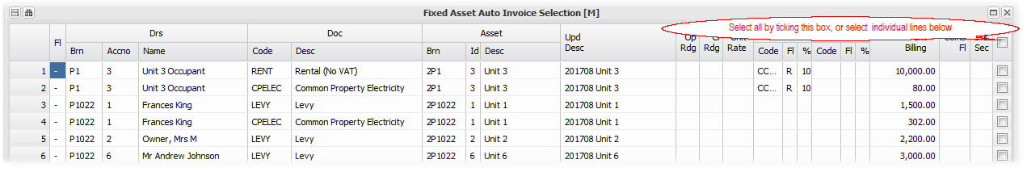

In some cases, especially where the display is very wide, there isn't a selection box facility:
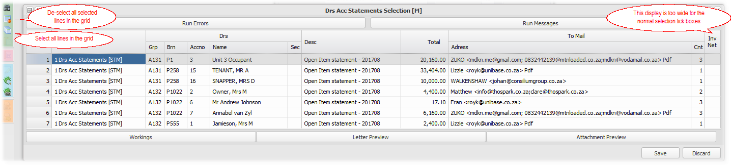

You can select lines by double clicking on them,or entering on them individually, or selecting all using the toolbar utility indicated above.

The toolbar also contains a utility to deselect all items selected.

General Data Searches
The system allows information / data searches within system screen. It also has detailed searches linked to Branches, Debtors and Creditors.

Each search / look up has several related field/s to base a search on. You can choose to match all or any entered filters.

The normal look up will show the match and the detail of the field that matched. The 'Information' option will show the field that matched and the detail of any other filter options entered.

Branch Look up
Menu: Branch, Auto Options, Branch Look up

Search Branches looking for branches that contain any information that matches any or all of the selected filters. You can choose to include a case sensitive match, or not:

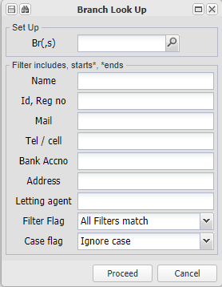

Debtors Look up
Menu: Debtors, Auto Menu, Debtors Account Look up

Search Debtors looking for debtors that contain any information that matches any or all of the selected filters. You can choose to include a case sensitive match, or not:

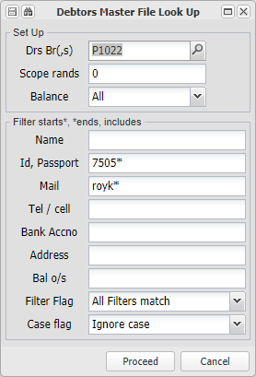
Creditors Master File Look up
Menu: Creditors, Auto Menu, Creditors Master file look up

Search Creditors looking for creditors that contain any information that matches any or all of the selected filters. You can choose to include a case sensitive match, or not:

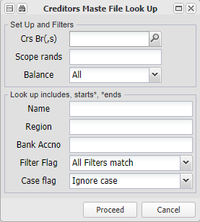

Creditors Document Look up
Menu: Creditors, Auto Menu, Creditors Document look up

Search Creditors documents looking for documents (eg. invoices) that contain any information that matches the selected filters. You can choose to include a case sensitive match, or not:

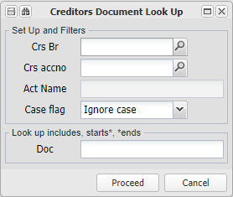

Spelling check
Your browser usually includes the ability to activate a spell check utility, This would act as a system field spell checker if activated.

Menu's
Click on the icon to access help for the full system menus.

Branch
A Branch is a generic term for an entity of any type. In the context of the system, it is the accounting home of a company, body corporate, individual etc.

A Branch can represent a classic business, a property management business, a sectional title scheme or a property that is rented out as a business.

As a Branch is also often the head of a group of other branches, these menus contain various set up's and bulk/control type facilities.

Template Variables
This utility is used to conveniently group and display data variables that are used in the various system reports.

When viewing the list of variables, they can be easily copied from your browser, and pasted into the Word/Excel template that you are developing.

These are useful in adding letters, changing or adding debtors statements etc. More detail about developing report templates is contained in Report Templates

This topic is discussed in more detail in the section focusing on Report Templates, Template Variables

Template Upload
This utility allows the upload of a report template into the system. Templates are the base of many reports, email bodies etc.

Choose the branch that you are uploading for (usually the central database branch), and click on 'Upload Templates':
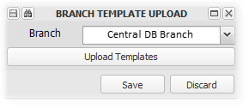

Click on the 'File Upload....' box:
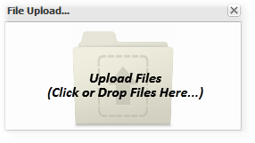
.... and select the template/s that you wish to upload:
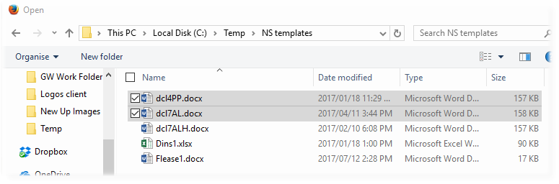

The system will confirm the successful upload and storing of the template/s

Create/Maintain Branch
This input screen allows the set up and maintenance of a Branch on the system. A branch is an entity of any kind, and takes on several forms in the system. For example, the data base has a central branch, a branch is a division of a business, a clients business (property or other) etc. Refer to the information below and to Terminology, Branch for more.

Other relevant links are:
Setting up a Business Branch
Setting up a Property Branch

The Create/Maintain Branch Screen is divided into three main areas, as seen in the example below:

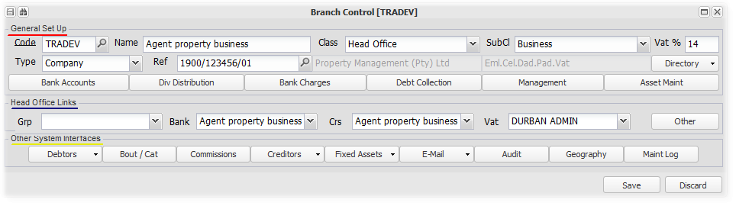
General Set Up - Base details of the Branch and some functional setups
Code - | Search for an existing or create a new branch, entering the chosen branch code. Although you can use any code, there is a naming convention for a property management structure. If the branch is a part of your management business, an Agent, the number if prefaced with an A - for example A132. If the branch is a property being managed by your business, it's number is prefaced by a P - for example, P1022.
Name - | The 'known as' name of the branch. This could be the legal name, or a group name within one legal entity. In property management, it is often a functional group, for example 'Sectional Title - West Rand'.
Class - | Choose the Class/Category that the branch fits into. These classes can be set up per data base, but some have significance in terms of their functionality. A Head Office, for example, can be home to a Shared Banking System. The classes are displayed below, and are self explanatory, and further catagorised by the sub-class below:  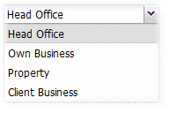
Sub-Class - | Having chosen a class, now choose a sub-class to further define the branch. If you have chosen property as a class, now define it's sub-class as Rental or Levy:  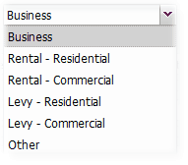
Vat % - | Enter the applicable VAT rate, which would be the current VAT rate or 0% if the branch is not registered.
Type - | Choose the branches legal entity, as opposed to its known as name above. Having chosen the type, choose a relevant directory item or create one:  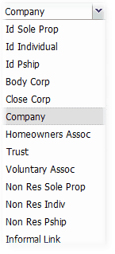
Reference - | Choose the relevant directory item or create a new one by entering the, in this case registration number, choosing create, and then maintaining the new entity from the Directory button below:
Directory - | Display the contents of, or change the selected directory item:  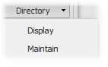
Bank Accounts
These accounts are accounts that belong to the particular branch. Usually all trading will use the Trade bank account, but the other accounts can also be used. Remember to block any bank charge recoveries if they are not to be raised by setting all of the charges to 0.

The M65 and CDI accounts will attract the deposit bank charges as set up, unless 0, as well as cash deposit etc. fees.

Each account is linked to an account in the bank account directory, which contains all of the details relating to the bank accounts. To use these accounts as defaults in the accounting system, you would set the bank setting under head office links to the branch itself, and set the branch class to head office.

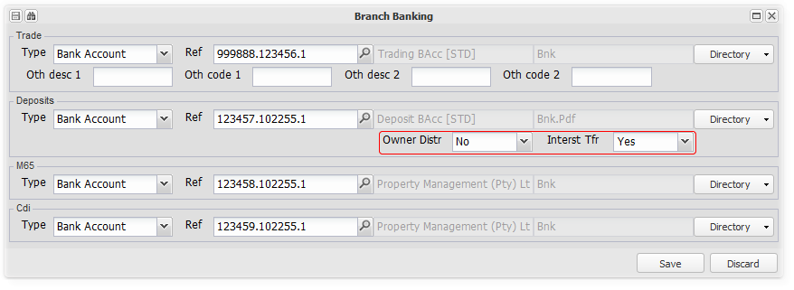

The system default cash flow is that cash inflows from external parties will either be receipted into the Trading, Direct Deposit (M65) or Internet Deposits (CDI) bank accounts. The system will facilitate the transfer of cash frpm them to the Trading account and to the Deposit bank account (if the holding branch has one) for tenant deposits received.

All cash outflows from the system will be from the Trading account, with the system facilitating the reimbursement of the Trading account from the Deposit account for deposits refunded to tenants.

1. The Owner distribution flag - This flag refers to the treatment of deposits belonging to this branch, in a shared (Head office) banking environment. If set to Y, the tenant deposits will be paid out from the Central bank account to the Branch's (Owner's) own bank account together with any rental surplus.
2. This flag controls the flow of interest accrued to tenants on their deposits, for all deposits held by the branch (Head office or own account banking). If set to Y, the interest will be accrued and the cash equivalent added to the deposit bank account, if N, only accrued.

Dividend/Surplus Distribution
Cash distributions from a branch (property) will be made when requested, either as a dividend or as cash transfer, based on the system rules and the set up choices.

The dividend calculation is based on the system identifying the amount of distributable reserves, and considering the cash available and any outstanding amounts due.

The cash transfer is commonly used in property management, as a distribution from the agents trust account of the net rental collected to the owner of the property, or of surplus funds to a body corporates own bank account. The amount available to transfer is based on the distribution rule chosen. There is, for example, an option to retain any debtors credit balances (Uar). .

You can flag general ledger codes that you expect there to be movement on before any distribution is made. If there is no movement on them, they will be highlighted when accruing branch distributions.

Refer to Setting up Branch Distributions for more information

The transfer is achieved by the system creating a creditors accrual for the distribution, which is then paid with normal creditors.

You can enter the creditors and the proportions that distributions will be transferred to:
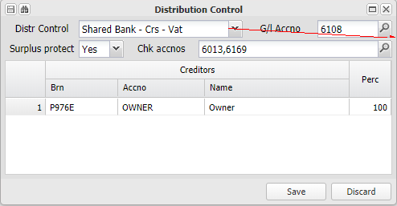 | 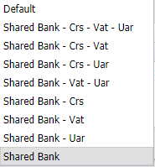

The Surplus protect flag is defaulted to Yes, which will ensure that any payments from the shared bank account will be limited to the available funds for the relevant branch in the shared bank account. Setting it to No requires a password.

Refer to Setting up Branch Distributions for more information

Bank charges
Set up the bank charge table, as in the example below.

The table set up on the database branch, will apply to all branches using shared banking as a default. You can set up a local branch, bank branch or group branch table that will override the central table, following the precedence rule detailed below.. You can block bank charges for one branch by setting the 'Block Flag' to Yes.for the relevant branch.

Bank charge table precedence rule - Bank charges will be charged, unless the branch is blocked or the branch uses its own bank account, based on the bank charge table set up on:
First the Branch itself,
If none, then on the Bank Account Branch,
If none, then on the Group Branch,
If none, then on the database Branch.

The bank charge service fee also works as per the above precedence rule. The amount is exclusive of VAT. It is raised monthly using Debtors, Debtors Auto General, Drs Igr Bank Charge Service Fee.

Debt Collection
Set up the various required information to control interest on arrears and the charges in terms of the Debt Collectors Act:

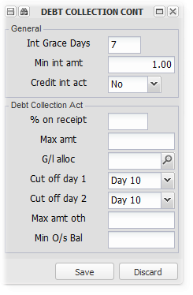
Refer to Setting up and charging interest on overdue amounts for more information on applying the interest grace period, the minimum amount to be charged and whether to allow interest to be credited when a debtors account has a credit balance.

Refer to Common Procedures - DCA for more information about the application of this act in the property management environment
Management
Enter details of the various managers relating to the management of this branch. The managers will default to all branches grouped with this branch, unless overridden by managers captured on the particular branch:

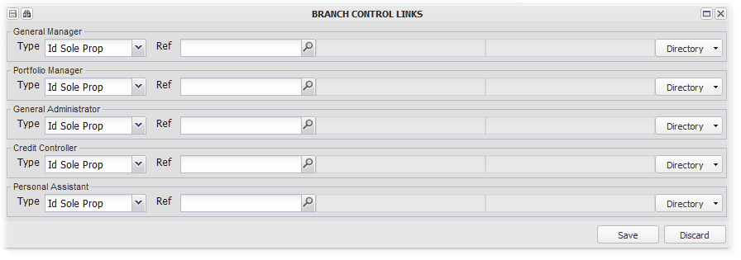
First add the managers to the individual directory, with all their contact details, and then link them to the branch here.

Asset Maintenance
:This section contains extended asset (property) information applied in maintaining and managing the property:
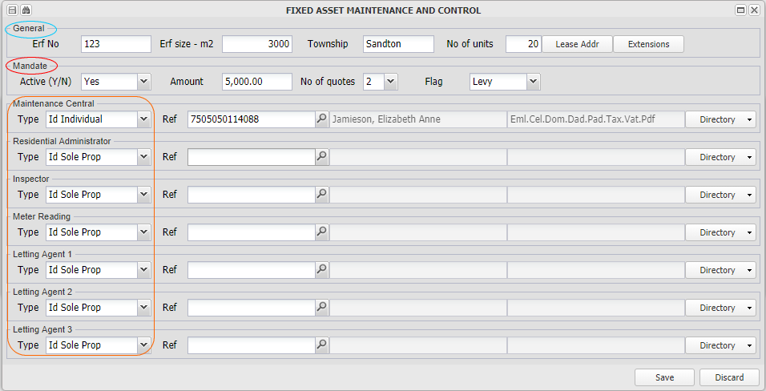

General
Capture details of a fixed property, and if it comprises many units, how many units.

Capture the physical address of the fixed property, to be used in lease agreements.

Enter additional asset information and control flags:
Extensions
Enter additional maintenance and management information as indicated below:
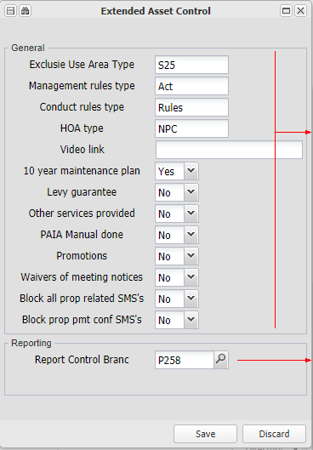
Capture information indicated by the field labels. The video link field is a link to a video which usually used in marketing the property (asset)
Enter a branch (property) which is the branch controller for this property (branch), which effectively sets up a group.

Mandate
Enter the key details of any mandate in terms of which authority for payments and maintenance quotes are managed by an agent:

The Flag field indicates if the branch is a Levy or Rental based branch. This is used in determining the heading composition of certain reports - eg. If the branch is flagges as a Levy branch, the Debtors Movement Report will be headed 'Levy Roll for .....'

Managers
Enter details of the maintenance approval details for this branch, and the names of the various managers relating to the property linked to this branch. The managers will default to all branches grouped with this branch, unless overridden by managers captured on the particular branch

First add the managers to the individual or relevant directory, with all their contact details, and then link them to the branch in the relevant field.

Head Office Links - How the Branch links to other Branches
The image below is an example of a typical property branch setup, with the central database branch, an agent branch and a property branch. It could also be a business group with divisions and separate VAT registrations. They all share the central bank account, different creditors and VAT branches (An example of an independent business branch setup is shown after this example):

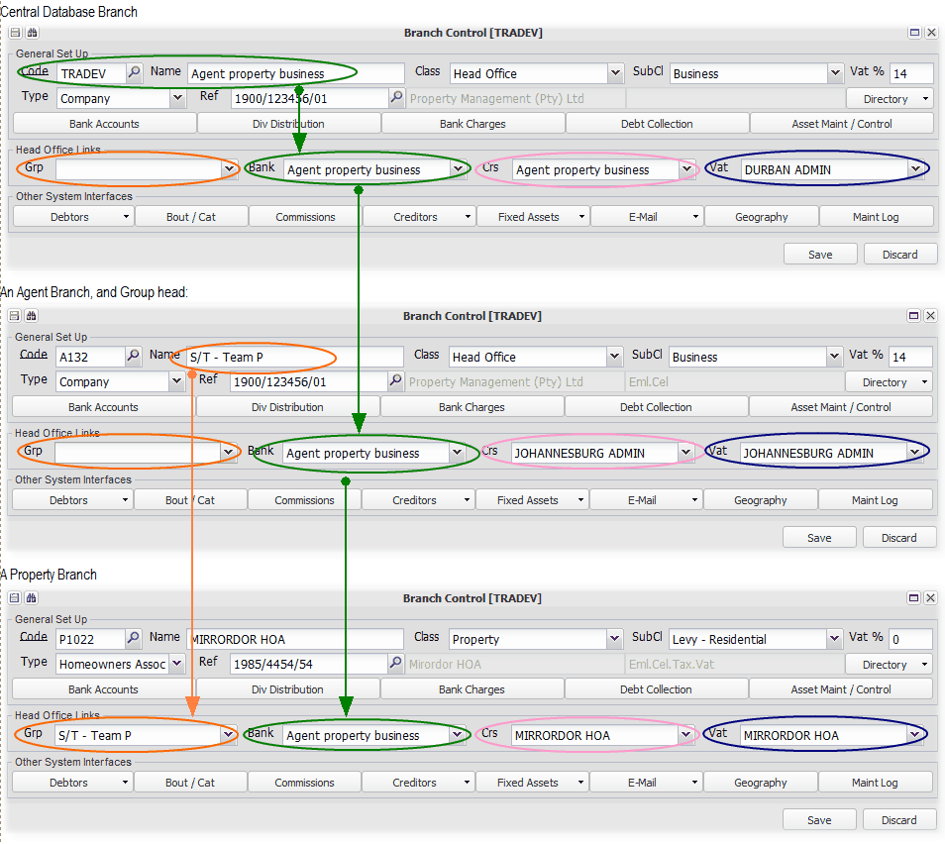
Group
The central database is the top of hierarchy, and has no group link. The agent branch, in this case is also the top of a group hierarchy, and therefore also has no group. The property branch belongs to the agent branch group, which is indicated by the link set up. The various selections will be based on groups first, and then the contents of the group. Inter-group fees will also be charged, usually by the agent, to properties linked to it. Groups are based on various factors, but often on a team that manages a group of properties, which team needs to track its financial and other performance. Report templates for the group will be used if the branch doesn't have its own set up.
Bank
This is the branch through which all banking transactions will default. This can either be the branch itself, another branch or the central bank accounts controlled by the central database branch. The central bank account is often a trust account system, that is shared by all clients of a managing agent. The bank account links to general ledger codes are setup using the Bank accounts button on the database setup screen.

In this example, all branches default and use the central bank account, which enables the transfer of funds between them without having to transfer funds between actual bank accounts. It is a bank account divided into many sub-bank accounts. Bank charges can be recovered from branches using the central bank account, based on their usage, to the central database branch.
Creditors
There are various ways of setting up creditors. If the branch is its own legal entity, as in the case of a property, it will be linked to itself for creditors. If it is a division of a legal entity, where other divisions use the same creditors, it will be linked to the controlling branch for the legal entity. It could also be where one legal entity operates in several geographic locations, each of which deal with local creditors. All branches in each geographic location will be linked to the the controlling branch for that region.

In the example above - The central database branch uses its own creditors. The agent branch is based in Johannesburg and uses that regions creditors. Both could be part of the same legal entity. The property branch is a separate legal entity, and uses its own creditors.
VAT
As for creditors above, VAT transactions can be grouped as required. One legal entity sometimes has regional VAT registrations. By grouping branches for VAT, the VAT component of transactions is centralised into the controlling branch.

In the example above, the central database branch is part of the Durban VAT registration, the agent branch part of the Johannesburg registration, and the property would use it's own registration, if it was registered.

The image below is an example of a normal business branch. Note that it is setup as a Head Office, with Bank, Creditors and VAT links to itself:

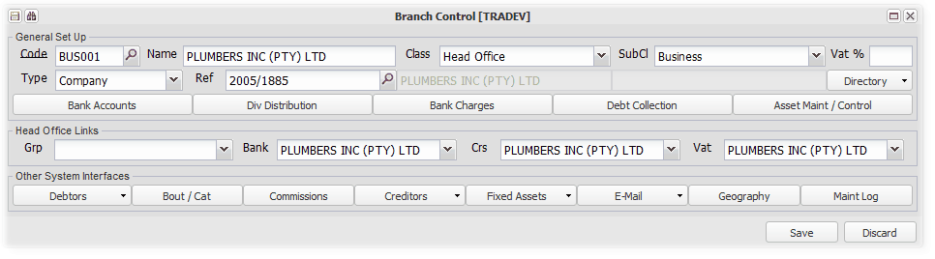
Other
This button contains several branch set up defaults as indicated in the image below. The property management system generally doesn't use the first group.

The second block contains branch local setting that control the application of the CSOS system:
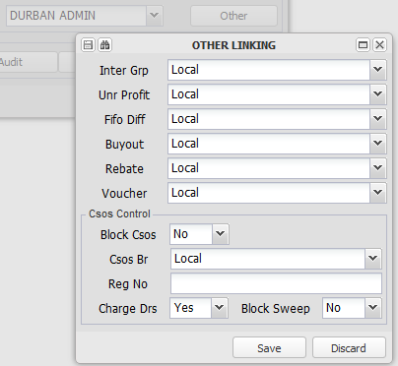

Refer to Setting up, Charging and Remitting CSOS levies for more information.

Other System Interfaces - Various Tables, Rules and Log's relating to components of the Branch
The various options and setups are detailed below. The setups on the database branch, will be the default for the whole database, being superceded by any setups on a particular branch for that branch:

Debtors
Set up tables with information relating to debtors. Details set up on the data base branch, will be the defaults for the system. Individual branches can set up their own, which will be the default for that branch. Some of the details are displayed below and are self explanatory:
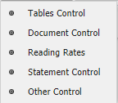

Tables Control
Various debtors related set up tables:
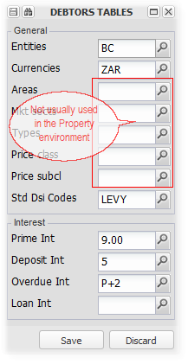
Entities
Set up as many types as required:
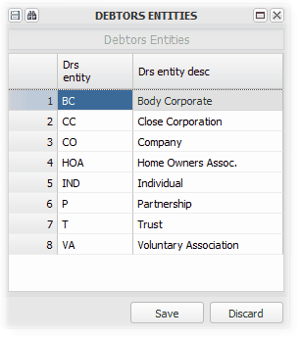

Standard DSI Codes
Codes selected here will appear under the Standard Charges column on the Debtors Movement Report
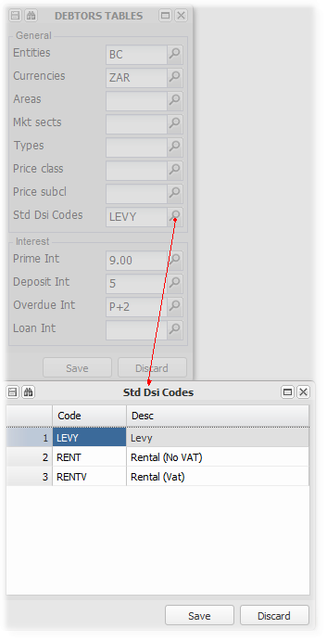
Interest
Interest rates are used by the system in calculating interest on arrears, on deposits and on loans. Refer to Setting up and charging interest for more information.
Setup the prime interest rate over time, the deposit, overdue and loan system interest rates for the branch. If you are setting them on the database branch, they will be the default for the system. If you are setting them on another branch, the rates used will override the database rates. Refer to Setting up and charging interest on overdue amounts, Deposits and Loans for more information.

Having set the prime rate, other rates can be captured relative to the prime rate as indicated below eg. P+2 for 2% above the prime rate:

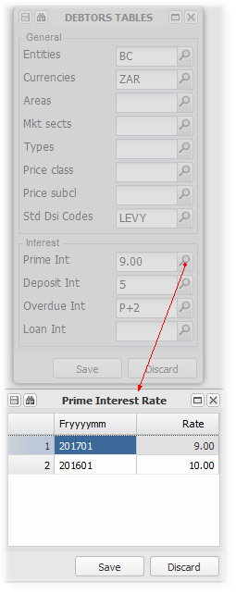

Document Control
Set up various aspects of the traditional invoice and costing selection. This isn't generally used in the UniPROP property system:
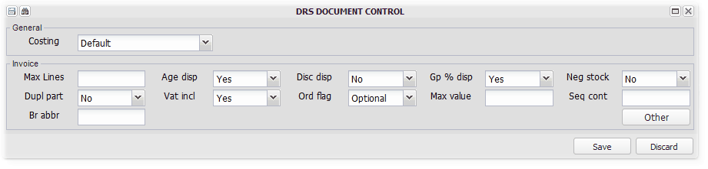

Reading Rates
Used to set up the various DCA fixed charges, letter charges and utility reading rates if applicable. These can be set up at a central data base, group (agent) or individual branch (property) level.

Refer to Setting up the Utility reading system for more information on setting up reading rates for utilities.

The following image indicates key features:
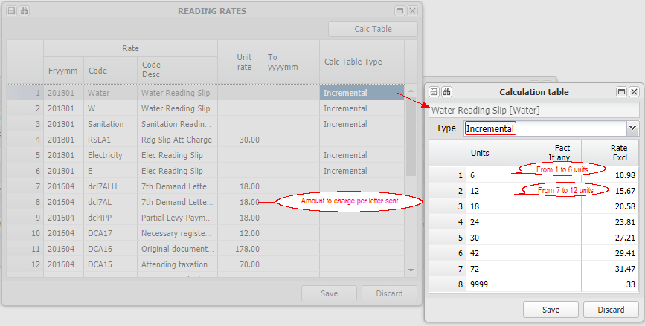 | 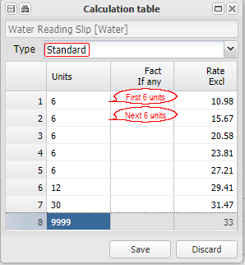

Statement Control
Choose a default reference for debtors statements, and enter a statement message that will be used for all statements of debtors linked to branches part of the group. Messages will be overridden by any message capture on the debtors branch or its group branch (Agent):
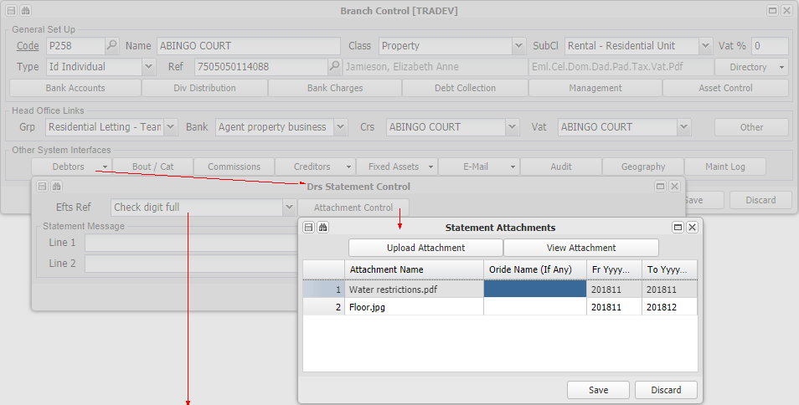
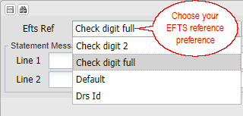

Refer to Setting up Debtors Statement Messages and attachments for more information.

Other Control
Various debtors related settings:
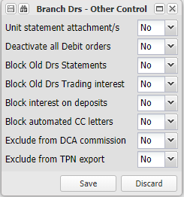

Bout/Cat
This isn't used in the UniProp system. It refers to a catalog system.
Commissions
Choose and further set up commissions payable on selected invoice types, triggered either by the processing of an invoice, or by a receipt from a debtor.

After choosing from the commission types already set up on Database setup, link the commission to a creditor, debtor, or both. You also choose which invoice codes will attract the relevant commission - for example, Deposit billed in the property environment, do not usually attract a collection commission, and then not selected from the list.

For a collection commission that is based on a receipt, you need to set up both a debtor and a creditor. The commission is set up on the branch that will be liable for the commission - the creditor will be the entity that the branch owes the commission to and is in the books of the branch, whilst the debtor will usually be in a separate branch, in respect of the original branch's commission due. In a property environment, the property will have it's agent as a creditor in its books, and the agent will have the property as a debtor in its books. You can set up more than one commission charge for a branch (property) with different invoice codes applied. You can also flag a branch to charge commission on unallocated receipts, and to charge commission on inter group transactions.

For normal sales commission based on invoice, you only need to set up to creditor to which the commission must be posted. If you are also accounting for the debtor, then set up the debtor too, and the commission income will be accrued in the debtors books. Set up commissions payable on selected sales invoice code/s. The commission is accrued, when the sale is invoiced, to the relevant creditor. You can choose a creditor in a different branch:

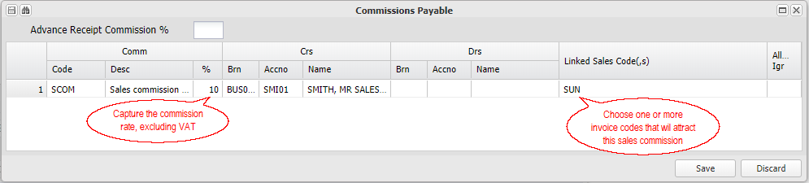

Refer to Setting up and charging fees to a property client for more information on applying commissions

Creditors
Set up some tables for creditors information. Some of the details are displayed below and are self explanatory:

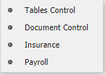

Tables Control
Set up table information used for creditors:
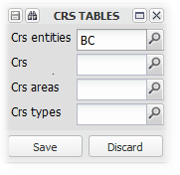
Set up legal entity types for creditors:
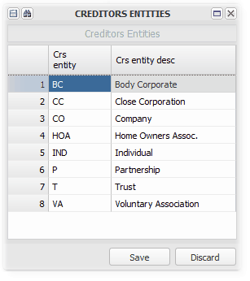
Crs is used to set up the creditors currency, areas and types relate to geographic and supply types, which can be set up using the relevant option.

Document Control
Set the rule for the approval of creditors invoices using the Other Update Flag, the invoice payment approval amount and the number of approvals required. The rest of the functionality is not generally used in the UniProp property system:
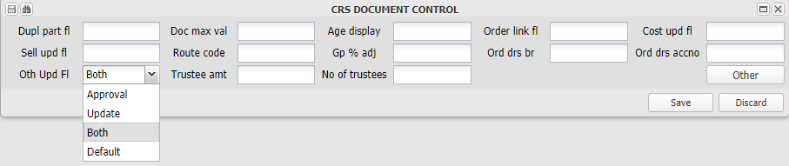

Insurance
Capture various insurance related information relative to the property (branch):
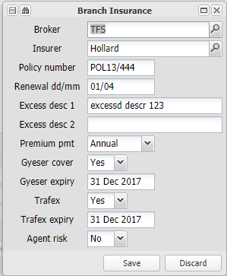

Payroll
Capture the branches PAYE and UIF registration numbers:
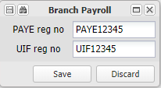

Fixed Assets
Setup tables containing fixed asset types and sub types, and link document templates to key system reports. Setting them up on the central database branch, will be the tables for the whole database.

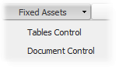
Tables Control:

Under the General tab, set up as many types of assets as you require. For each type you can set up sub-types as you require. Using a property example, setup a Residential Rental Building, and then the various types of units contained in the building. The units could then have furniture that is rented with the unit as a sub-type under the unit type.

In the example below, we see a Sectional Title Scheme set up with sub types for normal levy units and exclusive use areas, and then other assets owned by the body corporate:

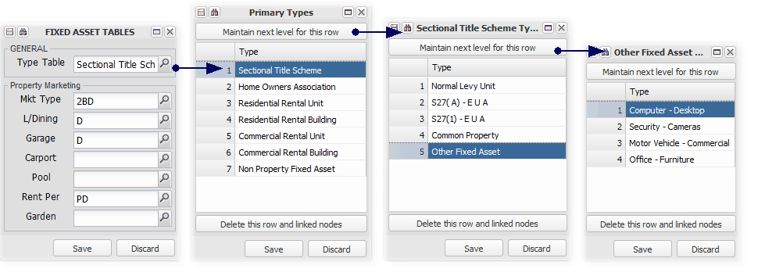
Document Control: Not generally used in the system.

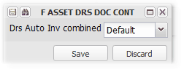

E-Mail
Various settings relating to the set up and Emailing of documents:
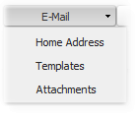
Home address
Capture the default from address from which emails will be sent from the database. Sometimes this is over-ridden when particular reports are sent,:
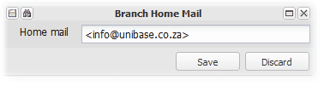

Templates
Enter details of uploaded templates relating to the various system reports:

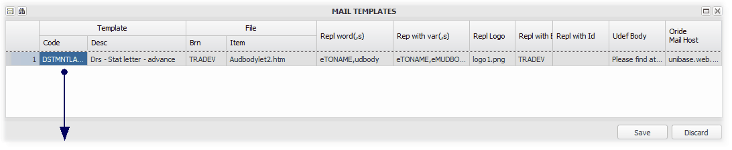
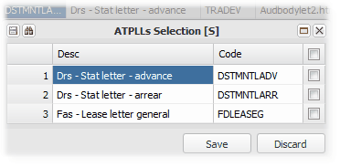

Attachments
Set up report templates and link them to system reports. Templates on the database branch will be the default for the whole system. Templates set up on a group branch (agent) will override the database branch, and will be overridden by those set up on a particular branch:
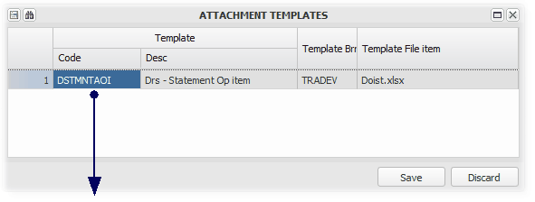
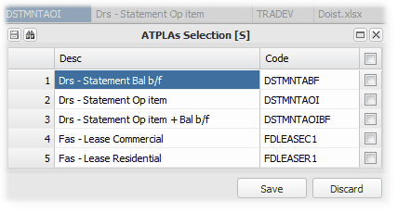

Click on the Drill to download the template. It can be edited and re-uploaded using Template Upload
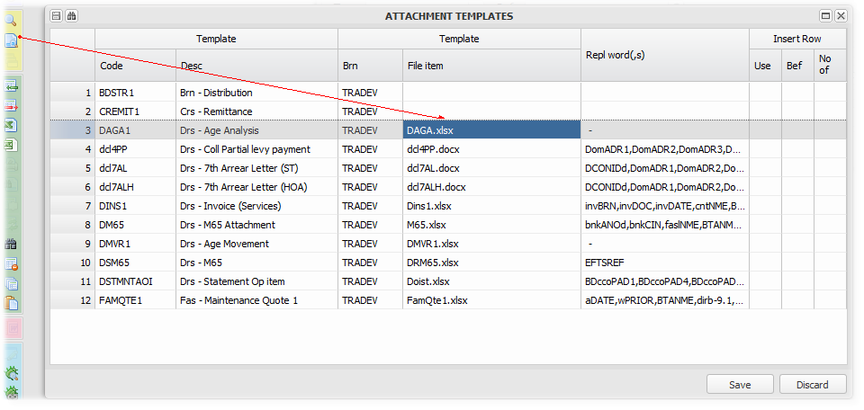

Audit
Audit and accounting settings for the branch:
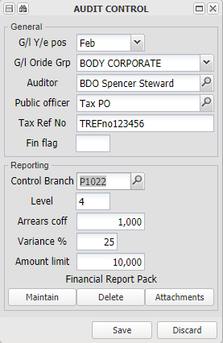
1. Capture the branches financial year end month.
2. Link the branch to relevant group of general ledger groups and reporting overrides. Refer to Setting up general ledger reporting group and description overrides for more information relating to this setting.

Add auditor and tax information, and various reporting control information.

Refer to Setting up and producing a Branch Financial Report Pack for more information.

Geography
Set up a table of countries to link the branch to:

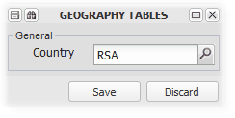

Maint Log
A log of changes made to the branch master file contents.

Choose the period and detail that you require (click on the top selection box to choose all), and click on Proceed with Selection to view the log:

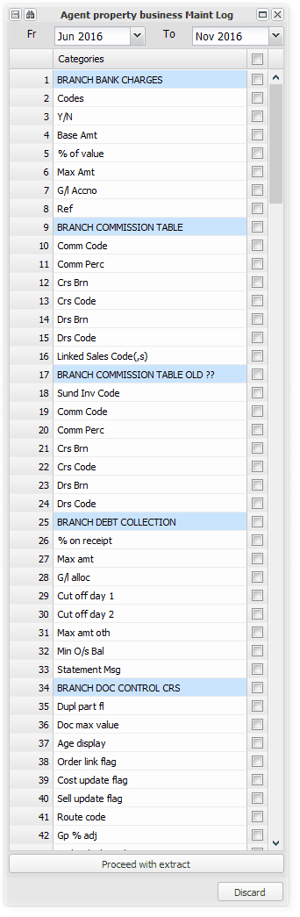

Create/Maintain Directory
The system has directories items in respect of entities/individuals/bank accounts based on their registration numbers, which are stored independently, and can be linked to branches, debtors or creditors. Each of the directory items contains key information relating to the entity/individual/bank account, details of which can be seen in the images below.

The purpose of having a directory, is that all the information relative to for eg. an individual, is stored in one place, and linked to wherever the individual is required to be linked. For example, if one person is an owner of a sectional title unit, a trustee in their body corporate, and owns a unit that is being rented out by you, her key information would usually need to be captured in each of those places. If a telephone number changes, it would have to be changed in each of those places. The system directory structure allows the changed information to be captured from any of the places, and it will update all of the others.

Directory entries are either manually entered using this option, from master file screens (eg. Debtors Master Maintenance), or uploaded from an Excel spreadsheet using the Directory Upload option.

Where an entity/individual is linked in any way to a branch, debtor or creditor, the link is established by linking the dictionary item to the relevant branch etc. The dictionary can be edited from each linked point, and will update all of the linked places. A full display of the details captured and all of the links to the directory item can be displayed from each linked screen.

We can store information gained for each entity, which could be useful in noting previous defaulters etc.

The bank account dictionary will be linked to wherever a bank account is entered on the system Eg. creditor master file, debtor debit order etc. It can be verified once by the relevant bank, which will be indicated in each linked point.

A Partnership Directory Item can be used where a group of individuals rent a property, with the Partnership directory item being linked to each partners Individual directory item

The informal link is a catch all, to provide for when you do not have identity or passport number, but need to capture someone on the system.

The menu option is explored below:

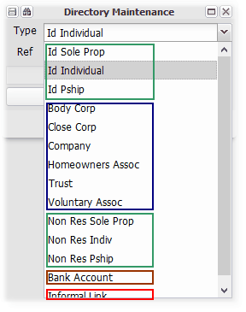 | After choosing the directory type, you can either Search for an existing entry, or enter a new number to create a new entry:  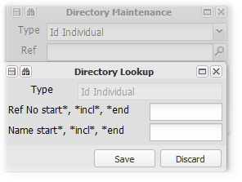

Types of Directories -
Natural Person
This directory has the person's identity number as the key. If the entry is in respect of a partnership, choose a primary identity number to create the dictionary item , and then add as many partners there are as individuals in the partnership in the Partners field, linking each of the partners to Individual directory entries. A sole proprietorship is usually an individual, but trading as a business.

The various fields are self-explanatory:
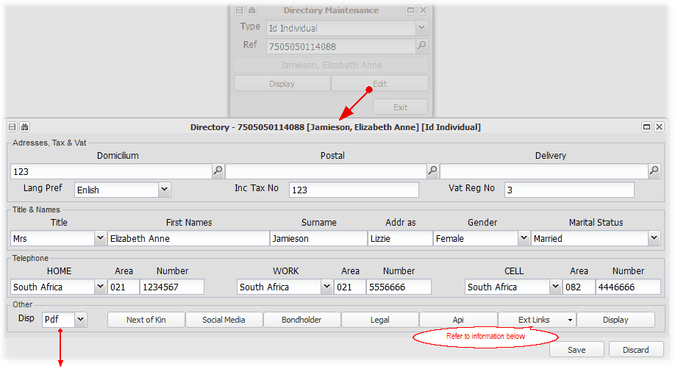
The 'Disp'lay option above, sets the default format for all reports produced for this person. The system default is Excel, the alternative is PDF.

External Links
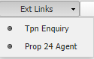 | TPN - Refer to Setting up TPN and credit checks  Property 24 - Refer to Setting up letting consultants on Property24

Un-natural/Artificial Person
This option has the entity registration number as the key. Un-natural or Artificial persons are persons in terms of the law, but are not natural people. Examples of these are companies, trusts, bodies corporate etc.

There is provision to capture details of an administration contact person, and details of office bearers with links to their directory items. Examples of office bearers are - director, treasurer, trustee, member.

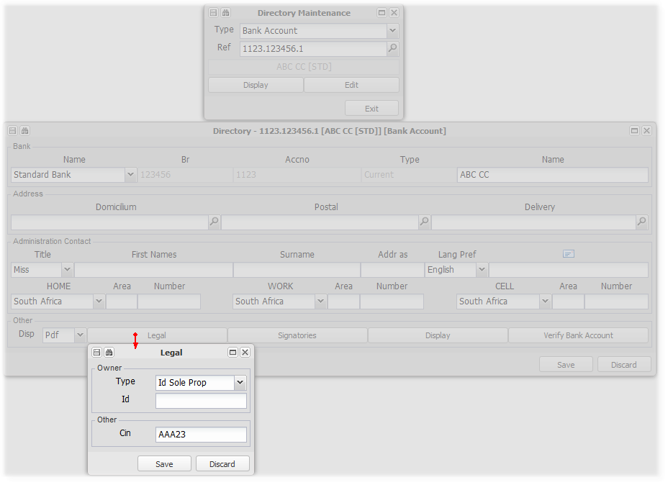

The following is an example of a dictionary item display, with the various items that it is linked to below:

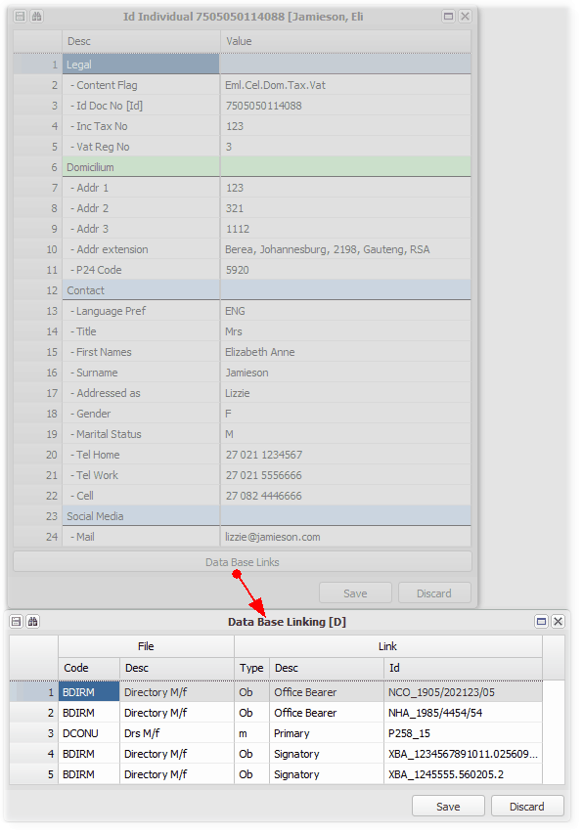

Informal Link
This option has the name used as the key. It is a catch all, to provide for when you do not have identity or passport number, but need to capture someone on the system

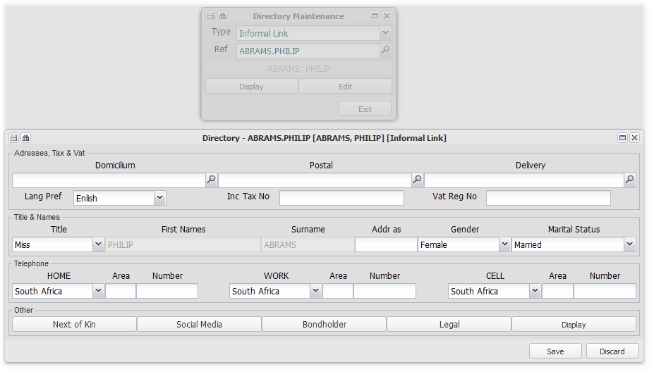

Bank Account
The key to this file is 'bank account number.branch code.type of account'.

Bank accounts can be validated and flagged as valid, and used wherever relevant.

If a CIN number is entered for this bank account under the Legal button, a pre-populated bank deposit slip will be attached to an email with the relevant statement. A template needs to be set up using the relevant banks layout:

Directory items for the signatories to the bank account can be captured:
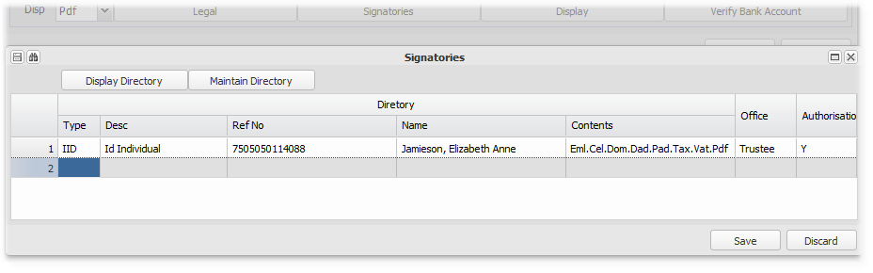

Entering addresses (non-eMail)
The system generally has three addresses per directory item (individual, company etc.):

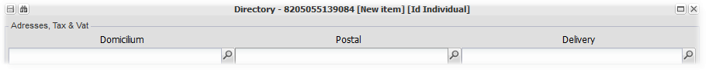

Delivery (Physical) address
The delivery or physical address is the address where the individual resides, or the registered office of an unnatural person entity (eg. a company). Enter the relevant information, leaving unnecessary lines blank. The country, province etc. information can be obtained by working through the country, province, city, suburb selection process, or using the 'Area Input' quick search:
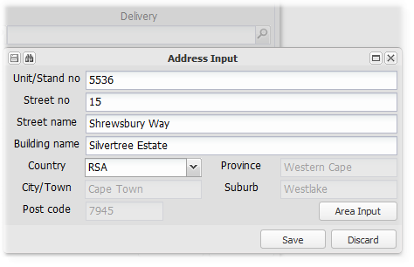

Postal address
The postal address is the address that the person chooses as their preferred address for any correspondence to be posted to. It could be the same as the delivery address. The detailed lines are not labeled, as these addresses will have several different forms (eg. PO Box No.). The country, province etc. information can be obtained by working through the country, province, city, suburb selection process, or using the 'Area Input' quick search:
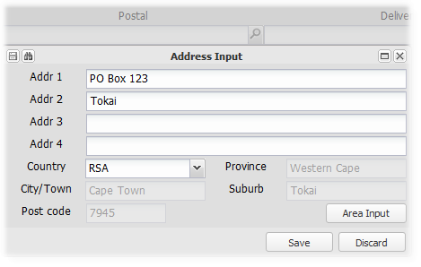

Domicilium address
The domicilium address is the address chosen by the person as an address for the service of legal process documentation. This is usually defined in a legal agreement (eg.a lease agreement). It is usually the delivery or postal address, but can be different. When entering this address, if there is no address already entered, the system will prompt you to choose either the previously entered delivery or postal address, which it will automatically copy, or you can enter your own address:
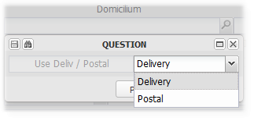
The detailed lines are not labeled, as these addresses will have several different forms (eg. PO Box No.). The country, province etc. information can be obtained by working through the country, province, city, suburb selection process, or using the 'Area Input' quick search:
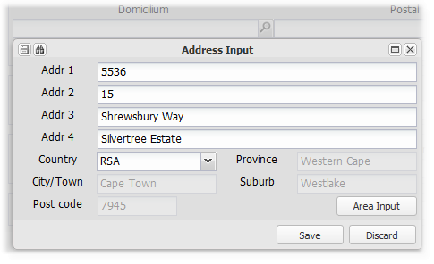

In order to take advantage of the utility to copy the domicilium address from either the postal or the delivery address, it is best to enter them first.

Managed Assets
These two menu items facilitate the setting up of a group of items that are necessary to set up a managed property and any units that it contains.

Step 1 - Add all of the necessary directory items by importing or adding them manually. These will include entries for the Property Owner (Body corporate or Individual etc) and for each Unit Debtor.

Step 2 - Create the Property Branch and Fixed Asset, choosing the relevant options from the capture screen.

Step 3 - Create the Units by importing from an Excel spreadsheet which creates new Fixed Asset level 2's, and Debtors in the property Branch Asset, with the relevant links.

Refer to Setting up a Property branch and it's units for more information.

New Managed Property
A Property is defined as a combination of items, that are linked for the purposes of managing and accounting for the affairs of the Property.

Refer to Setting up a Property Branch and its units for more information relating to this process

The items and links set up when creating a Property, are as follows:

Branch
Creates a new Branch for the Property, using the next available number for properties. The fixed asset (below) is created with the same number, linking the two items.
The first item chosen is the agent group that the Branch will be linked to. This will be used when selecting branches, debtors etc., and when charging fees to the branch by it's agent branch.
The name, class and type are selected too.

Fixed Asset - Level 1
Creates a new Fixed Asset, using the same number as the branch created above. The units (Fixed Asset level 2) in the property, are created as a second import - New Managed Units

Directory link
Select the previously created directory entry for the new property, or create one from the screen. Choose the type of directory based on the legal person that 'owns' the property - eg. Body Corporate, Individual etc.

Bank account and Grouping links
Choose the following -
Default bank account - usually the agents trust account, or the body corporates own bank account.
The creditors branch, usually the new branch itself, unless part of a shared creditors group.
The VAT rate, 0 or the current VAT rate.
Enter the maintenance mandate from the owner to the agent, and the surplus fund distribution rules

Agent/Property Debtor/Creditor Link
Creates an inter-group debtor in the agent branch, and an inter-group creditor in the property branch, which link is ued for the charging of management and collection fees to the property branch by the agent branch..

Agent fee setup
Enter details of the fixed amount management fee and/or receipt based collection fee to be charged by the agent branch to the property branch.
You can choose the items on which the collection fee will be charged eg. rental only, or choose all receipts.

The New Property branch screen:
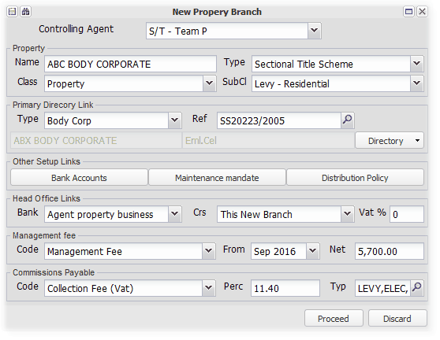

Refer to How do I charge Fees to a Property for more details on aspects of the above.

New Managed Units
Having created a Property, use this import option to add the units (flats, house, sectional title units etc.).

Refer to Setting up a Property Branch and its units for more information relating to this process

The import will create:
Units in the selected Property (Fixed Asset Level 2)
For as many valid lines of the spreadsheet, a new FA2 with the fee structure item/s, and a customer link to the new debtor created)

Debtors for each new Unit in the Properties' Branch
For as many valid lines in the spreadsheet, a debtor with the same number as the created FA2 and the existing directory links for the debtor and administration contact/s.
Remember to create the relevant directory items before importing the units

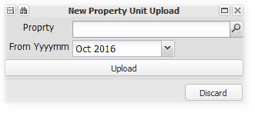
This option uses an Excel spreadsheet as the source of the import. After completing the details in the prescribed format (Download by clicking here), select the relevant contents, Copy, and then click on 'Upload'.

Intergroup Managed Loan
This utility facilitates a managed loan facility where a loan is made by a lender (branch) to a property (branch) to initially cover the levy arrears for some selected or all of its units, with the levy arrears ceded as security, and then a monthly loan advance to cover all of the lending branches billings. Levy debtors are then managed and rehabilitated by the lending branch applying it specialised expertise. The system accommodates a structure where both branches use shared central banking to facilitate the cash movement between them, and where one branch uses its own bank account. In the latter case, the system will process EFTS batches between the bank accounts to move the funds as necessary.

The full outstanding balance/s constitute the initial loan advance, with a further monthly loan advance equivalent to the property branches monthly billing to it's debtors for the period of the loan agreement. There is no interest charged on the loan. The lending branch the charges interest on arrears to the outstanding debtors. All debtors receipts are then recovered by the lending branch, as a reduction of the loan amount.

The loan is repaid when the debtors have all paid up to date, or at an agreed time when the property repays all outstanding loan amounts to the lender.

The examples below are in a shared banking environment, which demonstrates the principles for both banking structures.

Initial Take on / Setup
Set up an Inter-Group Debtor in the lending branch
Menu: Debtors, Debtors Master Maintenance
Create a new debtor in the lending branch which will carry the managed loan, remembering to set the Payment Flag to 'Intergroup'.

Managed Loan Worksheet
Menu: Branch, Managed Assets, Intergroup Managed Loan

This is the main setup and storage screen. Key selections can be made which will generate the transactions necessary to reflect the initial loan in the accounting records.

The screen workings can be saved, recalled and amended, until the loan has been finalised. You can upload and store a copy of the related signed loan agreement, which can be viewed on demand.
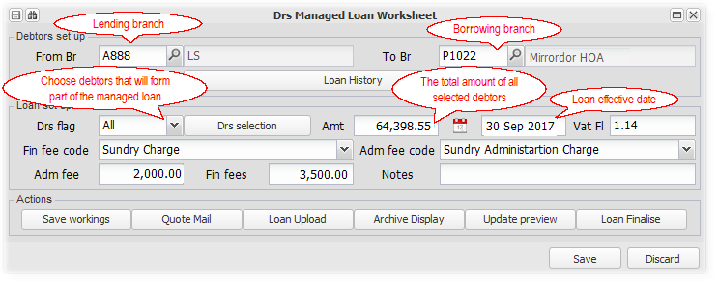
Select the From (lending) branch and the To (borrowing) branch
Having set up the inter-group debtor referred to above, choose your relevant branches. The debtors in the borrowing branch are the debtors that will be the subject of the loan.

Select all or only debtors relevant to the loan
Depending on the loan agreement, you can choose one or more, or all of the debtors in the borrowing branch.

The outstanding balance/s at the time of selection and then loan activation, will be the initial advance in terms of the loan. All interest and all receipts from then will be allocated to the lending branch.

Record the loan effective date
Record the effective start date in terms of the loan agreement.

Capture the loan fee amounts and their invoice codes
Capture the initial fees in terms of the loan agreement, and their relevant invoice codes.

Save the worksheet
You can save the worksheet and return to it to amend and finalise, or work through all of the steps and finalise it immediately.

Upload a copy of the signed loan agreement
If the loan agreement has been set up, you can view and print a copy from the 'Quote Mail' button. Once the agreement is signed, you can can upload a scanned copy and view archived documents as required.

Finalise the loan
Before finalising the loan which will activate and lock the initial position, check that you have selected the latest debtors balances.

You can preview the accounting entries that will be processed on finalisation, by drilling down using the 'Update Preview' button.

You will be reminded to upload a copy of the signed agreement before finalising the loan if you haven't done so, but can proceed with uploading a copy.

Monthly loan processing
Interest charged after the loan is finalised
All interest charged after the loan has been finalised, will be charged as usual to the borrowing branch debtors. The income side of the interest charge will be reallocated to the lending branch, increasing the loan balance. Refer to the accounting implications section below to see the effect of these transactions.

Debtors receipts after the loan is finalised
All receipts from debtors for transactions relating to the borrowing branch, reducing the debtors and the cash will be allocated to the lending branch, reducing the loan balance. Refer to the accounting implications section below to see the effect of these transactions.

Monthly advances amounting to the monthly billing to debtors
Menu: Debtors, Auto - General Functions and Reports, Debtors Intergroup Loan Managed Extension

The system will allow you to, after checking, advance an amount equal to the full amount charged by the borrowing branch to its debtors. This will increase the loan balance.

Specialised collection charges by the lending branch
Usually the lending or other branches provide specialised debt collections services for which the defaulting debtor is charged. These charges do not form part of the managed loan, and on receipt thereof they will be receipted as is usual for these type of charges.

Accounting implications
Referring to the example above, the following trial balances show the transactions at the indicated stages. In this example we do not reimburse the shared account 'overdraft', or demonstrate the monthly loan advances.

The example shows the summary of transactions in the form of trial balances for the borrowing and lending branches:
Borrowing branch Trial Balances | Lending branch Trial Balances

Trial balance from June 2017 to September 2017, immediately prior to the loan activation:
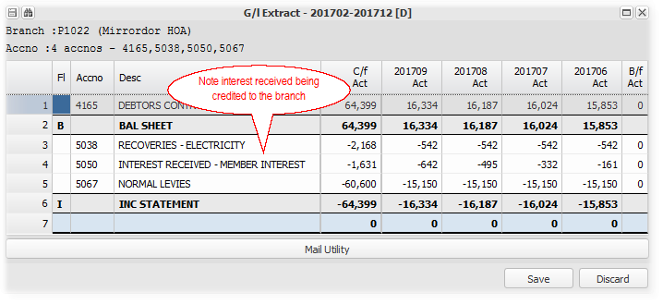

Trial balance immediately after the loan activation:
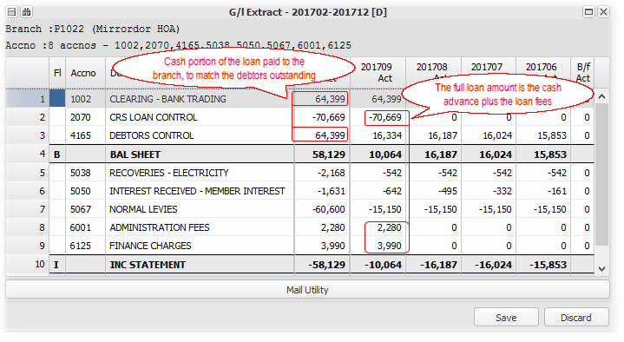 | 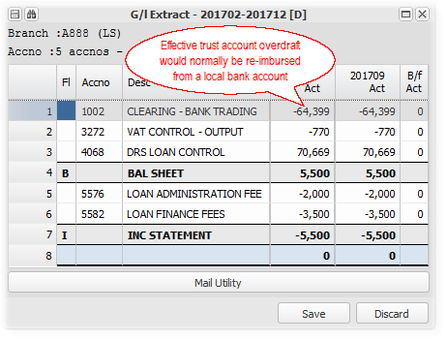

Trial balance after raising October levies and interest. Interest on P1022 debtors accruing to A888:
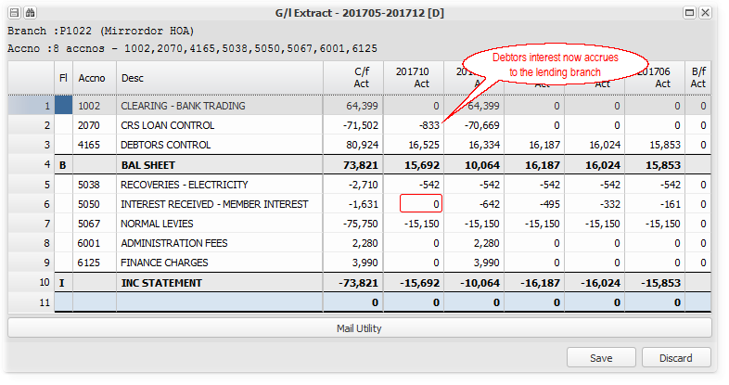 | 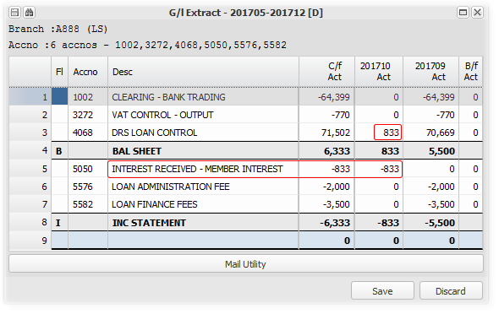  Note: The loan balances remain in balance

Trial balance after two P1022 debtors paid a total of R7300:
The debtors balances are reduced, and the loan is also reduced as the receipts are transferred to the lending branch:  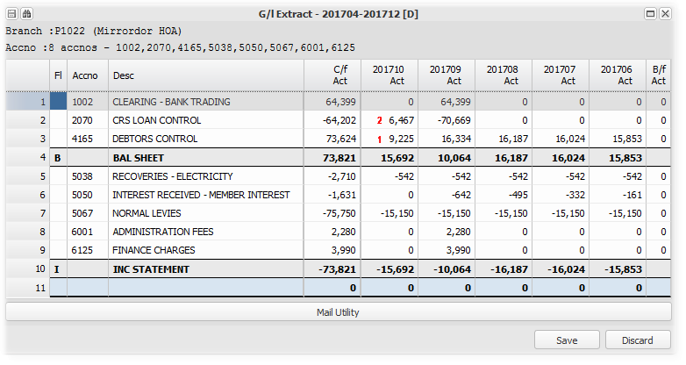  1. Debtors control movement - R 9225 - R 16525 (levies and interest), less R 7300 (receipts).  2. Creditors loan control movement - R 6467 - R 7300 (receipts), less R833 (interest) | Debtors receipts reduce the loan and increase the bank balance:  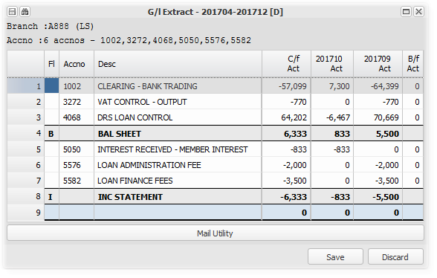

Loan history and transactions
Once a loan is finalised, you cannot amend the initial detail. You can view the initial detail and view a full loan transaction history by selecting the relevant branches, and choosing 'Loan History'. The loan ID will be the lending branch and the loan start month:
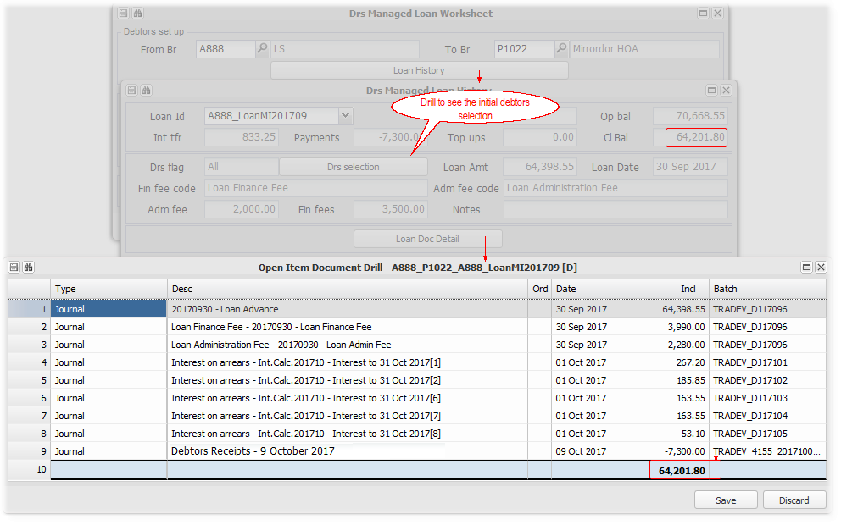

Ending a managed loan
XXXX input from MS

External Links
Enter topic text here.

Auto Options
Enter topic text here.

Branch Look up
A look up facility relating to Branches.

Refer to General Data Searches for more information.

Directory Upload
Use this option to import (upload) one or many directory items from an Excel spreadsheet.

Choose which type of directory you are uploading. After entering all the necessary items on the spreadsheet template (Download below), select them all and Copy, then click on Directory Upload. By not choosing a directory type, you can upload multiple types of directory items in one upload.

You will see the upload progress at the base of your browser.

The Upload Screen:

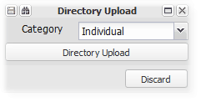

Download the import templates by clicking here

Refer to Create/Maintain Directory for more information about Directories.

The following is a list of directories and their type code, which is used in this upload:

Type | Code
Id Sole Prop | IIB
Id Individual | IID
Id Pship | IIM
Body Corp | NBC
Close Corp | NCC
Company | NCO
Homeowners Assoc | NHA
Trust | NTR
Voluntary Assoc | NVA
Non Res Sole Prop | PPB
Non Res Indiv | PPI
Non Res Pship | PPM
Informal Link | XIN

Branch distribution
Enter topic text here.

Debtors - Debit orders
Enter topic text here.

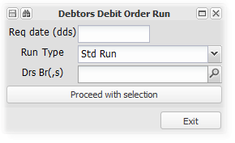

Management Log
These facilities in the sub-menus, assist in storing information and documents relating to various aspects of a branch's activities and the management thereof. Copies of documents can be uploaded,stored and retrieved, linked to the relevant section and actual date or month.

A history of the various aspects can be stored. For example, a call to the chairperson is stored for a date, keeping details of previous calls.

A summary report containing this and other key property information is available.

Agreements
Details of key agreements.

Agreement - Management
Capture details and documents relating to the management agreement for the branch (property):
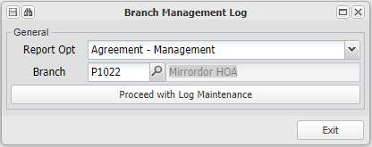

Drill to choose an existing agreement or add a new one:
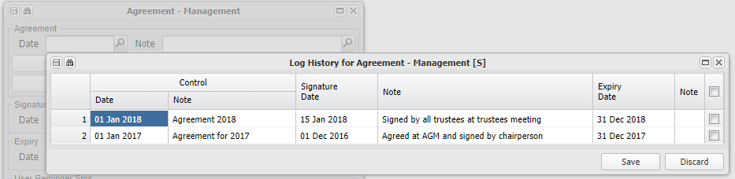

Enter the relevant details and upload or view relevant documentation:
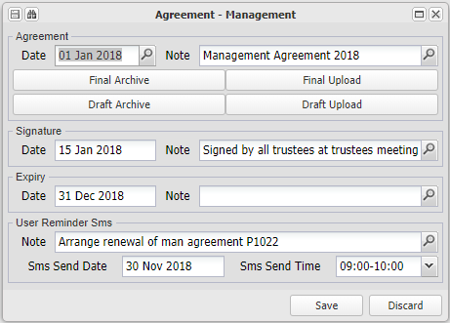
Add a reminder SMS with a note and a date and time to send you a reminder.
The system will send you an SMS based on the cellular number linked to your user record.

Refer to the notes relating to an annual general meeting for more information.

Approvals
Details of key approvals.

Approval - Budget
Capture and upload information and documents relating to branch (property) budgets. Assuming that there can only be one budget in a month, the key is YYYYMM. This month will usually be the relevant financial year end to which the budget relates:

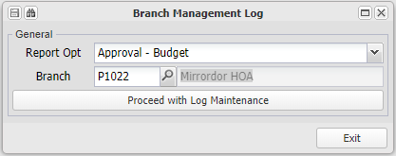

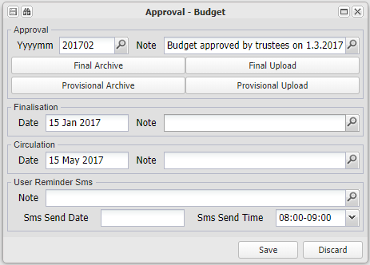
Add a reminder SMS with a note and a date and time to send you a reminder.
The system will send you an SMS based on the cellular number linked to your user record.

Refer to the notes relating to an annual general meeting for more information.

Audits
Details of annual or other audits.

Audit - Annual
Capture details and upload documents relating to the annual audit relating to the branch (property):

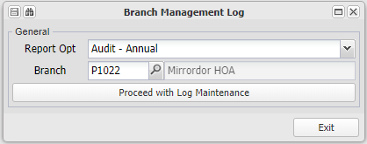

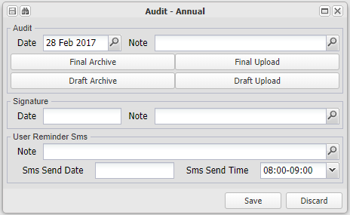
Add a reminder SMS with a note and a date and time to send you a reminder.
The system will send you an SMS based on the cellular number linked to your user record.

Refer to the notes relating to an annual general meeting for more information.

Audit - Other
Capture details and upload documents relating to any audit other than the annual audit relating to the branch (property):

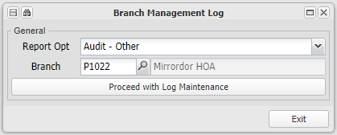

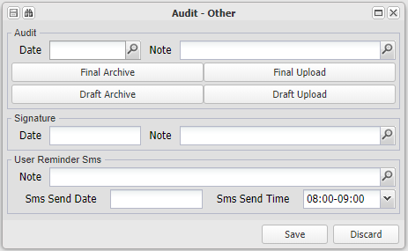
Add a reminder SMS with a note and a date and time to send you a reminder.
The system will send you an SMS based on the cellular number linked to your user record.

Refer to the notes relating to an annual general meeting for more information.

Contacts
Details of contacts with your client.

Contact Chairperson
Capture details relating to client contact calls relating to the property (branch):

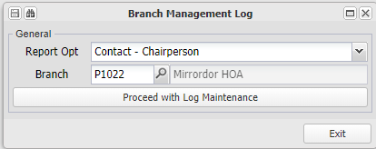

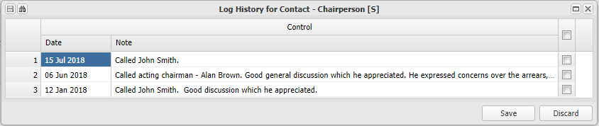

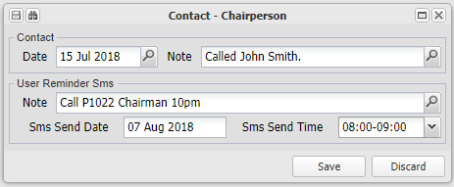
Add a reminder SMS with a note and a date and time to send you a reminder.
The system will send you an SMS based on the cellular number linked to your user record.

Refer to the notes relating to an annual general meeting for more information.

Inspections
Details of various inspections related to the property (branch).

Inspection - Electric Fence Compliance
Capture details and upload documents related to any electric fence compliance inspections and certificates related to the property (branch):

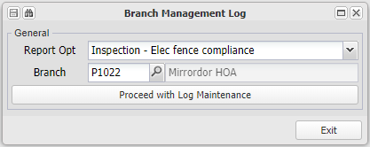

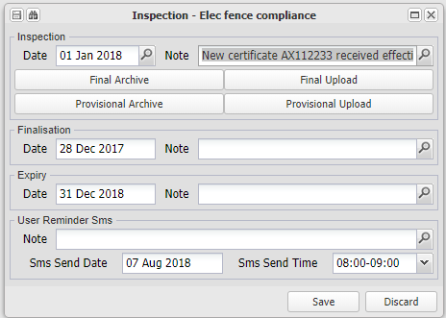
Add a reminder SMS with a note and a date and time to send you a reminder.
The system will send you an SMS based on the cellular number linked to your user record.

Refer to the notes relating to an annual general meeting for more information.

Inspection - Fire Equipment
Capture details and upload documents related to any fire equipment inspections and certificates related to the property (branch):

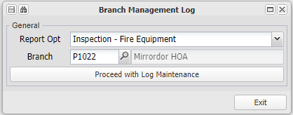

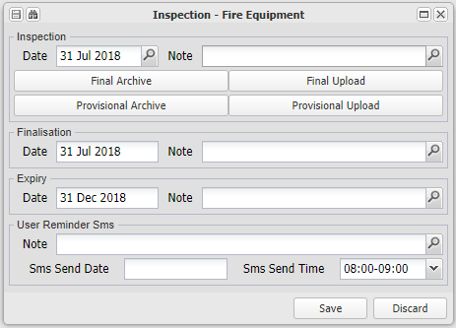
Add a reminder SMS with a note and a date and time to send you a reminder.
The system will send you an SMS based on the cellular number linked to your user record.

Refer to the notes relating to an annual general meeting for more information.

Inspection - Lift
Capture details and upload documents related to any lift inspections and certificates related to the property (branch):

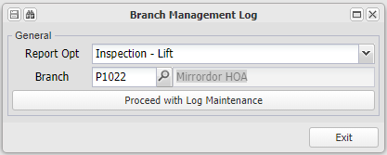

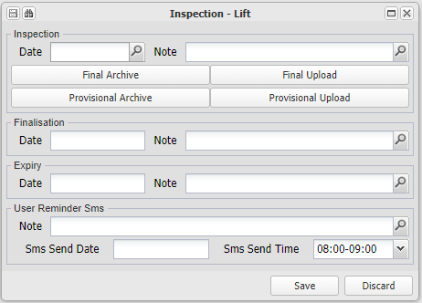
Add a reminder SMS with a note and a date and time to send you a reminder.
The system will send you an SMS based on the cellular number linked to your user record.

Refer to the notes relating to an annual general meeting for more information.

Inspection - Property Maintenance
Capture details and upload documents related to any general inspections and records related to the property (branch):

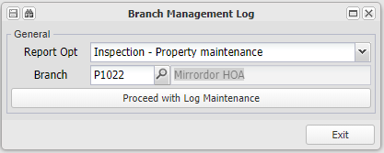

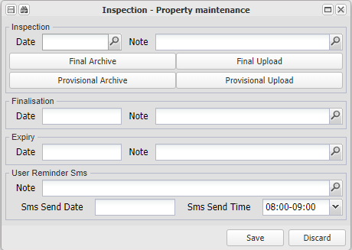
Add a reminder SMS with a note and a date and time to send you a reminder.
The system will send you an SMS based on the cellular number linked to your user record.

Refer to the notes relating to an annual general meeting for more information.

Meetings
Details of various legal and other branch (property) meetings.

Meeting - Annual General
Capture information and upload documents relevant to annual general meetings relating to the property (branch):
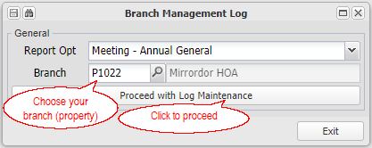

Choose the month that the meeting was/ is to be held, or the financial year end that the Annual General Meeting relates to. Entering a new date will create a new meeting worksheet, or call up a previously stored meeting to update its worksheet:
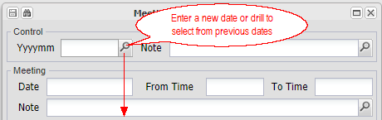
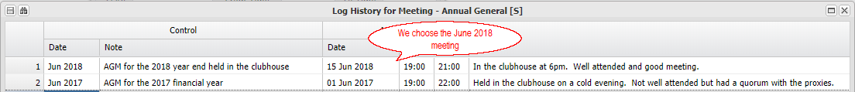
Add a reminder SMS with a note and a date and time to send you a reminder.
The system will send you an SMS based on the cellular number linked to your user record.

Meeting - Management
Capture information and upload documents relevant to management meetings relating to the property (branch):

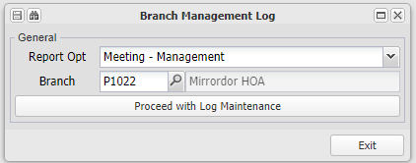

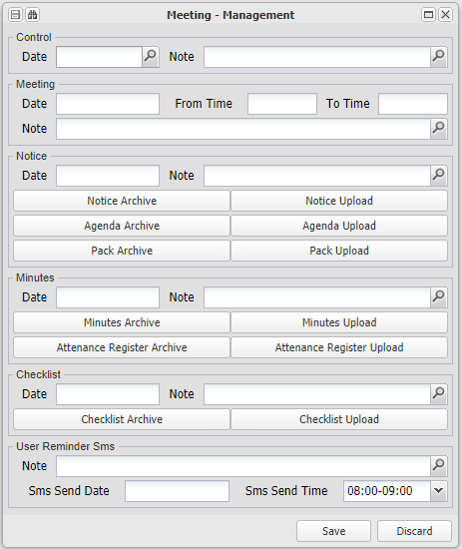
Add a reminder SMS with a note and a date and time to send you a reminder.
The system will send you an SMS based on the cellular number linked to your user record.

Refer to the notes relating to an annual general meeting for more information.

Meeting - Other
Capture information and upload documents relevant to any general meetings relating to the property (branch):

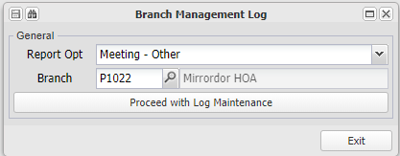

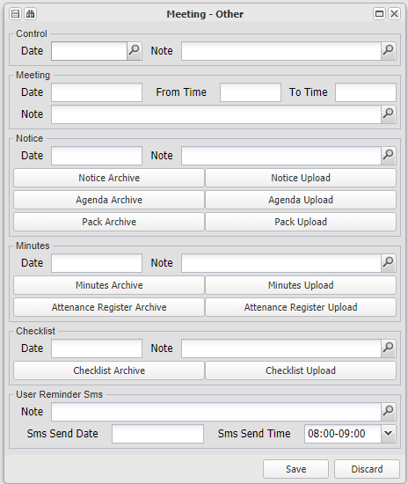
Add a reminder SMS with a note and a date and time to send you a reminder.
The system will send you an SMS based on the cellular number linked to your user record.

Refer to the notes relating to an annual general meeting for more information.

Meeting - Owners
Capture information and upload documents relevant to owner meetings relating to the property (branch):

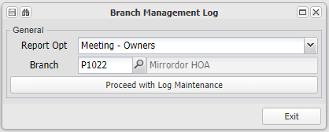

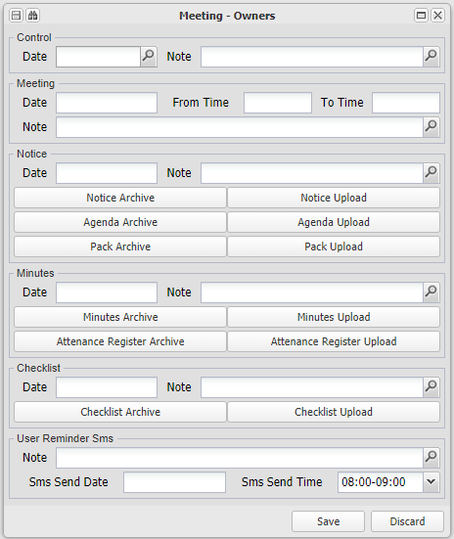
Add a reminder SMS with a note and a date and time to send you a reminder.
The system will send you an SMS based on the cellular number linked to your user record.

Refer to the notes relating to an annual general meeting for more information.

Meeting - Trustee
Capture information and upload documents relevant to trustee meetings relating to the property (branch):

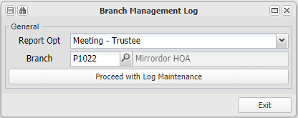

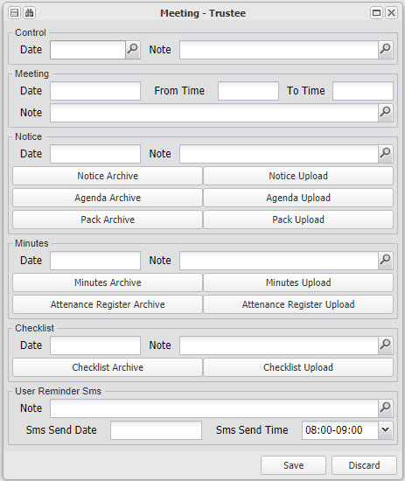
Add a reminder SMS with a note and a date and time to send you a reminder.
The system will send you an SMS based on the cellular number linked to your user record.

Refer to the notes relating to an annual general meeting for more information.

Resolutions
Details of various key resolutions related to a property (branch).

Resolution - Interest
Capture information and upload documents relevant to the property (branch) interest resolution:

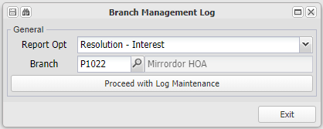

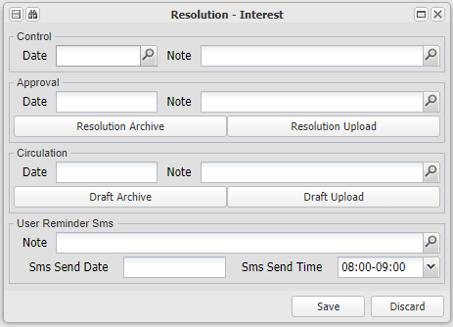
Add a reminder SMS with a note and a date and time to send you a reminder.
The system will send you an SMS based on the cellular number linked to your user record.

Refer to the notes relating to an annual general meeting for more information.

Resolution - Levy
Capture information and upload documents relevant to the property (branch) Levy resolution:

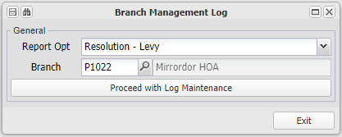

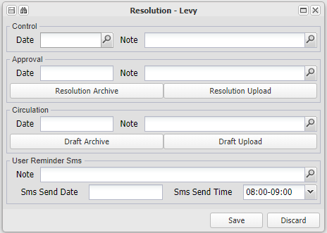
Add a reminder SMS with a note and a date and time to send you a reminder.
The system will send you an SMS based on the cellular number linked to your user record.

Refer to the notes relating to an annual general meeting for more information.

Resolution - Owner Payment
Capture information and upload documents relevant to the property (branch) Owner Payment resolution:

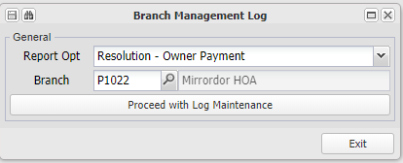

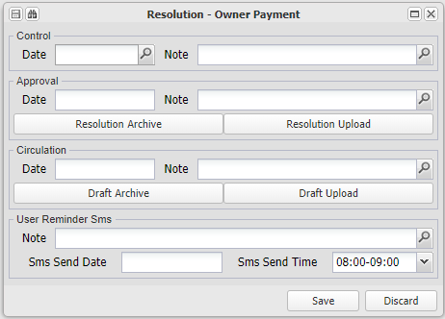
Add a reminder SMS with a note and a date and time to send you a reminder.
The system will send you an SMS based on the cellular number linked to your user record.

Refer to the notes relating to an annual general meeting for more information.

Resolution - Handover
Capture information and upload documents relevant to the property (branch) Handover resolution:

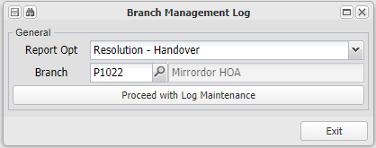

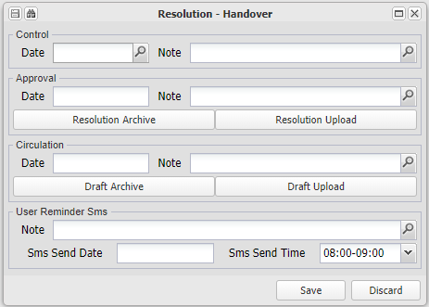
Add a reminder SMS with a note and a date and time to send you a reminder.
The system will send you an SMS based on the cellular number linked to your user record.

Refer to the notes relating to an annual general meeting for more information.

Returns
Details of various statutory returns related to the branch (property).

Return - CSOS Annual
Capture information and upload documents relevant to the property (branch) annual CSOS returns:

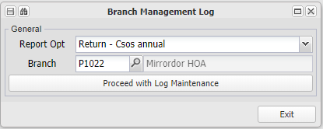

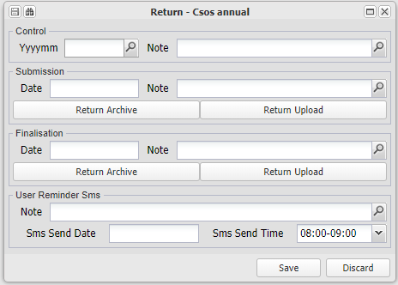
Add a reminder SMS with a note and a date and time to send you a reminder.
The system will send you an SMS based on the cellular number linked to your user record.

Refer to the notes relating to an annual general meeting for more information.

Return - Income Tax Annual
Capture information and upload documents relevant to the property (branch) annual Income Tax returns:

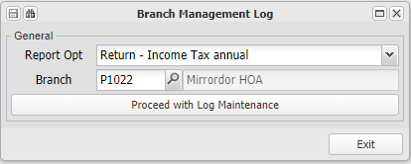

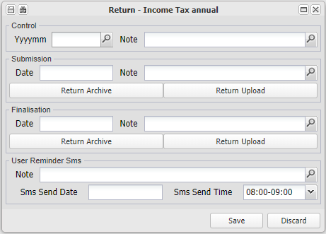
Add a reminder SMS with a note and a date and time to send you a reminder.
The system will send you an SMS based on the cellular number linked to your user record.

Refer to the notes relating to an annual general meeting for more information.

Return - VAT
Capture information and upload documents relevant to the property (branch) VAT returns:

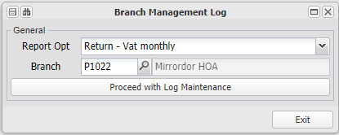

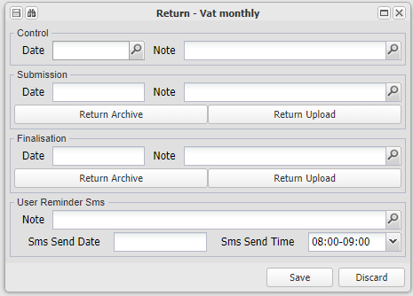
Add a reminder SMS with a note and a date and time to send you a reminder.
The system will send you an SMS based on the cellular number linked to your user record.

Refer to the notes relating to an annual general meeting for more information.

Reviews
Details of various key review areas related to the property (branch).

Review - Fidelity Cover
Capture information and upload documents relevant to the property (branch) periodic Fidelty Cover reviews:

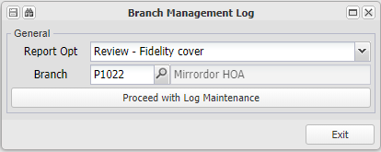

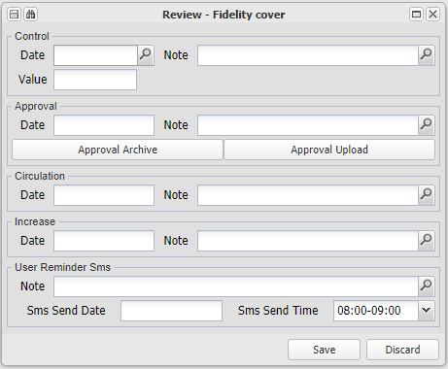
Add a reminder SMS with a note and a date and time to send you a reminder.
The system will send you an SMS based on the cellular number linked to your user record.

Refer to the notes relating to an annual general meeting for more information.

Review - Insurance
Capture information and upload documents relevant to the property (branch) periodic Insurance reviews:

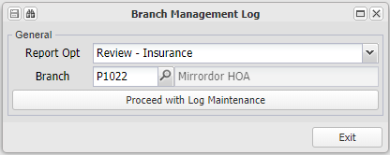

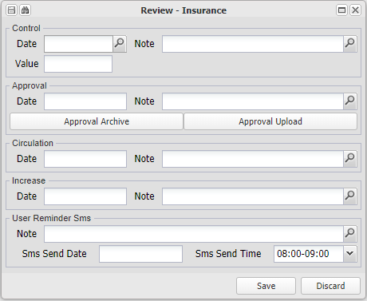
Add a reminder SMS with a note and a date and time to send you a reminder.
The system will send you an SMS based on the cellular number linked to your user record.

Refer to the notes relating to an annual general meeting for more information.

Review - Interest
Capture information and upload documents relevant to the property (branch) periodic Interest rate reviews:

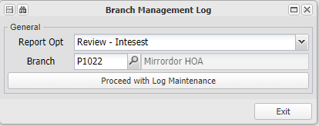

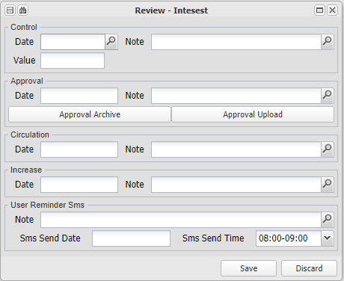
Add a reminder SMS with a note and a date and time to send you a reminder.
The system will send you an SMS based on the cellular number linked to your user record.

Refer to the notes relating to an annual general meeting for more information.

Review - Levies
Capture information and upload documents relevant to the property (branch) periodic Levy reviews:

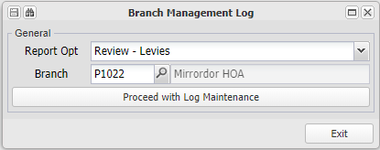

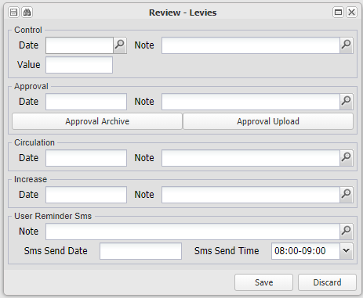
Add a reminder SMS with a note and a date and time to send you a reminder.
The system will send you an SMS based on the cellular number linked to your user record.

Refer to the notes relating to an annual general meeting for more information.

Review - Public Liability Cover
Capture information and upload documents relevant to the property (branch) periodic Public Liabilty Cover reviews:.

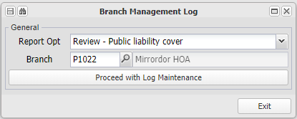

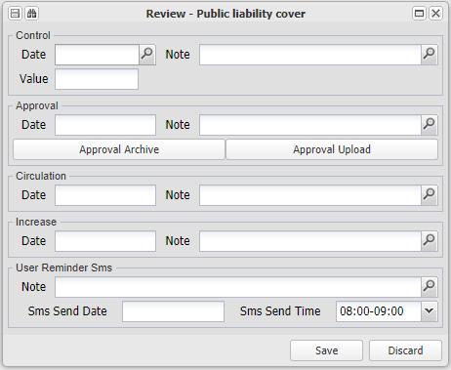
Add a reminder SMS with a note and a date and time to send you a reminder.
The system will send you an SMS based on the cellular number linked to your user record.

Refer to the notes relating to an annual general meeting for more information.

Review - Salaries
Capture information and upload documents relevant to the property (branch) periodic Salary level reviews:

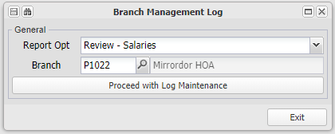

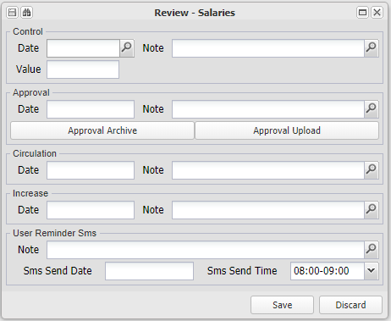
Add a reminder SMS with a note and a date and time to send you a reminder.
The system will send you an SMS based on the cellular number linked to your user record.

Refer to the notes relating to an annual general meeting for more information.

Valuations
Details of the valuation of the property (branch)

Valuation - Property
Capture information and upload documents relevant to property (branch) periodic Valuations:

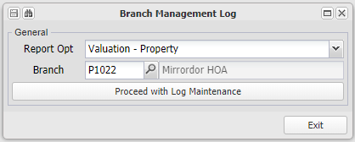

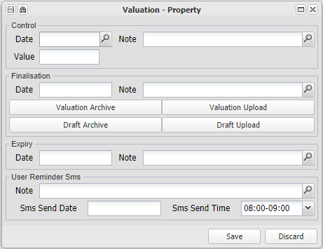
Add a reminder SMS with a note and a date and time to send you a reminder.
The system will send you an SMS based on the cellular number linked to your user record.

Refer to the notes relating to an annual general meeting for more information.

Debtors
Enter topic text here.

Debtors Master Maintenance
Use this screen to create a new or maintain a previously created debtor.

In the property management context, a debtor can be unit owner in a sectional title scheme, a tenant in a rental building (linked to a fixed asset), or can be a body corporate or property owner for fees charged by an agent for their services. There is a payment flag option - inter group - for the last example, where invoicing of fees and the payment thereof is automated.

The two examples below illustrate a tenant in a rental unit, and a property for fees in an agent branch.

The screen is broken into sections that are covered in detail below:

Rental unit debtor:

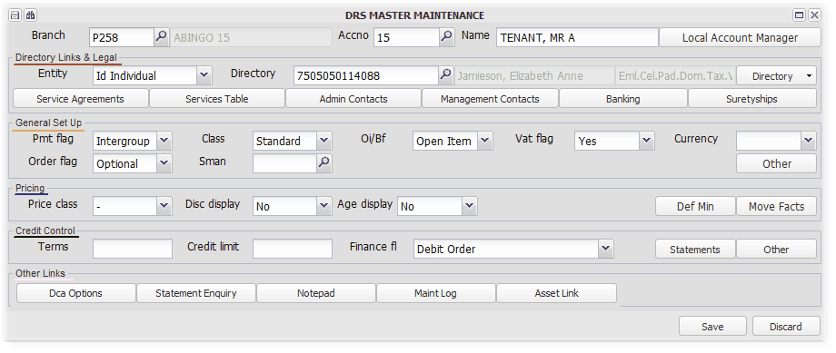

Agent for a managed property. The debtor will have a matching creditor with A132 as its creditor number, and be defined as intergroup:

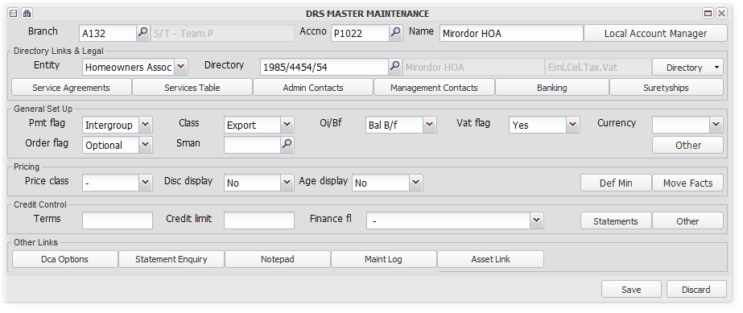

Enter an existing branch number, or click to search, then enter or search for a debtor account number. Entering a new number will create a new debtor. The debtor name is a field that is ofter used for a registered owner name if a sectional title unit, else any meaningful name. The directory entry below will record the proper name and details.

Enter a local account manager, which will be default reply to email address for correspondence send regarding this debtor. If no manager is entered, the branch default credit manager will be the reply email address.

Directory Links and Legal
Select the debtors legal entity type, and link it to an existing or create a new directory item.
Entity and Directory Link
Select the relevant type of entity from the selection drop down:
Entity:
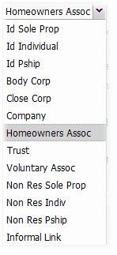

Enter a relevant directory key, or create a new one by entering a key that does not exist. You can then enter the required details of the directory item by clicking on the Directory button:
Service Agreements
Enter details of the Service Agreements set up to charge under the Services Table. This will contain a summary of the period of the agreement, its starting charge and escalation percentage:
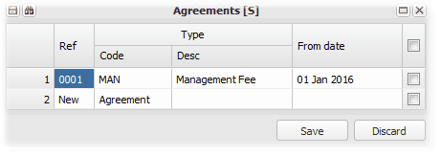
A copy of the agreement can uploaded for reference.

Refer to Setting up a Services Agreement and charging a Debtor for more information.
.
Services Table
Enter details of services that will be charged to the debtor by the branch. This is usually a monthly management fee that is raised in bulk each month. Link the invoice line to an agreement set up under Service Agreements above:
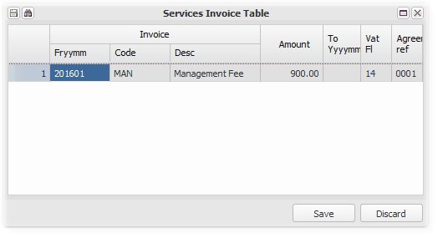
These fees are raised using Debtors, Debtors - Auto Functions and Reports, Debtors Account Billing

Refer to Setting up a Services Agreement and charging a Debtor for more information.

Admin Contacts
Set up as many administrative contacts as required. First add them as directory items, and then link them to the debtor.

System emails will go to each of the contacts:
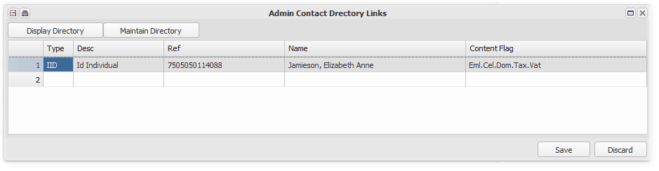
Management Contacts
If required, set up as many management contacts as required. First add them as directory items, and then link them to the debtor:
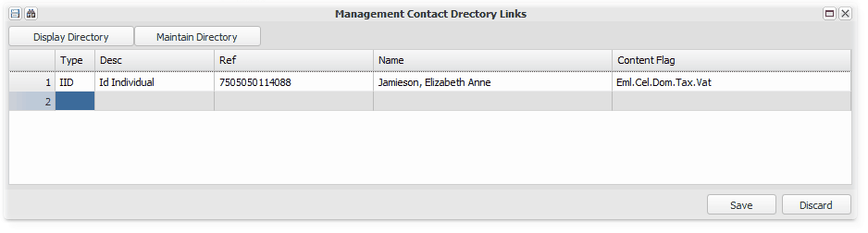
Banking
Link a bank account for a debtor, from a bank directory item.

Set up debit order instructions based on the mandate from the debtor, which will be drawn from the bank account set up:
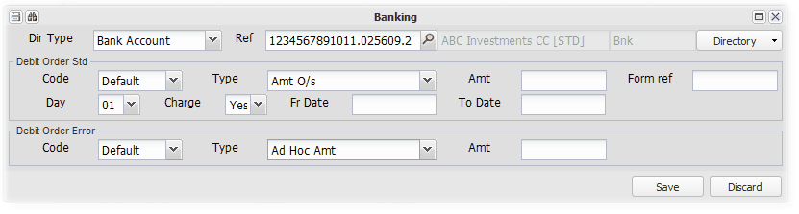

Suretyships
Link all sureties to relevant directory items:
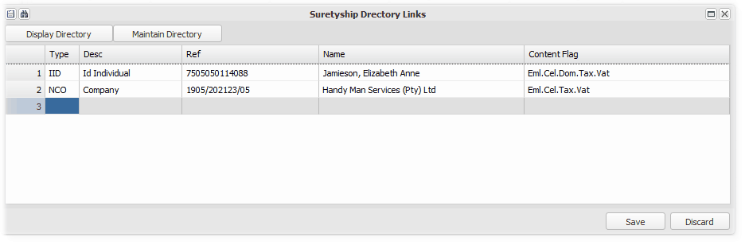

General Set Up
Payment flag:
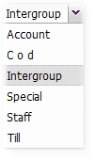

Define the way the debtor will usually pay and amount outstanding.

For property management and where properties share a group bank account, the amount due is paid automatically when the inter group debtors / creditors clear option is run. In this case, a creditor with the same number and also flagged as inter group, will be the other leg of the transaction.

Pricing
This section is used specialised trading environments, and not generally used in UniPROP.
You can leave the fields blank or the defaults in place.
Credit Control
Terms:
Enter the number of days that a debtor has to pay an invoice, or leave blank. This is more applicable in a normal trading environment, as property invoices are usually payable on the first day of each month.

Credit Limit:
Also more applicable in a normal trading environment. Enter the maximum amount that a debtor may owe to you in terms of your arrangements with him.

Financial Flags:
These are flags that indicate the status of a debtor. Credit control procedures are determined based on the flag. For example, if a debtor is flagged as 'H'anded over, there is no point in following up the debtor telephonically. Other examples of flags, that are set up in a separate table, are 'P'ayment plan and 'D'ebit order. Debtors financial flags are set up on Data Base Setup, Tables.

Statement Control:

Choose the default statement format from Excel or PDF, and the banking reference to be displayed on the statement, if it is different from the branch or database default:
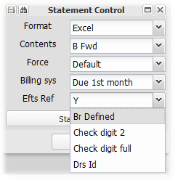

Choose the way that transaction and balances are displayed in the statement, from Open Item, Balance brought forward or both:
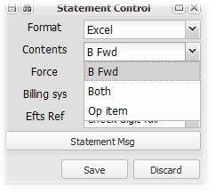

Choose the circumstances under which no statement will be sent out when sending out statements in bulk. Generally, a statement can only be sent out once per month from the auto-run option, but be resent from this screen: :
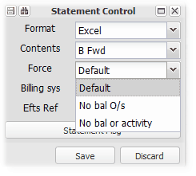
Enter a statement message which will override any message setup on the related branch, or database:
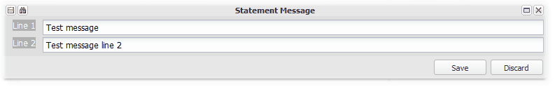
Refer to Setting up Debtor (Unit) statement messages for more information.

Other:

Enter the interest rate at which interest will be changed to this debtor on any outstanding amounts, and the normal settlement discount offered to the debtor:
Set the above interest rate to 0, to override the branch or database default interest rates. and block interest for this debtor. Refer to Setting up and charging interest on overdue amounts for more information on charging interest.

Other Links
Other functional links as described:

DCA Options
Use this option to charge debt collection fees to a debtor. The fee amounts are set up centrally, or per branch, on the reading Rates Button of Branch Maintenance
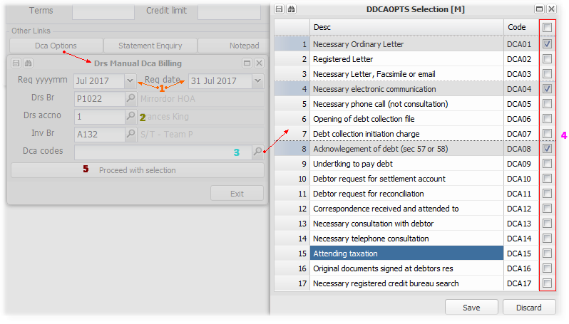

1 | Choose your billing period (usually the next statement month), and the due date for the charge in that month
2 | Accept or change the debtors and billing branch - These fees are usually charged by the debt collector, and not the branch (Property)
3 | Click on the view button to choose from a list
4 | Select the items that you wish to charge
5 | Proceed to charge

Statement Enquiry
Display debtors transactions for the selected periods, in open item or brought forward format, view or send an email version of a statement, and view the branch directory link:
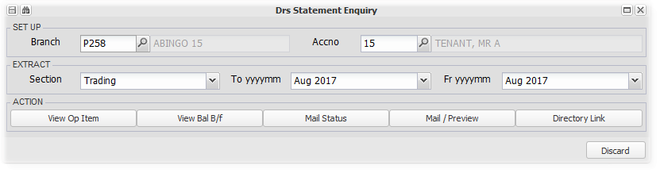
Refer to Debtors Statements in Debtors - Auto and Reports for more information regarding statements

Notepad
A notepad of relevant notes either entered here, or updated from system activities.

Set action dates that will be advised by mail, SMS or in a report as chosen:
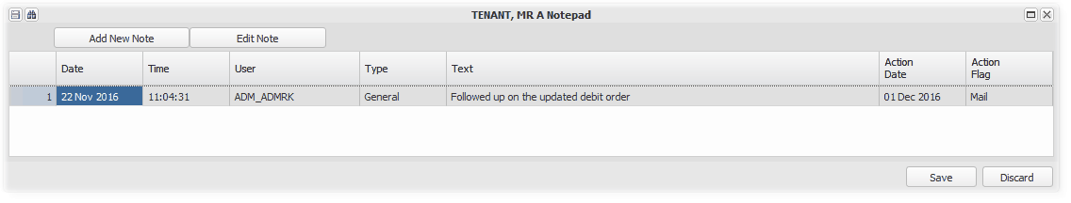

Indicate whether the note is legal or general. System notes will be flagged by the system:
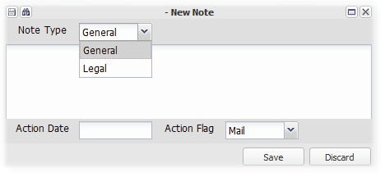

Choose the manner in which action date notes will be communicated:
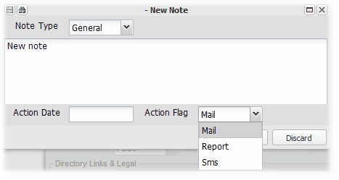

Maintenance Log
This option provides a log of changes to the debtors master file. Choose the areas that you want to cover, click on Proceed with Extract to view the log:
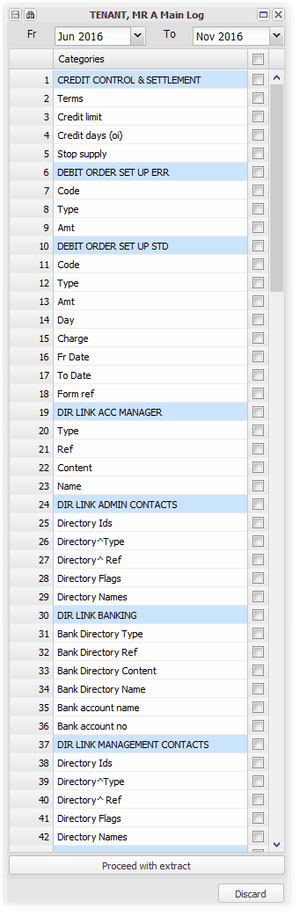
Asset Link
This options displays all Fixed Assets (Level 2) (Units), that have a Customer link to the relevant debtor. Linking a Unit to a Debtor causes any invoicing set up on the unit to be charged to the linked debtor. You could link more than one unit to a debtor, as in the example displayed below. Having selected a linked unit, you can edit the invoicing set up by clicking on 'Fee Table', and changing the details in the Invoice Set Up screen:
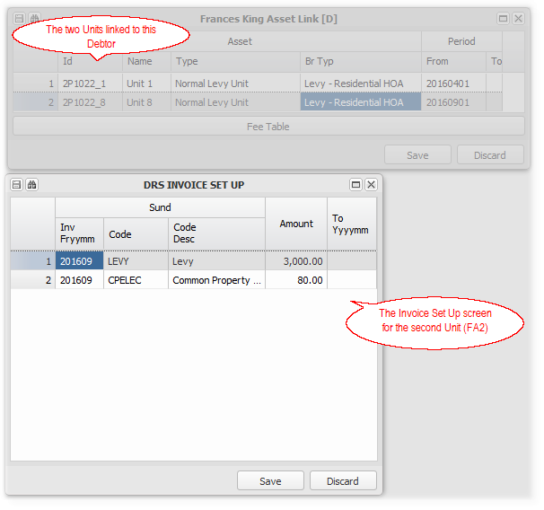

Journal
Enter topic text here.

Debtors Loan
This utility is a worksheet and loan working screen used to calculate and store debtors loan details:

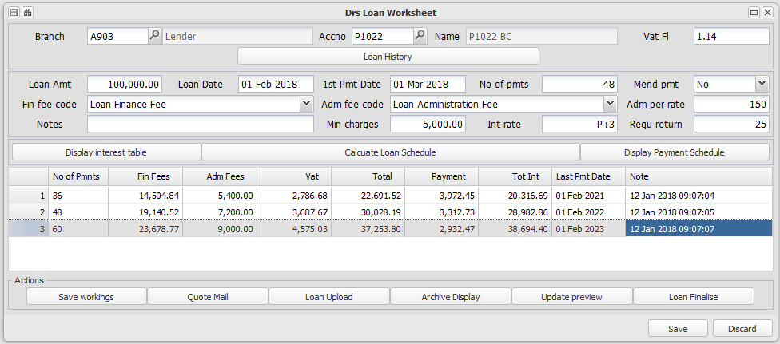

Refer to Setting up and processing Loan debtors for more information.

Auto Menu
The Auto Menu contains various actions and reports that all relate to debtors.

The following is an example of the run time options, with relevant general information in using this option. The individual section below will give more information for their particular section.

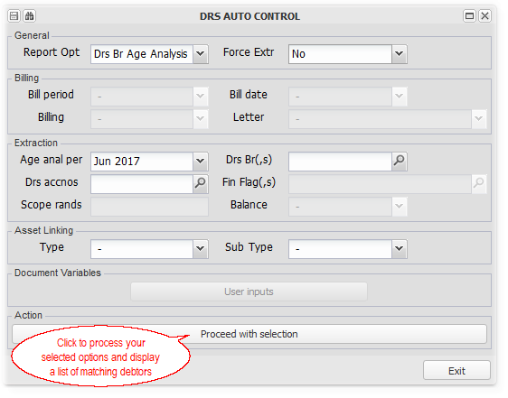

A list of debtors that match the options you chose will be displayed. You can then choose which items to process further by clicking the relevant check box, double clicking or entering on them, or selecting all by choosing that option in the left hand toolbar. The example below is a statement option, so we demonstrate how to view the statement to be sent:
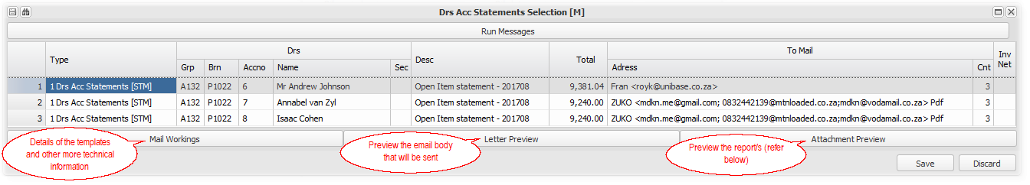
An example of the Attachment Preview for a debtors statement, where a deposit slip is also attached:
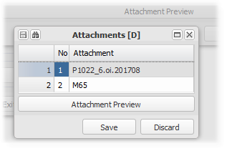

Auto Pilot
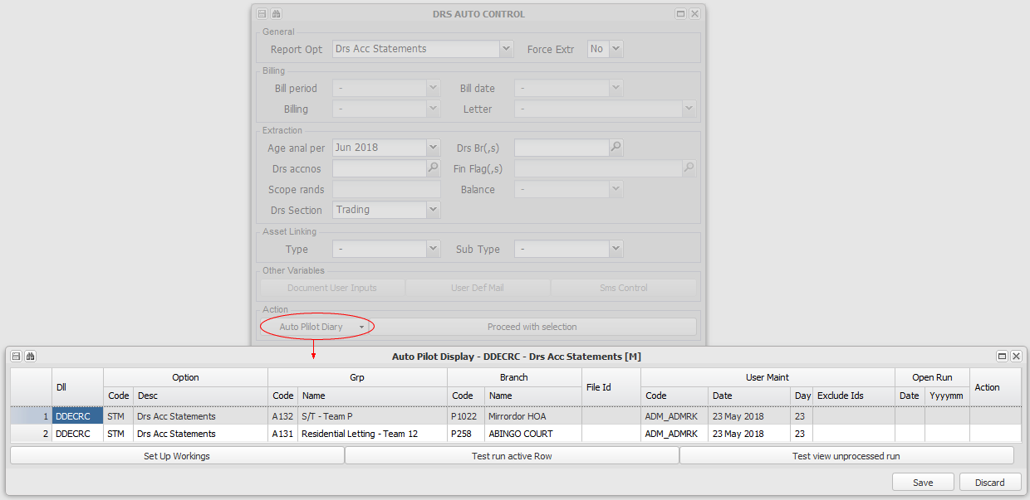

Auto - General
This option is usually reserved for system users, as it has all of the options in the menus below.

Debtors Account Billing
This option charges agreed fees from a branch (usually an Agent), to another branch (usually a Property), for its contracted management services. These fees are usually fixed amount fees, charged once per month. The system will only allow them to be raised once per debtor per month.

These fees are set up on the debtors master file record, in the charging branch, for the branch being charged. Refer to Debtors Master Maintenance, Services Agreement and Services Table for more information on setting these fees up.

A list of fees based on your selection will be displayed - choose the ones (or all) that you wish to raise and click 'Save' to process:
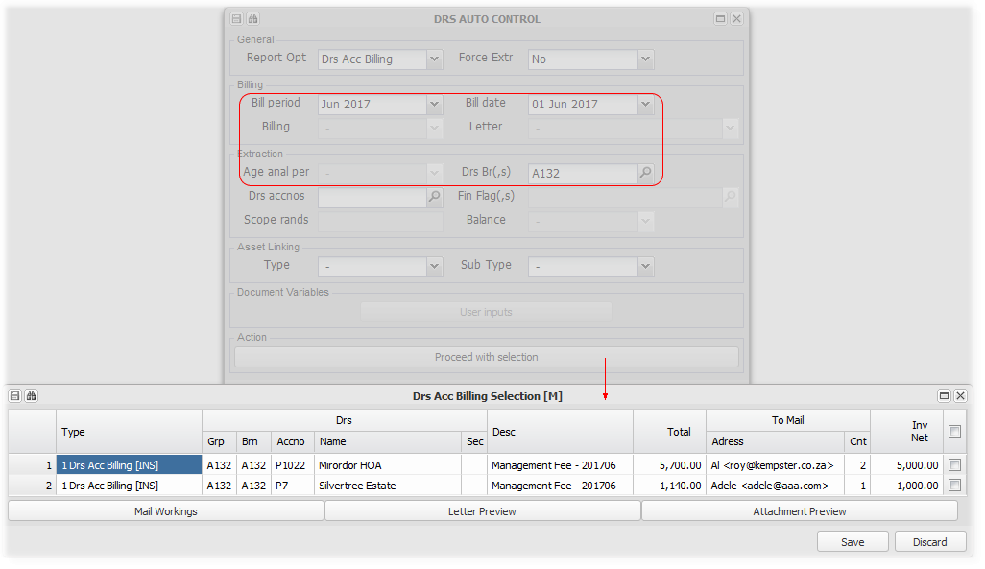
The system will raise a matching creditors entry in the branch (Property) being charged.
Both the debtor and creditor are defined as 'Intergroup', and the payment and receipt of the amounts due will be paid automatically when Debtors, Auto Menu, Debtors Inter Group Clear - Invoices, is run

Debtors Account Collection Letters
Debt Collection Letters are produced in the process of collecting outstanding balances from debtors.

Different letters are produced and emailed, based on the stage of the collection process, and the type of branch (Property) that is being collected for. The controlling branch (Agent), usually charges the debtor an amount defined in the Debt Collectors Act, for sending the letter, which will be automatically charged when the letter is sent. The system will add a note to the debtor that the letter was sent, which note appears on the Age Analysis.

You can add your own letters using the system template variables, creating them using Word, and following the steps described in Setting up Dcl (and for more information on setting up a new or amending an existing Dcl), and the relevant charges.

Remember that the format of the letter attachment will be based on the choice made on the directory item report format rule for the relevant debtor - this will either be PDF or Word.

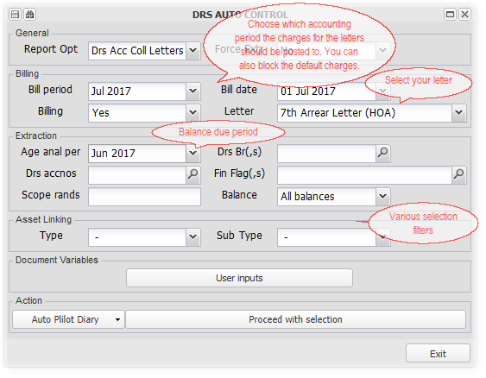
Certain letters require information that is only available when the letter is run. Templates can include a user defined variable, starting with an 'i' (eg. ~iVACDTE", which can be defined by clicking 'User inputs' and typing the information for the relevant variables.

Debtors Account Contra Journal
This option will contra open debtors transactions against each other. The rule is that any credit will be contra'ed against the oldest debit open items.

This process should be run as a maintenance function, usually once per month

Debtors Account Deposit Refund
XXXXXXXXXXX

Debtors Account Fee Increase Layers
XXXXXXXXXXXXXX

Debtors Account Fee Increase Letters
XXXXXXXXXXXXX

Debtors Account Interest
This option raises interest on arrears (trading), credits interest on deposits and raises interest on loan debtors.

Refer to Setting up and raising/crediting interest on Overdue amounts, Deposits and Loan debtors for more information

Debtors Account SMS
XXXXXXXXXXX

Debtors Account Statements
Debtors statements can be sent (or viewed) individually or in bulk using this option. A statement for one debtor can also be sent from Debtors Master Maintenance.

There are filters to allow the choice of statements to be restricted to all debtors in a Branch (Property), an individual debtor, or all debtors in selected types of branches (Asset Linking).

There is a base system principle that a statement for a selected period will only be sent once per month. To override this rule, set Force Extract to Yes.

Screen fields that are not relevant to statements, are not available having chosen statements, as can be seen in the example below:
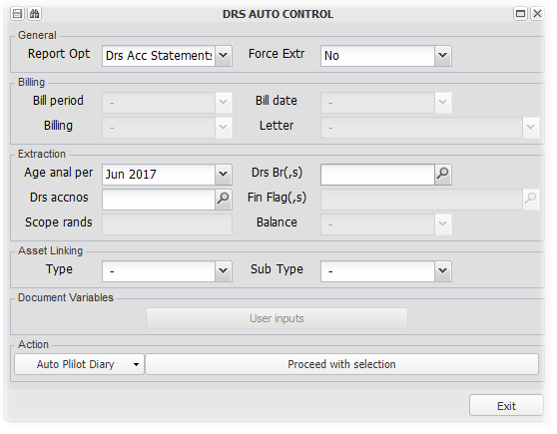

In selecting information to display on a statement, there are various precedence rules. In a property management environment, a statement combining the transactions of more than one branch is often the norm. Staff contacts also often relate to a group of branches, and only captured on the group branch. The group branch registration and VAT registration numbers are also often used, in place of the individual branch details. There are precedence and specialised variables to accommodate these requirements.

The standard statement is often used as a Tax Invoice as well. The relevant registration numbers and VAT charged details are detailed in the statement to accommodate this.

Please refer to Templates in more detail, Debtors Statements for more information about the statement layout and variable precedence rules.

The system default for the statement format is Excel. Each directory item has an option to change the default to PDF.

Statements can be sent in Open Item format, or in Brought Forward format - Set the default for each debtor or use the system default of Open Item. The brought forward statement ensures that the balance carried forward on any previous month's statement will be the same as the brought forward balance on the next month's statement. An open item statement balance will vary based on what items are still open at the time of producing the statement.

 | Brought Forward statement transaction cut off - A key rule for brought forward statements, is that when a statement is sent for a particular month, the detail of the statement and the fact that it has been sent is recorded. If transactions for that statement month are captured after sending the statement, those transactions will only appear on the next months statement.

A list of statements based on your filters will be displayed for selection to send. Choose one or all, and Save to send the statements:
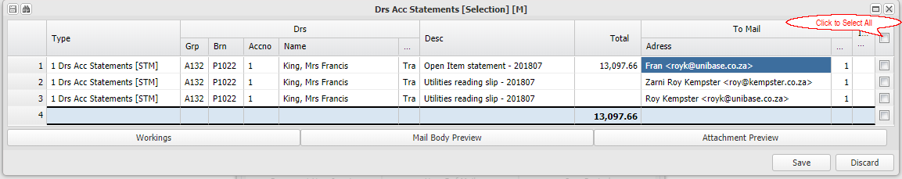

To view the attachments to an email, click on the relevant line, and then on Attachment Preview. Click on the relevant attachment and again on Attachment Preview - The attachment will be downloaded and displayed:
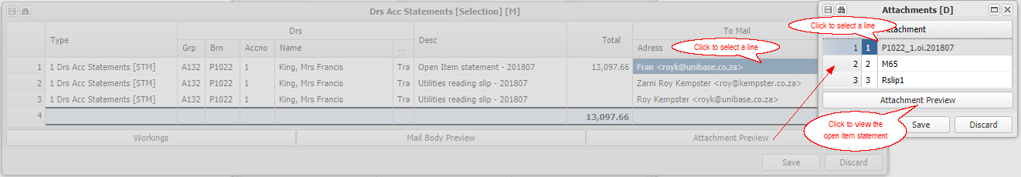

 | 1. | Set Force to 'Y'es if any of the debtors in your selection has already had a statement sent to them for the selected period
 | 2. | If a CIN (Bank reference number) is added to the branches bank default account directory entry, a pre-populated bank deposit slip will be sent with statements. Refer to Templates in more detail for more information.

Debtors Account - User Defined Email
This option allows you to send user defined eMail to selected debtors, with attachments that you choose and upload. This option is useful in sending for example, meeting notices, event notifications etc.

Choose your branch/es and debtors:
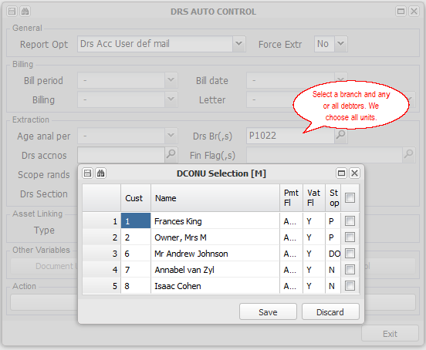

Click on User Defined Mail to set up the email:
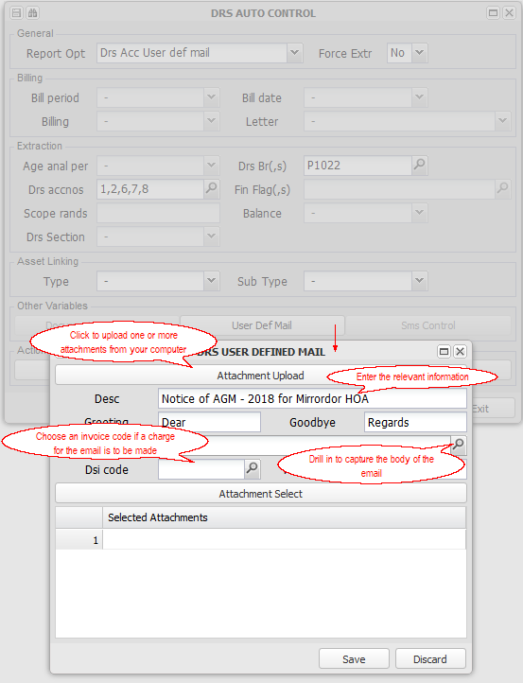

Drill to enter the body of the email. This can be copied and pasted into the capture window:
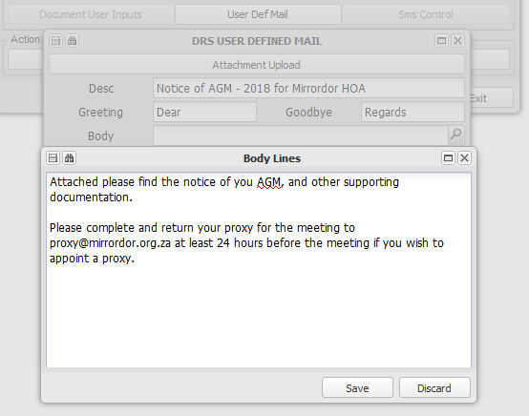

We upload two documents:
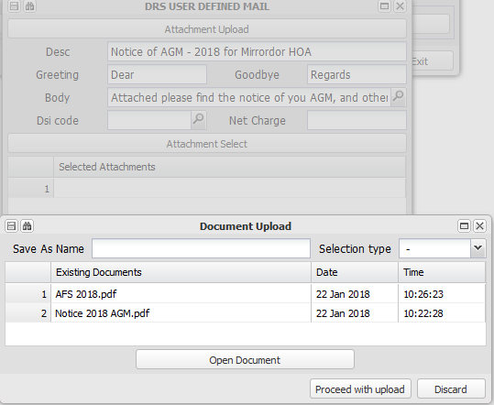

And then choose to attach both:
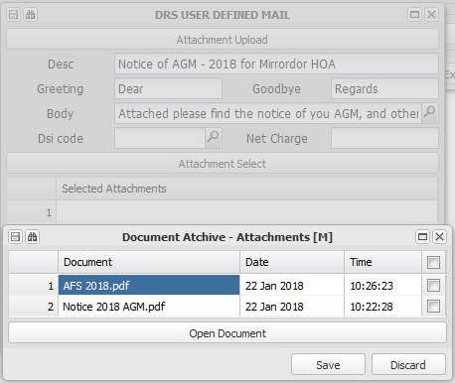

Click on Save, confirm your selection, and Save to send the emails:
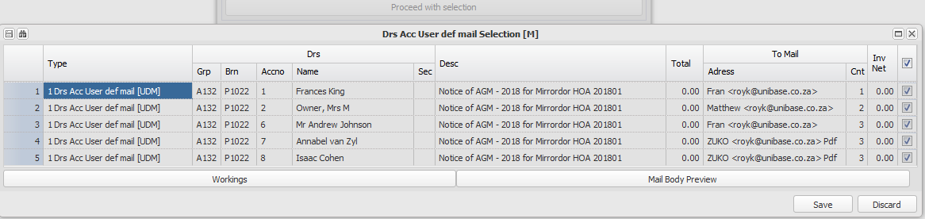

Debtors Inter Group Clear - Invoices
This option will display a list of amounts due for selection and payment:

If the inter group accounts are within a shared banking environment, they will be automatically paid and receipted. If not, the funds will be paid using Transaction Approval, either via. Host to Host banking or manually using a bank interface.
Interest accrued on shared banking overdrawn balances will also be paid using this option.

Debtors Look up
A look up facility relating to Debtors.

Refer to General Data Searches for more information.

Debtors Account Loan Recalculation
This option recalculates debtors loan installments, based on their current balance and current interest rate. It is usually run each month, but must be run after any interest rate changes, or if any loan installments are missed.

Refer to Setting up and processing Loan debtors for more information

Debtors Intergroup Loan Managed Extension
This option advances the amount of a borrowing branches billing from the lending branch to the borrowing branch, as part of a managed loan arrangement.

Refer to Intergroup Managed Loan for more information regarding its use.

Debtors Branch Age Analysis
A branch Age Analysis for one or many branches can be viewed or emailed using this option. Any notes captured for the debtors for the selected period will be displayed.

Selection based on branch (property), debtor (unit) and branch type is available.

Note that the fields that are not relevant to an age analysis are not available:
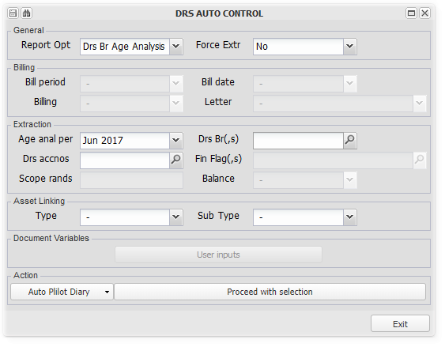

As described above, the result of your selection will be displayed for you to view or send the reports.

Please refer to Templates in more detail, Age Analysis, for more information about the age analysis layout and variable precedence rules.

Debtors Branch Move Report (Levy/Rent Roll)
The Debtors Branch Move Report (Rent Roll or Levy Roll) reflects the opening and closing balance for each debtor in a branch, and details and summarises the transactions for the selected month.

Selection based on branch (property), debtor (unit) and branch type is available.

Note that the fields that are not relevant to a movement report are not available:
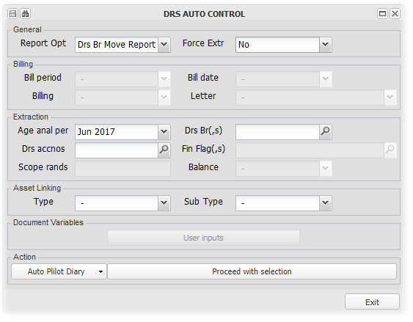

As described above, the result of your selection will be displayed for you to view or send the reports.

Please refer to Templates in more detail, Debtors Branch Move Report, for more information about the age analysis layout and variable precedence rules.

The heading for this report will default to 'Debtors Move Report', or be a Rent Roll or Levy Roll based on the setting under Create/Maintain Branch, Asset Maintenance

Debtors CSOS Levies
This option raises CSOS levies for the periods and branches selected.

Refer to Setting up, Charging and Remitting CSOS levies for more information.

Debtors Intergroup Bank Charge Service Fee
This option raises a monthly bank charge service fee for all but excluded branches, that use shared banking.

Refer to Setting up Bank Charge Recoveries for more information

Debtors Intergroup Bank Interest Accrual
This option raises interest, if set up, on any overdrawn shared bank accounts.

Refer to Setting up and charging interest on shared banking overdrafts for more information on using this facility.

Debtors Intergroup Clear - Collection Commission
This option will display a list of amounts due in respect of collection commission for selection and payment.

Refer to the Inter group Invoices option below, which uses the same method of payment.

Debtors Intergroup Clear - CSOS
This option transfers the funds raised as CSOS levies from the originating branch, to the sweeping branch.

Refer to Setting up, Charging and Remitting CSOS levies for more information.

Debtors Intergroup Clear - Sales Commission
This option will display a list of amounts due in respect of sales commission for selection and payment.

Refer to the Inter group Invoices option above, which uses the same method of payment.

Debtors Intergroup Loan Payment
This option raises installment payments in terms of debtors loan agreements.

Refer to Setting up and processing Loan debtors for more information.

Csos Manual Journal
This utility allows for manual CSOS adjustment batches to be processed:

Refer to Setting up, Charging and Remitting CSOS levies for more information

Debtors Refund
Use this utility to refund a credit balance on a debtors account to the debtor.

The debtor must have banking details loaded. The system will charge the debtor any bank charges incurred and refund the balance less the bank charges.

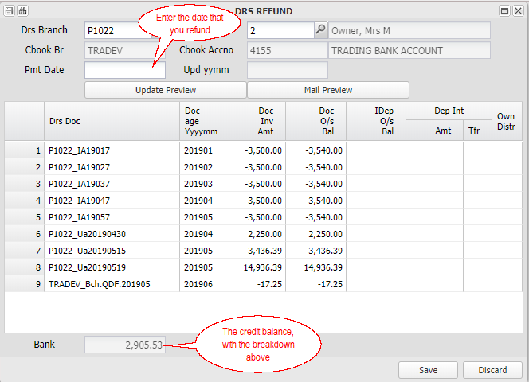

Once Saved and updated, the payment can be released using Bank Transaction Approval and Bank Transaction Perform

The debtor will be sent a confirmation of the refund with a breakdown of the amount via. eMail.

Creditors
This group of menus contains various maintenance, reports and utilities relating to creditors. It also includes creditors payment options.

Capturing invoices from creditors is achieved using one of the options under Purchasing.

Creditors for a branch can be setup to be creditors for that branch, or shared creditors with another branch.

Creditors Master Maintenance
Create or maintain a previously created creditor, linked to a branch.

A creditor can be any entity to which a branch owes money. In a property management environment, is is often the agent branch, for the services that it renders to the property branch. These type creditors will be flagged as Intergroup (payment flag), to facilitate their automated payment within a shared banking environment. Refer to How do I charge fees to a property for more information regarding this process.

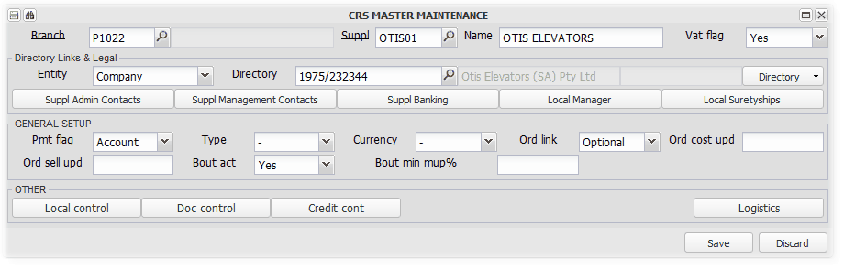

Directory Links and Legal
Directory Link:

Supplier Admin Contacts:
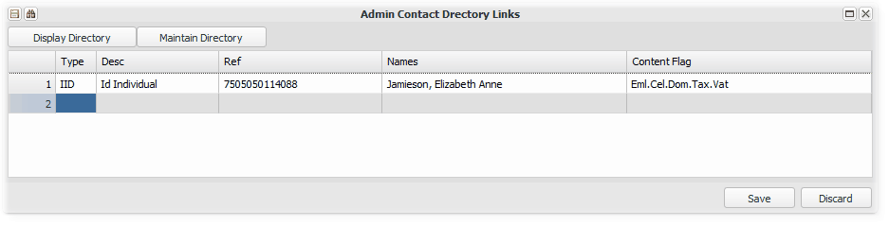

Supplier Management Contacts:
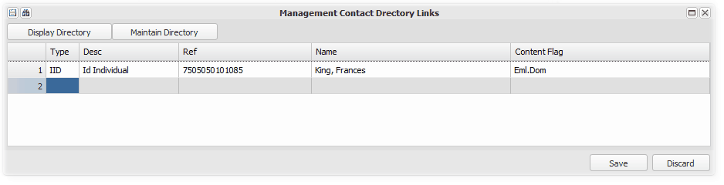

Supplier Banking:
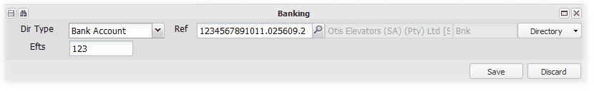

Local Manager:
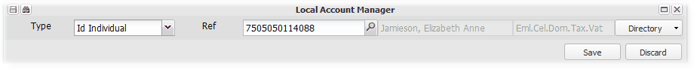

Local Suretyships:
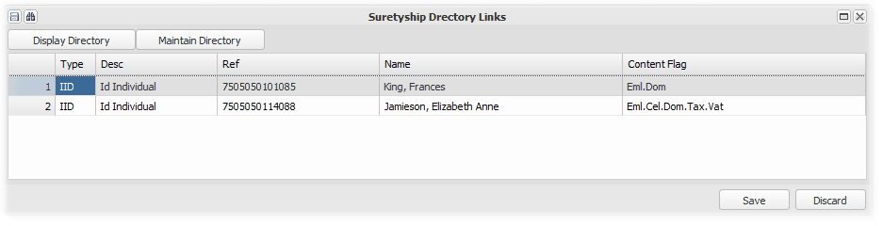

General Setup
Payment flag
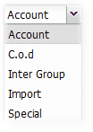

Other

Creditors Transaction Enquiry
This item provides views of creditors transactions.

You can choose the document and content format, the required period and email an extract directly from this screen:
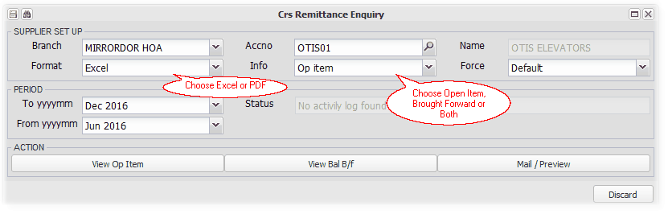

Clicking on the 'View Open Item Button'. This will display all unmatched transactions up to the end date:
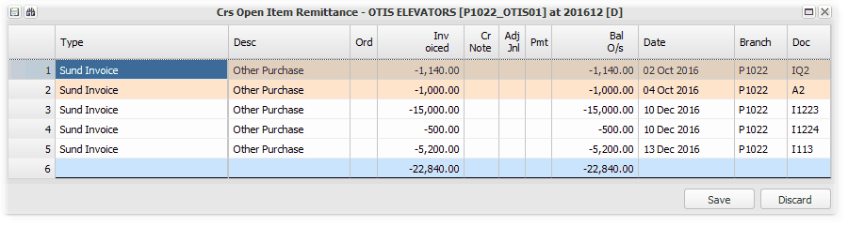

Clicking on the 'View Balance Brought Forward' button, displays all transactions for the selected period, with an opening and closing balance. Note the closing balance is the same as in the open item example above
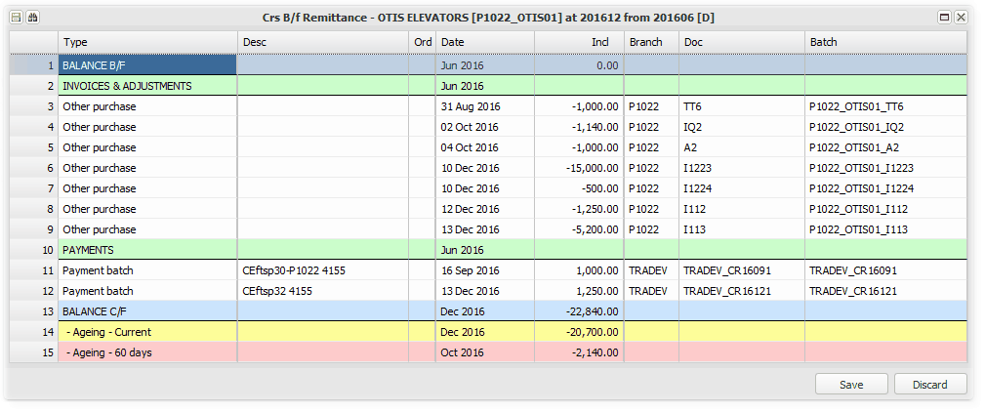

You can send a copy of the above by clicking on Mail/Preview

Auto Menu
Various Creditors related functions

General
This facility groups various actions and reports that all relate to Creditors.

The following are examples of the run time options, with relevant general information in using this option. The sections below give more information for their particular section.

Before choosing a report option, all fields will be available:

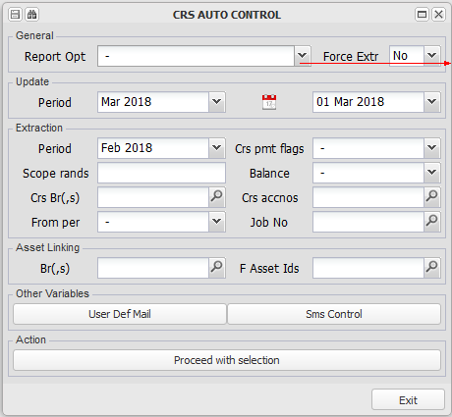 | 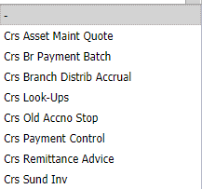

Creditors Asset Maintenance Quote
Creditors Payment Control
This option facilitates the payment of one or more branch's (property or agent's)creditors. Paying for many branches will bring up the balances due to creditors per branch, where there are sufficient funds available to pay. The Run Messages and Run Errors will indicate insufficient funds or set up issues. Paying for one branch will allow you to choose which invoices to pay, indicating the funds available to pay.
Pay for All branches
Choose the month (Extraction Period), and do not restrict the branch selection. All creditors for all branches that you have access to, and that have sufficient cash availability to pay all outstanding invoices, will be processed, for all approved invoices up to and including the month specified:
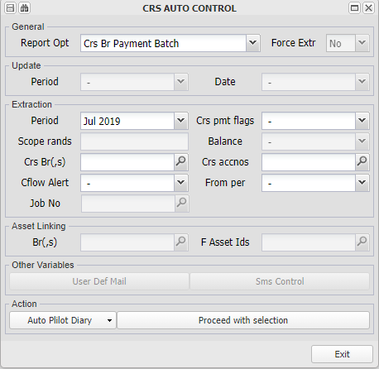

Choose which items you wish to pay by checking the tick boxes on the right:
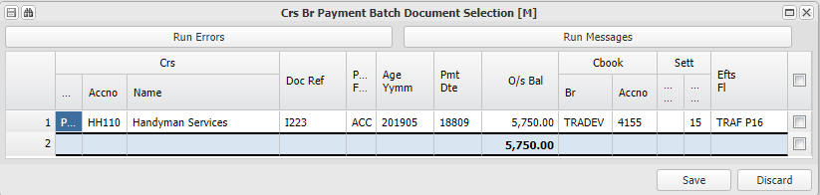

Click on the Run Errors button to view set up issues for branches that you have access to:
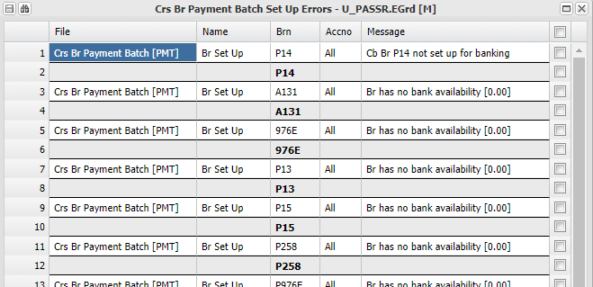

Click on the Run Messages button to view details of invoices not included in the amounts to be paid. These can be followed up by using the Pay for one branch facility referred to below::
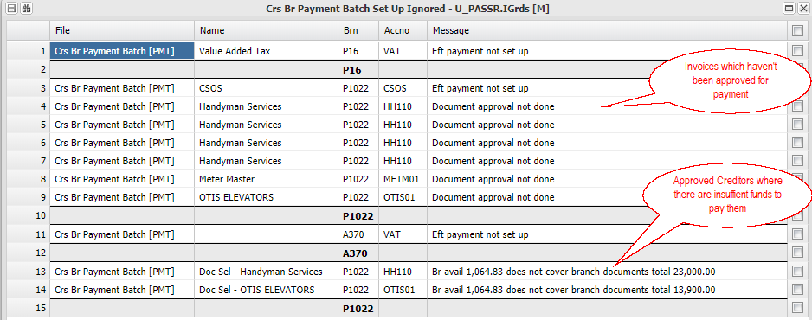

Payment batches created are paid using Bank Transaction Approval and Bank Transaction Perform

Pay for One branch
This option is useful where there are insufficient funds to pay all amounts due. All outstanding invoices for all creditors will be displayed. The screen will indicate the funds available considering preferred other creditors, and other invested funds.

Choose the branch and the period that you require:
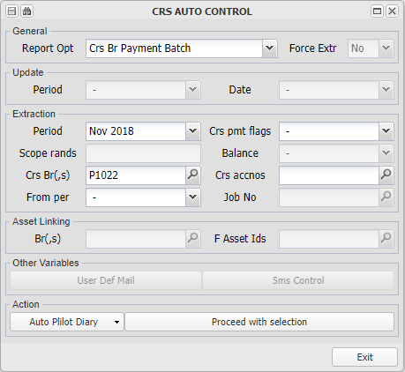

From the funds available for the branch (property), choose which invoices (or part of an invoice) that you wish to pay by capturing the amount to pay next to each selected invoice:
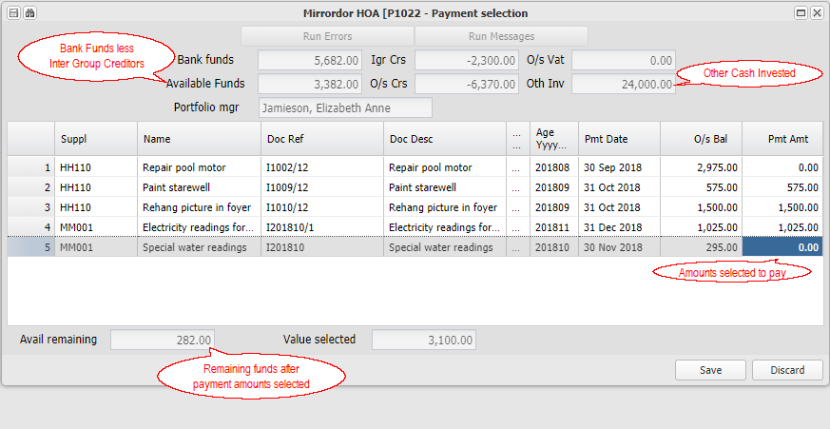

Payment batches created are paid using Bank Transaction Approval and Bank Transaction Perform

Creditors Branch Distribution Accrual
This option initiates the distribution of either surplus fund or a dividend from a branch, based on the distribution rules set up.

Choose this option, month and branch/es, and Proceed with Selection. Check the run errors for any exceptions with explanations.

Refer to Setting up Branch Distributions for more information about this process.

Creditors Remittance Advice

Creditors Master File Look up
A look up facility relating to Creditors..

Refer to General Data Searches for more information.

Creditors Document Look up
A look up facility relating to Creditors documents (Invoices)..

Refer to General Data Searches for more information.

Management Log
Enter topic text here.

General Ledger
Various accounting and set up utilities and reports.

G/L Reporting
Enter topic text here.

G/L Trial Balance
This option displays a general trial balance, with drills down to transaction level for each item. In the branch extract, branches will be shown separately, with selected months being combined. In this report, months will be shown separately, with selected branches being combined..

You can choose any period, and multiple branches that will be consolidated into one report. Transaction drills will display branches separately. Click on Proceed with Report to display the trial balance.

You can export the display to Excel by clicking on the Excel export button on the left.

Note that income and expense items will be grouped into an appropriation account for the opening balance brought forward.

The options available are displayed as detailed below:
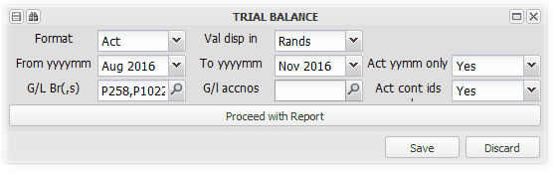
Choose the format options that you require:
Choose the trial balance format, as actual, actual and budget, or actual budget and variance, for each period selected:  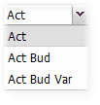  Budgets are uploaded using Budget Capture | Choose to display the values in:  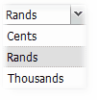
Choose your branch/es and drill into the details
Choose your period, whether to display active periods only and restrict the trial balance to any selected general ledger codes. We chose two branches in the example below:
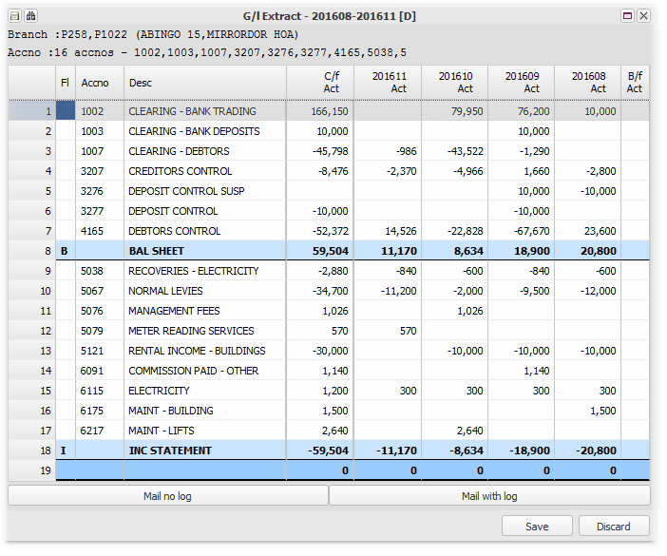
We drill in on general ledger code 6217. Note the two branches shown separately:
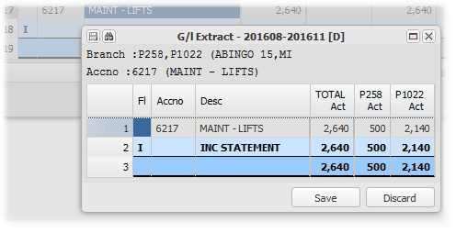
The next level drill displays displays the base transactions:
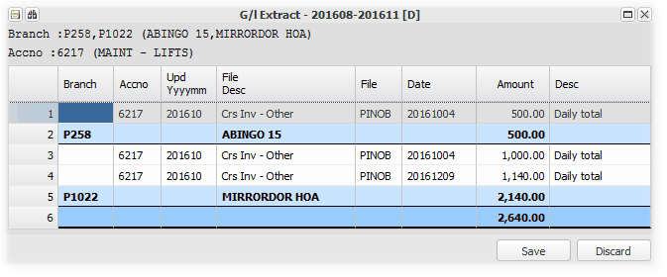
We drill on P258:
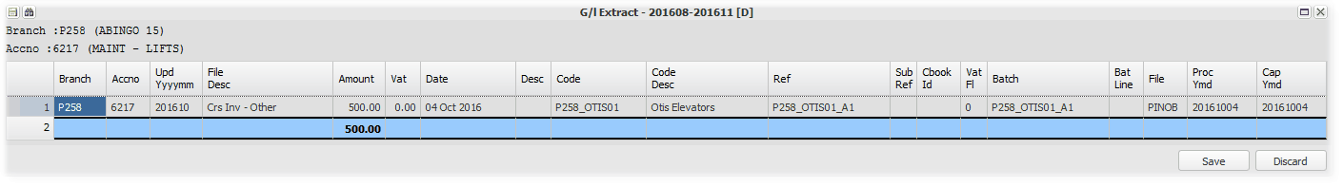
And then on the one transaction:
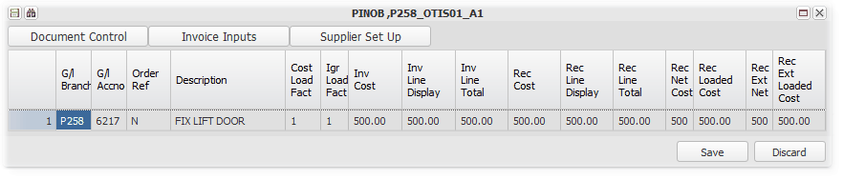

Clicking on Document Control, shows more details including the user that captured the batch:
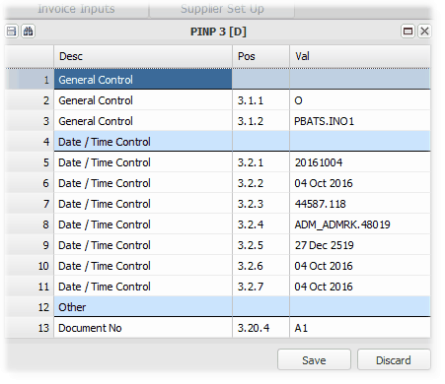

General ledger transaction listing
There are two transaction drill levels - first level summary totals, and second level detail drill. If your trial balance period covers a financial year based on the branch financial year end, you can obtain a classical general ledger export with opening balances, and with income and expenditure accounts starting off at zero.

First level summary drill
Click on the total line and then on the Drill button:
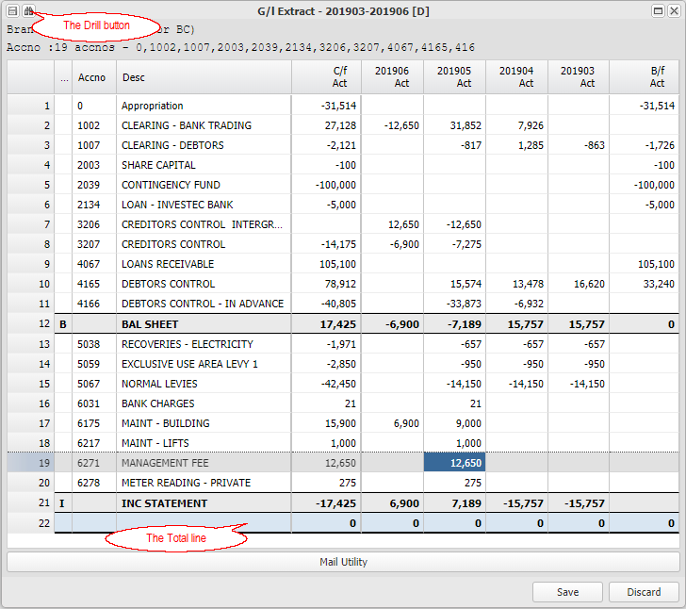

First level summary detail drill, with totals per month and per batch type:
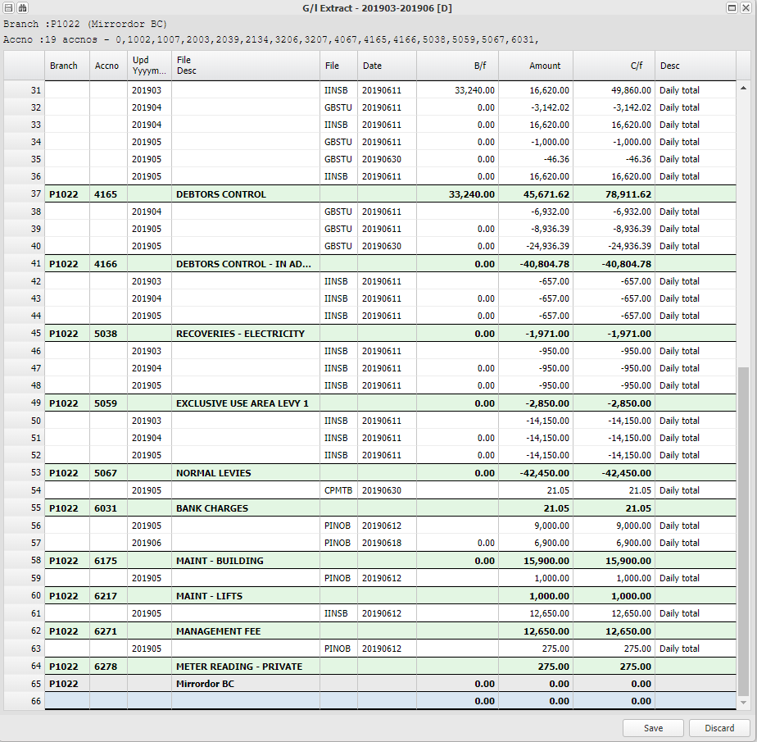

Second level detailed transaction drill
Drilling on the Total line of the first level drill, displays the full detailed transaction listing with opening balances, transactions and closing balance, which can be exported into Excel:

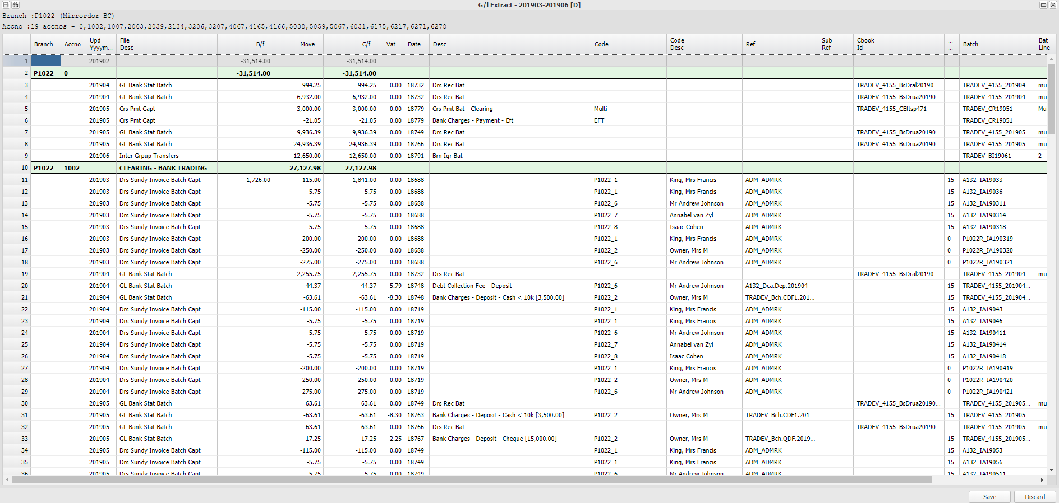

An overview:
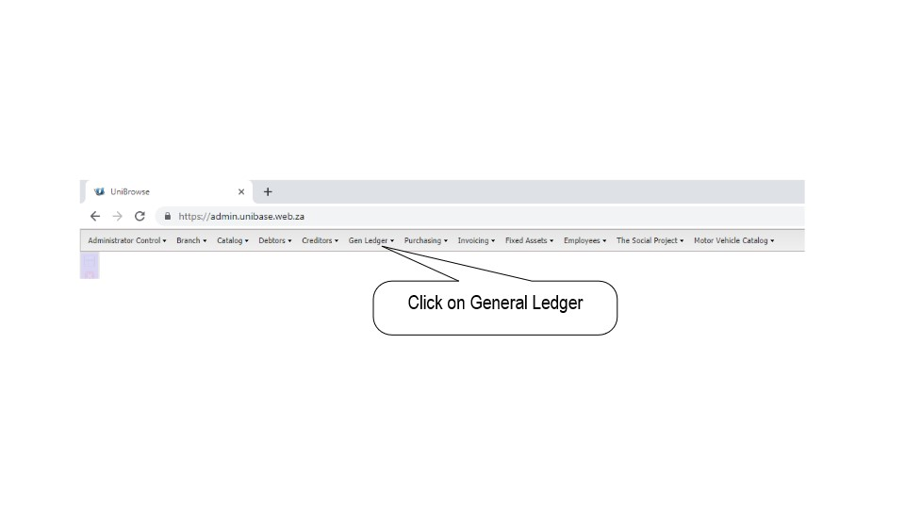
Trial Balance and GL Listings

G/L Branch Extract
This option displays a multi-column trial balances, with selected branches in each column. In the trial balance, months will be shown separately, but branches combined. In this report, branches will be shown separately, with months combined.

You can choose any period. If you choose year to date (YTD), the to date will be the effective date, and multiple branches that will be consolidated into one report. Transaction drills will display branches separately. Click on Proceed with Report to display the trial balance.

You can export the display to Excel by clicking on the Excel export button on the left.

Note that income and expense items will be grouped into an appropriation account for the opening balance brought forward.

The options available are displayed as detailed below:

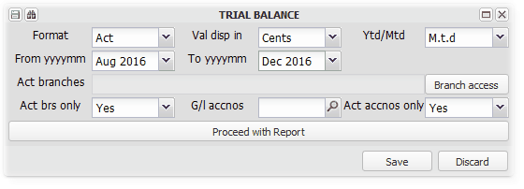

Choose the trial balance format, as actual, actual and budget, or actual budget and variance, for each period selected: | Choose to display the values in: | Choose Month to Date or Year to Date Values:  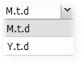

Choose your period, remembering that income statement opening balances will be grouped.

Select which branches you want to display in your report, by clicking on Branch Access.

We chose two branches, YTD, from Oct 2016 to Jan 2017:

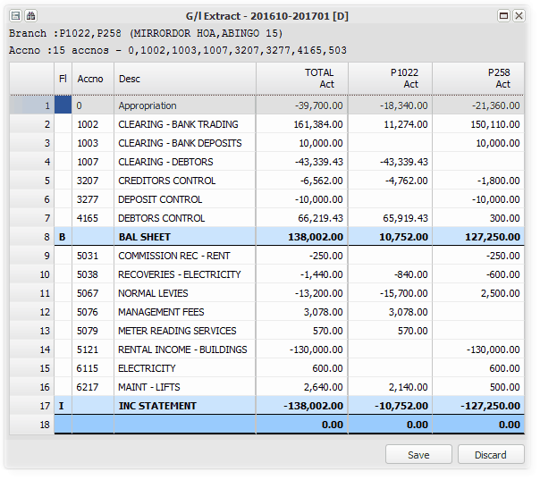

We drill on 5121:
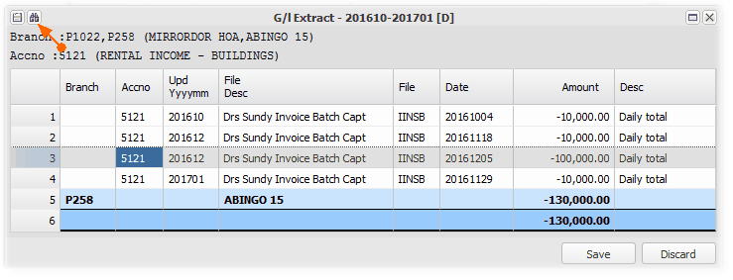
and then on the R100000-00:
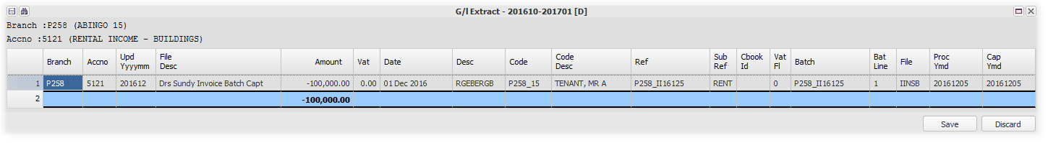

and then to see the invoice capture screen for the transaction:
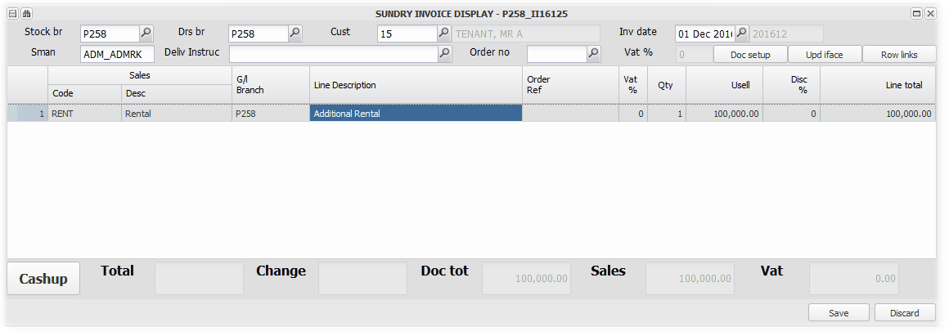

GL % Comparison Report
This utility allows you to compare the movement / balances on two matched general ledger codes, expressed as a percentage.

The comparison selection is based on debtors sundry invoice codes that are set up with a matching / opposite general ledger code. You can choose to filter the results by the percentage or the variance being positive or negative.

Setting up matching codes
Menu: General Ledger, Database Setup, Debtors Sundry Invoice Codes

This report will display a list of debtors sundry invoice codes that have an income and an expense general ledger code. Choose the items that you wish to compare:
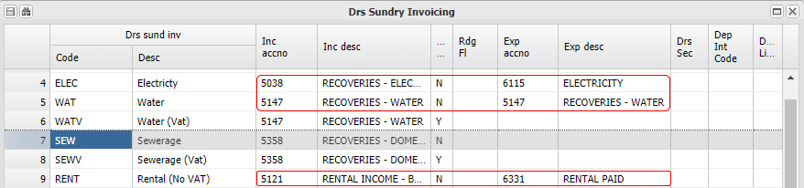

WATV, SEW and SEWV will not appear for selection in the example above.

Running the report
Menu: General Ledger, G/L Reporting, GL % Comparison Report

Select one or more branches (properties) and invoice codes, the period and year to date balance or month movement. Filter by percentage and positive, negative or all variances:
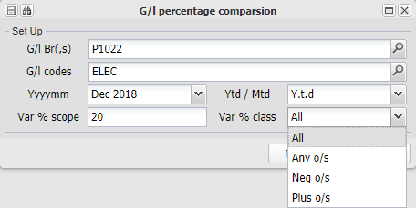

A report example, which can be exported to Excel:
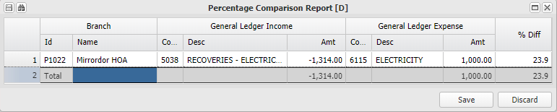

Journal
A multi-line standard general ledger journal facility.

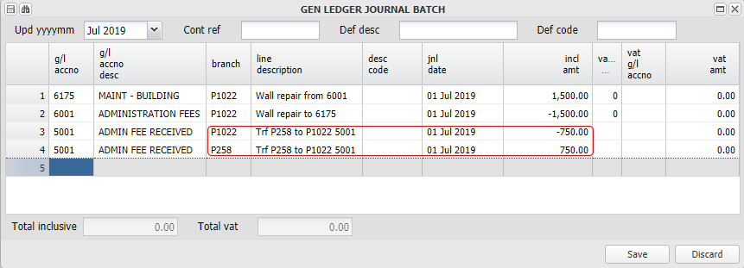

A batch can be imported from an Excel spreadsheet which is in the same format as the screen.

Entries can be captured for periods from one month ahead of the current month, and for three years prior thereto.

Entries can be captured for difference branches, as long as the net total at the end is zero. The system will automatically allocate inter branch differences to the general sharing account (Inter branch loan account) set up for that purpose in Database Setup. Any branch imbalance balanced via general sharing.

TO CONFIRM RULES

Bank Statement Menu
The menus in this section are used to manage the importing, allocating, reconciling and balance control of bank statement transactions, which is used as both a source and confirmation of transactions.

After the initial setup of a bank statement format:

1. | Bank statements are downloaded form the bank into Excel, and imported using Bank Statement Upload
2. | The imported statement is then processed, batches built or entries flagged to analyse later using Bank Statement Maintain
3. | Items flagged to analyse later, are allocated using Bank Statement Ext. maintain

Bank Statement Upload
This menu item allows for the import of a bank statement file, that has been downloaded from a bank. Refer to Bank account and cash control for further information.

The following are the various steps - Click on the for more information:

Step 1 - Download your bank statement into Excel

An example of a Standard Bank Statement Export -

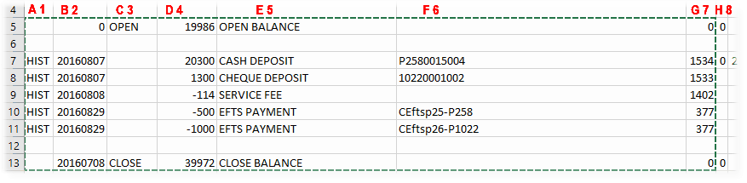

Step 2 - Open the Bank Statement Upload screen, and copy and paste the bank statement into the system

The system will make sure that the system opening balance is the same as the imported statement opening balance, and that the statement closing balance is the same as the system calculated closing balance based on the opening balance and the imported transactions.

The file type allocated by the system will depend on the codes, as setup when setting up the Bank Statement Format, and can be edited in the upload screen if necessary.

The import screen can be saved once the totals balance, and each line has a File Type allocated (This can be changed later). The next step is to Maintain the Bank Statement and create and post batches and matches that arise from the import.

Below is a screen shot of the Upload screen, after the bank statement example has been imported. You can mouse over the shaded fields to display a short description of their function, or click on them to view more detailed notes. Click on the arrow on the right to return to this screen shot:

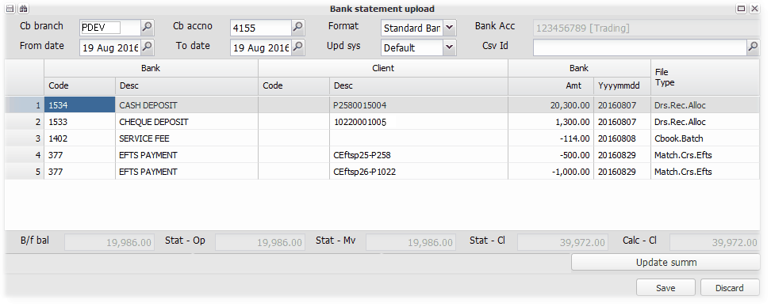

Cb branch | - | Select the Branch whose cash books you are maintaining. If you are maintaining a shared bank account, choose the Head Office Branch that contains the shared bank account/s .
Cb Acc No | - | Select the bank account within the branch that you are maintaining.
Format | - | Choose the bank statement format that you have downloaded and now importing. This will usually be a bank's format, but there could be more than one for a bank. Formats are set up using Bank Statement Formats. Example of a bank statement export file below, in this case, Standard Bank
From date | - | With your first upload, choose the start date of the bank statement that you are importing. The next date selection is the last date covered by the bank statement that you are importing - This plus one day will be the system start date when you next upload to this bank account.
To date | - | Choose the last date covered by the bank statement that you are importing. this plus one day will be the system start date when you next upload to this bank account.
Upd sys | - | Various options that determine the division of the imported entries when the screen is saved and update file/s are produced. The next stage after the upload is to Maintain the imported statement, by allocating entries and creating batches. The 'Default' option will create one update file, the "File Type' one update per file type etc. Choose the option best suited to your import operating environment, bearing in mind that you could allocated batches to different system operators to process:  1. Default - One Update batch  2. File Type - One Update batch per File Type (Debtors Allocation etc.)  3. Bank code - One Update batch per Bank Code  4-7. No of rows from 100 to 1000 - As many batches as necessary based on the selected number of rows per batch.
CSV Id | - | This is a link for automated download and imports if setup with your bank.
Bank Code | - | The type code determined by the bank, that indicates a Cash or Cheque deposit, an Efts receipt or payment etc. and from which the batch type is determined from the bank statement format setup.
Bank Descr | - | The banks description, usually based on their code.
Client Code | - | From the imported bank statement, usually initially sent to the bank by the account holder.
Client Desc | - | From the imported bank statement, usually initially sent to the bank by the account holder.
Bank Amt | - | The transaction amount per the bank statement
Bank Date | - | The transaction date per the bank statement.
File Type | - | The file type (action) that the transaction will initiate when the upload is maintained and posted. The various file types are shown below, and are discussed in more detail in the Bank Statment Maintain topic.
Update Summ | - | Based on your update choice, displays a list of update batches that will be produced when this screen is Saved. The example for this screen is shown below.
Balancing | - | The system opening bank statement balance, the calculated closing balance and actual closing balance. These must balance and agree to proceed.
Save or Discard | - | Saving will check that all items have been linked to a file type, and that the balancing is correct. Update batch/s will be created. Discard to cancel.

File types based on the bank code and as set up using Bank Statement Formats - (These will be discussed in more detail in Bank Statement Maintain):

Step 3 - Save the screen and proceed to Bank Statement Maintain to allocate and match the imported bank statement

The Update Summary for the example above:
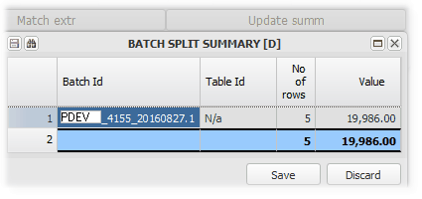

As we update this manual, some of the balances in the examples change and might not flow correctly. The principle being explained is however still correct and relevant and can be understood from the above notes. Wherever practically possible, we have used the same amounts.

Bank Statement Maintain
This menu item is the next step, after the Bank Statement Upload. Refer to Bank account and cash control for further information

Once you have saved your import, use this screen to allocate, match and create batches.

This example follows on from the example of the import, which was all in one batch.

After choosing your branch and cash book, choose which import batch you wish to work with, by selecting from the drop down list on Pg Ref: The list will display all unmaintained import batches for the selected bank account:

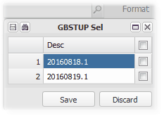

We choose 20160819.1 :

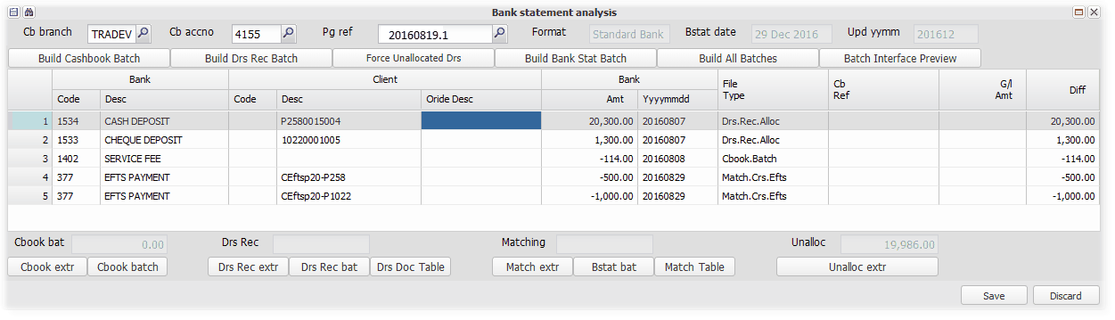

The imported transactions are displayed, which now need to be processed.

We choose to 'Build All Batches', which processes all that can be processed or matched, building the relevant batches. You can change the File Type if it is incorrect, by pressing 'F2' in the File Type column, selecting the correct file type (from the list below), and then building the batches.

Note that one of the Debtors receipts cannot be automatically allocated, and the creditors EFTS references are not automatically matched, after clicking 'Build All Batches':

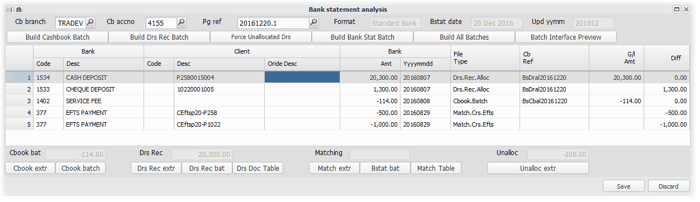
Note that the total of the unallocated values is R-200.00.

We are able to recognise that the Client Description for the R1300-00 receipt is incorrect - We could capture the correct description in the override column and re-build the batches (see example below), or manually allocate the receipt to the correct debtor and invoices, by pressing 'F3' on the File Type column (See example of this below) on the relevant row, but we choose to Analyse.Later, and as we cannot match the EFTS payments now, we change their file type to Analyse.later...:

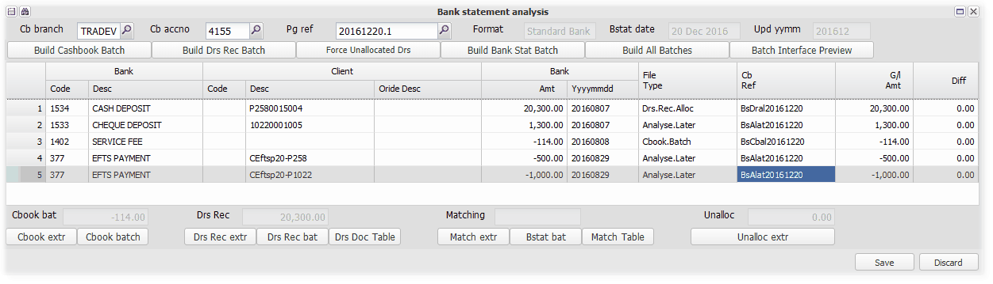
...and Save the screen. You van view and edit the system built batches by clicking on the relevant buttons at the bottom of the screen.

The unallocated (Analyse.Later) items will be stored in a batch, and can be processed using Bank Statement Ext. Maintain.

In the example above, we chose to analyse the receipt for R1300 later. The example below shows how to manually allocate the receipt, and how to allocate the unmatched portion to a new open item transaction, an Unallocated Receipt:

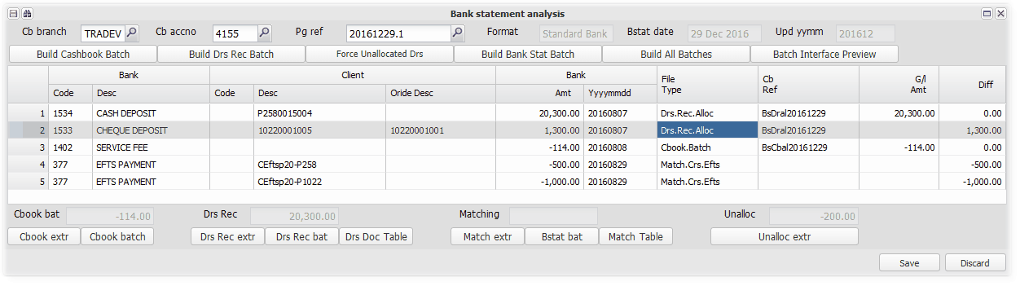

We capture the correct description in the override column, and then press F3 on the Type column to manually allocate the receipt, as the automatic allocation does not balance to 0:

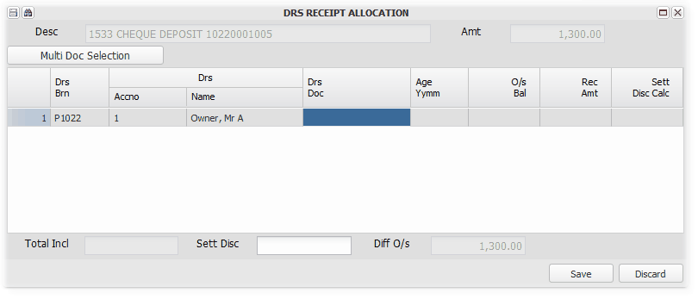

Pressing F2 or searching on the Document column, displays the open item unmatched items, and an option for an unallocated receipt amount:

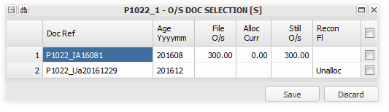

First we match the R300-00, and then create an unallocated receipt of R1000-00:

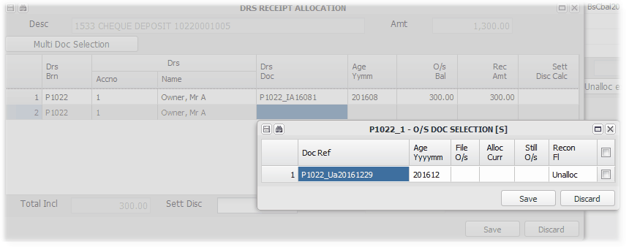

The outstanding difference is now 0:

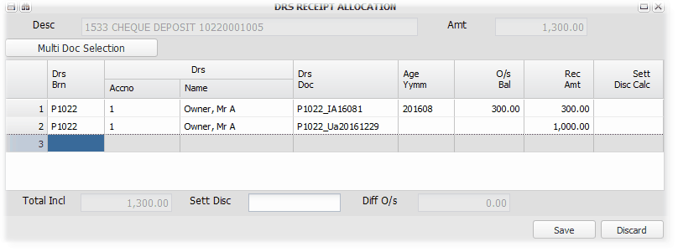

Save and back to the maintain screen, that now has 0 as unallocated.

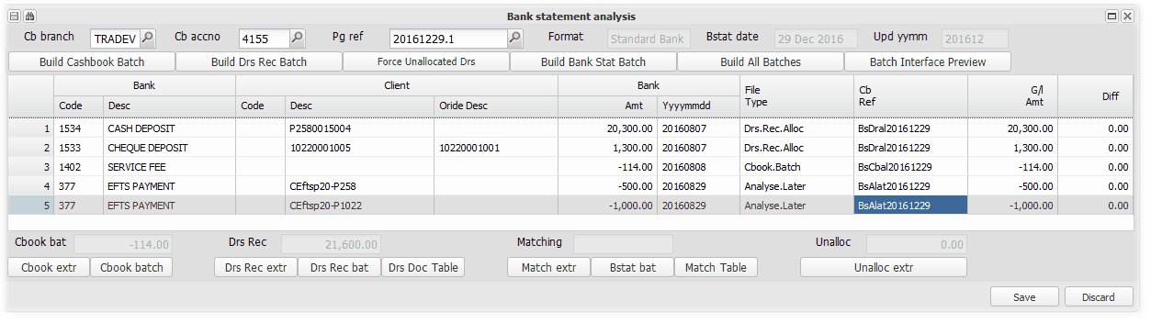

We save which updates all of the transactions.

If your preference is to not spend time allocating all of the entries before processing those that do auto-match, use the Force Unallocated Debtors button. This will change all unmatched receipts to 'Analyse Later', and receipt all amounts that do have a matching reference as an Unallocated Receipt within the linked debtor.

Various File Type and their descriptions:

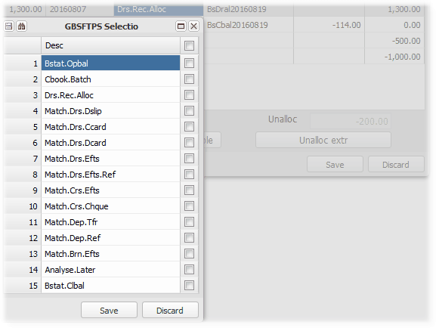
  1. Record the item as a bank statement opening balance
  2.
  3. A debtors receipt batch, allocated against invoices
  4.
  5.
  6.
  7.
  8
  9.
  10
  11
  12
  13
  14. Choose to not process now.
  15

Bank Statement Ext Maintain
This menu item is the next step, after the Bank Statement Maintain. Refer to Bank account and cash control for further information

This item enables you to allocate items from batches previously flagged as 'Analyse.Later'. It is usually used to track unallocated receipts per bank account.

Note that the unallocated items have been included in the bank account balance, and stored in the general ledger, as indicated below:
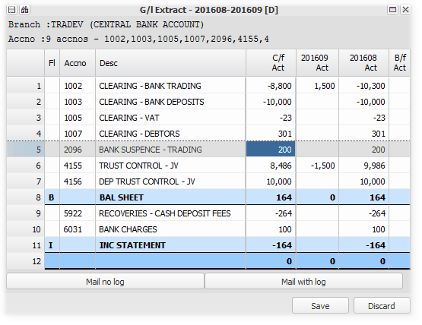
The steps in reallocating:
Choose Bank Statement Ext. Maintain from the menu
Choose your branch and bank account, and click on Pg Ref:
We choose our branch and bank account, and click on Pg ref, which brings up a list of 'Allocate later' items. You can use the search facility to look for an item. This list can be distributed to assist the reallocation.

Choose the item that you wish to reallocate and click 'Save':
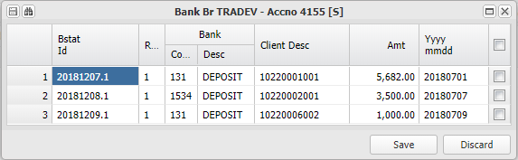

Having chosen an item, reallocate it to its correct allocation
We chose the first item:
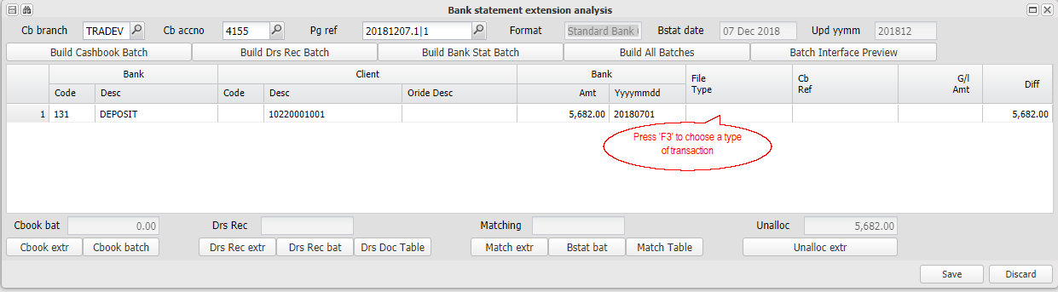

We first choose the type of receipt or payment, by pressing F3 on the file type column, and choosing Drs.Rec.Alloc, in this case:
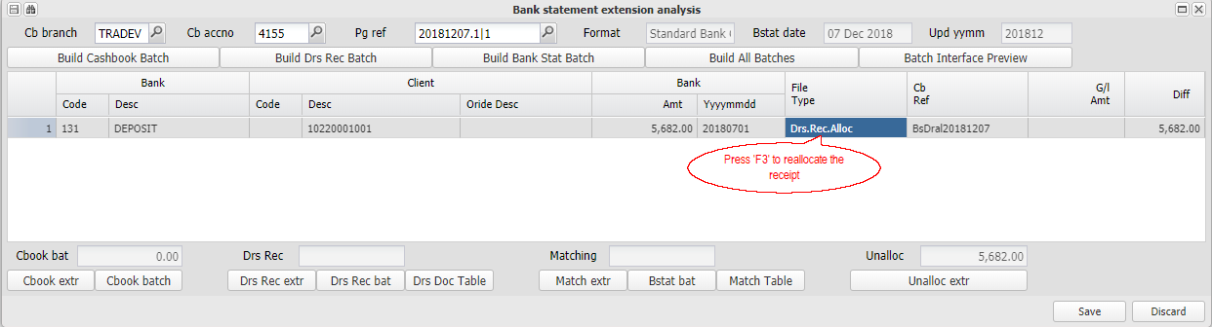

and then pressing F3, which allows us to allocate the receipt to outstanding invoices for a selected debtor (or debtors):
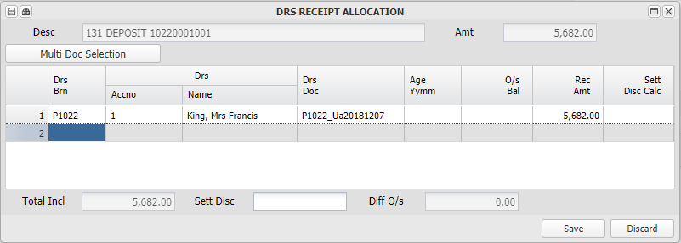

Bank Transaction Approval
This option controls the management of the approval for release to the bank, of various system generated bank batches. The final release to the bank is performed using a similar utility, Bank Transaction Perform, usually be a separate person.

If your account is set up to accommodate host to host banking, the cash movements generated using this option will be automatically processed in or to the bank environment. If not, you can export the relevant cash movement into a file in your banks format, and then upload it using their upload utility, or manually perform the transaction using the relevant bank's system.

For example, if a creditors payment batch has been processed on the system, and now needs to be actually paid to the creditors, we would choose Creditors EFTS payment from the drop down menus, select the relevant bank account from which it was processed. A list of batches awaiting approval for that bank account will be displayed for you to choose from. Select the batches that you approve and click on Save. Once approved, usually a different staff member will use the Bank Transaction Perform utility, which will then have the approved batch available to it, to release the batch to the bank via the host to host option, or via a bank format batch which is exported and uploaded to the bank.

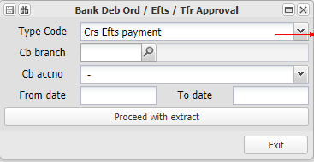 | 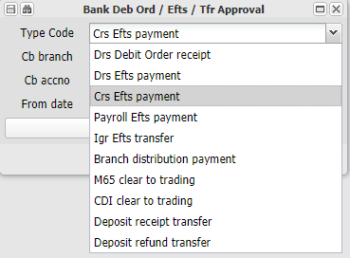

The system produces a list of amounts that need to be paid, indicating their bank account details. A deposit refund batch below:
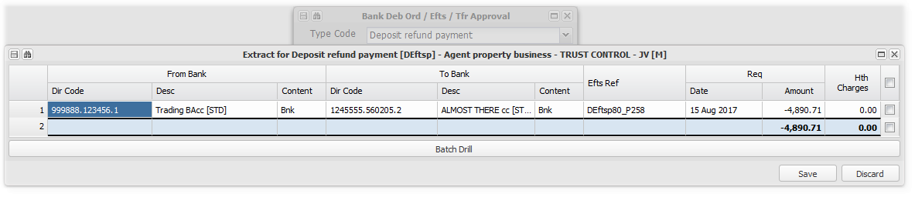
A bank export batch file will be produced after the batch is Updated, and the export function is run, or if your account is linked to Host to Host banking, the transfers will be processed directly in the bank accounts when running that option.

Another example, is the control of cash movement between the trading and deposit accounts. The deposit account is usually an investment account, which holds the net amount of deposits received. Deposits are usually received and refunded using the trading bank account. This facility tracks the receipts and refunds, and facilitates the cash movement in total (with a detailed breakdown).

The options in more detail:

Debtors Debit Orders
This option, after Approval and Update, produces a bank export file or Host to Host transactions for debit orders raised using Auto - Debtors debit orders

Deposit refund payments
This option, after Approval and Update, produces a bank export file or Host to Host transactions for Deposit refunds processed using Fixed assets, Debtors, Deposit refunds

Debtors EFTS payment
XXXXXXXXXXXXXXXXXXXX

Creditors Efts payments
This option, after Approval and Update, produces a bank export file or Host to Host transactions for Creditors payments produced using Creditors Branch Payment Batch

Intergroup EFTS Transfer
This option, after Approval and Update, produces bank export files (for both the paying and receiving branches), or Host to Host transactions if both bank accounts are linked to Host to Host banking. The need for this type of transfer arises from several different type of transactions, that result in a debtor/creditor relationship between two branches that use different bank accounts. For example - Management fees charged, Loan installment due, Initial loan advance.

Branch distribution payments (Owner payments)
This option, after Approval and Update, produces a bank export file or Host to Host transactions for Distributions (payments) from branches (Owner payments) produced using Branch, Auto options, Branch distribution

Direct deposit account to trading account (M65)
The system assumes that all deposits (less any bank charges) paid into the direct deposit account, will be transferred into the main trading bank account. It will post the entries directly to the trading account, and store the amount to be transferred, using this option.

This option, after Approval and Update, will produce a bank export file or Host to host transactions to achieve this transfer.

Internet deposit account to trading (CDI)
The system assumes that all deposits (less any bank charges) paid into the internet deposit account, will be transferred into the main trading bank account. It will post the entries directly to the trading account, and store the amount to be transferred, using this option.

This option, after Approval and Update, will produce a bank export file or Host to host transactions to achieve this transfer.

Deposits received transfer to deposit account
Debtor (tenant) rental damages deposits received are usually deposited into the main trading account. The system assumes that they will be transferred to the deposit bank account, and posts them directly to it. It tracks the amounts that need to be actually transferred, and this option, after Approval and Update, will produce a bank export file or Host to host transactions to achieve this transfer.

Deposits refunded transfer to trading account
Debtor (tenant) rental damages deposits received are usually held in the deposit bank account, but refunded from the main trading account. The system assumes that refunds from the main trading account will be transferred back from the deposit bank account, and posts them directly to it. It tracks the amounts that need to be actually transferred, and this option, after Approval and Update, will produce a bank export file or Host to host transactions to achieve this transfer.

Bank Transaction Perform
This utility allows previously approved system produced bank batches to be released directly to your bank using host to host banking, or to be exported into a bank format batch for upload using your banks banking interface.

Refer to Bank Transaction Approval for more information.

Bank Recon Takeon
Enter topic text here.

Bank Reconciliation Transfers
This option allows the for any necessary correction of either a bank statement or general ledger cash book reference, by allowing the full or part of the reference amount to be transferred to a different or new reference.

The screen will ensure that the original amount of either reference will be maintained making sure that an accounting balance is maintained.

The various fields and auto reversal options are easily understood from their labels, bearing in mind that the system will process a reference amending journal that needs to be in balance before it can be posted:

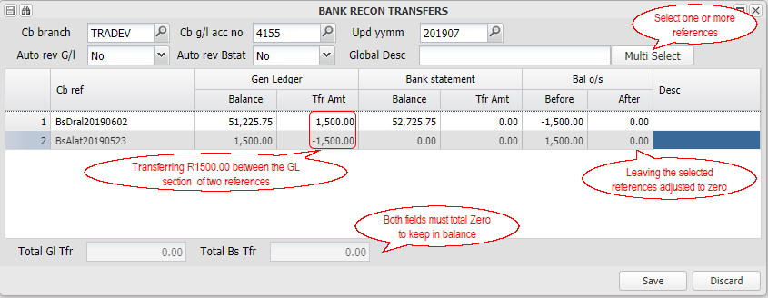

Bank Statement Formats
You can set up formats relating to the exported bank statement files from the different banks, that are used by the system to interpret the imported file, build the necessary batches and automate allocations. You can build up a list of allocations based on references used by clients.

The format is also used to determine what bank charge type is linked to each transaction, which is then matched to the system bank charge table and charged out on import, as set up.

The banks use transaction codes that allow the system to know what type of transaction it is importing, and what bank charge will be incurred. The transaction can then be grouped with like transactions, relevant batches built, and the bank charges charged out as set up.

The following are the various steps - Click on the for more information:

Using the information obtained from the bank or bank statement, set up the main format table
The following is an example of an exported bank statement file from Standard Bank:

This layout is captured as Format 1, using this screen as follows:

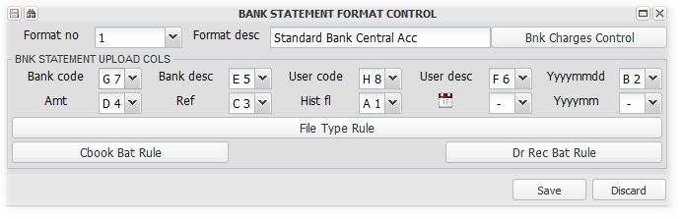

The bank statement layout is entered on the above screen as follows:

Bank Code | The bank transaction code, Column 7 (G). Used to determine the relevant batch type for it to be added to, and what bank charge it will attract (Refer below)
Bank Description | The banks description of the transaction type - Column 5 (E)
User Code | Column 8 (F) in the above example, which is used by some banks.
User Description | This is the code that is originally generated by you, and used when exporting or making bank payments, or by debtors when they deposit into your account - Column 6 (F)
YYYYMMDD | Transaction date in relevant format - Column 2 (B)
Amount | The transaction amount - Column 4 (D)
Reference | A field used by the bank to indicate, in this case, Opening and Closing Balance lines - Column 3 (C)
History Flag | The statement type as described by the bank - Column 1 (A)
Calender | The transaction date in normal calender format DDMMYYY
YYYYMM | A period used by some banks

Set up the Bank Charges Control Table, which is based on the transaction type
For each format, enter the general ledger code that any bank charge costs are to be posted to, and add the transaction codes to their bank charge categories (You could enter many for one category), as in the examples below:

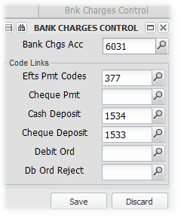

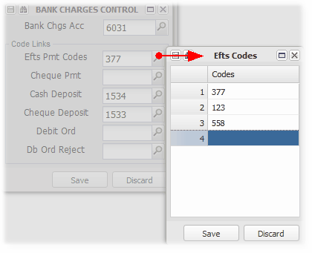
The bank charge categories relate to the charging out of the bank charges, based on the table setup in Create/Maintain Branch

Setup Batch Types based on the Bank Codes for transactions. Your bank can provide you with a list, or you can determine a list from your bank statement:
Transaction types usually determine what type of batches the transaction needs to be posted as. You can set up as many rules as you wish, using the batch type rule screen.

In the example below, if the Bank Reference in column three includes OPEN, the amount will be used as the bank statement opening balance. If the Bank Code in column 7 is 1534, it is usually a payment from a debtor etc:

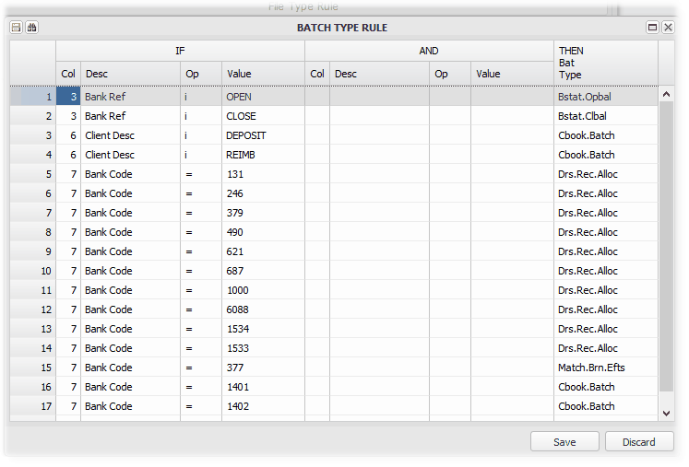

The options for the Op column are:

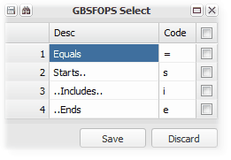
There is also an option for a second condition, to more accurately determine the allocation if necessary.

The various batch types are included in the list below:

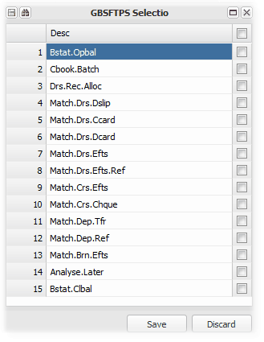

You can amend the batch type when Maintaining the Bank Statement Import

Setup Cash Book Batch Rules used in building the Cash Book Batch:
You can also set up actions/allocations of cash book batch entries, as in the example below:

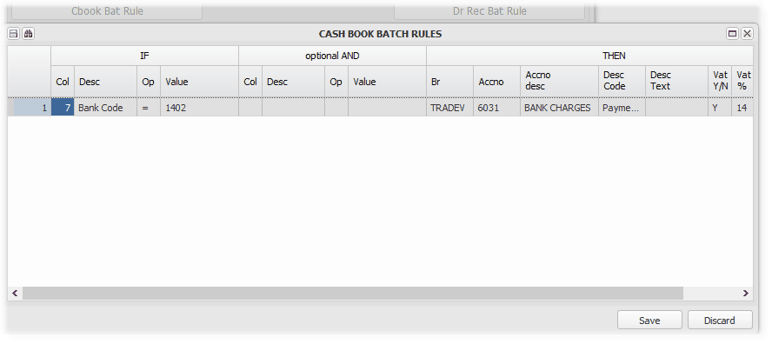

If the Branch in the 'THEN' column is left blank, it will default to the Cash Book Branch.

Setup Debtors Receipt Rules used in building Debtors Receipt Batches
This facility is used to assist where a debtor has captured their own reference, which you have established links to a particular debtor on the system. You can set up one or two conditions, that the system can use to link a receipt to a debtor that you define. To Action column is for future use.

In the screen below, for example, you can enter that if Column 6 has a reference of 'Lungi', that the receipt is allocated to Branch P258, Debtor 15:

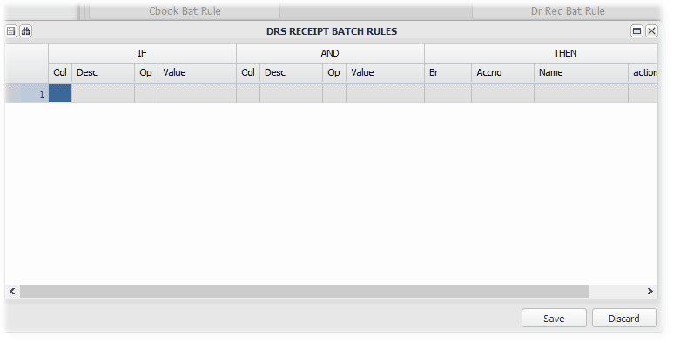

:

Data Base Setup
This option is used to set up various aspects of the accounting system and other table setup and communication. It will generally be used in the beginning, and only reused as changes to the original setup are required. This option and the Branch maintenance screen for the database branch, contain most of the database setup options. It should be used with great care, and only by authorised users, as changes have far reaching implications.

In the beginning, you will create a new master table, and then maintain it over time, of if necessary, replace it. The various aspects of the screen can be imported directly of a spreadsheet, into the relevant section.

When running the option, choose the option as required:
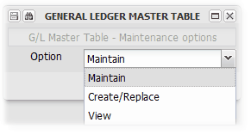

The example below is the maintenance screen, and it's are components detailed below:
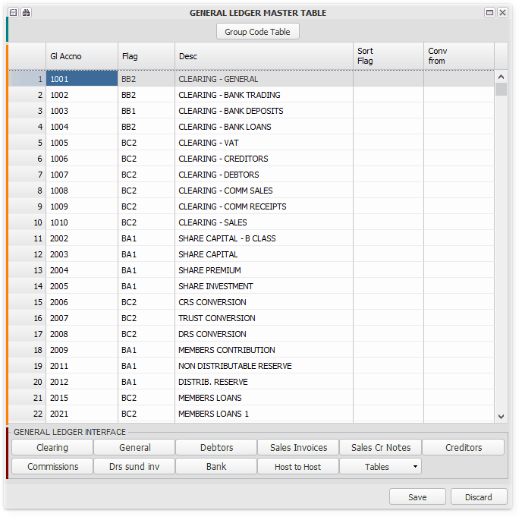
 | Remember that you can search the grid by clicking on the binoculars in the toolbar on the left

Group Table
Groups are used in various ways and for various purposes. You can link each general ledger code to a default group, which will be used in reports unless the relevant branch is part of an override group. Examples of their use are:

1. Determining a dividend that can be declared by a branch
2. Determining the amount of cash that is available to a branch in paying out funds
3. Grouping codes on reports, for example, a balance sheet.

The details of each column and its use are described below.

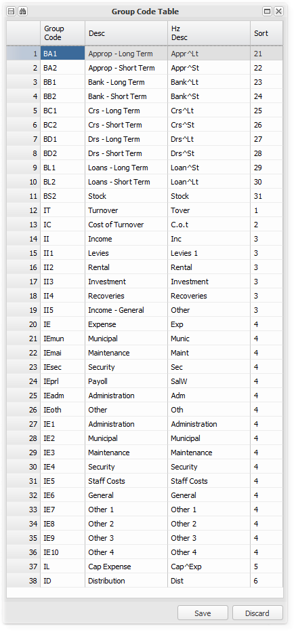

General ledger codes
The system allows you to decide on which codes, their format and their structure. Once you have decided, you add the codes to a group, and link your codes to the key sections using the General Ledger Interface below.

The groups will be used when reporting the various codes in the various system reports. The key sections will be for example, bank account and debtors control.

You can either capture the codes and groups directly into the screen, or import them from a spreadsheet. Refer to Importing Information for more details on how to import.

A commonly used structure for general ledger codes on the system is as follows -

1000 - 2999 Capital and Reserves
3000 - 3999 Liabilities and related
4000 - 4999 Assets and related
5000 - 5999 Income
6000 - 6999 Expenses

General Ledger Interface
As described in General Ledger Codes above, use these screens to link your general ledger codes to the relevant areas of the system:

Clearing
The system offers general ledger sharing, as described in System Overview. It accommodates the sharing of transaction components with other branches, using Clearing Accounts. The areas of sharing can be seen in the example screen below, with the general ledger codes previously set up:

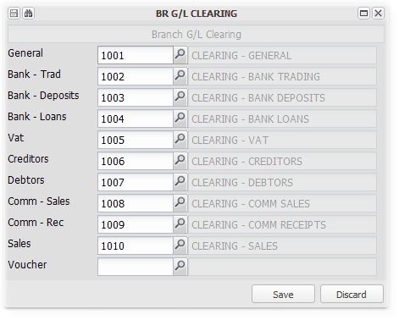

General
Link general ledger codes to more key control accounts:

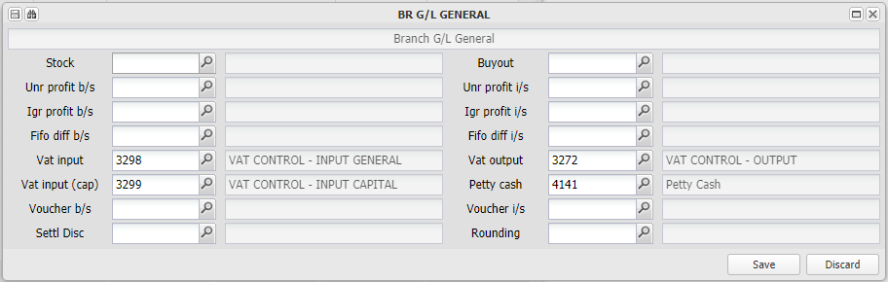

The Petty Cash account is used in the Property Management Report.

Debtors
Link general ledger codes to Debtors related control accounts:
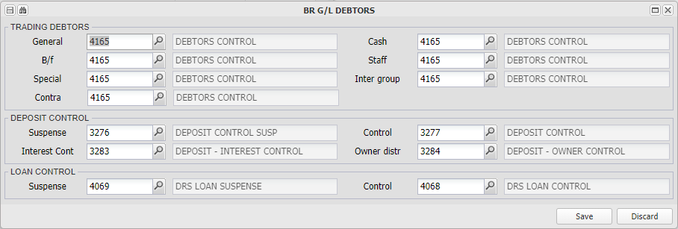
The key accounts to set up are the General and Inter Group debtors control accounts. The other control accounts are for specialised purposes not used in all accounts.

Sales Invoices
Link sales related general ledger codes for the system to use when processing invoices for sales:

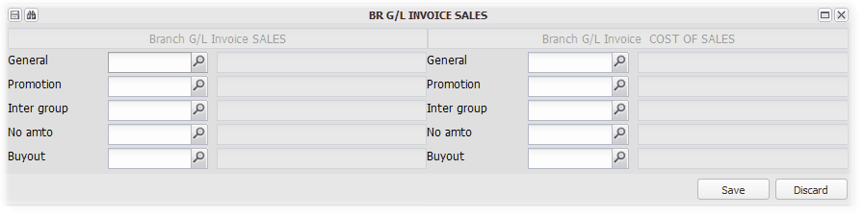

Sales Credit Notes
Link sales reversal related general ledger codes for the system to use when processing credit notes for invoices:

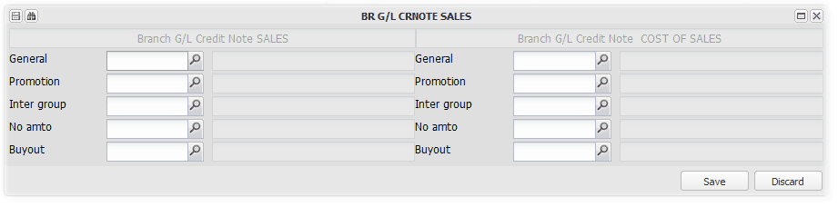

Creditors
Link general ledger codes to Creditors related control accounts:
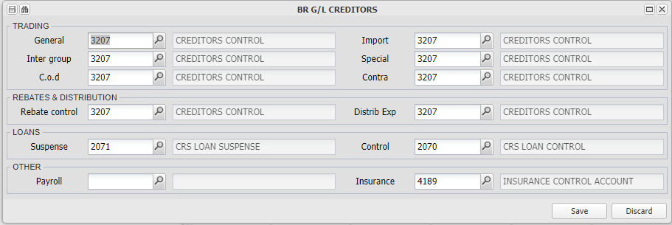

The key accounts to set up are the General and Inter Group creditors control accounts. The other control accounts are for specialised purposes not used in all accounts.

The Insurance account is used in the Property Management Report.

Commissions
Set up Commission types and their rules.

These will be accessed and refined when applied for a Branch, using the Commissions button on Create/Maintain Branch.

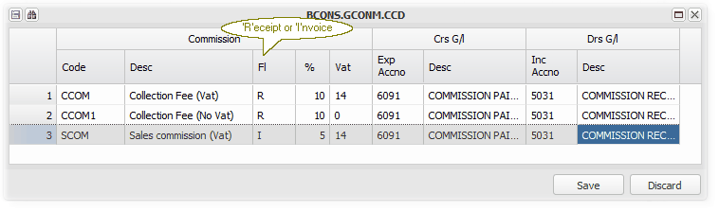

Set up a code, a description, a trigger indicator (Receipt or Invoice), VAT to be added, and the general ledger allocations for the expense and the income.

For each Branch that uses these commissions, you will be able to link a debtor and a creditor, and which invoice codes the commission will be applied to. Refer to Create/Maintain Branch for more details regarding these rules.

Debtors Sundry Invoicing
Set up as many invoice codes and their details as you require. These will be used wherever debtors are invoiced, by selecting the relevant invoice invoice code where required.

Examples of its use are when capturing a Bulk Sundry Invoice, and when setting up an Invoicing Table (Fee structure) for a Unit (Fixed Asset 2).

Codes and their associated general ledger codes are set up here. You can define codes with and without VAT etc. The income General Leger Code is where the income component of the invoice will be posted to. The expense General Ledger Code is applicable where Unit Linking or other sharing (Commissions) is employed, and the invoice raised is matched with an expense transaction in another branch.

There are some codes that have specialised set up requirements, which are detailed in their sections of this manual - for example, Interest on arrears, Deposit and Deposit Interest Billing, Debt Collectors Act charges as seen in the example below, and are explained in their relevant sections:

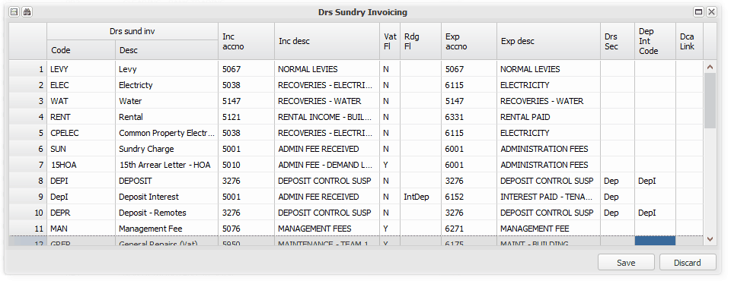
If the VAT flag is left blank, the branch VAT status will be the default. If you set the flag to 'N', the default for the entry when the code is used will be 'N'.

Bank
Link the key system bank accounts to your general ledger codes.

The bank accounts are named around common property related bank account types, and are described below. For a branch that does not share a bank account with a group, it would be set up as a Head Office, and the bank accounts described below can be used for the business as it requires. Remember to set Bank Charges to 0, if you do not want bank charges to be recovered, by clicking the 'Zero Bank Charges' button.

Certain of the accounts are the default bank accounts for system components, and will be used by the system if you use those aspects of the system. For example, The Deposit system, or the Loan system. However, if you do not use these components, you can use the bank accounts.

The Suspense accounts, are used to include unallocated bank transactions in the accounting records, pending their re-allocation.

These accounts are generally used in a shared head office environment:

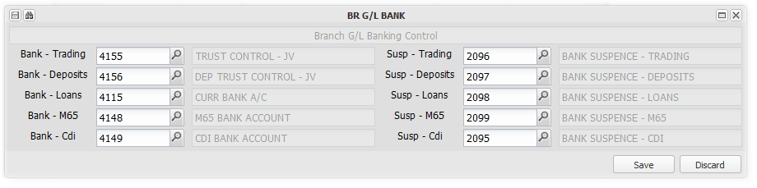
The above accounts described:
Bank - Trading | This is the main trading account used by a branch. If the branch is a head office, it can be shared with any branch that is linked to it for banking.
Bank - Deposits | This is an account generally dedicated to holding deposits received that are refundable by the branch. It is commonly used in the property management area for tenant deposits. Deposits are generally first deposited intio the Trading account, and then transferred to or from (as refunded) this account using a system utility to control the movement.
Bank - Loans | This account is the default account for the loan system, to where loan related bank transactions will be posted.
Bank - M65 | This account relates to a specialised bank system, where debtors deposit money into an account using a specialised deposit slip, using a defined reference. The system imports the transactions, recognising the reference and allocating the transaction accordingly. Standard Bank call this an M65 system, ABSA a Deposit Identifier system etc.
Bank - CDI | This account relates to a bank account that is dedicated to receiving payments directly from debtors via. internet based banking solutions. Often references are not correct, and hence isolated from the main trading account, but held to allocate when their correct allocation path is established.

A structure for local bank accounts for a branch that uses shared banking facilities by default, will be added to the system

Host to Host
Host to Host banking is available for certain banks, and is dependent on you having arranged the facility with yours. Refer to System Overviews for more information on using this facility:

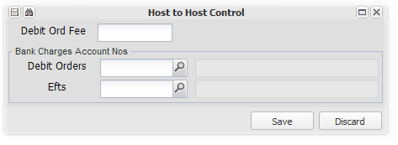

Tables
Various set up tables:

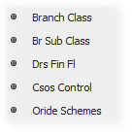
Branch Class and Sub-Class
Set up Branch Class and Sub-Class categories, used in Create/Maintain Branch.

These classes or types are used to indicate how the branch relates to you, and what type of business it conducts - part of your business, a clients business etc.:

Examples below:
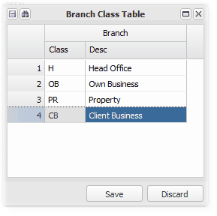
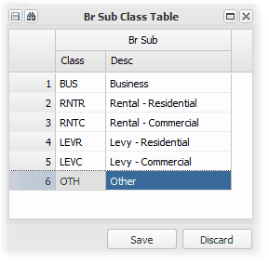

Debtors Financial Flags
Add or maintain a flag that is linked to a debtor and used to filter the selection of debtors, for eg. in sending collection letters, and in statistical summaries on certain debtors reports. A flag from this table can be selected on Debtors Master Maintenance:

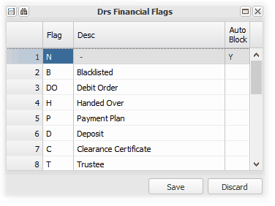
CSOS control
Set up CSOS control information using this utility:
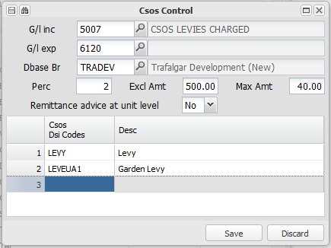

Refer to Setting up, Charging and Remitting CSOS levies for more information

Override schemes
Set up as many groups as are required, to allow for redefined account descriptions and groups based on the norms for the different groups. You can also set up a group for an individual branch, if its redefinition requirements are different from any other group:
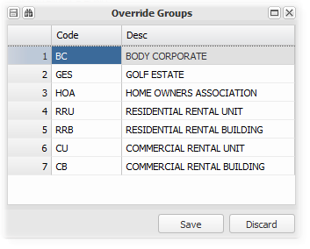
Refer to Setting up general ledger reporting group and description overrides for more information relating to this utility.

Data Base SMS Table
This option allows for the setting up of standard SMS messages that are usually sent to debtors as part of the debt collection process.

Refer to Setting up and sending Debt Collector SMS's for more information.

Bank Statement Capture
Enter topic text here.

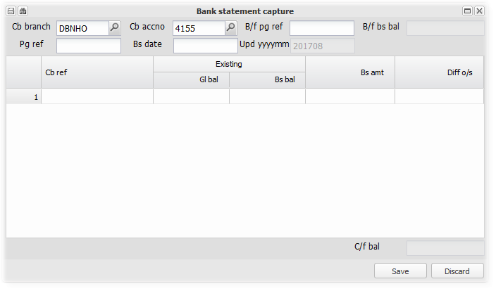

Bank Recon Report
This option is a classic bank reconciliation report, which supports line drills displaying originating capture batches.

References can be transferred using Bank Reconciliation Transfers.

Choose your branch, bank account, To period, and any reference restriction:
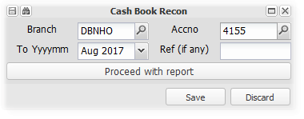
An example:
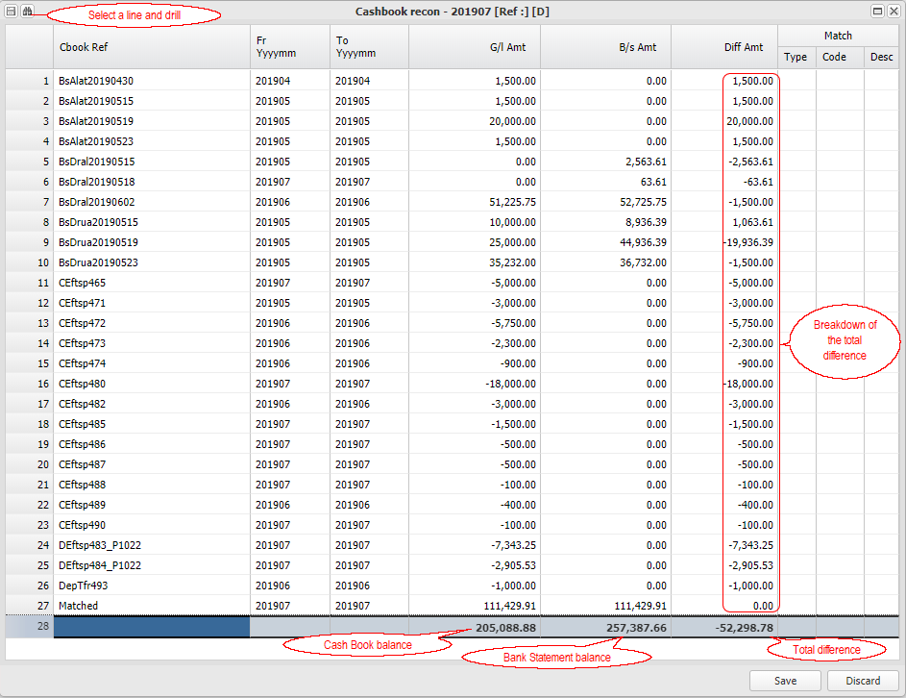

Budget Capture
Branch budgets can be uploaded using this utility.

Arrange your budget in the system format, as per this example
1. Create a spreadsheet as in the example below.
2. Enter the relevant information in the capture window (as indicated below):
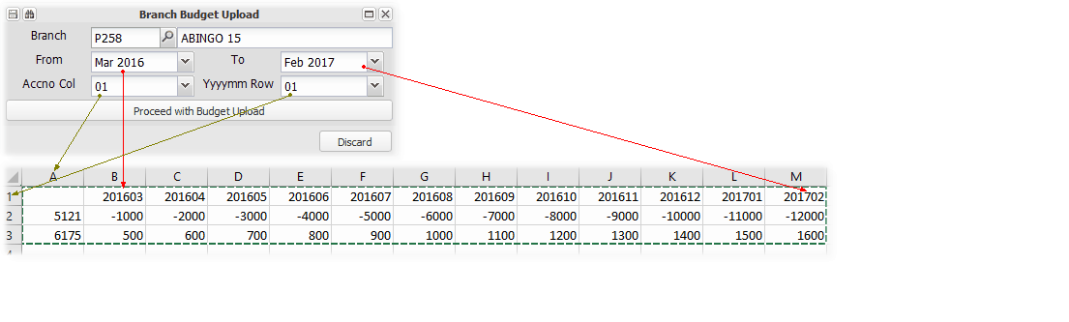
Select and 'Copy' the information to be imported, and paste it into the system
3. Select and 'Copy' the cells that you wish to import
4. Click on 'Proceed with Budget Import'
5. Type 'Ctrl V' to paste the date into the system

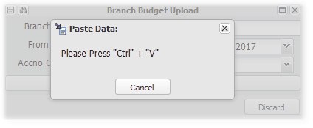

The imported information will be displayed, to be Saved
6. Check the information and 'Save' if correct.

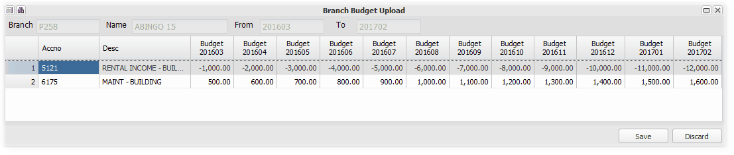

Any existing information will be over written by the information imported.

Auto - General Reports
Various financial and control type reports:
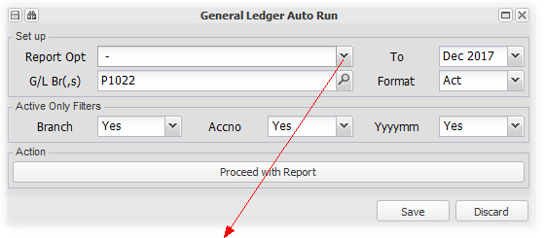
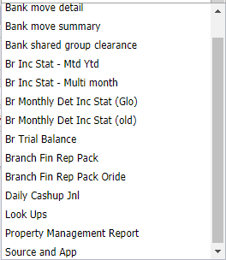

Bank shared group clearance
This facility will transfer all positive shared bank account balances from the branch in which they are, to a specified group branch. It is usually used where several branches in a group choose to transfer all their available funds to a central branch.

The amount that will be transferred is the amount that would be distributed from the branch (property) in normal distribution processing usually the balance less and creditors or VAT due.

Groups are set up on the Create / Maintain Branch screen, where the main group branch is captured.

Branch Financial Report Pack and its Override
The Branch Financial Report Pack is a group of reports, set up per branch (Property), that is usually sent to the office bearers of a branch each month.

The pack is emailed to branch office bearers, choosing either a PDF or Excel format. You can also upload additional documents that will be attached to the email with the report pack.

This option can also be used to produce any of the component reports for internal purposes.

Refer to Setting up and producing a Branch Financial Report Pack for more information.

Property Management Report
This report contains key base information relating to a property (branch). and key management indicators.

For example - the branch registration number and financial year end is included. The last trustee meeting date and the date the minutes were completed and circulated - the cell is red if the circulation date is more than one week after the meeting date (an exception).

There is an option to run the report for a group of properties (branches), which will produce one spreadsheet with each branch on a separate page. There is also an 'Errors Only' option, which will only list exceptions (late circulation of minutes etc.).

The standard option displays all populated fields for a branch, and any exceptions. You can also choose between PDF or Excel format.

An example of the report wit the error/exception rules:
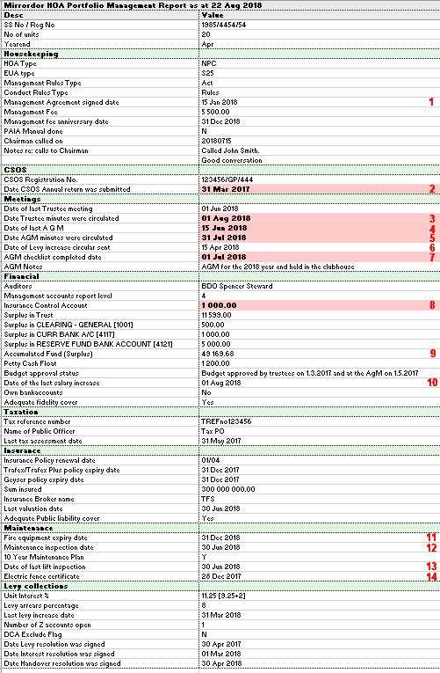 | A red background to a cell indicates an exception or error condition. The following are the rules that cause a cell to be flagged as an exception - (Date comparisons are relative to the period selected when the report is run):  1. If the latest agreement signed date is three years or more ago.  2. If the last CSOS annual return submission date is more than one year ago.  3. If more than seven days after the meeting date.  4. If more than four months after the last financial year end.  5. If more than seven days after the meeting date.  6. If more than fourteen days after the last AGM.  7. If more than fourteen days after the last AGM.  8. If any balance on the nominated insurance control account. See the note below.  9. If the branch (property) is insolvent.  10. If more than twelve months ago.  11. If more than twelve months ago, or beyond the expiry date.  12. If beyond the expiry date  13. If beyond the expiry date  14. If beyond the expiry date

The report uses the Petty Cash Control account set up in Database Setup, under the General Tab.
The report uses the Insurance Control Account set up in Database setup, under the Creditors Tab
'Z' accounts (non- current) are based on Fixed Asset Level 2 (Unit) customer link to date, and any balance outstanding.

Set up Override Group Details
This option allows for the setting up of the structure and detail of general ledger override groups that are used as override descriptions in general ledger reporting.

Refer to Setting up general ledger reporting group and description overrides for more information regarding using this option.

The menu option:
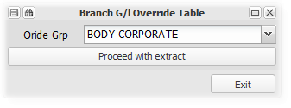
Choose the group that you wish to set up:
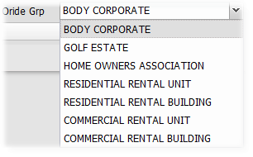

The following overrides can be effected for any group:
1. The general ledger account description.
2. The group to which the account is linked.
3. The group description.

Two examples for the group 'BODY CORPORATE' based on the screen shots below:

General Ledger Code | Default details | Override details | Note
5050 | II5 - INTEREST RECEIVED - MEMBERS INTEREST | II4 - INTEREST ON ARREARS | Group changed from II5 to II4 and description changed
5067 | II1 - NORMAL LEVIES | II1 - ADMINISTRATIVE FUND LEVY | Same group but changed description - group name changed from 'Levies' to 'Administrative Fund Levy Income'

The override group set up screen, and its related 'Group Code Table', for the BODY CORPORATE' group:
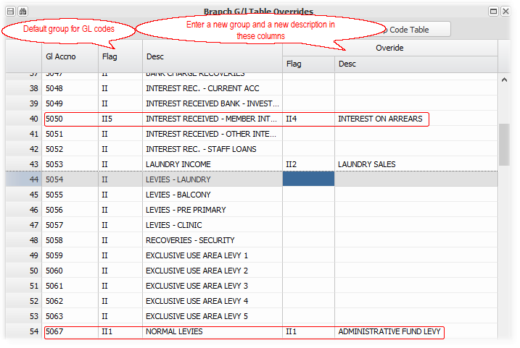

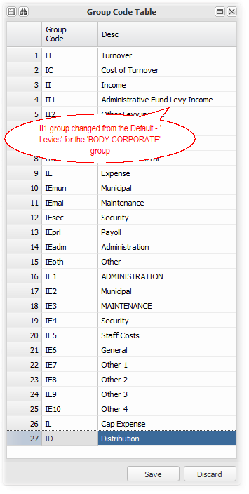

Purchasing
These menu items relate to the issuing of documents related to the purchasing of goods or services from creditors, including orders, invoices and credit notes.

Other
Purchasing not related to stock or buyout purchases.

Other Purchase - Bulk no order
This screen allows the capture, (or import from Excel), of invoices from creditors, for which no order was issued.

You can capture multiple invoices on one screen. As creditors can be shared, you can raise invoices for goods or services received in one branch, and allocate the cost to another branch.

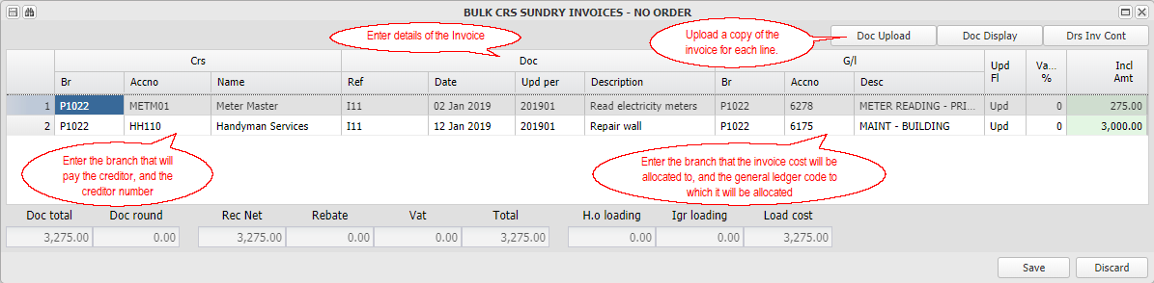

The Update Flag column will indicate if the invoice will be 'Updated', or whether it will be sent the branch office bearers for 'Approval' This option is set up on Create Maintain Branch, Creditors, Document Control.

Other Purchase Order - New
Issue an order to a supplier.

Refer to Setting up Creditors and Paying approved invoices for more information.

Other Purchase Order - Maintain
Maintain / Update an order that was issued to a supplier.

Refer to Setting up Creditors and Paying approved invoices for more information.

Other Purchase Batch (Order)
Receive an invoice from a supplier, relating to an order.

Refer to Setting up Creditors and Paying approved invoices for more information.

Other Purchase - Document Upload
Receive an invoice from a supplier, and upload it into the system to be processed through the payment approval work flow..

Refer to Setting up Creditors and Paying approved invoices for more information.

Other Purchase - Document Setup
Set up a previously uploaded supplier invoice or set up and upload a new supplier invoice (not linked to an order), to be processed through the payment approval work flow..

Refer to Setting up Creditors and Paying approved invoices for more information.

Other Purchase Order - Document Setup
Set up a previously uploaded supplier invoice or set up and upload a new supplier invoice (linked to an order), to be processed through the payment approval work flow..

Refer to Setting up Creditors and Paying approved invoices for more information.

Other Purchase - Trustee Manual Approve
This option allows the manual recording of an office bearers' (trustee) supplier invoice payment approval.

It is usually only used if the office bearer doesn't reply via. eMail

Refer to Setting up Creditors and Paying approved invoices for more information.

Other Purchase - Administrator Manual Approve
This option allows the manual recording of an administrators' supplier invoice payment approval.

It is usually only used if the office bearer doesn't reply via. eMail

Refer to Setting up Creditors and Paying approved invoices for more information.

Unapproved Document Extract
This option provides a summary list, sorted by status, of all invoices linked to branches (properties) that you have access to. It is usually used in managing the maintenance process.

Refer to Setting up Creditors and Paying approved invoices for more information.

Invoicing
These menu items relate to the issuing of invoicing and related documents to debtors, including quotations, invoices and credit notes.

Bulk Sundry Invoice
This facility allows you to capture multiple invoices to any number of debtors in one capture screen. You can paste data from a spreadsheet as a quicker way of capturing.

The screen is displayed and explained below:

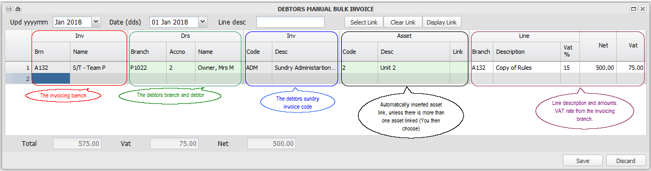

Enter period that the invoices will be posted to, the invoice date within that period, and any default line description, in the screen header.

In the example screen display above, you will see one invoice captured - to a debtor not in the invoice branch. The debtor (Unit) is charged by the related Agent branch for a copy of the rules. The system will post the income to the selected invoice branch, and to the debtor in the selected debtors branch, using the sharing facility. Invoicing will usually be by a branch to one of it's own debtors.

1. There is an option to exclude shared transactions from relevant reports
2. When the invoice is paid, the cash will be automatically routed back to the invoicing branch, when within a shared banking environment.

Fixed Assets
Enter topic text here.

Maintain/Create Fixed Asset
Use this option to Create or Maintain previously created Fixed Assets.

A fixed asset is, as its name suggests, an asset that has a useful life span of more than one year. Examples are Properties, Vehicles, Computers and Security equipment.

The system allows for several levels of an asset - Eg. A property, block of flats, with many units in it, some of which might contain furniture. We refer to a Property as Fixed Asset Level 1 (FA1), it's units as Fixed Asset Level 2 (Dependent assets) , and so on.

There are special provisions for property related assets, as indicated below. In the case of a property related fixed asset, the asset will be linked to a Branch, which will be it's accounting base. The branch will have Debtors, to which the Fee Structures (Levy, Rent etc.) of the related units (FA2's) will be linked for the billing thereof. The Fixed asset number will be prefaced by a 'P', eg. P1022, which will also be its Branch number. If the Branch is part of a group for management purposes, it will have a link to a group branch, usually an agent branch, whose number will be prefaced by an 'A' eg. A132.

The system allows the entry of purchase particulars, disposal details, depreciation rates etc., and will calculate and provide for depreciation when the relevant option is run. More details of this can be seen in the Normal Fixed Asset section below. An asset trial balance provides an asset register

The capturing and related information for the different categories of asset are described in the sections below:

Setup or Maintain a Property Related Fixed Asset - Levy based
Set up a Property - Level 1 Fixed Asset (FA1)
A Property is a fixed asset that is one unit, occupied by one occupant, or divided into many units occupied by many occupants.

In the case of, for example, a sectional title property, it is one property which is divided up into different sections. The sections are owned by as many owners, who are all members of a body corporate who owns the common property. Sometimes the common property will include for example, clubhouse, which will have equipment that are also fixed assets.

The individual owners will all contribute to the costs of running the property by paying a levy to the body corporate, that combines the levies and pays, for example, the local authority for assessment rates.

To accommodate this on the system, you would set up a structure as discussed in the Managed Assets topic. We focus here the Fixed Asset component of that structure.

To accommodate the above example, we would set up a Level 1 fixed asset for the property as a whole, as many Level 2 fixed assets as there are units/sections, for the clubhouse and other fixed assets. We would then add Level 3 fixed assets, under the other fixed assets, for as many items of equipment as necessary.

The following is an already set up example, similar to the above description:

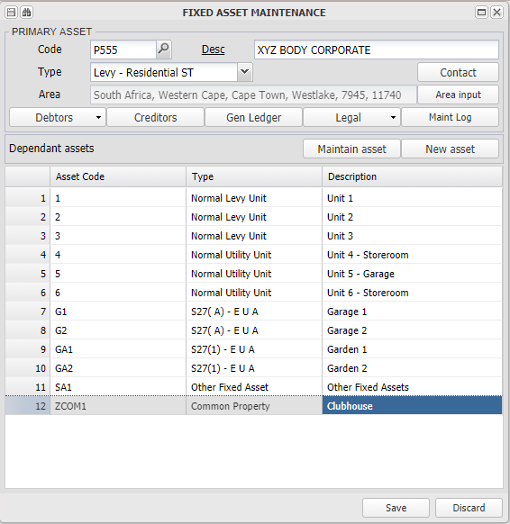
Remember that you can search the grid by clicking on the binoculars in the toolbar on the left

Type - In this case, we chose Sectional Title screen from the type drop down list. These types and their related sub-types are setup on the Fixed Asset Table Control on Branch maintenance.

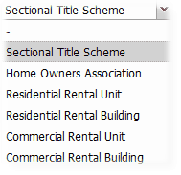

Area Input - Search and choose the area that the fixed asset is located in.

Debtors
Various links relating to debtors -

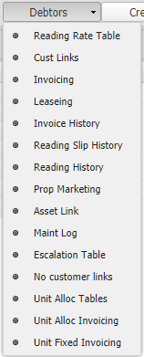

No customer links - This option displays all FA2's (Units) that do not have a current customer link. These units are either available to be occupied, or have a missing link.

Unit Allocation Tables
You can set up five different allocation tables, which can be used to base general ledger billing on:

We chose Table 2 -

You can exclude one or more debtors (units) by setting their allocation percentage to 0%.

Refer to Setting up General Ledger based Debtors (Unit) Billing for more information.

Unit Allocation Invoicing
Based on one of the unit allocation tables set up above, you can charge debtors (units) based on the movement or balance in a general ledger account.

In the example below, any plus month move in GL account 6013, for two months prior to the month being billed for, will be billed to Debtors |(Units) in the proportions set up on Table 2, using the Sundry Charge (SUN) invoice code:

Refer to Setting up General Ledger based Debtors (Unit) Billing for more information.

Unit Fixed Invoicing
This facility allows for the billing to multiple units in a branch, of a fixed amount. It can be billed from the actual or another branch. It is often used to charge all units in a branch for basic administration fees, from the agent (group) branch. Specific units can be excluded from the billing:
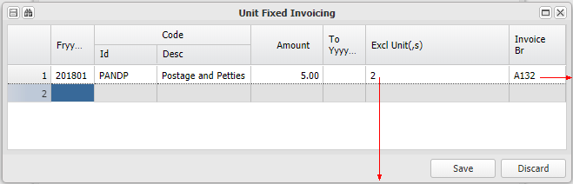 | 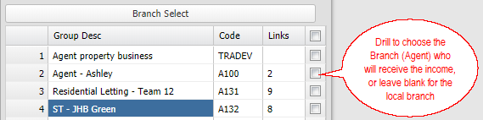
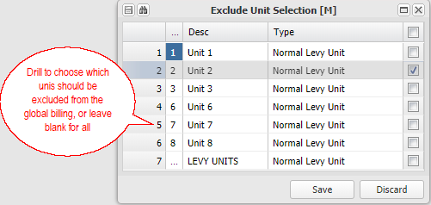

Creditors
Not used at this stage

General Ledger
Insert General Ledger links relating to the relevant fixed asset level 1 item (property).

Legal
Property PQ Display
Display the official (per the plans) and the actual m2 per Unit (FA2) type, that are entered using the option below:
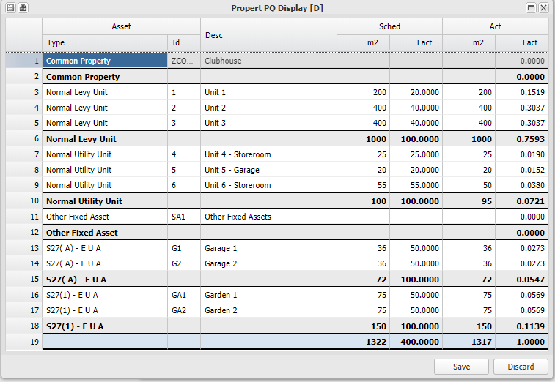
Property PQ Input
Capture or import the official (per the plans) and the actual m2 type:
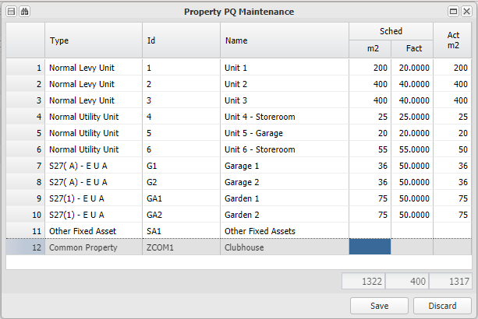

Maintenance Log
An audit log of amendments to the FA1 (property) level

Set up a Unit - Level 2 Fixed Asset (FA2)
We then add as many 'components' of the Property as there are. In our case, normal units that pay a levy, exclusive use areas (that might or might not pay a levy) and other fixed assets.

Click on the grid and then on New Asset (or Maintain if you are editing an existing one).
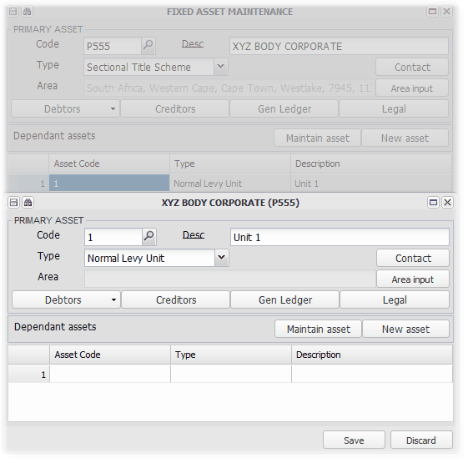
Choose it's Type from the drop down list -
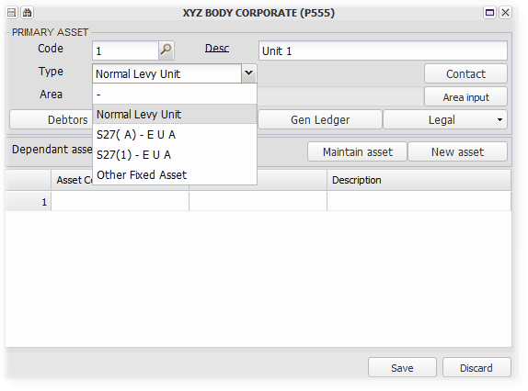
Next we link the fixed asset to a debtor - Customer link - which is usually a debtor linked to a branch with the same number as the fixed asset. Billing amounts set up below will charge this debtor when raised.
You can link many assets to one debtor:

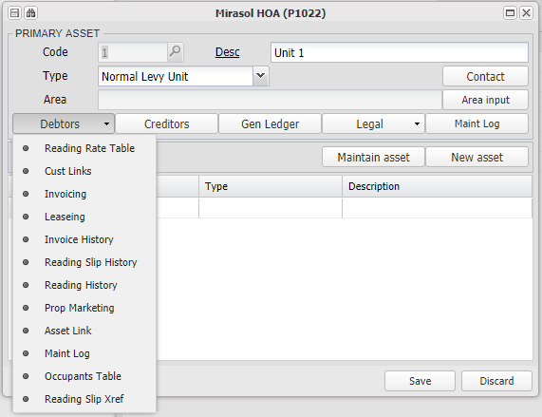

After clicking on Customer Links, choose the debtor using the table displayed:
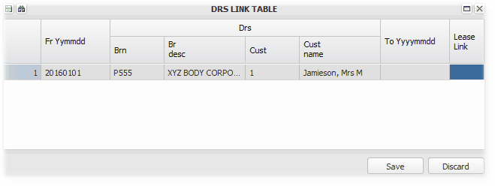

Next we set up a fee structure (billing table) for this fixed asset - usually a normal or specialised levy. After clicking on Invoicing, enter the billing items:
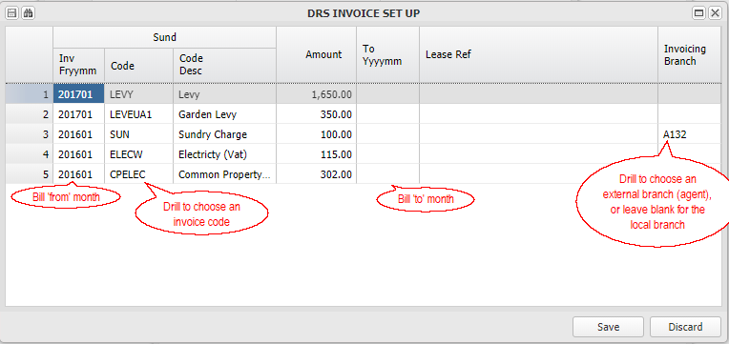
Choose the Code from the invoice codes set up in Debtors Sundry Invoicing on the Database Setup section:
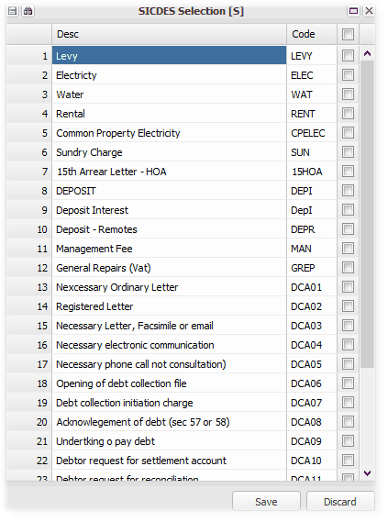
The other FA2 Debtors options in more detail:

Reading Slip History
Refer to Setting up and charging Utilities for more information on how this information is used.

The image below is an example of the utility history for a unit. These charges have been imported but not yet invoiced:
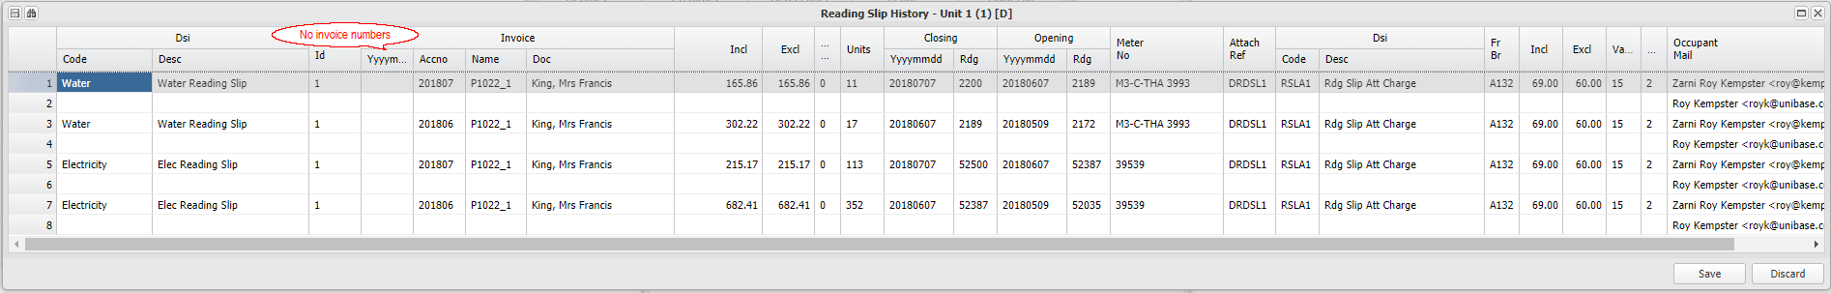

The same utilities after being invoiced:
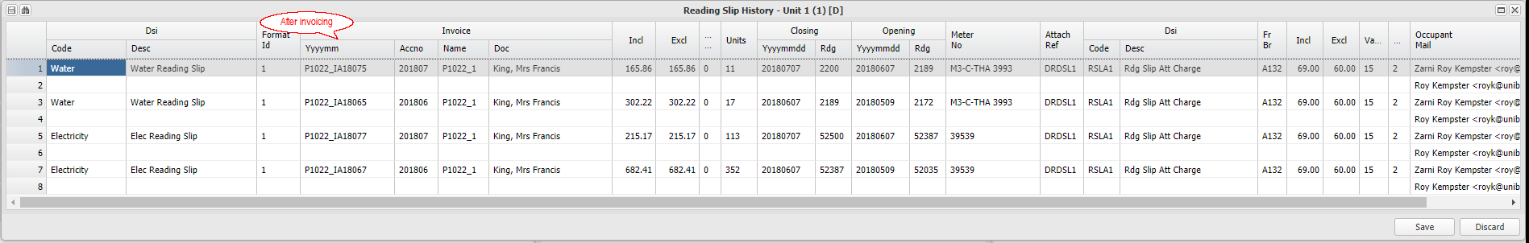

Property Marketing
Capture various information and upload images relating to the unit:
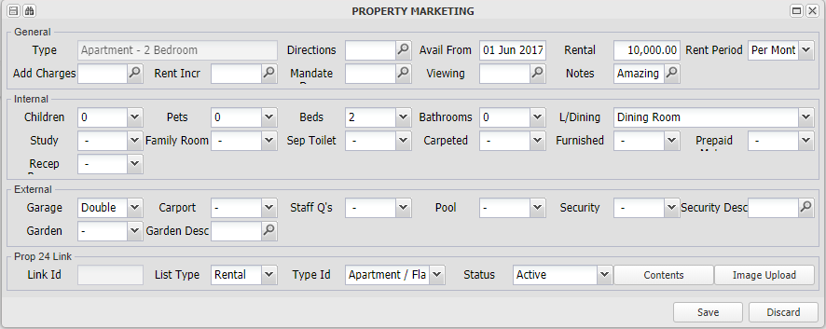

Asset link
If you would like to link an asset to a dependent asset, choose Asset Link from the Debtors drop down list, and enter the unit and the charges to on-bill. This facility will on-charge selected charges to a linked asset and automatically pay any outstanding balance when a receipt is processed for the linked asset. Refer to Asset Linking for more information on using this option:
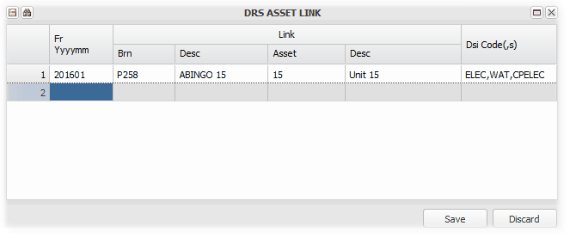

Occupants Table
Capture details of the occupants of units where the occupant isn't a tenant on your system or the owner of the unit in a community scheme. Refer to Setting up and charging Utilities for more information on how this information is used:

Reading Slip X-reference
Alternate asset ID number for matching readings
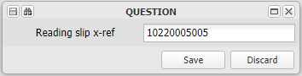
Generally used when a data conversion has taken place, and external meter readers have a previous system ID or reference number. It can be used on this system if it is captured here.

Setup Level 3 Assets for the Other Assets
Having created a level 2 asset with a description of Other Fixed Assets, you can add level three assets to it, as an asset register of the other assets:

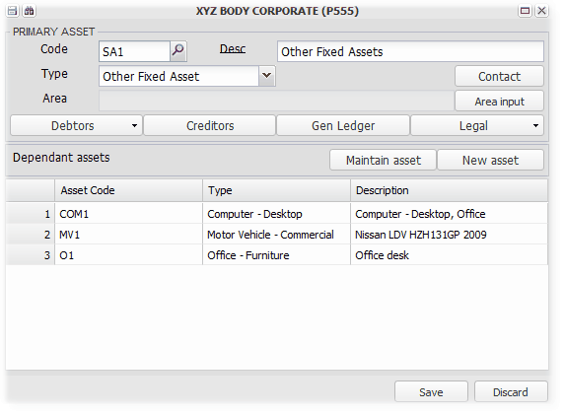

The relevant cost etc. information can be added by clicking on the General Ledger button:

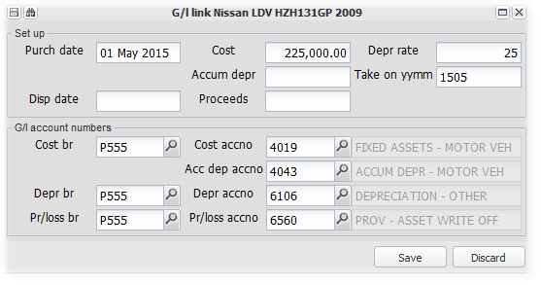

Depreciation, disposal and profit/loss journals are put through using General Ledger Auto Journal, and an Asset Trial Balance can be viewed using General Ledger Asset Trial Balance:

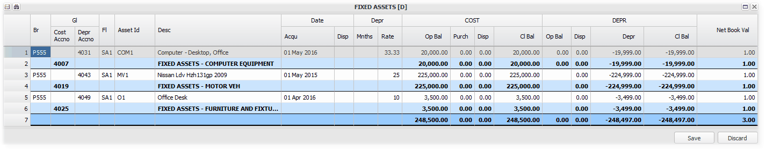

Setup or Maintain a Property Related Fixed Asset - Rental based
Please refer to the Levy based property section above for more information. We highlight rental type properties in this section, which have many similarities to levy based properties in certain areas.

A Property is a fixed asset that is one unit, occupied by one occupant, or divided into many units occupied by many occupants.

In the case of, for example, a Residential Rental property, it is one property which is divided up into different units. The units are occupied by tenants in terms of a rental lease. Sometimes the Unit is furnished or contains contents that are rented with the unit.

To accommodate this on the system, you would set up a structure as discussed in the Managed Assets topic. We focus here the Fixed Asset component of the structure.

To accommodate the above example, we would set up a Level 1 fixed asset for the property as a whole, as many Level 2 fixed assets as there are units. We would then add a Level 3 fixed asset, linked to, in this example, Unit 4, for its contents.

Refer to the Levy Based property section above for information about capturing marketing type information.

The following is an already set up example, similar to the above description:

Set up a Property - Level 1 Fixed Asset
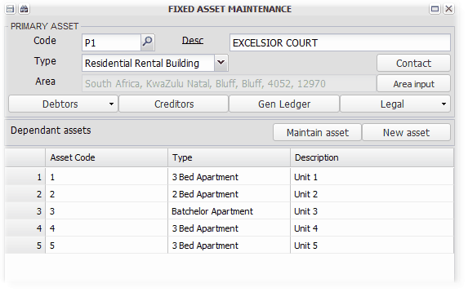

In this case, we chose Residential Rental Building from the type drop down list. These types and their related sub-types are setup on the Fixed Asset Table Control on Branch maintenance.

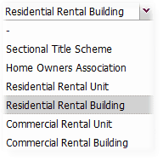
We have already setup the areas for all units:
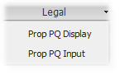

First the display of the PQ's/Areas, grouped by type:

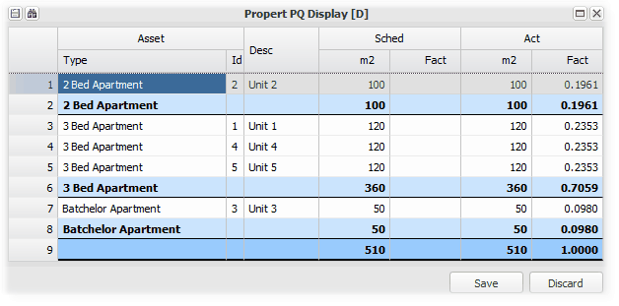
And the import/capture option:
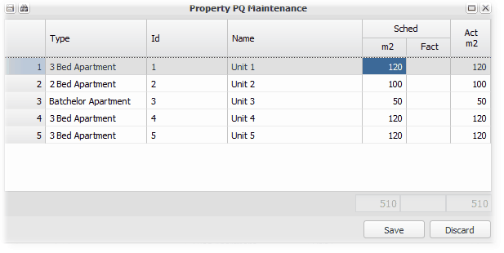

Choose the geographic location of the property using the Area Input button.

The other buttons information will be added later.

Set up a Unit - Level 2 Fixed Assets
We then add as many 'components' of the Property as there are. In our case, various rental units.

Click on the grid and then on New Asset (or Maintain if you are editing an existing one).

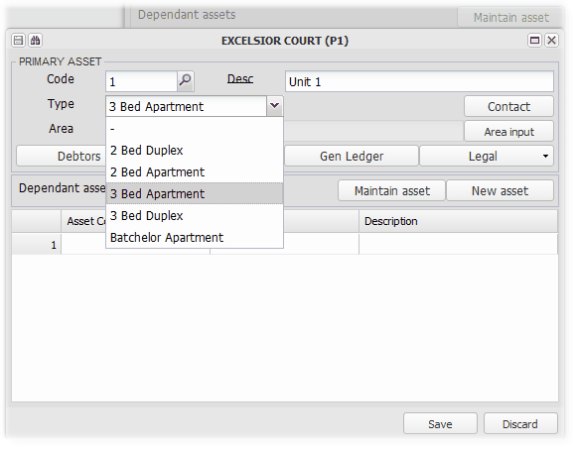
We now link the asset to a customer/debtor, and set up its fee structure. This is the same process as covered in the levy unit set up above. Please click here to go to that section.

Add a level 3 fixed asset linked to a unit to record its contents
We add a level 3 asset to unit 4, by clicking on unit 4 and then on maintain asset. Then click on the grid and click on New Asset. Add as many assets as necessary, capturing the costs etc. if necessary. You can follow the setup and asset report section of a levy unit setup, which is a similar process by clicking here.

The relevant screen as an example:

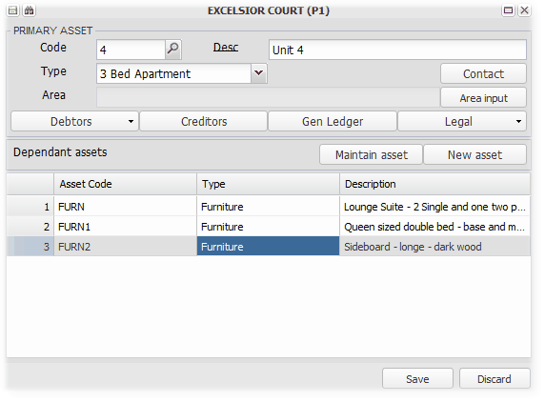

Setup or Maintain a Normal Fixed Asset
Non- property assets can be setup either independently of a Branch, or linked to an accounting Branch.

After creating you asset code, choose Non Property Fixed Asset, and proceed to add level 2 assets for as many as required.

You can set up different categories of assets under the Non Property Fixed Asset group (using Branch Maintenance), create level two assets for the categories and add level three assets to each group as required.

An example of the input screen:

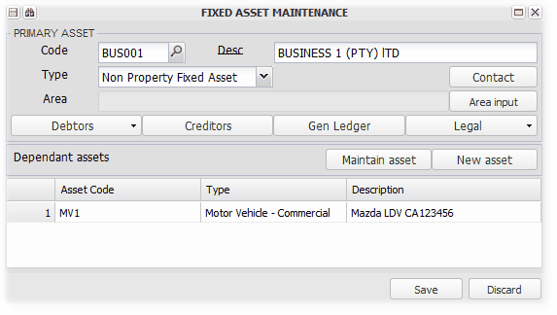

You can add the cost, depreciation and other financial details by clicking on the General Ledger button:

Depreciation, disposal and profit/loss journals are put through using General Ledger Auto Journal, and an Asset Trial Balance can be viewed using General Ledger Asset Trial Balance:

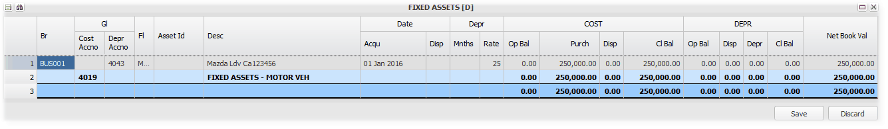

General Ledger
Enter topic text here.

General Ledger Auto Journal
Enter topic text here.

General Ledger Asset Trial Balance
Enter topic text here.

Debtors
Enter topic text here.

Deposit refund
Enter topic text here.

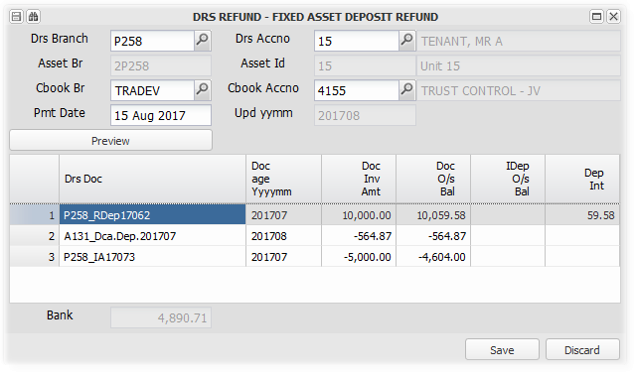

pool req and approval

Lease - New Customer
This option is a worksheet that is usually used when new tenant moves into a unit, and allows for -
- the capturing of the new tenants directory information
- the creation of a new debtor and lease record

Once these steps are completed, the lease is finalised using Lease - Existing customer

Set up the necessary directory items
Use this Lease screen to link an existing directory item (identity, registration number etc.), or create a new item. A directory item is based on the tenants legal status - an individual, a group of individuals (partnership), a company etc. Refer to Create/Maintain Directory for more information on using directories.

If you have several individual lessees for one lease (often for student leases), create a Partnership directory item, and link each person as a partner. All of their names will be displayed in the lease as lessees.

Create a new Debtor and Lease record
Add the directory link created above. Knowing which property and unit (asset), choose the next available debtors number and 'Create':
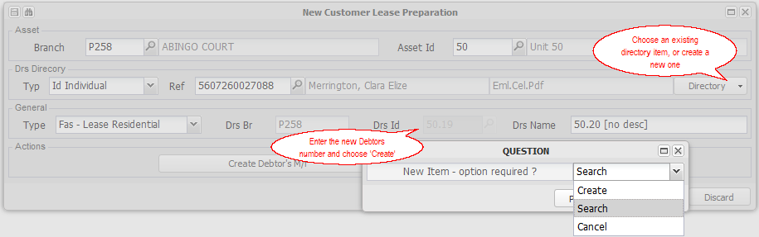

Add the new debtors name:
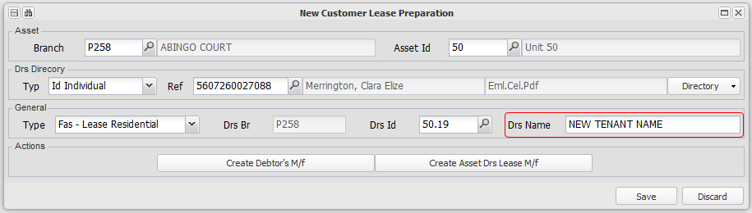

Then -
Create the new Debtor's Masterfile
Save the details on the screen if you haven't completed the set up, and want to return to it. If you have completed the setup, create the new debtors account by clicking on the button at the base of the screen:
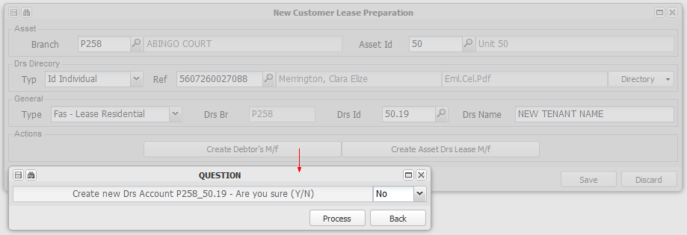

Remember to add any additional details required to the debtors master file record eg. banking details.

Create the new Lease Record
Click on the Asset Debtors Lease Master file button to create the new lease record:
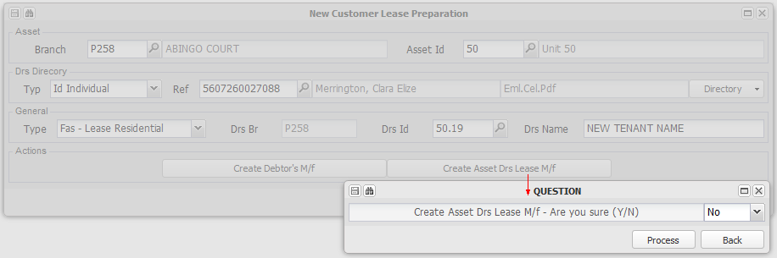
Warning on Saving if updates not complete
When Saving the screen without creating the new debtor or the new lease record, you will be warned and asked to confirm:
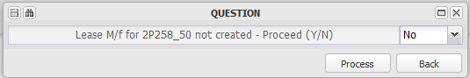

Once these steps have been completed, the lease is finalised using the Lease - Existing customer screen.

Lease - Existing Customer
This option is a worksheet that is used after a new tenant lease record has been created, or when an existing tenant lease is renewed. It allows for -
- the capturing of lease information for a new tenant created using the Lease - New Customer screen
- the updating of previous lease information for an existing customer (tenant) by updating the new lease information
- updating the new lease information on the relevant fixed asset (unit)
- the charging of all initial lease and related fees
- the production and eMailing of a lease document
- the upload and storage of a signed lease document
- the viewing of previously uploaded leases

As opposed to the Lease - New Customer screen, this screen is used to enter a newly created debtors lease information, and to renew an old lease. You can also upload a copy of the signed lease, and then view it and older leases uploaded. Refer to the new lease screen for information relating to capturing a new tenants details.

Capture the lease information not captured on the Lease - New Customer screen
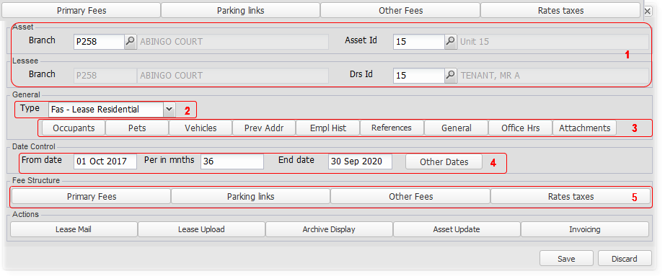
1. Choose which Branch, Fixed Asset (Unit) and Debtor
A fixed asset (unit) will be let to different debtors over time. A lease agreement record is created for each combination of the asset number and the debtor number when the new customer lease screen is saved. This record can have several leases linked to it, as the same debtor (tenant) renews their lease.

When entering the debtor number, you will be advised when the last credit check was performed, and you will be asked to confirm that you wish to proceed. If not, choose No, and perform a new credit check.

2. Choose which type of lease
Select which type of lease you wish to produce from the selection drop down:
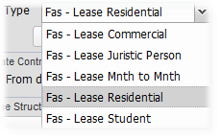

3. Enter the relevant tenant and occupation information
Enter the various groups of information which will be stored as a record of the tenants information, and be displayed in the lease document where relevant:
Occupants
Enter the details relating to the people who will occupy the relevant property (unit):
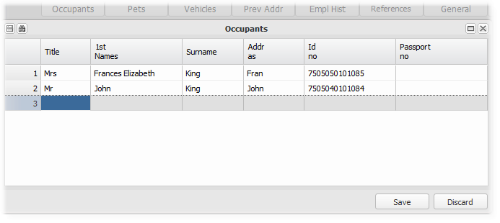

Pets
Enter the type and number of pets that are allowed to kept by the tenant:
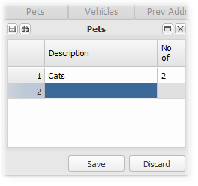

Vehicles
Enter details of the vehicles that will be allowed to park on the premises:

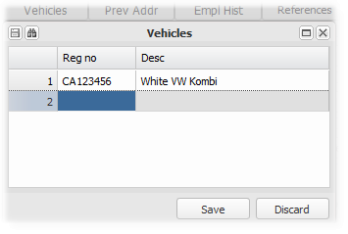

Previous addresses, References and Employment history
Enter the tenants details relating to previous addresses, their lease references and employment history.

General
Capture various information and options that will display in the lease agreement. Only enter the commercial options if you are producing a commercial lease.

The owner Agent override is used where a lease is produced that will be managed by the owner of the property. The owners contact details and bank account number will then override the agents (which is the default):

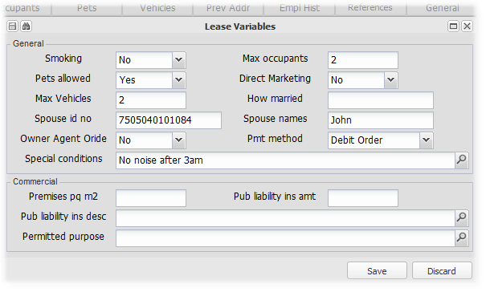

Office hours
Enter the days and hours that constitute office hours in terms of the lease agreement :

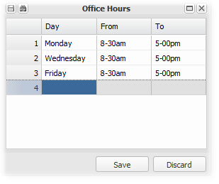

Attachments
List the documents that will be attached to the lease produced:

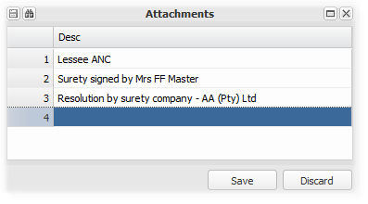

4. Enter the lease period and other key dates
Enter the main lease period - From date, the number of months and the system will default the end date:
Enter other key lease dates as indicated in the screen shot below:
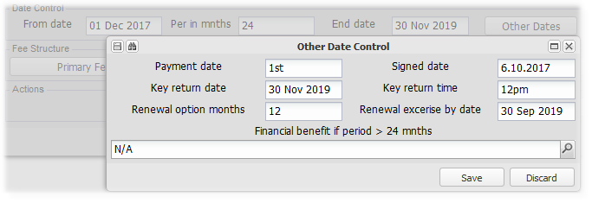

5. Enter the various charges in terms of the lease and build their fee structures
Capture and update the charges, for example rental, for the lease period.
Primary fees
Capture and update the primary fee payable in terms of the lease agreement - rent Operating costs

Bearing in mind the lease period entered above, enter the rental amount, the invoice code and escalation percentage and month:
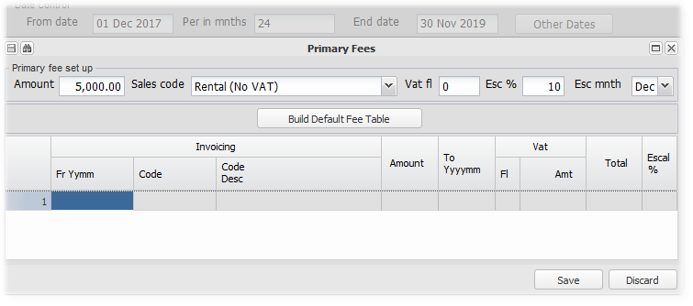

and 'Build the Default Fee Table':
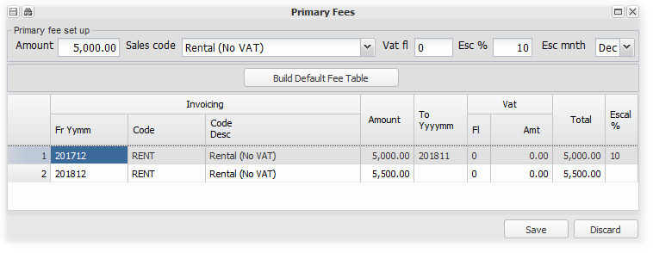
Add other primary fees, in this case, Operating Costs, following the above procedure:
: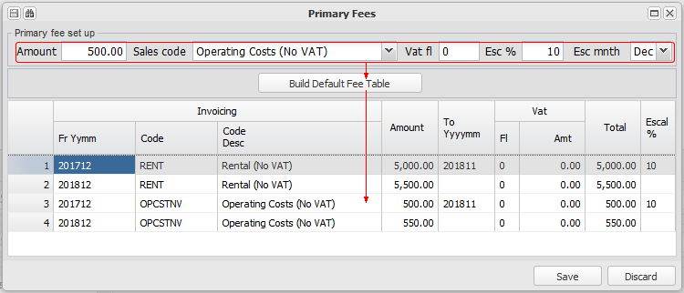

Note the periods and escalated amounts. The last period for each code is left without an end date, to avoid not charging if the lease renewal is overlooked. This fee table will be added to the invoicing table on the relevant fixed asset (unit). Any existing invoicing table lines will be closed.

Remember to check and confirm the fixed asset invoicing table once complete to be sure that the new set up is correct.

Parking links
Link any parking assets (units) to the new debtor (unit) and build fee structures for each one:
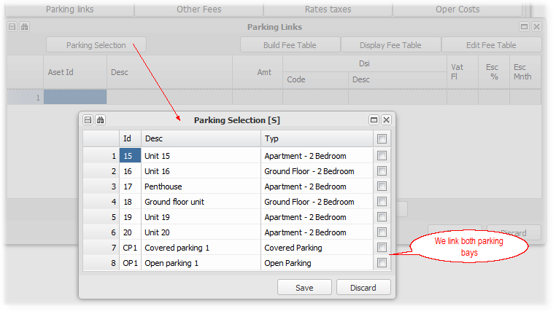

Having linked the parking bays, we need to enter the rental details:
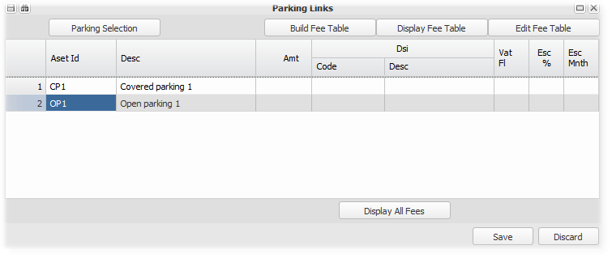

We add the parking rental amount, invoice code, escalation % and escalation month:
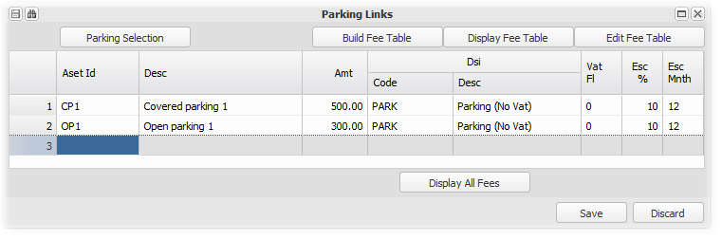

Then highlighting each line, we 'Build the Fee table' :
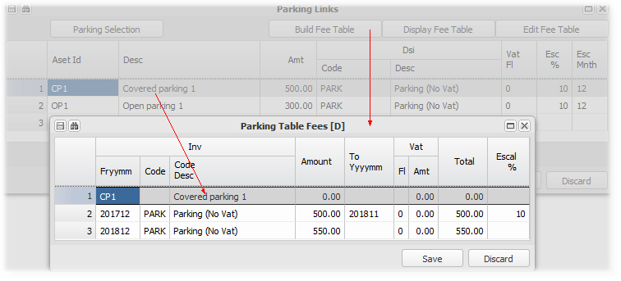

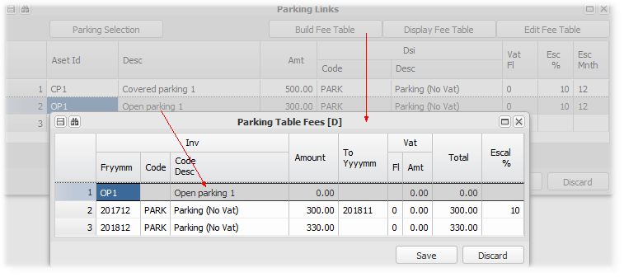
Note the period and escalated amounts. The last period is left without an end date, to avoid not charging if the lease renewal is overlooked. This fee table will be added to the invoicing table on the relevant fixed asset (parking unit). Any existing invoicing table lines with matching dates will be closed.

Remember to check and confirm the fixed asset invoicing table once complete to be sure that the new set up is correct.

Other fees
Enter the amounts of other fees that will be charged when the lease is finalised (Invoicing' button below), and other lease information:
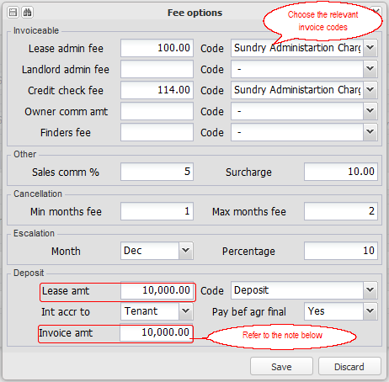

Deposit 'Lease amount' and 'Invoice Amount'
These two amounts will usually be the same for a new lease - invoice the full initial deposit.
When a lease is renewed, usually only the deposit increase will be invoiced, with the lease amount being the full amount of the deposit.

Rates and taxes
For commercial leases, enter the rates and taxes amounts at the inception date of the lease. Tenants usually pay a share of the increases in these amounts:

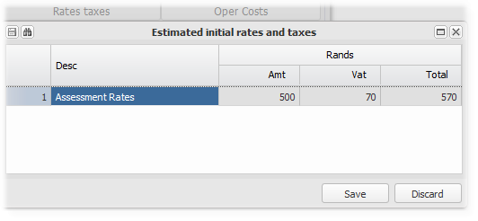

Preview and send a copy of the lease for signature
Click on Lease Mail to preview and send the lease agreement via. email -
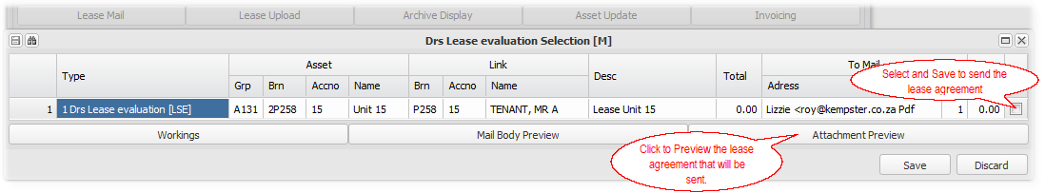

Signed lease - Upload and View
To upload a new lease agreement document, click on Lease Upload -

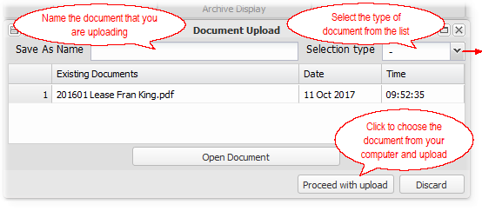 | 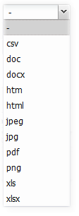

To view archived lease documents, click on Archive Display -
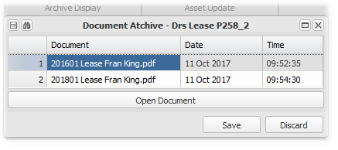
Select a document by clicking on it, and then click on Open Document to download and view it.

Update the fixed asset invoicing tables and charge the initial fees
When all the necessary information is captured -

Asset update - Clicking this button will: | 1. Add a customer link to the fixed asset (unit), and insert an end date for any existing link.
 | 2. Add the fee structures created, to each relevant fixed asset (unit), ending all existing fee structure items the day before the new items commence.
Invoicing - Clicking this button will: | Invoice the fees and other charges captured under 'Other fees' fields.

Remember to check that the customer links and invoicing table have been updated in accordance with your expectations.

Debtors - Auto General
Enter topic text here.

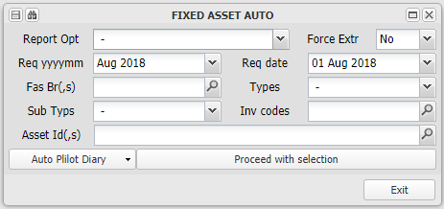

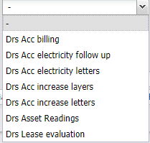

Debtors Account Billing
This menu item raises the charges for selected Units (Fixed Asset 2's), that are set up on the Fixed Asset 2 as recurring charges.

It will only allow you to raise the charges once for a month for a Property (Fixed Asset 1). It is usually run around the 22nd of a month, for the next month, as charges are due on the first of the next month. You can run the fee raise for selected items, and then run the unselected ones later.

You can either select one branch, any debtors from it or only selected invoice codes. Usually, you will select all branches on a certain date:

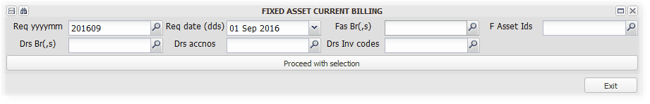
We chose P258 and P1022, for September 2016, and for all units/assets. We chose a due date for the billing as 1 September 2016. After checking the display, we chose all by clicking on the tick box at the top of the column, as indicated by the arrow:

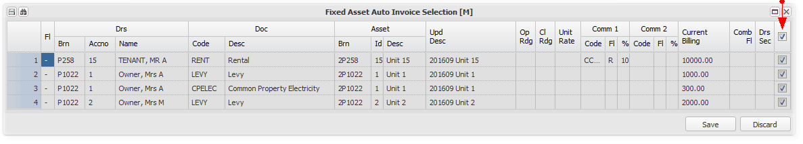
The system asks for confirmation, and then raises the requested billing:

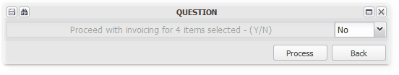

It confirms the billing - note the linked item billing which was not in the original window:

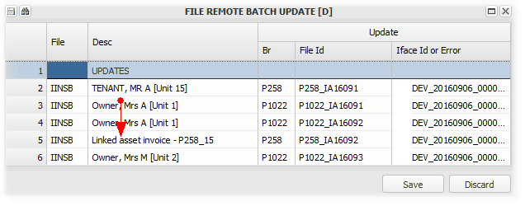

Debtors Asset Readings
Use this option to import asset utility reading and charges.

Refer to Setting up the Utility reading system for more information on performing this function

Reading Slip Formats
Use this option to set up the import rules for various utility import files. Refer to Setting up the Utility reading system and charging Debtors for Utility usage for more information.

Referring to the import dialog box below - you can set up as many formats as you require. Each can be linked to the same or a related meter reading slip template, or not linked to a template. This allows for the authorised use of external meter readers templates. For each format, you can indicate whether the amounts are in cents (the default being in rands and cents), and whether the cost should be calculated assuming a 30 day cycle for the reading table. If you indicate that the 30 day cycle is relevant, and if the reading period is longer than 30 days, the average daily consumption is calculated and the tariff applied in groups of 30 days.

The standard Asset ID is the branch code and the asset level two number, preceded by a 2 indicating asset level 2. For example, Unit 1 in Property (branch) P1022, has an ID of 2P1022_1. An alternate or previous system reference can be captured in the XRef field of the asset set up screen, which by setting the Asset Scan option to Yes, will be used to match the reading to the unit.

The import dialog box:
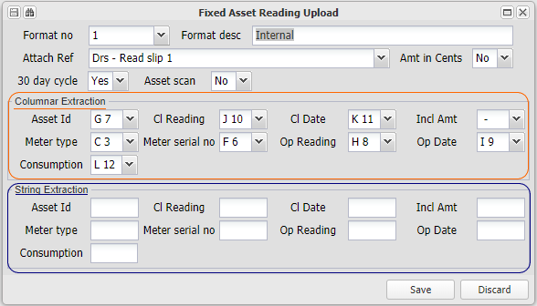

The system accommodates two types of files that can be imported:
1. Columnar layout from a spreadsheet
Meter readers files that are supplied in an Excel spreadsheet, can be imported using the Columnar Extraction set up, as indicated in the example below. Note how the fields in set up screen, are linked to columns in the spreadsheet.

Where an amount is present, that will be charged. When no amount is present, the system will attempt to calculate the charge.

At least an Asset ID, closing reading and date should be included. If no amount is imported, the system will need a system opening reading to use in calculating the charge. If the opening reading is not present on the system, the charge or the opening reading will need to be included.

You can set up an Excel spreadsheet in a format that you require to capture your own readings and charges as necessary.

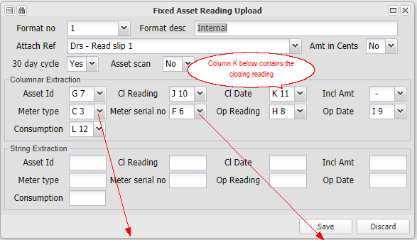
The following is an example of a meter readers export file into Excel, which has been linked to Format 1 above. Certain of the columns are not needed or accommodated.
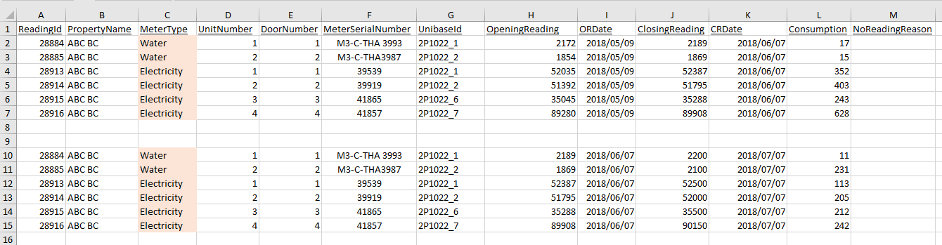

2. A fixed width data string
Meter readers files that are supplied in an text string file, can be imported using the String Extraction set up, as indicated in the example below. Set up the import fields from the key to the import file. In the example below, the Asset ID, is an 8 character field, starting in the first position in the string (1,8). The meter type, in this case 'E' for Electricity, is the next field - it starts in position 9, and is one character long (9,1).

Where an amount is present, that will be charged. When no amount is present, the system will attempt to calculate the charge.

At least an Asset ID, closing reading and date should be included. If no amount is imported, the system will need a system opening reading to use in calculating the charge. If the opening reading is not present on the system, the charge or the opening reading will need to be included.

Where an amount is present, that will be charged. When no amount is present, the system will attempt to calculate the charge. Note also that not all fields are necessary.
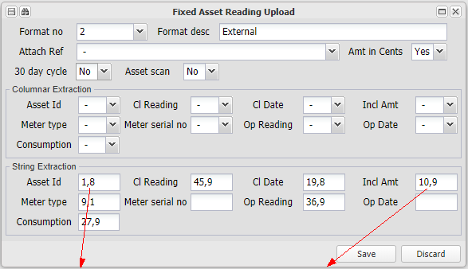
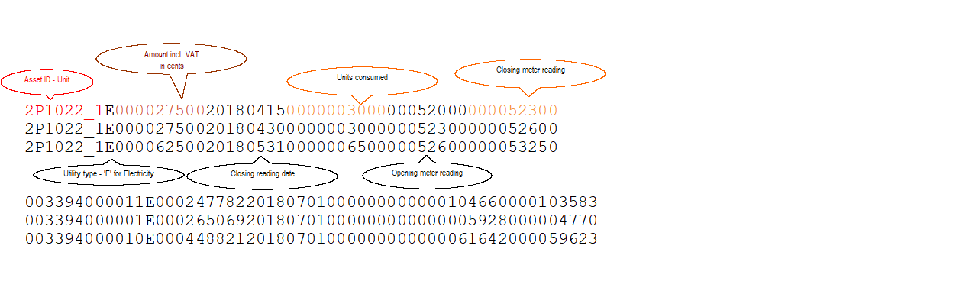
.

Maintenance
Enter topic text here.

New Job - Occupied
This option allows for the logging of a new maintenance job for a unit that is occupied and linked to a debtor. It facilitates the recovery of the cost (or a portion thereof), from the debtor. This will begin the maintenance work flow process which facilitates the management of and payment for the job.

Refer to Setting up, processing and paying for Maintenance Jobs for more information.

New Job - Unoccupied
This option allows for the logging of a new maintenance job unoccupied units, including maintenance relating to areas of the common property. This will begin the maintenance work flow process which facilitates the management of and payment for the job.

Refer to Setting up, processing and paying for Maintenance Jobs for more information.

Maintain Job
This option allows for the further processing of a maintenance job, once it has been logged. This is the second step in the maintenance workflow process which facilitates the management of and payment for the job.

Refer to Setting up, processing and paying for Maintenance Jobs for more information.

Manual Reply - Supplier Quote Approval
This option allows the recording of a supplier quote reply on the system, and the uploading of a copy of the quote.

It is usually only used if the supplier doesn't reply via. eMail.

Refer to Setting up, processing and paying for Maintenance Jobs for more information.

Manual Reply - Trustee Quote Approval
This option allows the recording of an office bearers (trustee) approval of a quote for a maintenance job on the system, and the uploading of a copy of the approval document.

It is usually only used if the office bearer doesn't reply via. eMail.

Refer to Setting up, processing and paying for Maintenance Jobs for more information.

Manual Reply - Administrator Quote Approval
This option allows the recording of a maintenance administrators approval of a quote for a maintenance job on the system (once approved by branch office bearers), and the uploading of a copy of the approval document.

It is usually only used if the administrator doesn't reply via. eMail.

Refer to Setting up, processing and paying for Maintenance Jobs for more information.

Purchase Invoice Upload
This option allows for the setting up and uploading of invoices received from suppliers for maintenance jobs.

Refer to Setting up, processing and paying for Maintenance Jobs for more information.

Job Extraction Report
This option provides a summary list, sorted by job status, of all jobs that you are responsible for. It is usually used in managing the maintenance process.

Refer to Setting up, processing and paying for Maintenance Jobs for more information.

Unit Management Log
Enter topic text here.

Clearance
Enter topic text here.

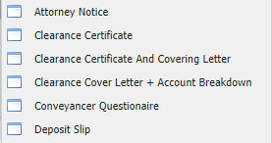

Letting
Enter topic text here.

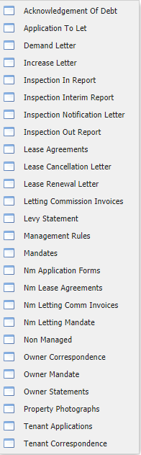

Other
Enter topic text here.

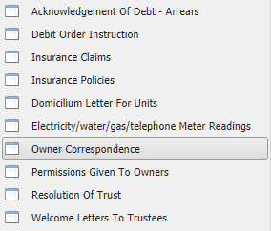

Take On
Enter topic text here.

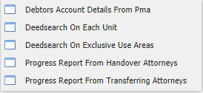

Refund
Enter topic text here.

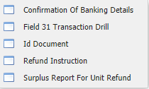

Employees
Enter topic text here.

Create/Maintain
Enter topic text here.

Management Log
Enter topic text here.

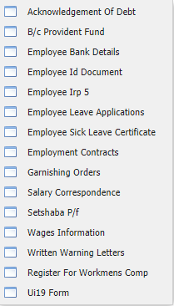

FAQ ?
Enter topic text here.

How do I link two units to pass on charges and payments ?
Linking two units (Fixed Asset 2's) is useful and intended for when a unit in a body corporate/HOA, is rented out by the owner to a tenant, and when both use the central bank account of the agent.

If you are managing both properties, one as managing agent and the other as a rental collection agent, you will charge levies and utilities to the unit owner from the body corporate, and charge rental and usually the same utilities to the tenant in the unit on behalf of the owner. You would also need to pay the amount due to the body corporate on behalf of the owner, usually out of the proceeds of the rental paid by the tenant.

To facilitate the automation of the charging and levy payment, you can link the two units as follows:

The body corporate is the Controlling unit, as it generates the charges to be on billed. On the fixed asset 2 that represents the unit, click on Debtors and Asset Link. In this example, we are linking P1022, Asset 1 (HOA), to P258, Asset 15 (A rental unit):

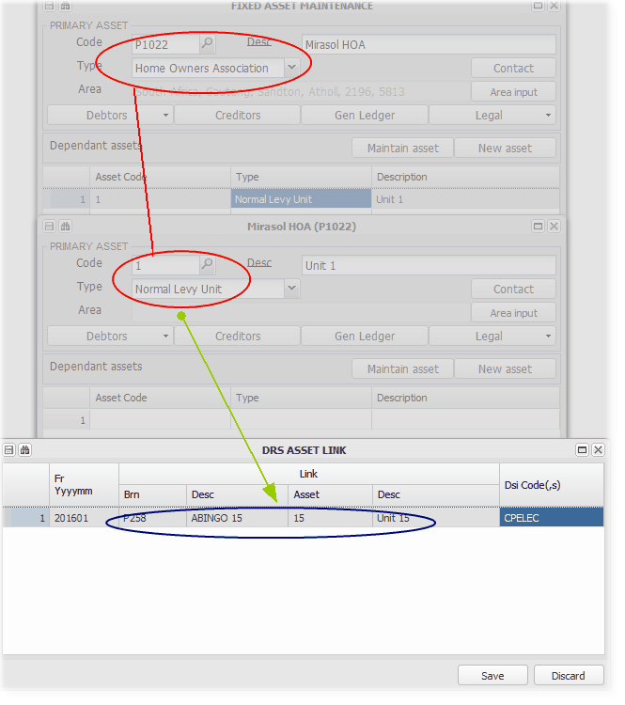

And choosing the items to on bill to P258 Unit 15 from the drill on DSI Code/s. we choose CPELEC below:

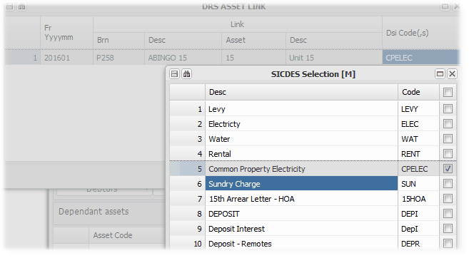

Each time P1022-1 is charged for CPELEC, a matching billing will be made to P258-15. The charges would both be made to the Debtor currently linked to the Fixed Asset, as set up in Maintain/Create Fixed Asset. All charges to P1022-1 will be raised as creditors in P258.
.
When the tenant in P258-15 pays his rental and CPELEC, the full amount due (including any levy etc.) to P1022-1 will be automatically paid from P258.

How do I set up and charge Bank Charges to clients ?
Enter topic text here.

How do I setup Debt Collector Letters and their Charges
There are a few steps in setting up a debt collectors letter before sending it out using Debtors, Auto - General.

Groups are set up on a table for Debtors documents, one of which is 'DCL' for these letters. The letters are then flagged as part of that group:

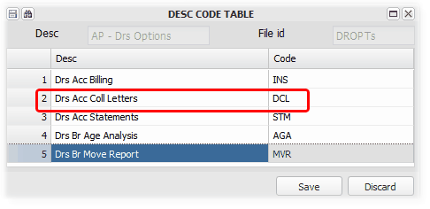
This option is on Administrator Control, Maintenance, Machine Selection Control, AP - Drs Options

Setup your letter template with relevant variables and upload it - naming convention

Setup a link to the new letter template

Add the new letter to the list of Debt Collector Letters to choose from when sending the letters out

Add a new Sundry Invoice code for the new letter
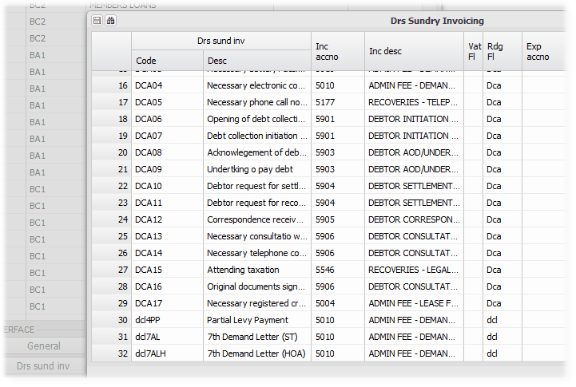

Add an amount to charge for the new letter

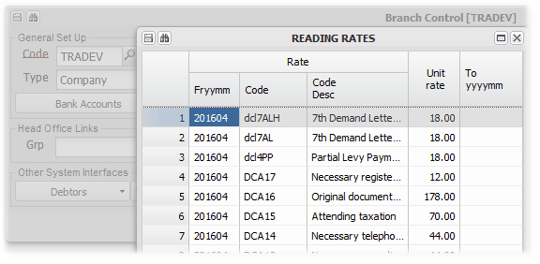

Terminology
This section contains definitions of key terms used in the system.

Please also refer to the, 'New and Old', which compares the terminology used in the current system, as compared with that used in it's predecessor.

Branch
A Branch is a generic term for an entity of any type. In the context of the system, it is the accounting home of a company, body corporate, individual etc.

A Branch can represent a classic business, a property management business, a sectional title scheme or a property that is rented out as a business.

A Branch can be linked to a Fixed Asset structure, to record it's assets, by using the branch number for the Fixed Asset number. This is a necessary link in a property management structure, where the physical property and its unit/s are set up as a fixed asset structure.

So that the nature and type of branches are easily identifiable, the property system includes an A or a P as the first character of property type branch numbers, which are generally numeric. An 'A' is used to identify Agent branches, and a 'P' to identify Property branches. For example, branch A121 would be an agent branch, and branch P1399 would be a property branch. Although this is not a requirement for the system to function, it makes using the system easier.

Debtor
A debtor is classically defined as a person, natural or not, that owes money.

In the context of the system, a Debtor is a person that owes money to a Branch. As the system allows the sharing of Debtors, one Debtor can owe money in respect of transactions arising from several different Branches.

Examples of system Debtors are, tenants in a property for rental due, persons that have borrowed money on loan, sectional title owners for levies due, persons that owe money for services rendered or products supplied by a business Branch - in the property context, collection and management fees charged by an agent branch to a property branch.

As indicated above, a debtor is always linked to a branch. The system has no restrictions in choosing debtors numbers, which will usually be chosen to be meaningful in each branch context. In the property management context, it is generally useful to have the debtors numbers the same as the apartment or unit number. To maintain this link in the systems' predecessor, the unit number was always reserved for the current occupant, with previous occupants being archived/suspended. This resulted in external debtors references usually used for banking transactions, changing within the system, but externally leaving preceding debtors with the same number, resulting in incorrect receipting and allocation of utility charges.

This system addresses the above issues, by keeping debtors numbers unique to a debtor. The various relevant screens allow for looking up debtors based on the debtors number or the fixed asset (unit) number that the debtor is linked to. Transactions that are linked to a unit, will be applied to the debtor who was active at the date of the transaction.

Directory
The system has directories items in respect of entities/individuals/bank accounts based on their registration numbers, which are stored independently, and can be linked to branches, debtors or creditors. Each of the directory items contains key information relating to the entity/individual/bank account.

The purpose of having a directory, is that all the information relative to for eg. an individual, is stored in one place, and the directory item is linked to wherever the individual is required to be linked. For example, if one person is an owner of a sectional title unit, a trustee in their body corporate, and owns a unit that is being rented out by you, her key information would usually need to be captured in each of those places. If a telephone number changes, it would have to be changed in each of those places. The system directory structure allows the changed information to be captured from any of the places, and it will update all of the others.

Refer to Create/Maintain Directory for more information

Fee Structure
A fee structure is a table of fees (amounts) that is selected from to calculate the amounts due by a debtor for a service/rent/levy etc. It can have to and from dates, amounts or percentages, to be charged for the indicated periods.

There are a few types of fee structures in the system:

1. Rental and related charges in terms of a lease, charged by a property owner to a tenant (sometimes referred to as an Invoicing Table)
2. Levies and related charges charged by a body corporate/HOA to the owners of units in the scheme.
3. Commission charged by a property management company for the collection of rental and related charges on behalf of its client.
4. Commission charged by a sales person on invoices generated for sales initiated.
5. Fixed amount management fees charged by an property management company for monthly services performed by them.

Fixed Asset
Fixed Assets are classically defined as assets which are purchased for long-term use and are not likely to be converted quickly into cash, such as land, buildings, and equipment.
In the context of the system, fixed assets are longer term assets as described above. Businesses that use the system for their administration, will have assets that are used in their business operations. In the context of property management, the relevant fixed asset is the property that is being managed, which will generally be 'owned' in some way by the branch that the asset is linked to.
The system allows for fixed asset levels -
Level 1 - | primary asset group, which can be the only asset or be a group of assess for a branch, and have sub-assets.
Level 2 - | sub-assets of Level one, which is common if level one is used as a primary branch group of assets
Level 3 etc.

An example of the above structure in a property management context -
Level 1 - | The building or property, which is usually comprised of various apartments or houses
Level 2 - | Each of the various apartments or houses
Level 3 - | Furniture in one of the houses

Refer to the image below demonstrating the above:
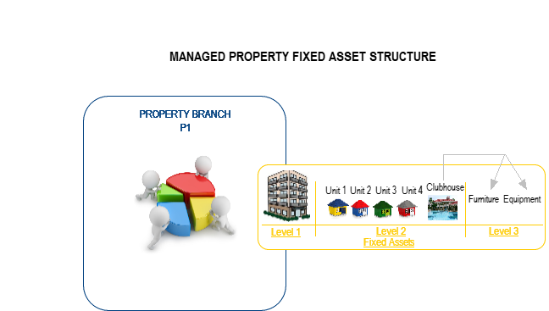

Fixed Asset Table setup.

Fixed asset types are set up by using the Fixed Asset Tables button on the central data base branch:
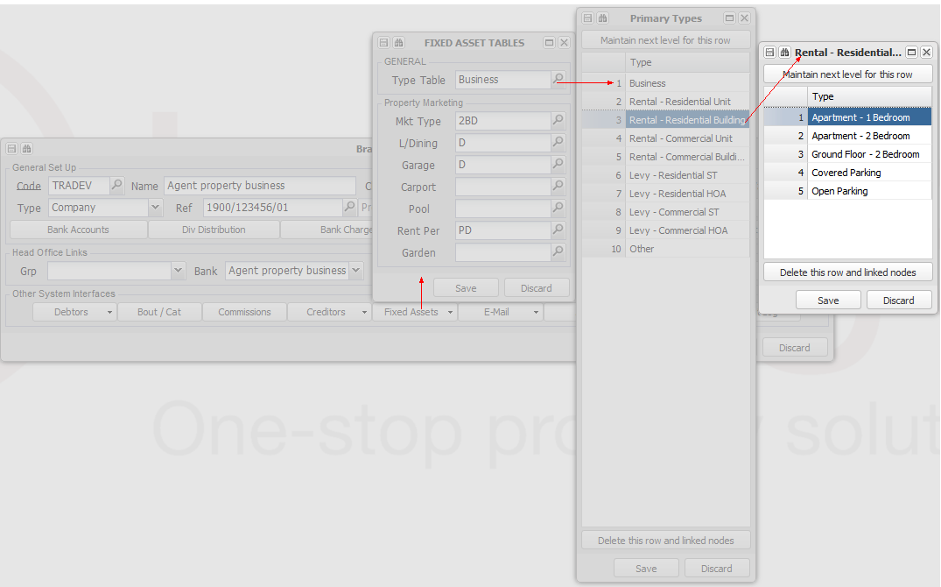

Head Office
A head office is traditionally understood to be an administrative centre for a company or an organisation.

The system apply's this concept in two primary ways -
 | If a branch is flagged as a Head Office, it will accommodate a central shared bank account, which can be used by other branches
 | - | Any branch that is flagged as a Head office, will have a banking structure that belongs to it, and can be shared with other branches. The systems supports a main trading bank account, a deposit holding account, two specialised direct deposit accounts, and a sundry bank account. The EFTS management facility controls the movement of funds between the accounts. Refer to the Shared Bank Account link above for more information.
 | - | There can be many Head office branches in any one database.
 | Branches can be linked to a Group, which is then used for branch selection and various precedence rules.
 | - | Each branch can operate independently, or be linked to a Group. This choice can be set on the Create/Maintain Branch Screen.
 | - | Users are usually given access to groups, which then include all branches in the group.
 | - | Report templates can be set up for a group, which will be the default for all branches in the group. A branches own templates would be used ahead of the group templates.

Intergroup
In the context of the system, Intergroup relates to the relationship between branches, debtors and creditors.

Intergroup is used to indicate that a debtor or creditor is linked to another debtor or creditor in the same database. The link is defined in the debtor/creditor numbering - If branch A1 invoices Branch P1022 for services, the debtor number in branch A1 will be P1022, and the creditor number in branch P1022, will be A1. The payment Flag is both cases will be set to Intergroup. This will be automatically set up by the system, when using the managed asset setup utility.

It is used as an indicator of payment, and of a trigger to mirror transactions -

Payment indicator:
 | Same back account - | Where both branches share the same bank account, amounts due will be automatically paid and receipted when running Debtors - Intergroup clear, reducing and increasing each branch's share of the bank account.
 | Different bank accounts - | Where the branches use different bank accounts, the receipt and payment batches will be automatically produced when running Debtors - Intergroup clear, and the actual transfer of funds from the creditors bank account to the debtors bank account will be processed using Transaction Approval
Transaction mirroring:
 | Where an Intergroup Debtors Loan or Managed Loan arrangement is set up, relevant transactions in the Lending branch will be mirrored in the Borrowing branch - Interest and finance charges. In the managed loan environment, receipts and interest will also be redirected based on the linking.

Invoicing
Invoicing is the term used in the system to indicate a charge to a debtor, in the form of an Invoice.

Purchasing
Purchasing is a term used in the system to indicate the recording of a creditors invoice.

Sharing - Bank, Debtors, Creditors and VAT
Sharing in the context of the system is where aspects of one branch's accounting structure is used by one or more other branches for various purposes.

Sharing enables -
One branch to share it's Bank account with other branches
Sharing bank accounts is commonly used in the property management environment, usually for a central trust account, where rental received on behalf of many clients is paid into a trust account/s. The host branch then records and controls the transactions of all participants. It is also common that one owner has many different properties, that all use one bank account, administered by the collecting agent.

In general business, many divisions of a business also share one bank account, with the income and costs for each division being allocated to them.

The system records and reports the break down of the balances by the branches sharing the account.

Each branch can have a share of a shared bank account, and it's own local bank accounts.

One branch to share it's Creditors with other branches in a group
Often in a group, one branch pays the group's creditors, on behalf of several other branches in the group.

This sharing is achieved when capturing or importing creditors invoice journals:
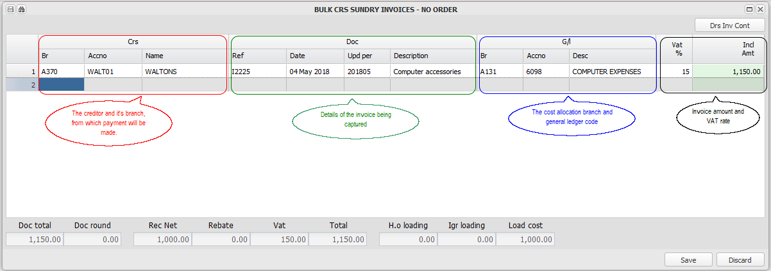

By default, the VAT accounting treatment of a tax invoice will be determined by the VAT status of the creditors branch.

One branch to share it's Debtors with other branches
As with creditors, one branch can allow other branches to invoice amounts to its debtors.

This sharing is achieved when capturing or importing debtors invoices:

By default, the VAT treatment of the invoice will be determined by the VAT status of the invoicing branch, and the Invoice Code being used.
The output VAT will be accounted for in the invoicing branch..

One branch to administer VAT for other branches in a group
By setting the default VAT branch to be another branch, all VAT transactions will be shared to the other branch, which can then return and remit to SARS. This can be done for several branches.
VAT sharing is set up by choosing a VAT head office link from the Create/Maintain Branch screen

Sharing is achieved by general ledger sharing, with default sharing accounts set up
From an accounting perspective, sharing is achieved by processing the entry that would have been posted to say, for eg., Bank Account, to the bank sharing default account, and posting it to the Bank Account in the host branch (as well as the opposite sharing entry).

Sharing defaults are set up by capturing default sharing/clearing general ledger codes using the Datbase Setup Menu.
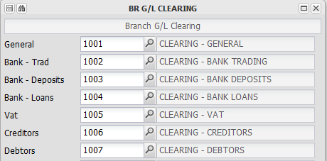

Old and new

Old System |  |  | New system
 | Agent |  | Branch
 |  | An agent is an entity, or branch of an entity, usually a business, and can have properties grouped under it. |  | A branch is an entity, or a branch of an entity. It can be a business, or a property entity. It can also be a group header for other branches.
 | Property |  | Branch and Fixed Asset level 1
 |  | A property is an entity. It can have units linked to it and contains information relating to the property owner and the property, and any fees charged to it by an agent. |  | A property is a combination of a branch and a fixed asset level 1 (FA1). These are linked to a branch. The branch contains information relating to the owner, whilst the FA1 contains information relating to the property.
 | Unit |  | Debtor and Fixed Asset level 2
 |  | A unit is a part of a property, usually an apartment or house. It is also a debtor, for any levy or rental charged in respect of the unit. |  | A unit is a combination of a Fixed Asset Level 2 (FA2), and a debtor. The FA2 is linked to a debtor, and can have several FA2's linked to it.
 | Fee structure |  | Invoicing fee structure
 |  | A fee structure is a table of fees and periods, which are stored on a property or a unit. The property fee structure is in respect of management fees, and the unit fee structure in respect of levies or rentals. |  | Also a table of fees and periods. Management fees are stored are stored on the branch, and unit fees are stored on the FA2.
 | Central banking |  | Head Office banking
 |  | Each account allows for the sharing of one bank account by many properties and agents, with controlled movement between it and a deposit trust account. |  | Head office banking is the same as shared banking, except that you can have several head offices in one account. Each will have a separate deposit trust account, and also two direct deposit accounts that transfer to the main shared account.
 | Brought forward | All unit debtors and all creditors use the brought forward principle in grouping transactions. Transactions are posted to a period, and a balance calculated at the end of the period, carried forward to the next month as its' brought forward balance. A balance cannot be easily broken down to its comprising transactions. | Open item | Both debtors and creditors allow transactions to remain open, until the individual transaction is either paid or credited. Receipts are automatically (or manually) allocated to the earliest transactions. Any balance outstanding will always be made up of outstanding transactions, which will all appear on statements and inquiries.

Report Templates
The system contains various links to it's underlying data, which in the context of reports are named variables. This section contains information on how to access and view the various levels of template variables, and how to download, create and upload report templates into the system.

The overall template usage rule, is that any template can be uploaded to any branch, with that branches stationery as its base. When reports are run, the relevant branches template will be used. If the branch does not have its own template, the data base branch template will be used.

Template variables
This utility is used to conveniently group and display data variables that are used in the various system reports. More will be added over time.

While viewing the list of variables, they can be easily copied from your browser, and pasted into the Word/Excel template that you are developing.

These are useful in adding letters, changing or adding debtors statements etc. More detail of developing reports is contained in the relevant sections.

To accommodate the usually structure relating to property management, the system is set up to obtain information, variables, from a branch's (Properties) group branch, or from the central database branch. For example, a credit controllers address is first looked for on the local branch, and if not captured there, on the group branch. More detail relating to this is described in the relevant template section in Templates in more detail

The initial selection window:
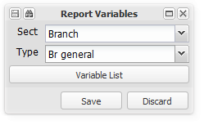

Choose a Section - Branch, Debtors etc:
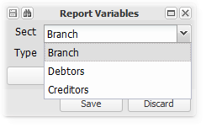

Choose a type linked to the Section selected:
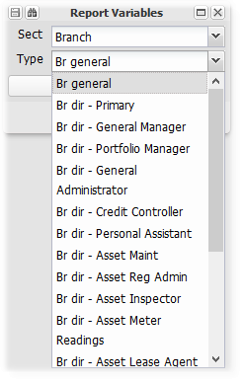

A list of variables and their descriptions will be displayed:
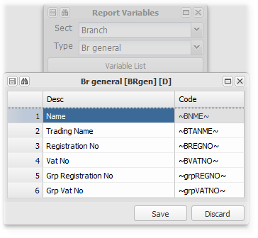

Depending on your browser, pressing 'CtrlC' (once or twice) will copy the variable that can then be pasted into the relevant template:
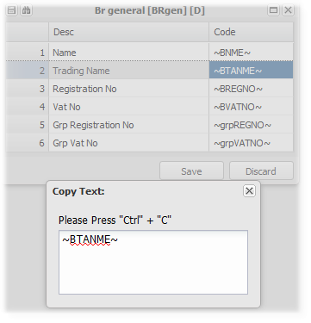

Templates in more detail
This topic describes how to create a template, complying with the system parameters. It also has examples of the common system templates and their related reports.

Some comments have been added to each template example. The best way to understand them is by cross referencing the template variables used on the templates, to the template variables utility, which will indicate other relevant variables that might be useful to you, and describe the variables used in the example template.
Creating a report Template
The system allows the importing of templates created using Microsoft Excel or Microsoft Word, and using the defined system Template Variables.

The details of each template is described in the report templates section below.

In essence, most reports have a header, detail and footer section. Letters usually have only one section.

Transaction based reports are usually produced in Excel (or PDF), where template variables can be added to the header and footer sections, with the system populating the detail section. One line with the desired formatting is left for the detail or transactions. The system first populates the header variables, then inserts as many lines as it needs for the transactions part of the report, and then populates the footer variables. The length of these type reports usually varies based on the number of transactions or records. Refer to the age analysis template below for an example of an Excel report template.

Letters are usually produced in Word (or PDF), with the system populating the document with information based on the variables included. They are normally fixed length reports. Refer to the debt collectors letter template below for an example of a Word based report.

Upload or Download a report template
Upload
Once a template has been completed, it can be upload into the system using Template Upload, which topic has more detail on the upload process. Ensure that the name of the template file is in accordance with the system report expectation. The system will add a branch number to the uploaded report to link it to a branch.
Download
You can download a template from the template list for the relevant branch. The list can be found on Create/Maintain Branch, eMail, Attachments

Referring to the example below, and downloading the age analysis template:

Click on the File Item column which contains the template that you want to download. Then click on the Drill (as indicated below) to download the template. It can be edited and re-uploaded using Template Upload:
Remember to check the name of the template before re-uploading a downloaded copy. The system sometimes adds to the original name to link it to the branch that it is uploaded to. The system will add what it needs to the name at the point of upload.

Template Precedence Rule
Templates are uploaded and linked to a branch at the point of upload.

When reports are produced, the system will first attempt to find a template linked to the relevant branch ( A debtor in a branch for example), and if no template exists for that branch, it will use the data base branch template as a default.

This enables you to set up templates for some reports that are unique to one branch, and allow the use of the central templates for other reports. In the property management environment, a particular branch might want its debtors statements to be on their own stationery, whilst allowing debt collectors letters to be based on the central templates set up by the agent.
Debtors related reports
Debtors Open Item Statement
Debtors statements are run from Auto Menu, or from Debtors Master Maintenance, Statement Enquiry
Example
This is an example of a debtors open item statement. In the property management environment, it also represents a tax invoice, in that it is usually only sent out once per month, and the individual invoices are not sent. It does comply with the requirements of the VAT act to be a valid tax invoice.

Property management companies usually act as an agent for the owners of the properties, and send out these statements on their stationery. There are variables to accommodate this by using the information relating to the group branch (agent), instead of the property branch.

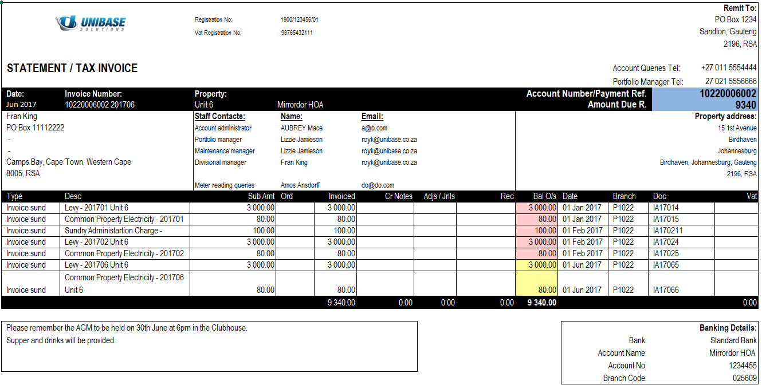

Template
The system name for this report is Doist.xlsx

This template is generated using Excel. The space reserved for transactions must be kept in the same position as in the example below.

The branch address is generally linked to the credit controllers postal address. If the relevant branch does not have a credit controller, the group branch credit controller will be used.

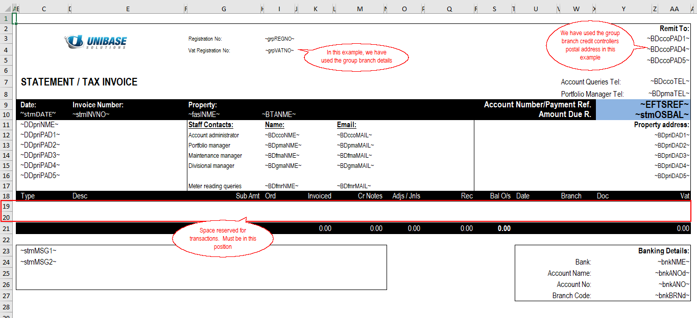

Deposit Slip
A deposit slip can be attached to the email sending a debtors statement to assist the debtor in making payment. This will happen automatically if a CIN number is added to the default bank account directory item, used by the relevant branch.
Example
An example of a Standard Bank M65. Other bank templates can be used, using the relevant template variables:

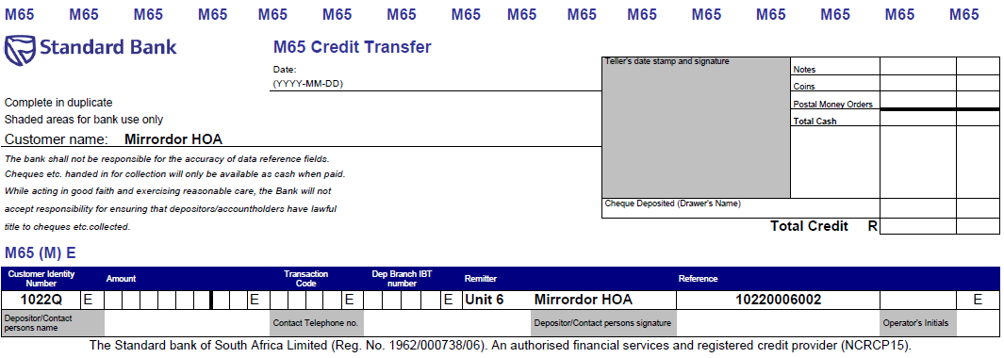
Template
This template is developed in Excel. It has no transactions, so is a fixed length report:
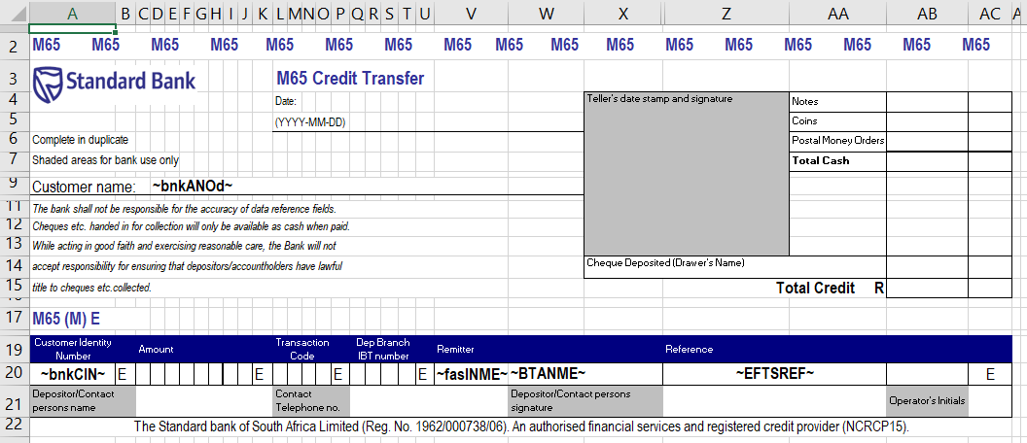

Debt Collection Letters
These letters are usually sent out as part of the outstanding balance collection process. This is an example of one letter, with the template below to show the commonly used variables.

We have used a run time variable, which is captured at the time of running the letters, and based on the knowledge of the person sending them at that time. These variables are user defined, and start with a small 'i', as can be seen in the template example below. You will be prompted to enter the information to replace the variable when you are producing the letters.
Example


Template
These templates are developed using Word. Note the run time variable in red, referred to in the example above.



Age Analysis
Example
This is an example of a typical debtors age analysis, with debtors notepad entries added on the right:
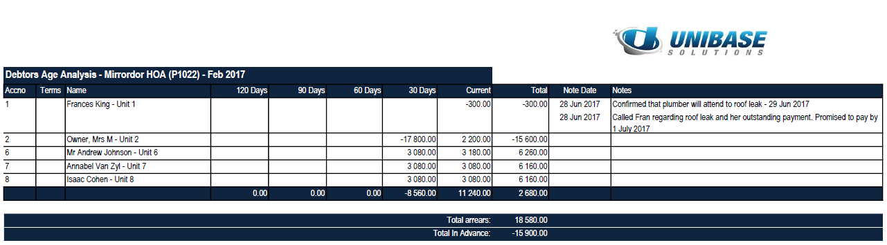
Template
This template is developed in Excel. Any fixed information variable scan be added in the first five rows:

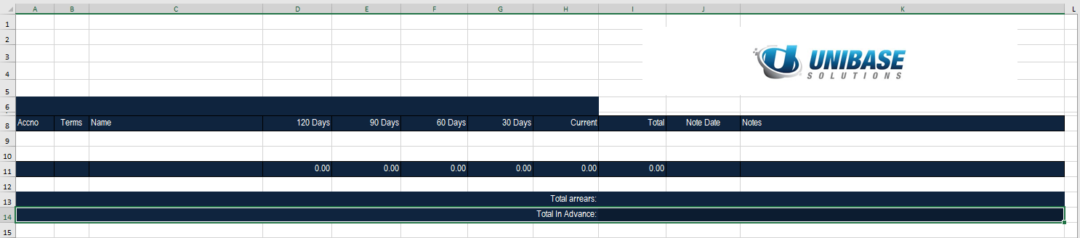

Debtors Movement Report (Rent Roll or Levy Roll)
This is an example of a debtors movement report, commonly know as a rent roll or levy roll in the property management area. Based on the branch indicator, the heading will be displayed accordingly.

It has header information, transactions in the middle, and totals and summaries in the footer:
Example
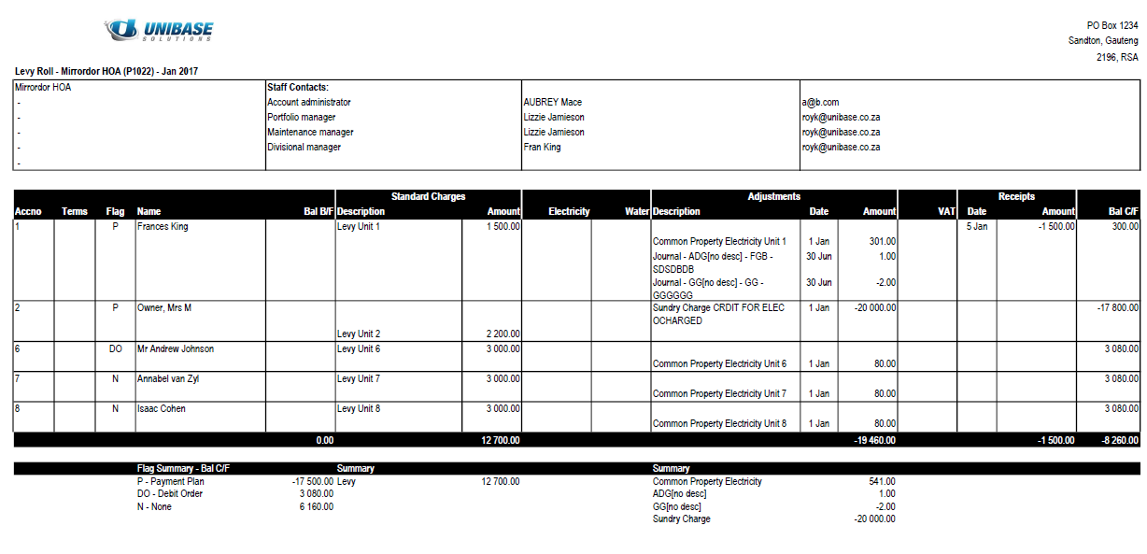

Template
This template is developed in Excel.

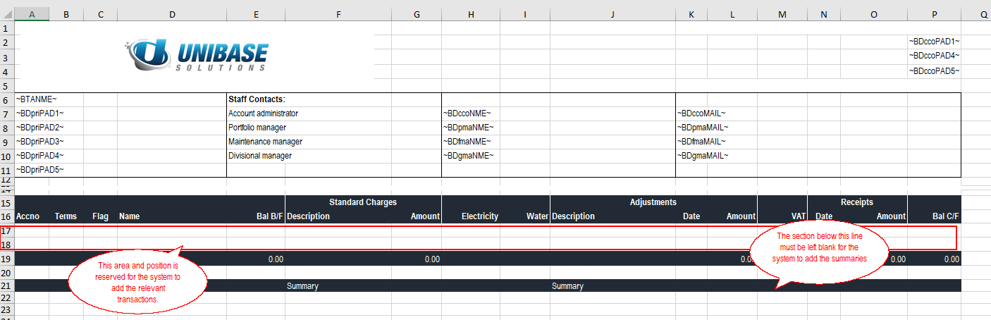

The system will choose which items to group under 'Standard Charges' based on the codes set up on Create/Maintain Branch, Debtors, Tables. Items set up on this table will appear under the Standard Charges column.

Keyword index

%
% Comparison · 235
A
Access · 5
Accessing · 5
Accounting · 108
Accounting roles · 7
Addresses · 152
Age analysis · 325
Agent to Unit billing · 273
AGM · 175
Agreements · 167
Approval · 246, 248
Approvals · 168
Approve · 57, 59
Archive · 19
Archive lease · 293
Asset depreciation · 290
Asset disposal · 290
Asset link · 273
Asset maintenance · 307, 308, 309
Asset register · 290
Asset trial balance · 290
Attachments · 67, 130
Audit · 169, 170
Automated options · 165
B
Bank account structure · 8, 114
Bank accounts · 114
Bank charge service fee · 217
Bank charges · 29, 217, 248, 314
Bank recon takeon · 248
Bank reconciliation · 248
Bank reconciliation report · 264
Bank setup · 253
Bank statement · 239, 243, 248
Bank Statement · 237
Bank statement capture · 263
Banking setup · 253
Billing · 206, 303
Branch · 129, 130, 316
Branch class · 253
Branch distribution · 48
Branch management · 167
Branch move report · 216
Branch sub-class · 253
Budget · 168, 264
Bulk invoices · 272
Business roles · 7
C
Capture budget · 264
Capture meter readings · 304
Cash control · 7, 114
Central Bank Account · 320
Central Data Base · 253
Change incorrect receipt reference · 239
Charge debt collection fees · 194
Charge fees · 53
Check interest charged · 71
Clearance · 309
Commission · 53, 130
Common · 7
Comunity Schemes Ombud Service · 34
Contact · 171
Contra Debtors Transactions · 208
Create · 152
Credit check · 165
Credit checks · 69
Creditors · 57, 59, 219, 221, 222, 270
Creditors control · 31
Creditors Control setup · 253
Creditors invoice approval setting · 130
Creditors masterfile · 219
Creditors setup · 253
CSOS · 34, 130, 217, 218, 253
D
Data searches · 126
DCA · 130
DCA letters · 314
Debit order · 194
Debit orders · 166
Debt collection · 65
Debt Collectors Act letters · 314
Debt collectors fees · 194
Debtors · 63, 194, 272
Debtors billing · 206
Debtors billing - General Ledger · 89
Debtors Conrol setup · 253
Debtors contol · 31
Debtors Contra Journal · 208
Debtors email · 210
Debtors functions · 206
Debtors masterfile · 194
Debtors movement report · 325
Debtors setup · 253
Debtors statement · 325
Default distribution · 48
Default report format · 152
Definition · 316, 317
Definitions · 316
Deposit · 113, 208
Deposit interest · 8
Deposit refund · 208
Deposit structure · 32
Deposits · 8, 32
Depreciation · 290
Deselect · 126
Directory · 152, 165, 317
Distribution account check · 48, 130
Distributions · 48, 130
Dividend · 48
Document archive · 19
Document storage · 19
Document templates · 130
Download template · 130
E
EFTS · 222, 246, 248
Electricity · 23
Email · 210
Email templates · 130
Employee documents · 311
Enquiry · 221
Expense exceptions · 130
Export · 124
External links · 165
F
FAQ · 312
Fee increase · 208
Fee increase letters · 208
Fee raise · 303
Fee structure · 317
Fees to a debtor · 91
Fixed asset · 273, 317
Fixed Asset Debtors · 303
Fixed Assets · 273
Format · 304
Formats · 248
G
G/L Reporting · 226
General ledger · 31, 108, 268
General Ledger · 226
GL account comparison · 235
GL Journal · 236
Group shared banking balances · 265
H
Head office · 319
Heading flag · 130
HOA properties · 7
I
Import · 23, 124, 159, 160, 165, 237
Inspections · 171, 172, 173, 174
Insurance details · 130
Interest · 45, 71, 77, 86, 208, 217
Interest - Trading · 71
Interest on deposits · 86
Interest on loans · 77
Interest on overdue amounts · 71
Interest rates · 130
Intergroup · 53, 194, 320
Invoice · 272
Invoice approval · 57, 59, 271, 272
Invoice codes · 259
Invoicing · 272, 303, 320
Invoicing table · 253
J
Journal · 236
L
Lease · 90, 291, 293
Lease address · 130
Ledger · 226
Letters · 65
Letting · 309
Levies · 63
Levy roll · 216
Levyroll · 325
Lines · 126
Link · 312
Link assets · 312
Linking · 273
Loan · 204, 215
Loan debtor · 204
Loan extension · 215
Loan interest · 77
Loan payment · 218
Loans · 77
M
Maintain imported bank statement · 239
Maintenance · 93, 307, 308, 309
Management fee · 194
Management information · 123
Management Log · 19, 167, 168, 169, 170, 171, 172, 173, 174, 175, 176, 177, 178, 179, 180, 181, 182, 183, 184, 185, 186, 187, 188, 189, 190, 191, 192, 193
Managers · 130
Mandate · 130
Marketing information · 273
Meetings · 175, 176, 177, 178, 179
Menu · 129
Menus · 129
Message precedence rules · 67
Messages · 67
Meter reader · 130
Muli branch trial balance · 232
Multi month trial balance · 226
Multiple unit billing · 273
N
No customer links · 273
O
Occupants · 23, 273
Open item unmatched receipts · 239
Operating · 5
Order · 271
Other - Unit uploads · 310
Other purchasing · 270
Overdue interest rate · 130
Override descriptions · 108
Override groups · 108, 130, 268
Overview · 5
Owner payments · 48, 130, 222
Owner payments less advance debtors · 48
P
Pack · 109
Pack precedence rule · 109
Pay Creditors · 217
Pay inter group creditors · 214
Pay invoices · 214
Pay sales commission · 218
PAYE · 130
Payment · 246, 248
Payment approval · 57, 59, 93, 271, 272
Payments · 222
Petty cash control · 253
Petty Cash Control Account · 253
PQ · 273
Prime interest rate · 71
Procedures · 7
Processes · 7
Property · 273
Property control information · 130
Property group cash clear · 265
Property Management Report · 265
Purchase · 270
Purchase order · 271
Purchasing · 270, 320
Purchasing approval setting · 130
Q
Questions · 312
Quote approval · 93
R
Raise deposit · 113
Raise interest on deposit · 113
Reading import · 303
Reading slips · 304
Reallocate · 243
Receipt commission · 53
Receipt deposit · 113
Refund · 218, 311
Refund credit balance · 218
Refund deposit · 113
Rent roll · 216
Rental · 90
Rental properties · 7
Rentroll · 325
Report · 109, 265
Report pack · 109
Report pack set up · 130
Report templates · 323
Report writing · 129
Reporting · 108, 265
Resolutions · 180, 181, 182, 183
Retain debtors credit balances · 48
Returns · 184, 185, 186
Reviews · 187, 188, 189, 190, 191, 192
Roles · 7
Rule · 109
S
Search · 124, 126
Sectional title properties · 7
Select · 126
Select grid lines · 126
Services agreement · 91
Set up · 263, 314
Setup · 5, 29, 31, 50, 253, 268, 314
Setup Property and Units · 50
Shared banking · 320
Shared banking overdraft · 45
Shortfall interest · 45
SMS · 208, 263
SMS's · 66
Spelling · 128
Staff · 7
Statement · 194
Statement attachments · 67, 130
Statement messages · 67
Sundry invoice · 272
Sundry Invoice Code Setup · 253
System Overview · 5
T
Template · 129, 323
Template variables · 323
Templates · 129, 323, 325
Terminology · 316
TPN · 69, 130, 165
TPN access password · 165
TPN setup · 253
Transaction · 221
Transaction listing - General ledger · 226
Trial balance · 226, 232
U
UIF · 130
Unallocated · 243
Unallocated bank items · 243
Unallocated receipts · 239
Unapproved creditor · 93
Unit · 273
Unit marketing information · 273
Unit not being charged for · 273
Unit refund · 311
Unlinked FA2 · 273
Updated terms · 322
Upload · 129, 165, 264
User defined email · 210
Utilities · 23, 123, 304
Utility import rules · 23
V
Valuations · 193
Variables · 129, 323
Varied receipt commission rates · 53
VAT default · 253
W
Water · 23
Y
Year end · 130

